**16.1 Using Distributed cache join the two datasets and find out the number of temperature variations in each country using mapreduce.**

**Input:**

**Here, we have the temperatures collected every minute, from 20 top buildings all over the world. For this data analysis, you can download the necessary dataset from the below link:**

<https://github.com/prateekATacadgild/DatasetsForCognizant/blob/master/Sensor%20data-20161205T052506Z.zip>

**Program:**

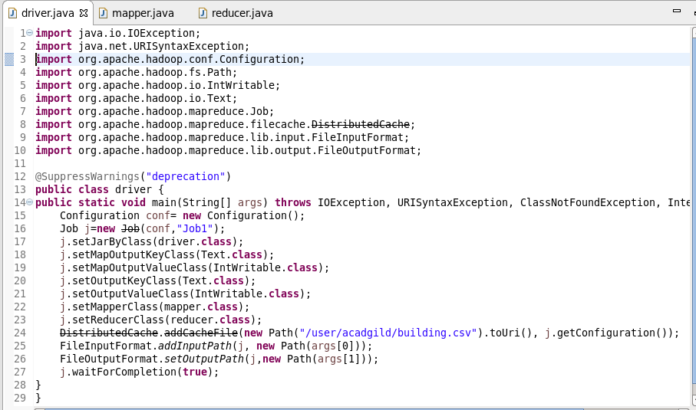

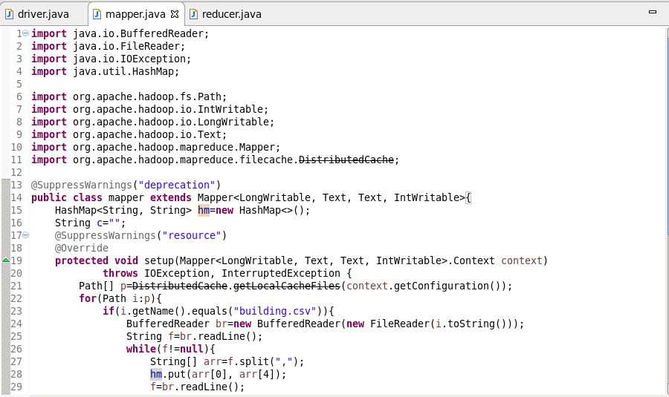

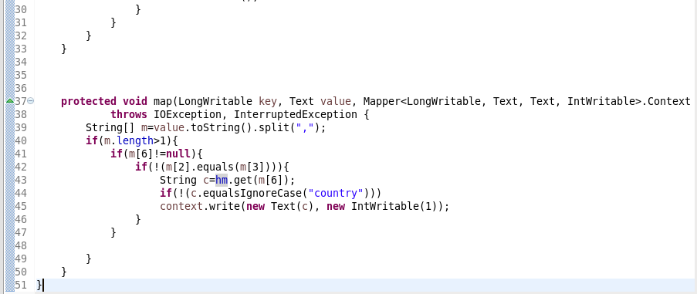

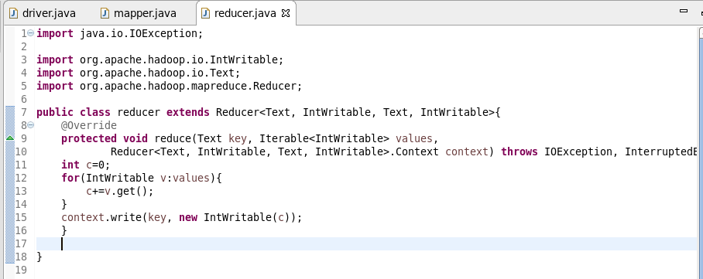

**Output:**

