**16.6 Problem Statement:**

**Write a map reduce program to join the below given two datasets using Reducer side join. You can download the datasets from the below link :**

[**https://drive.google.com/open?id=0ByJLBTmJojjzSWhfXzI5NGh4RGM**](https://drive.google.com/open?id=0ByJLBTmJojjzSWhfXzI5NGh4RGM)

**Program:**

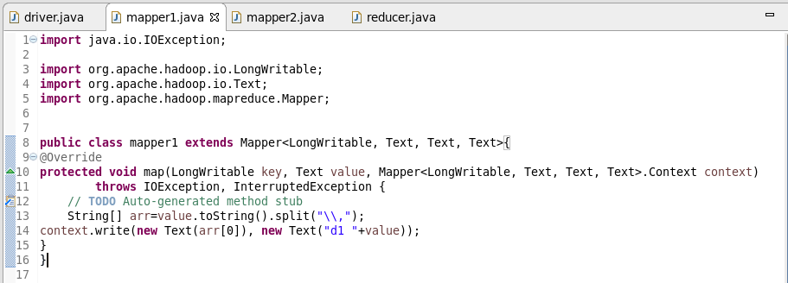

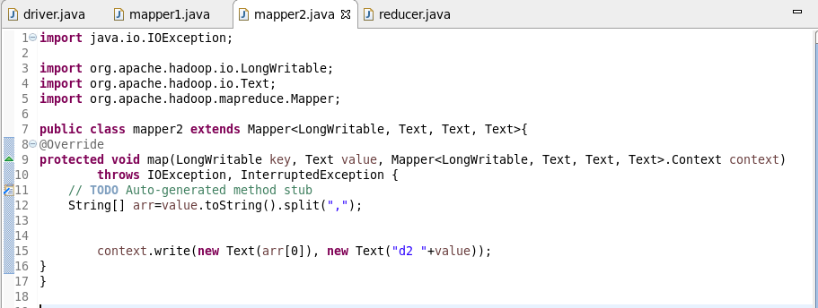

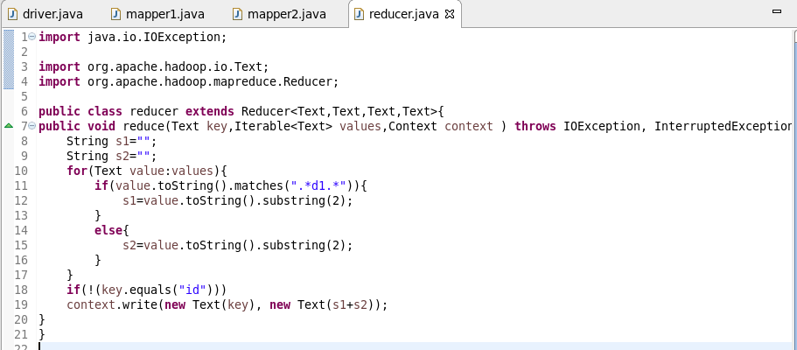

**Output:**

