**17.2 Write a secondary sort program to generate the top 2 maximum temperatures corresponding to every year from the temperature dataset.**

**Task Class:**

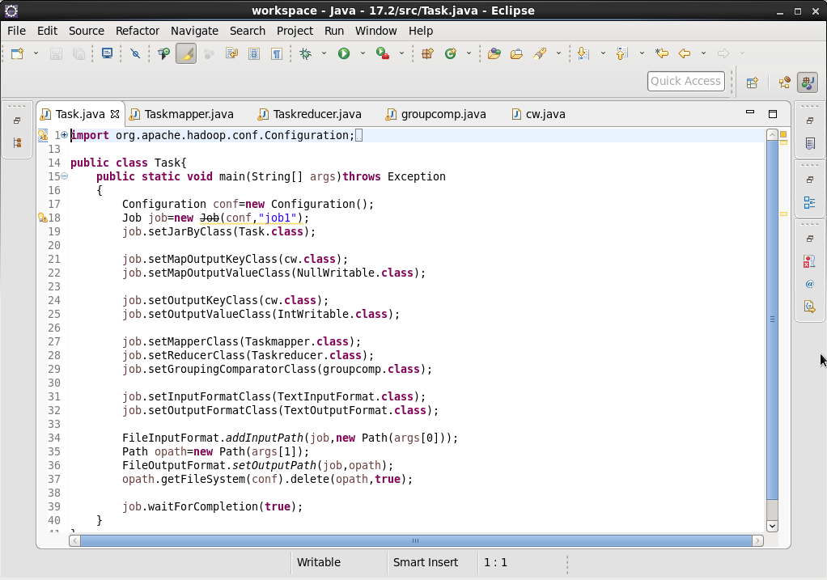

**Mapper class:**

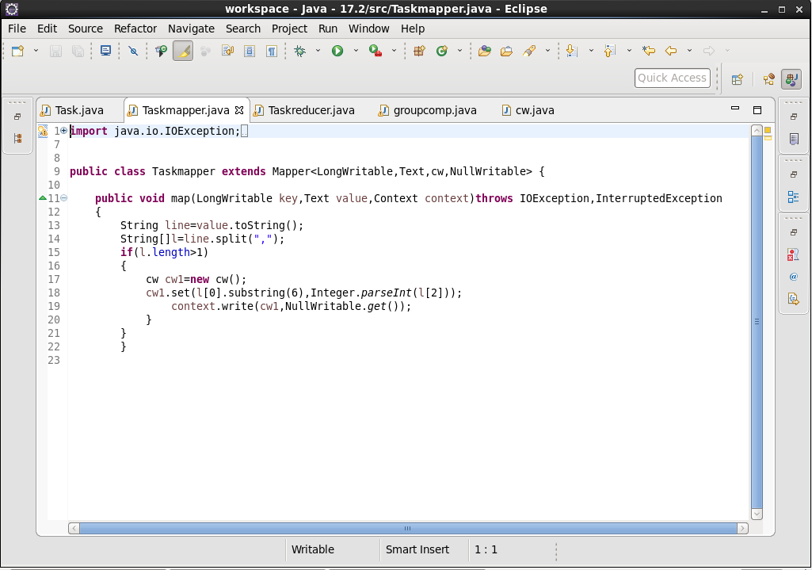

**Reducer class:**

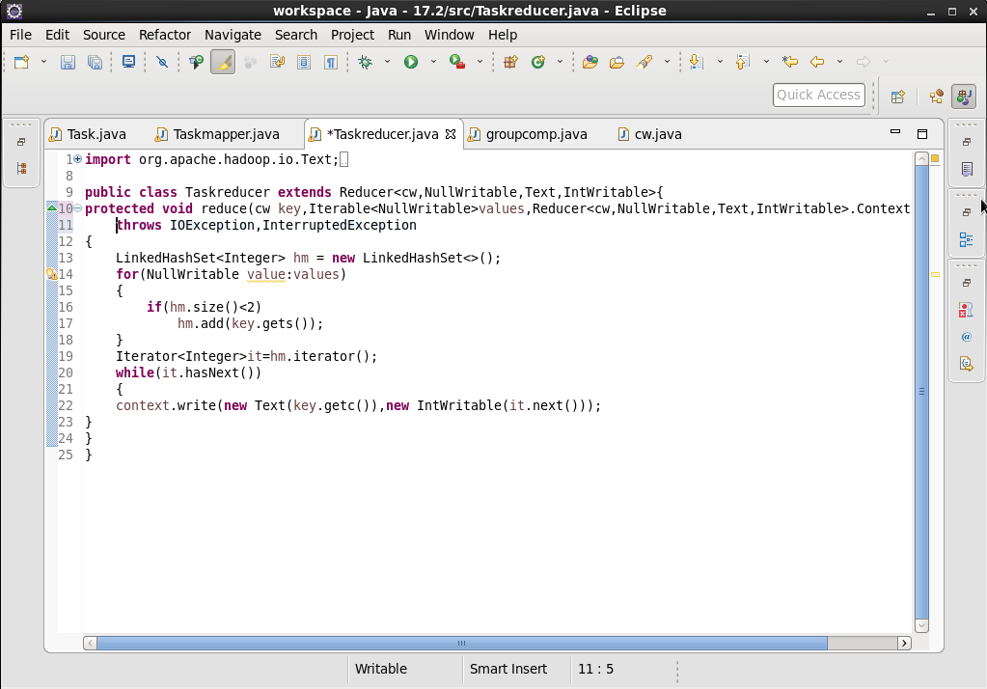

**Group Comparator class:**

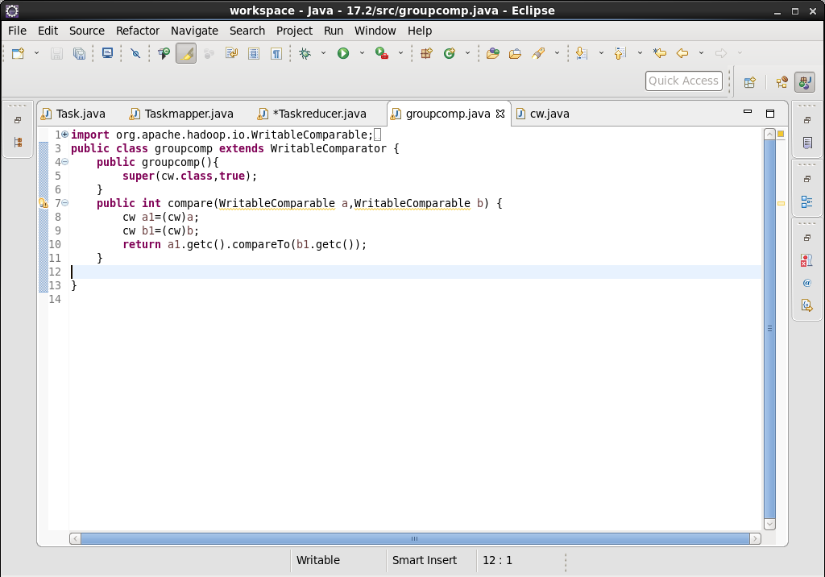

**Writable Comparable class:**

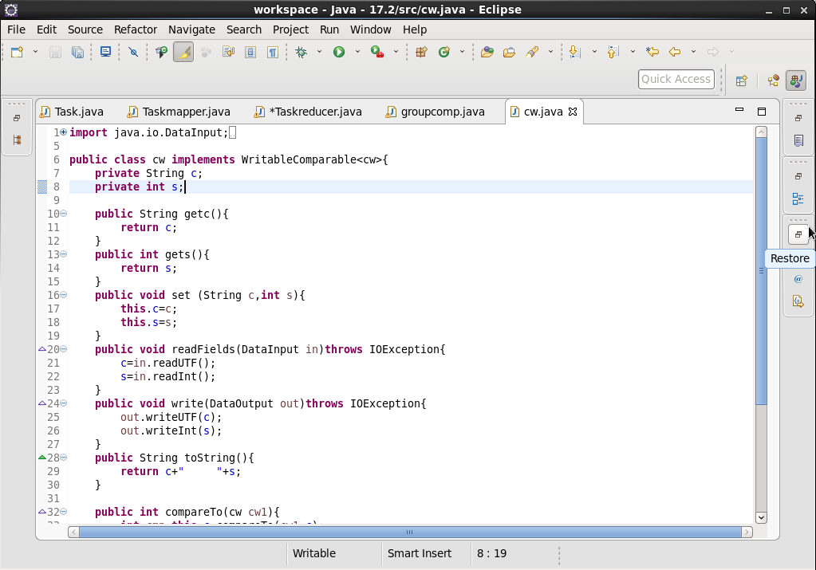

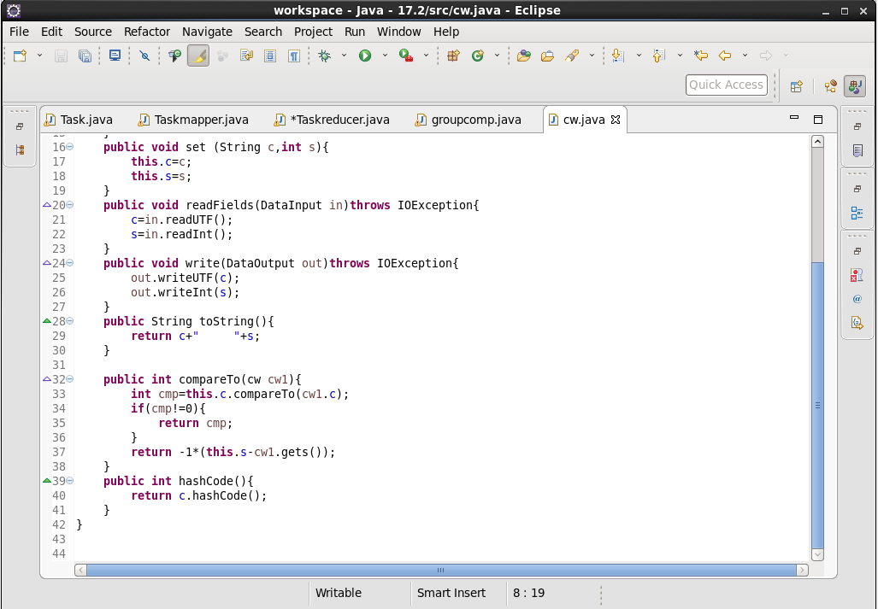

**Output:**

