**17.5 Write a map reduce program to design a custom counter to count number of people are affected with 'PULMONARY' disease and 'BRONCHITIS & ASTHMA' in the state 'CA'.**

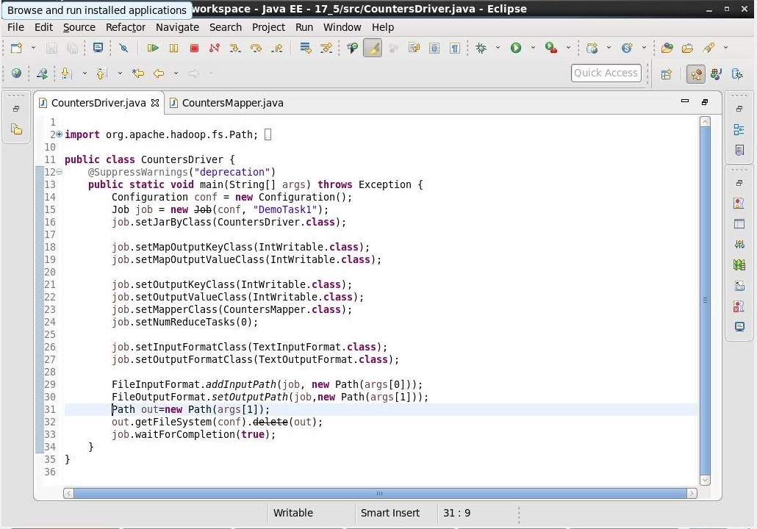

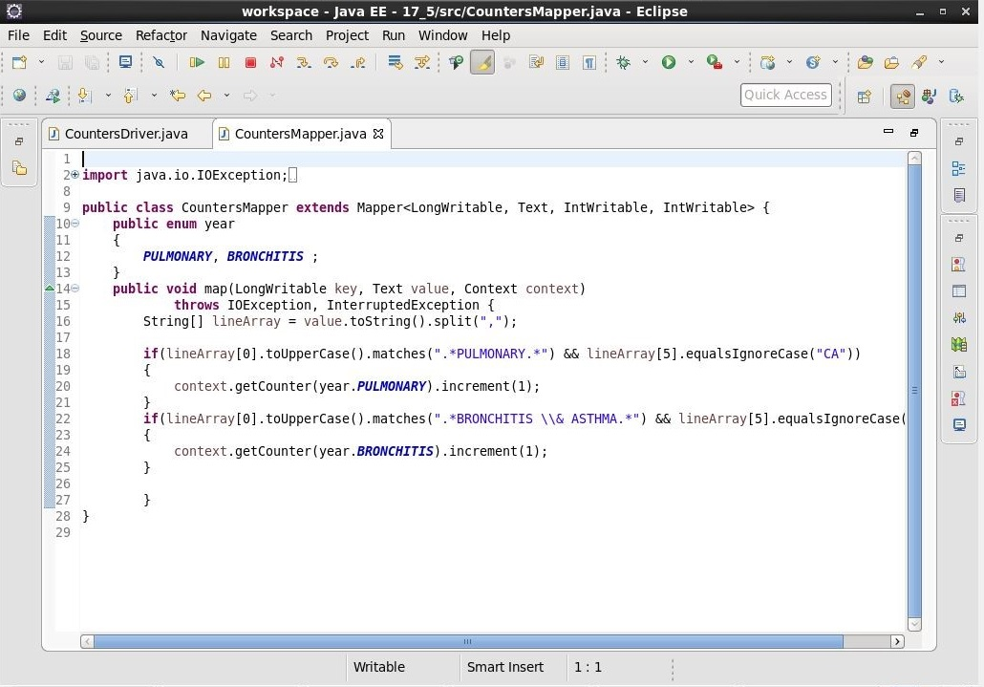

**OUTPUT:**

