**Merge the small files in Hadoop**

**Making of a directory:**

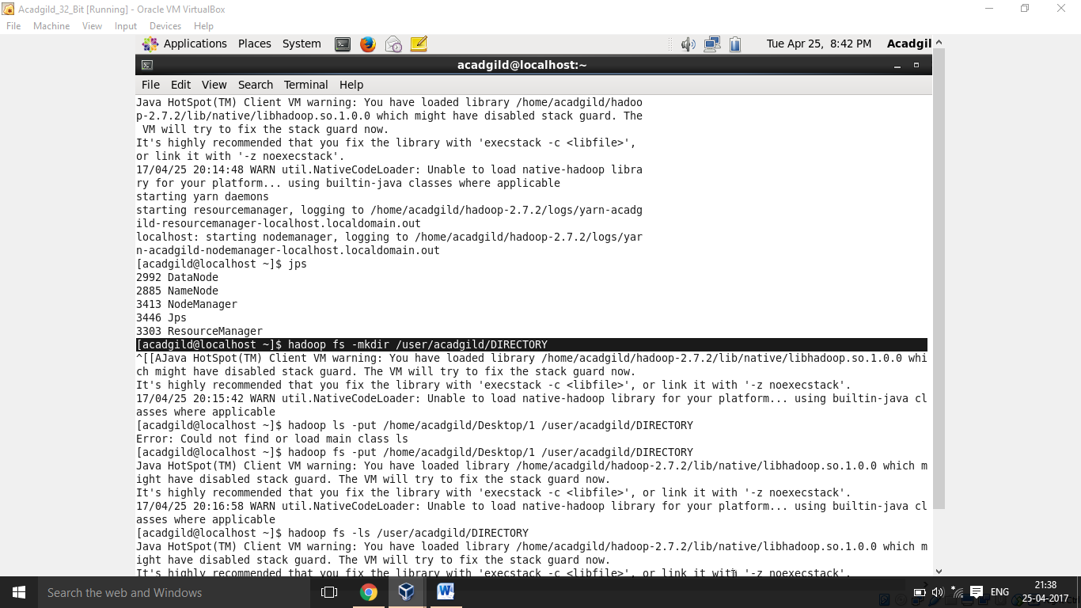

**THREE INPUT FILES:**

**1:**

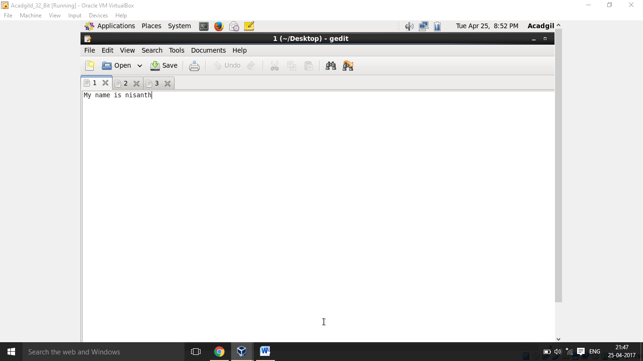

**2.**

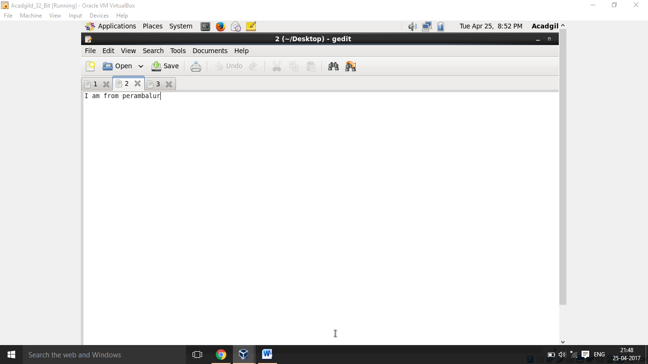

**3.**

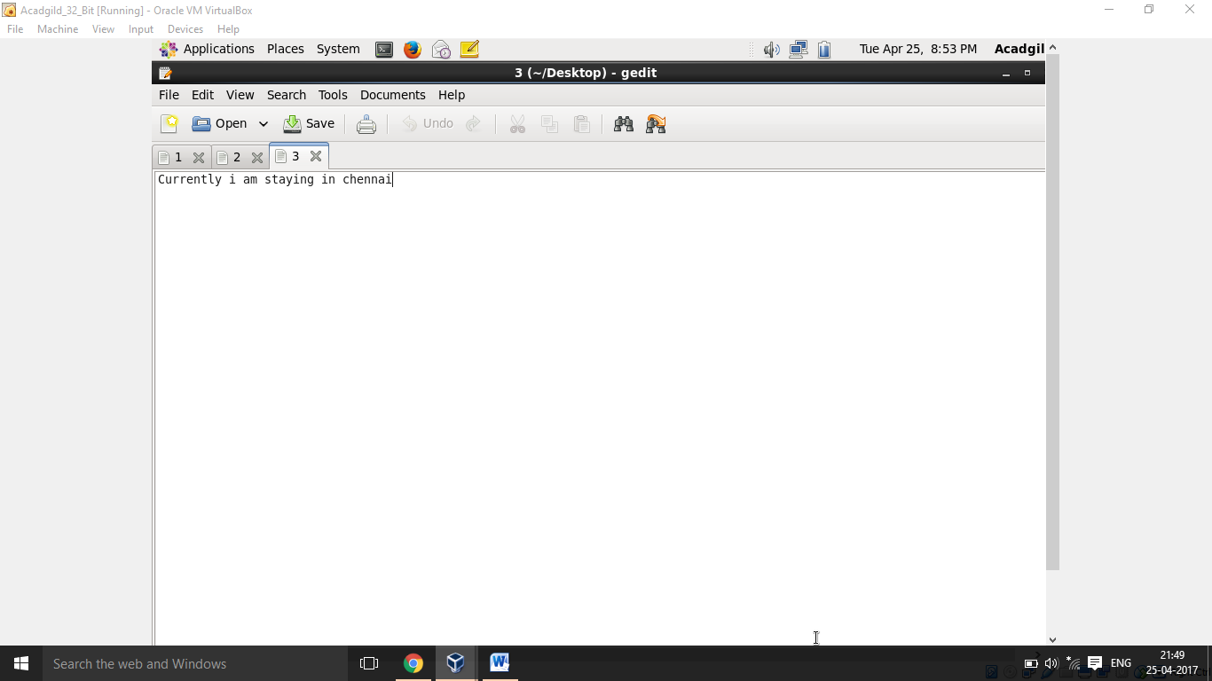

**Loaded three files from local system into the directory created above:**

**The name of the files are 1,2 and 3 respectively.**

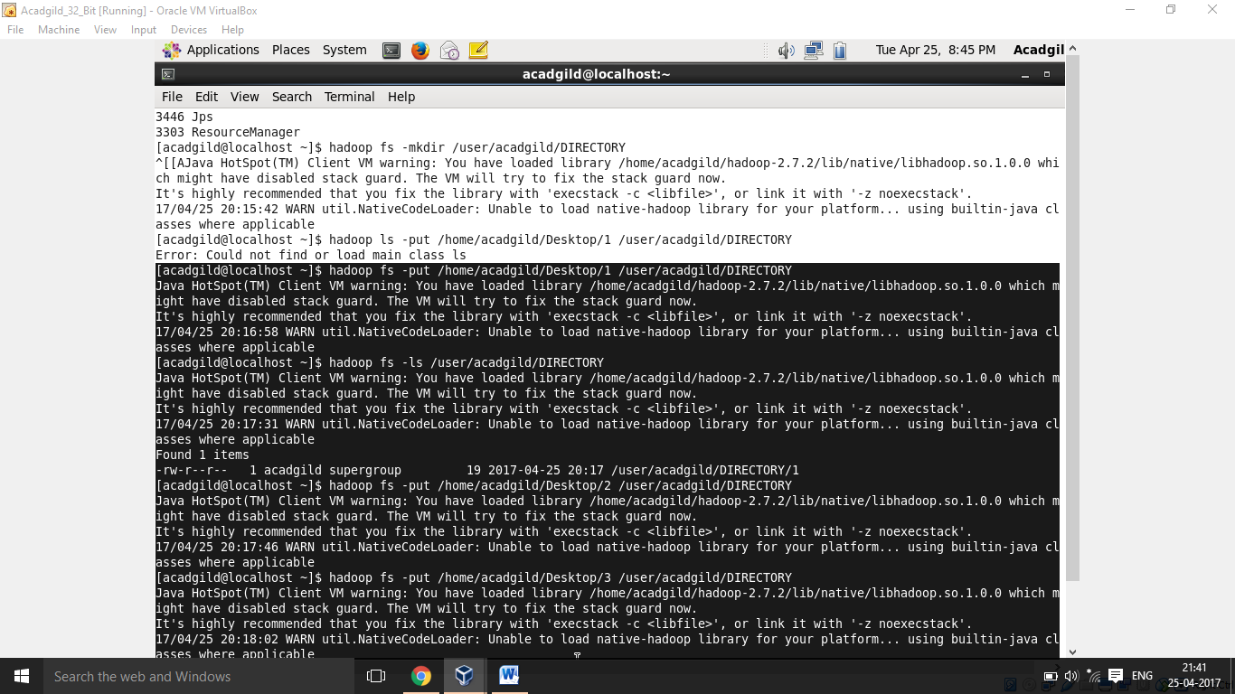

**Merge command:**

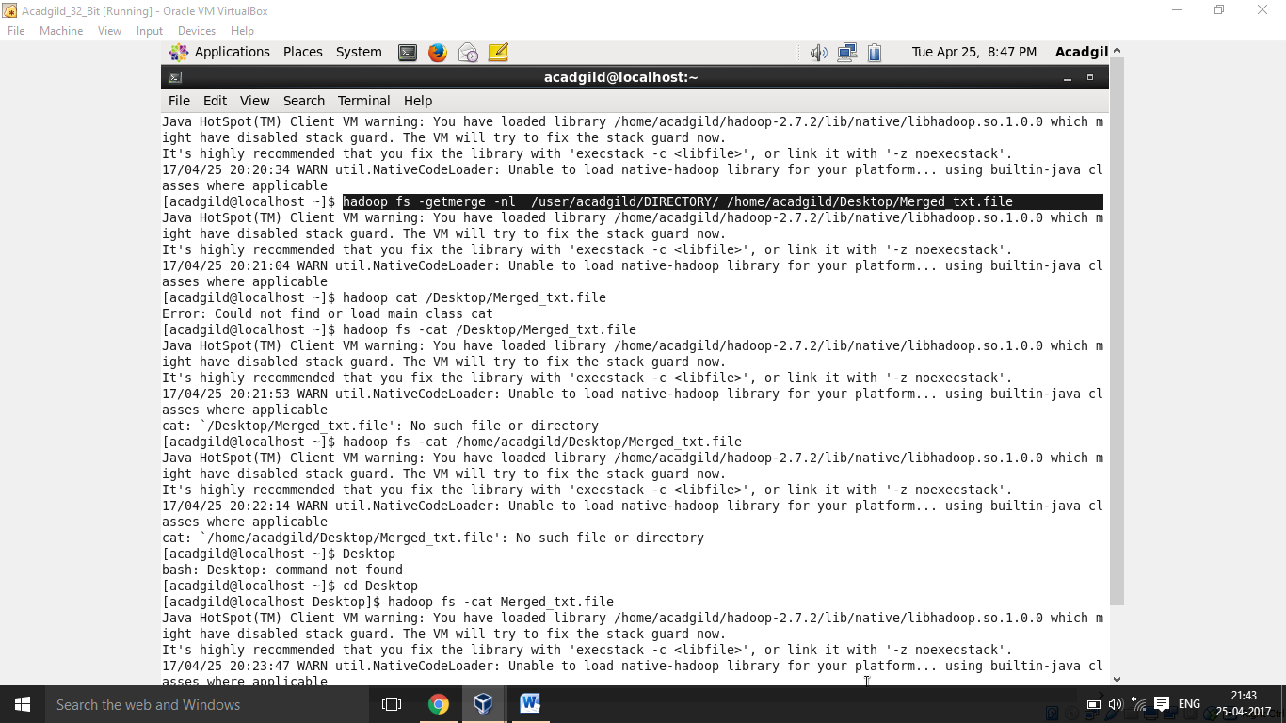

**OUTPUT FILE:**

