**Problem Statement:**

**Create a database named 'custom'. Create a table named temperature_data inside custom having below fields: 1. date (mm-dd-yyyy) format 2.zip code 3. Temperature.The table will be loaded from comma-delimited file. Load the dataset.txt (which is ',' delimited) in the table.**

**Custom Database created**

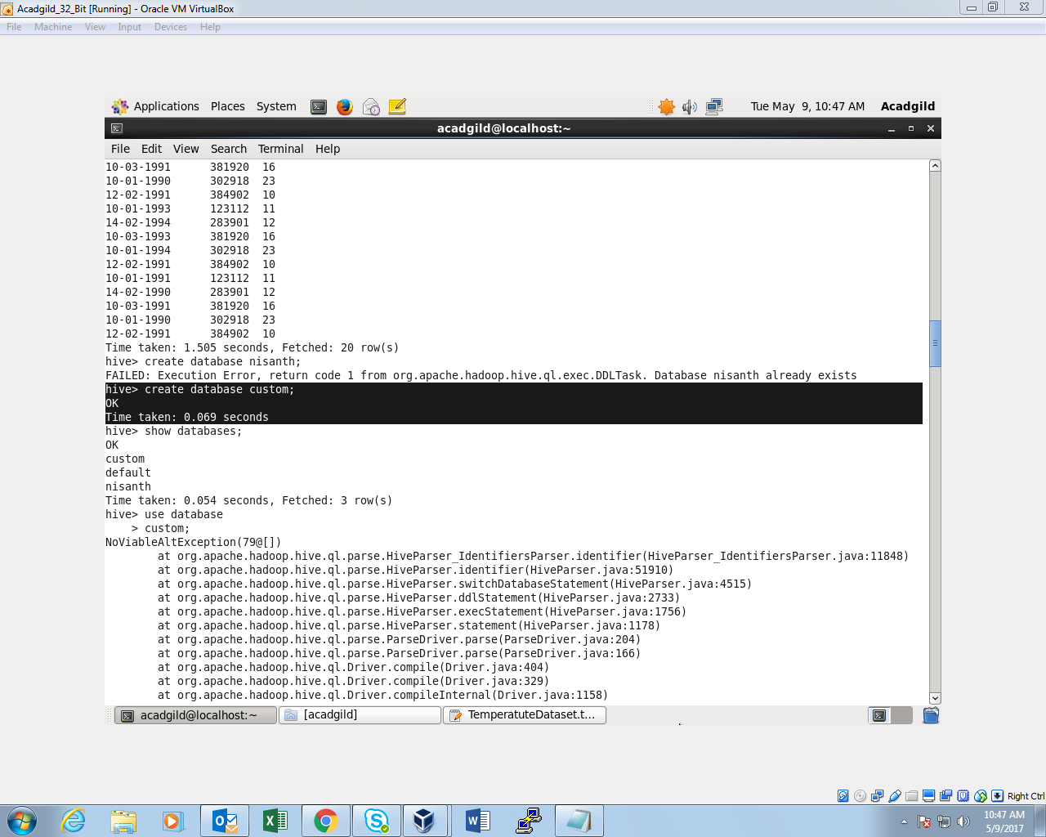

**Created a table inside the database:**

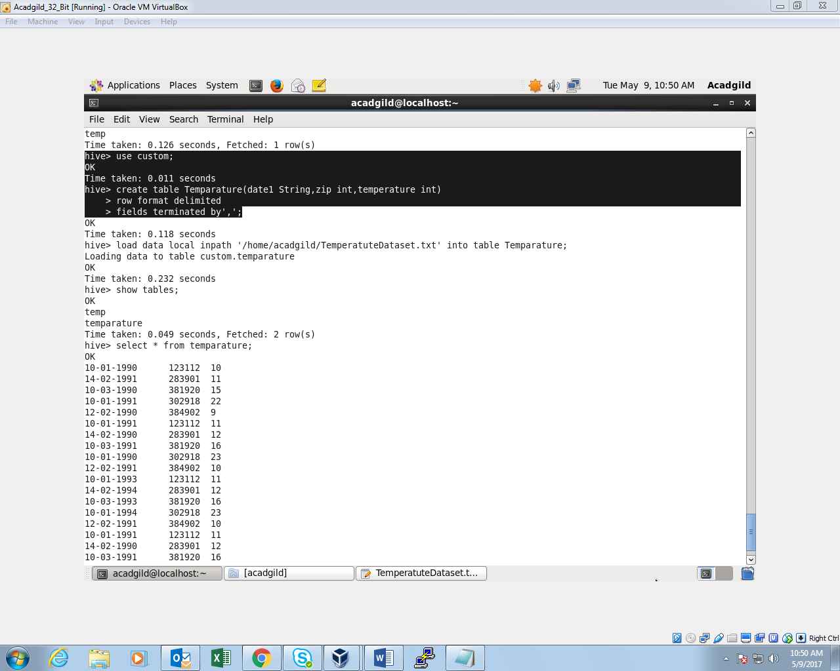

**Data loaded into the table:**

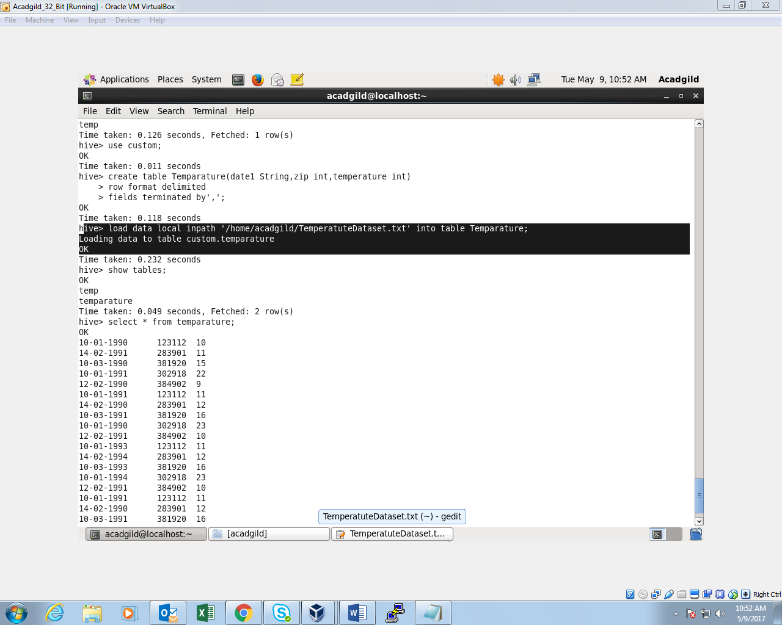

**Data from the table:**

