**Assignment 25.1**

**Write a Hive program to find the number of medals won by each country in swimming.**

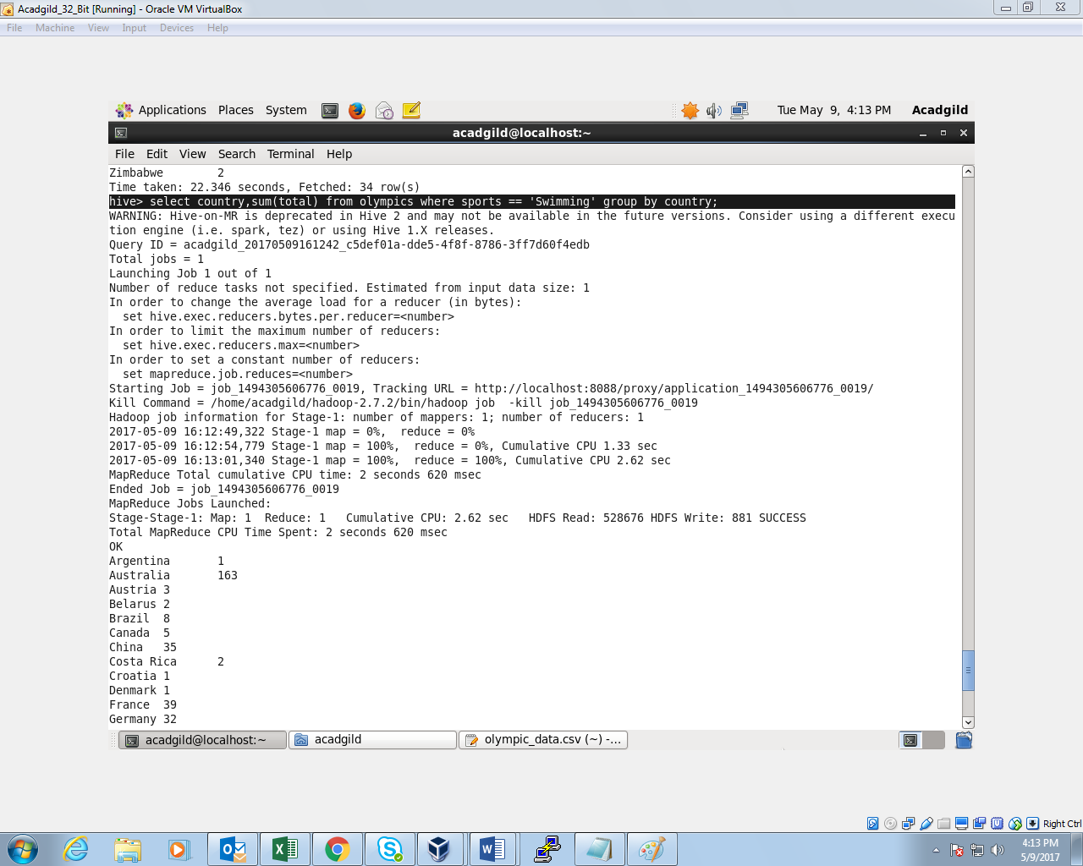

**OUTPUT:**

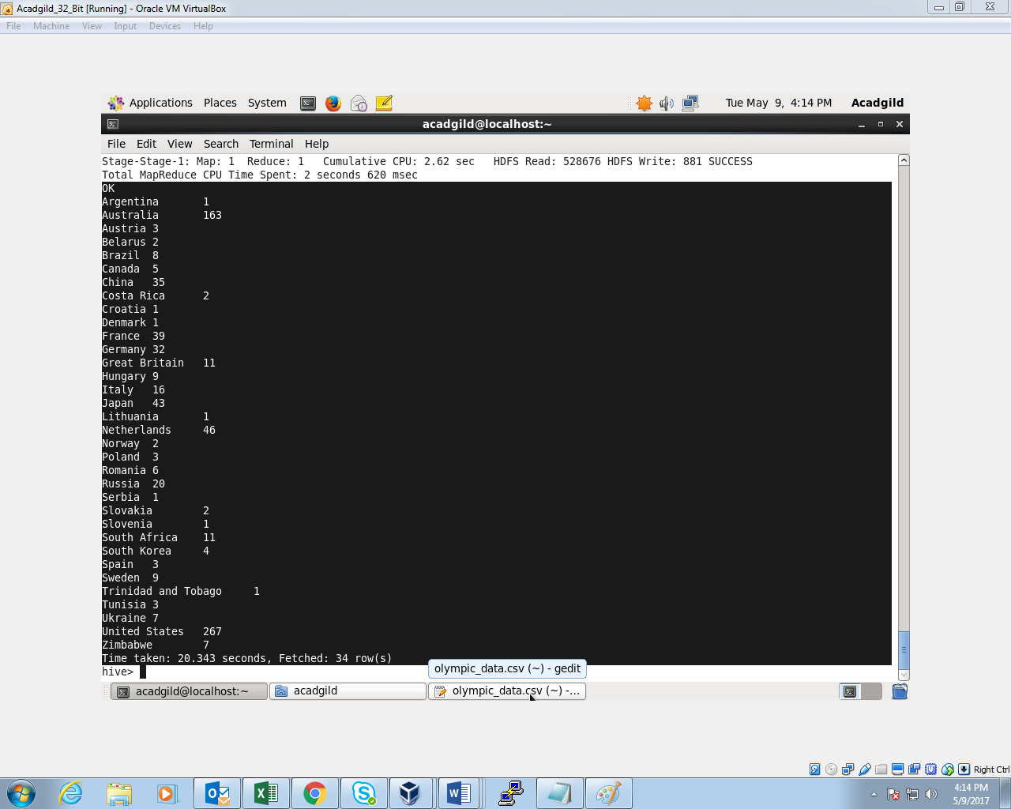

**Write a Hive program to find the number of medals that India won year wise.**

