**ASSIGNMENT 25.4:**

**Write a hive query to find the top 20 destination people travel the most: Based on the given data**

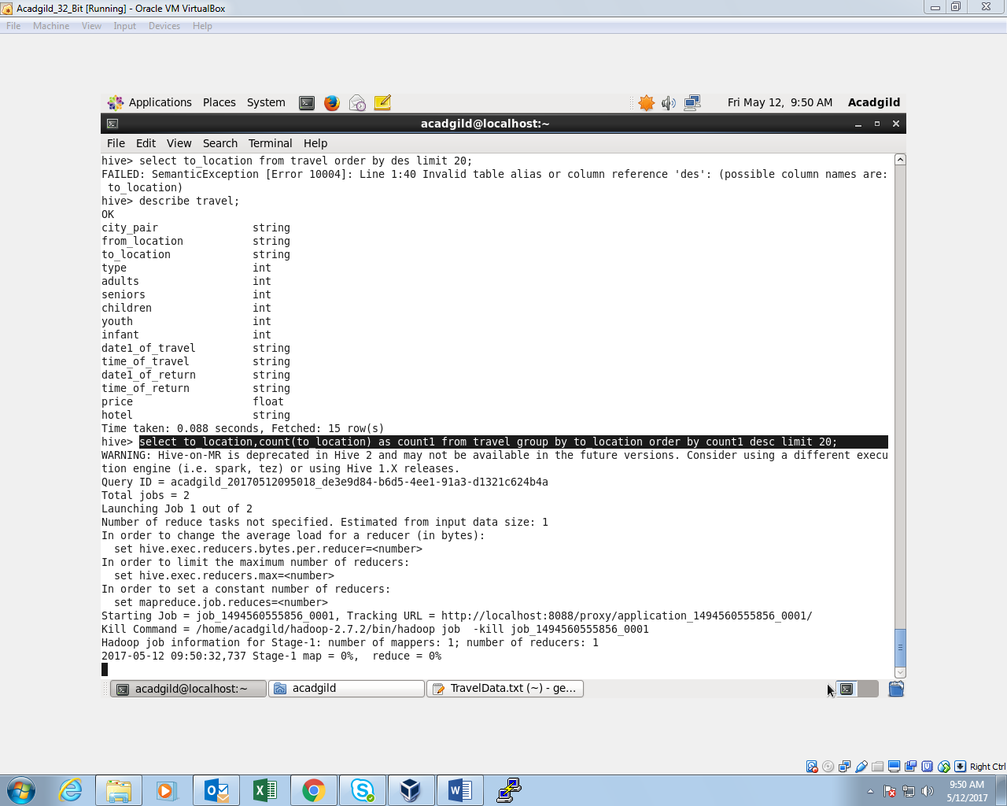

**OUTPUT:**

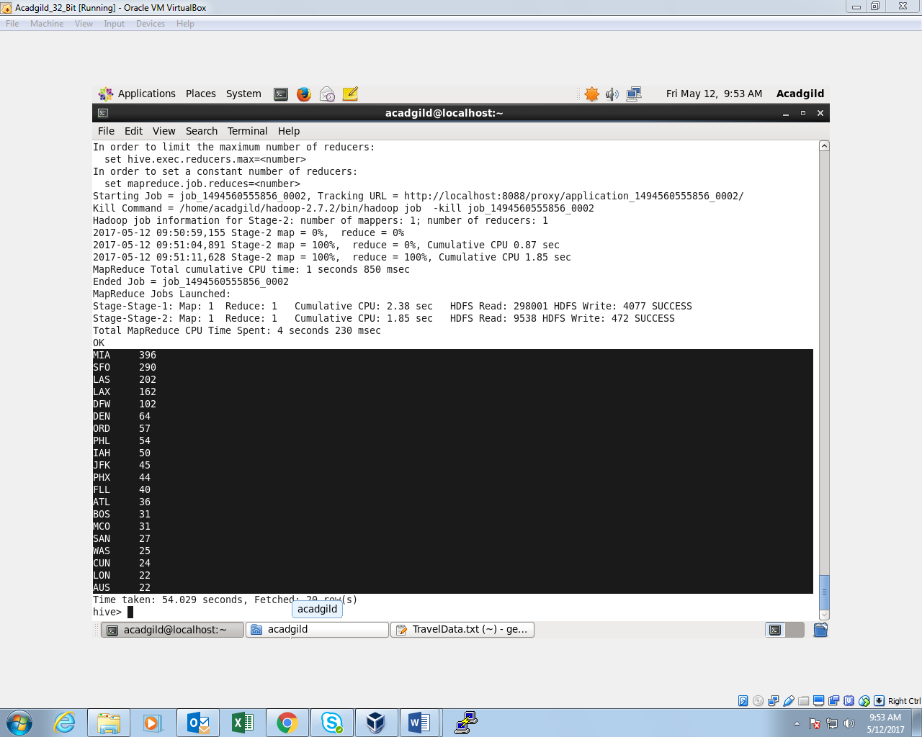

**Write a hive query to find the top 20 locations from where people travel the most**

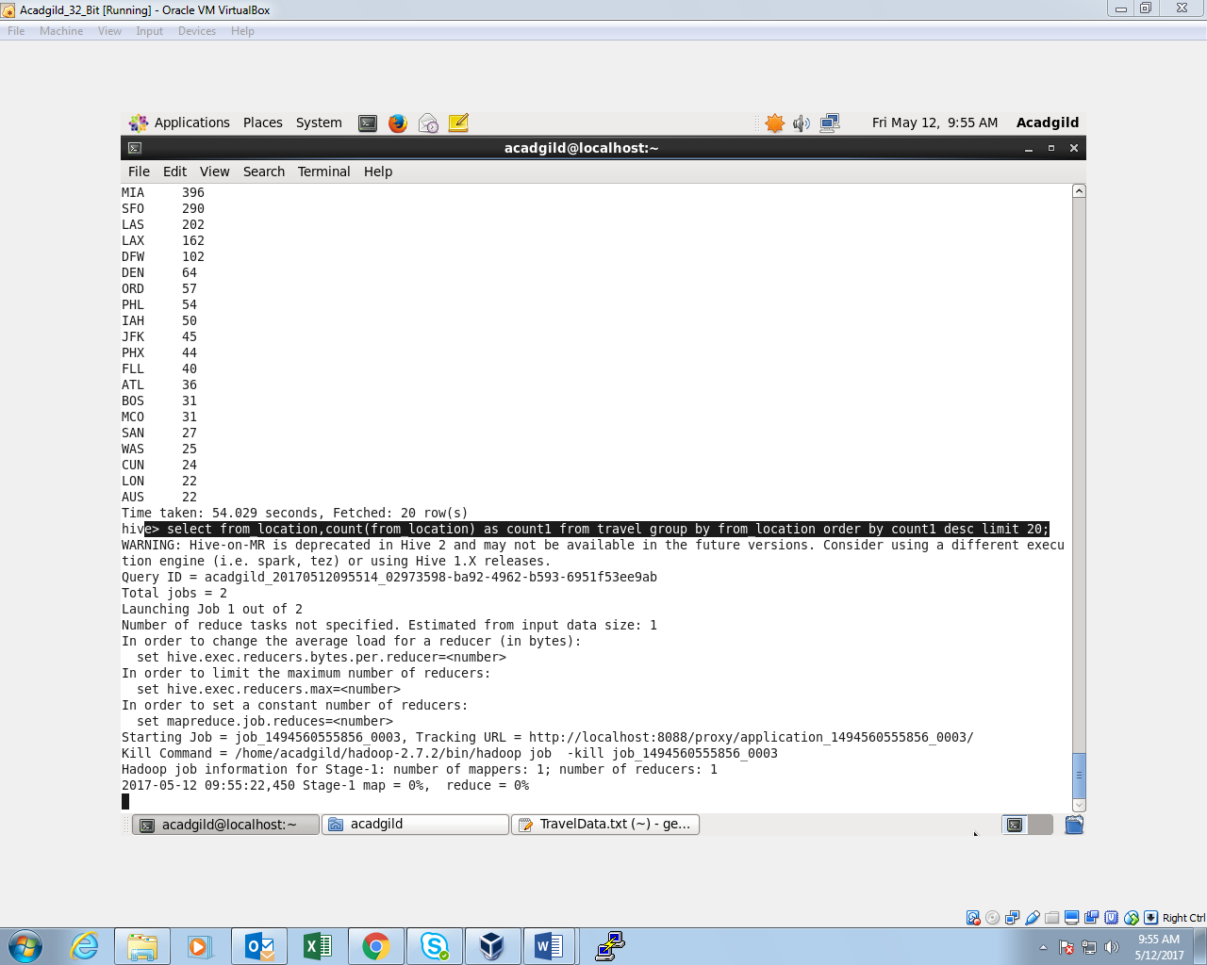

**OUTPUT:**

