**ASSIGNMENT 26.3**

**Use real_estate to solve queries.**

**Using Dynamic partition get separate lists of residential apartments with more than 2 beds and include columns in following order City,Baths,Sq_feet,Price,flat_type,Beds respectively.**

**Create table RealEstate in Hive database, with all the columns present in dataset**.

**Load dataset into table realEstate.**

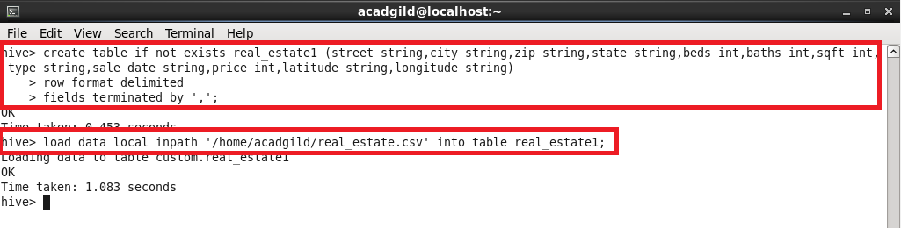

**Creating a partition table:**

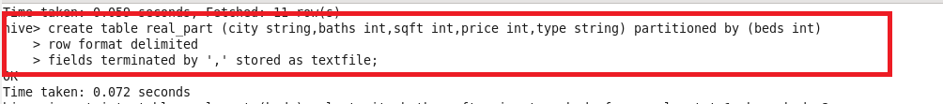

**Setting parameters in hive shell:**

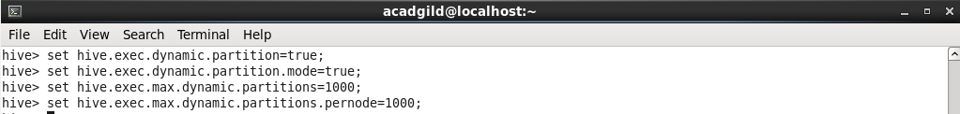

**Data copied to partitioned table:**

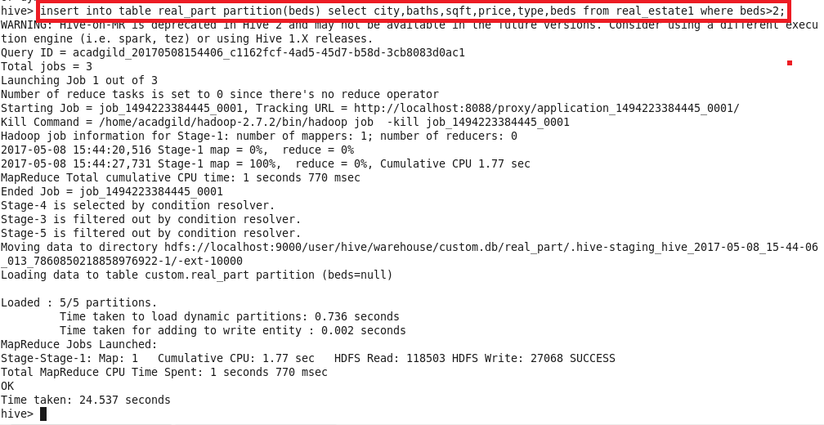

**Contents of the created directory:**

