**ASSIGNMENT 26.4**

**Implement view in hive by following the steps in the below blog**

**Taking emp_salary table**

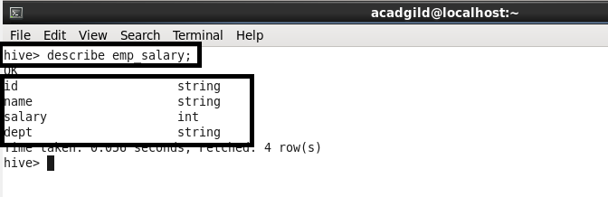

**Creating view:**

