**ASSIGNMENT 26.6**

**Explain the differences between static and dynamic partitioning in hive and their working procedures.**

In Hive Partition - there are 2 different type of partitions

**Static Partition**

**Dynamic Partition.**

**Static Partition** in Hive are:

* Inserting the input data files individually into a partition table is called as Static Partition.

* While loading the files into the Hivetables, static partitions will be preferred.

* Static Partition will save your time for data loading when compared to dynamic partition.

* While statically adding a partition in table and when we move the file into that partition of the table. One can alter those partition in the Static partition.

* One can get the partition column value form from *filename, day of date etc.* without reading the whole file.

* If you want to use Static partition in hive you should set property set hive.mapred.mode = strict.this property set by default in hive-site.xml

* Static partition is in Strict Mode

* One should use where clause in order to use limit in the static partition.

* One can perform Static partition on Hive Manage table or external table.

Example:

**CREATE** **TABLE** cityreport (cityid string, c_report string, ctover string)  
partitioned **BY** (city string)  
row format delimited  
**FIELDS** terminated **BY** ‘|’  
stored **AS** textfile;

Loading data using static partitioning:

**LOAD DATA LOCAL inpath ‘/home/nish/hive-related/hyderabad.log’ INTO TABLE cityreport1 partition (city = ‘vellore’);**

**Dynamic Partition**in Hive

*single insert into partition table is known as dynamic partition

*Usually dynamic partition will load the data from non-partitioned table

*Dynamic Partition will take more time for loading data when compared to the static partition.

*When a large data is stored in a table in such case Dynamic partition will be suitable.

*In case if one needs to partition number of column but don’t know how many columns were present then dynamic partition can be used.

*Dynamic partition will not be required where clause to use limit.

*One can’t perform any alter on those Dynamic partition

*On HIVE one can perform dynamic partition using the external table as well the managed table.

*In HIVE when one need to use the Dynamic partition in such case the mode will be in nonstrict mode

*Here is hive dynamic partition properties you should allow

SET hive.exec.dynamic.partition = true;

SET hive.exec.dynamic.partition.mode = nonstrict;

Example:

hive> **INSERT** **INTO** **TABLE** t2 PARTITION(country) **SELECT** * **FROM** T1;

**2. Use static partitioning in hive and evaluate the below problem statements**

- Find the number of medals India won year wise

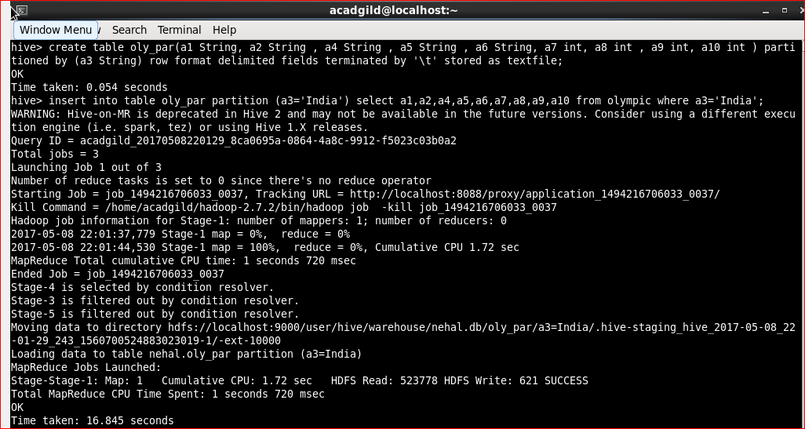

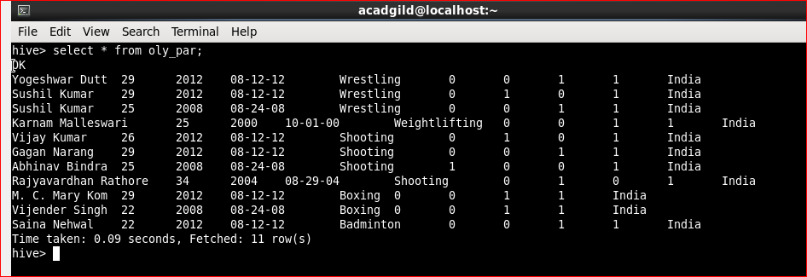

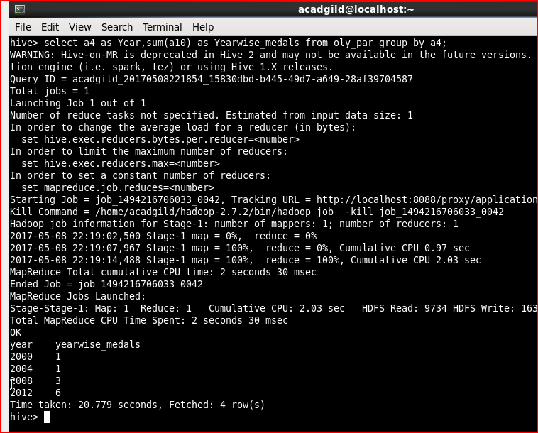

- Find the number of medals India won in swimming year wise

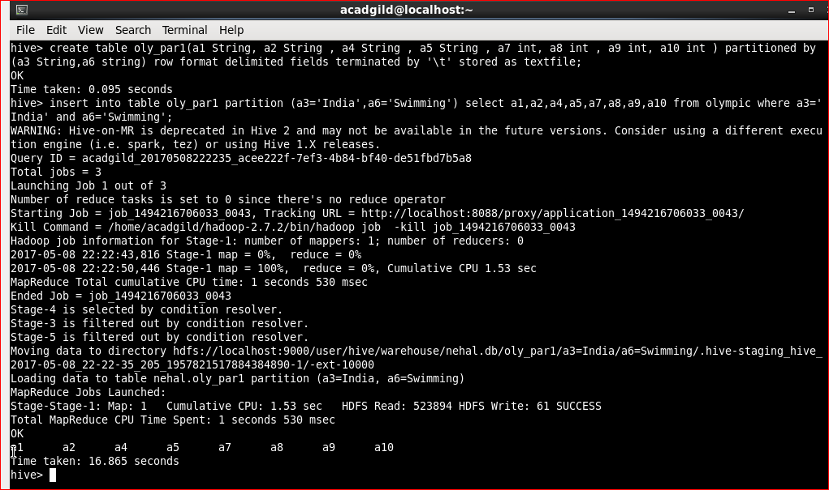

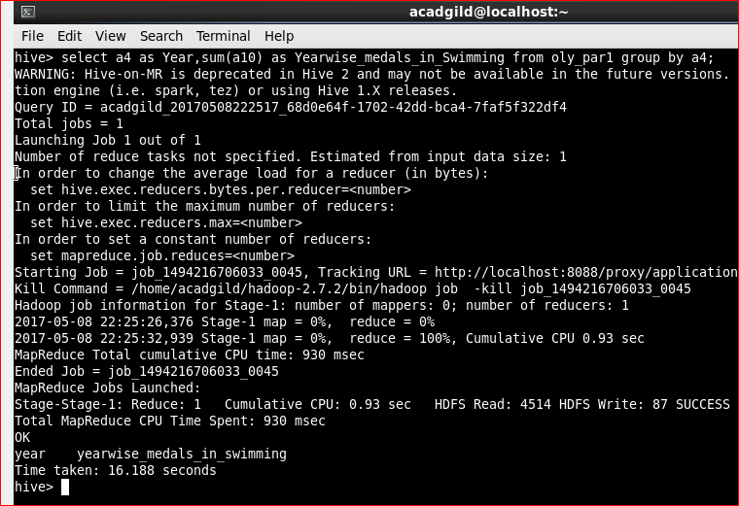

- Find the number of gold and silver medals India won year wise

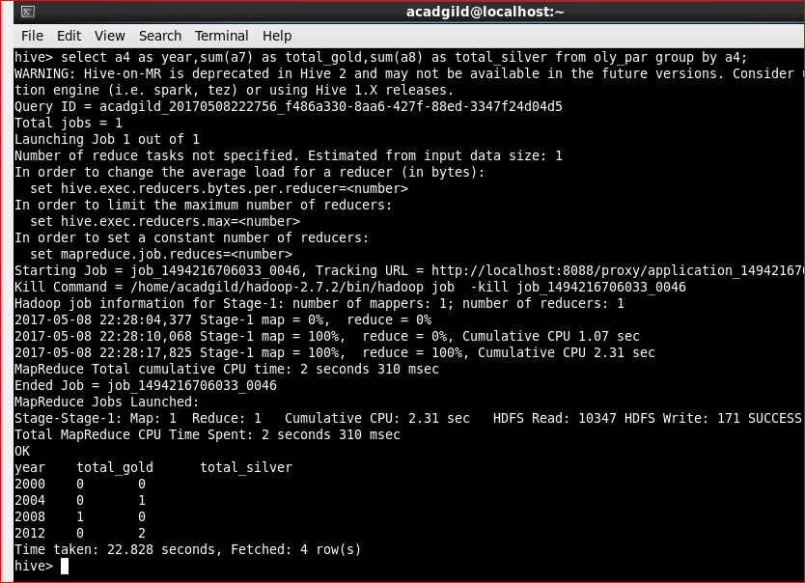

**3. Use dynamic partitioning in hive and evaluate the below problem statements**

- Find the total number of medals won by each country.

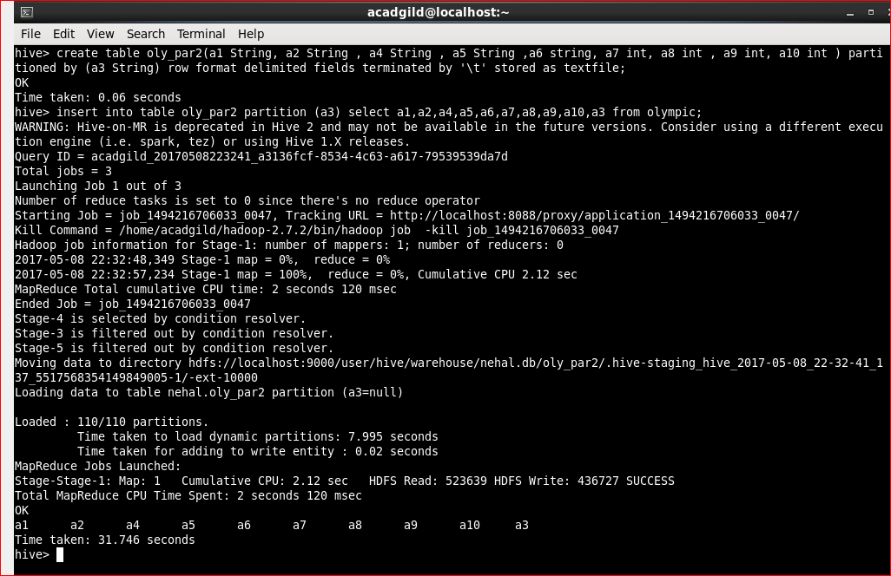

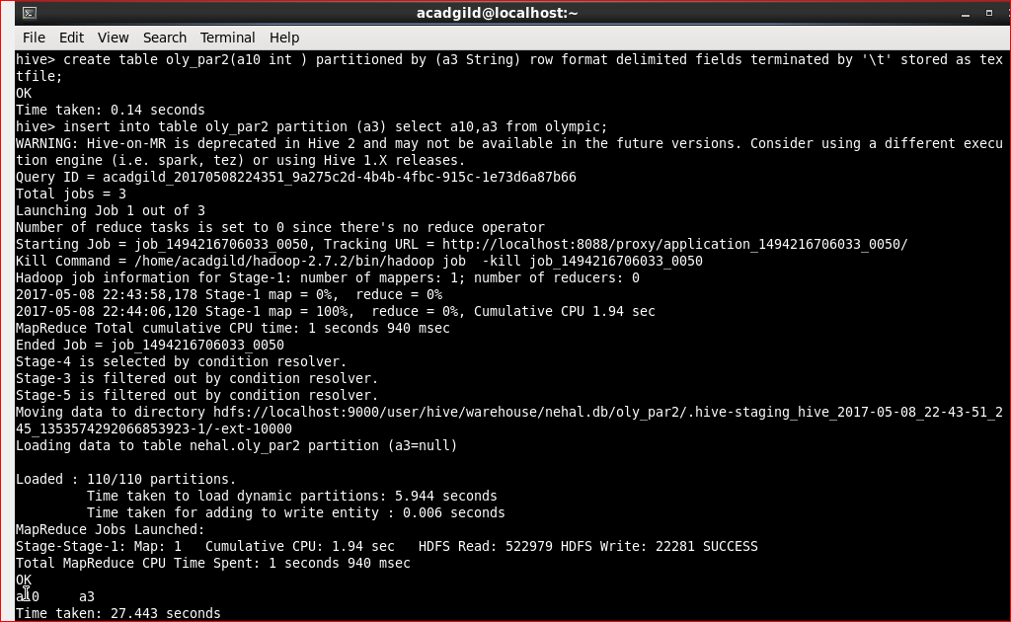

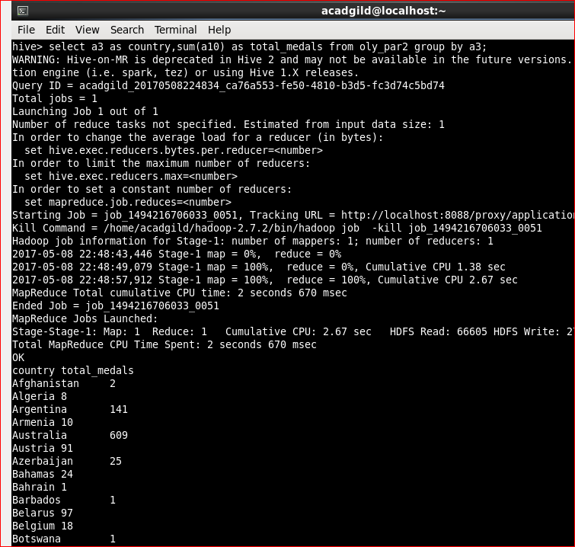

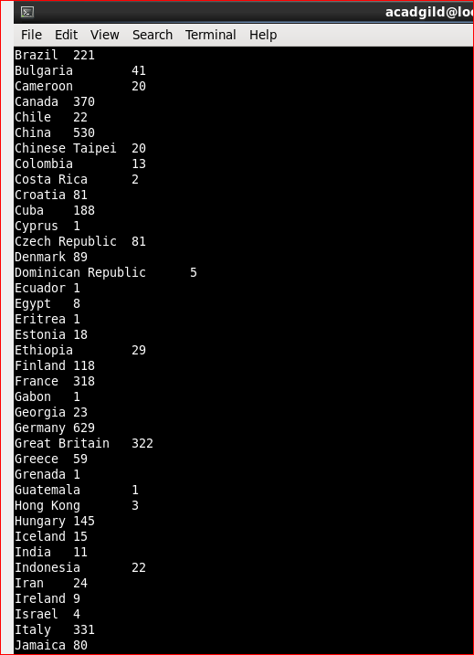

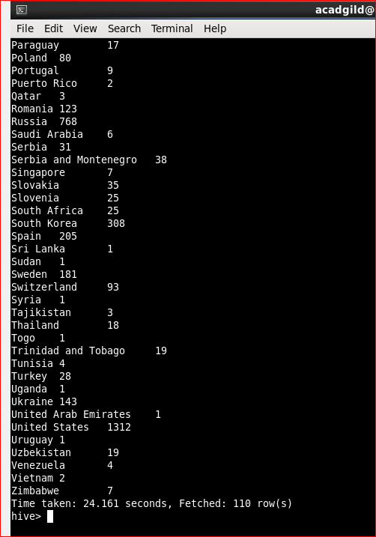

- Find the number of medals each country won in Athletics year wise

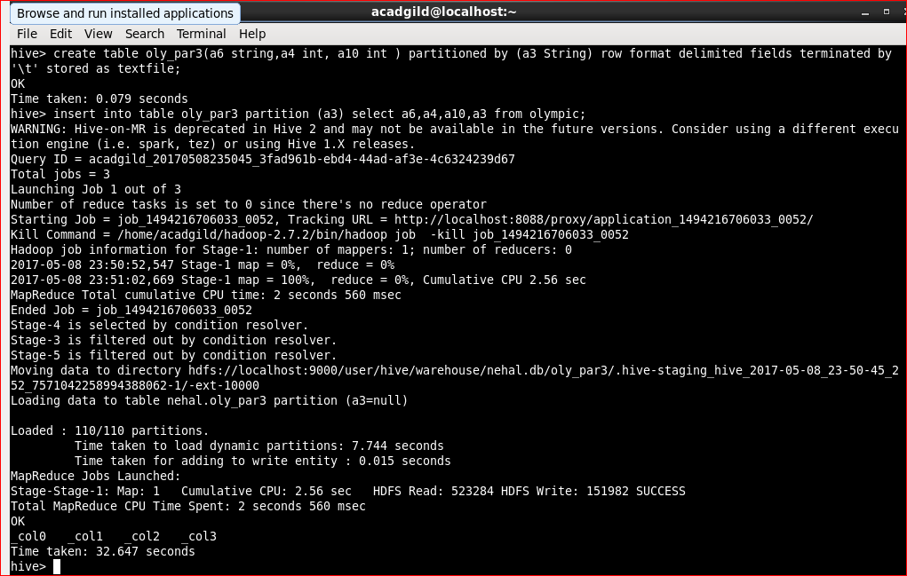

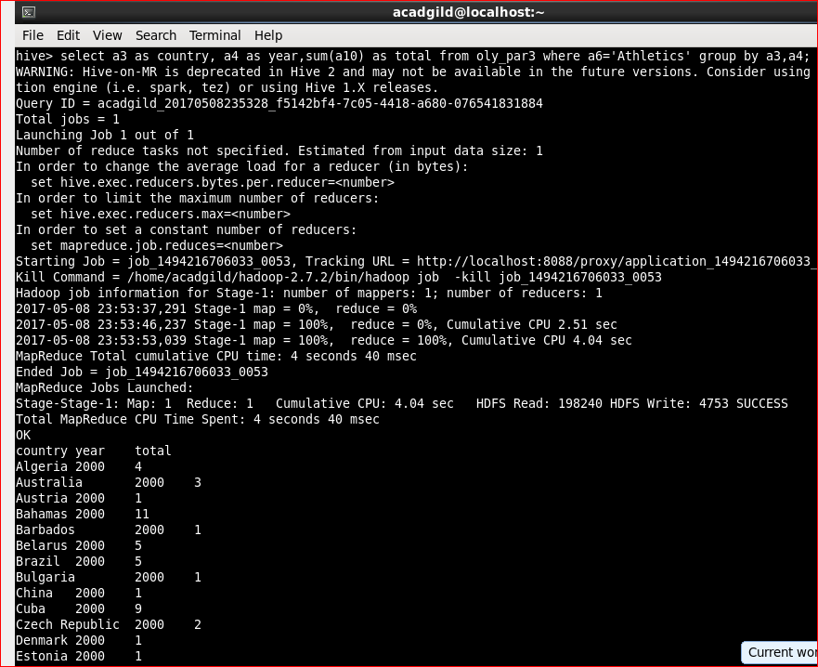

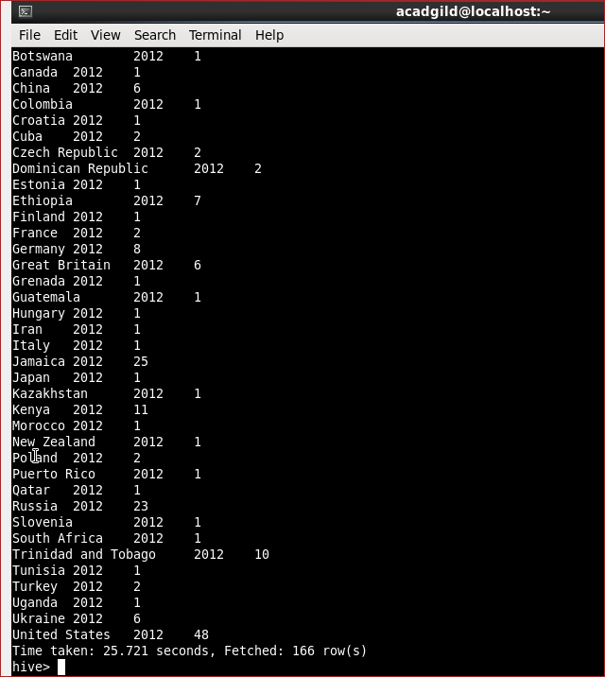

- Find the average age of athletes participated from each country in Olympics year wise

