**ASSIGNMENT 27.3**

**Bucketing operation:Step 1: setting configurations in hive shell**

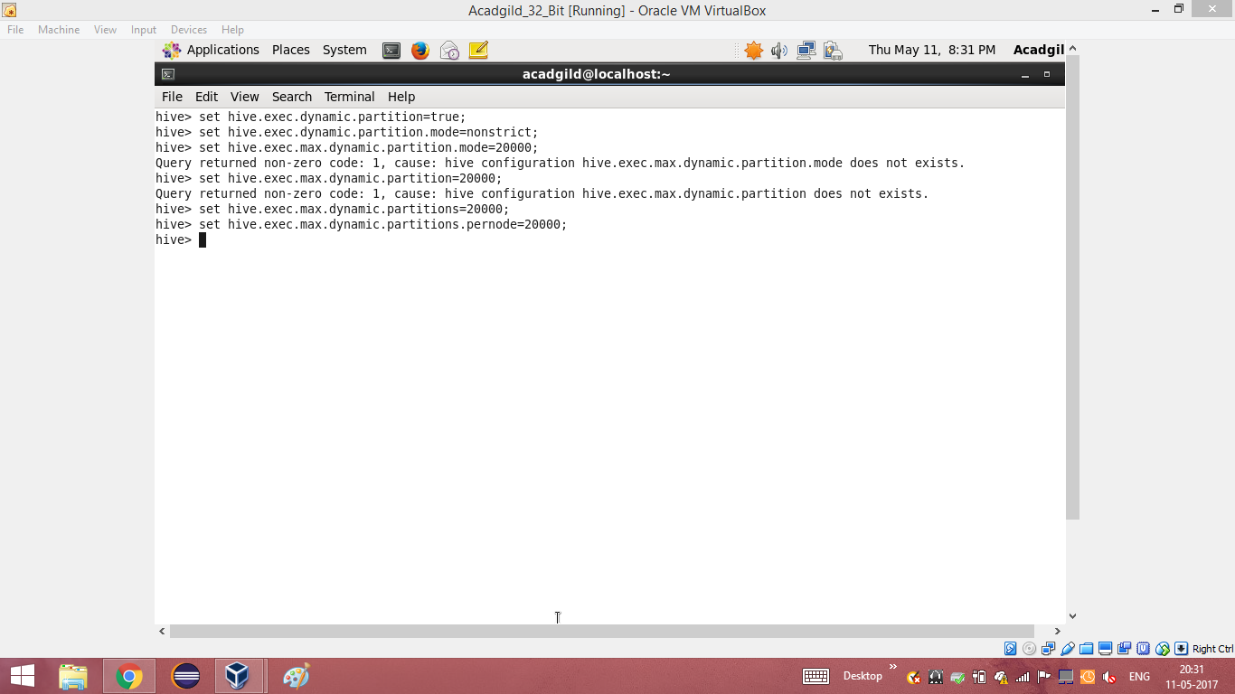

**Step 2: creating a bucketed table**

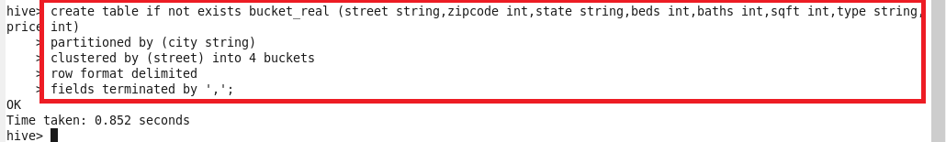

**Step 3: inserting into the bucketed table**

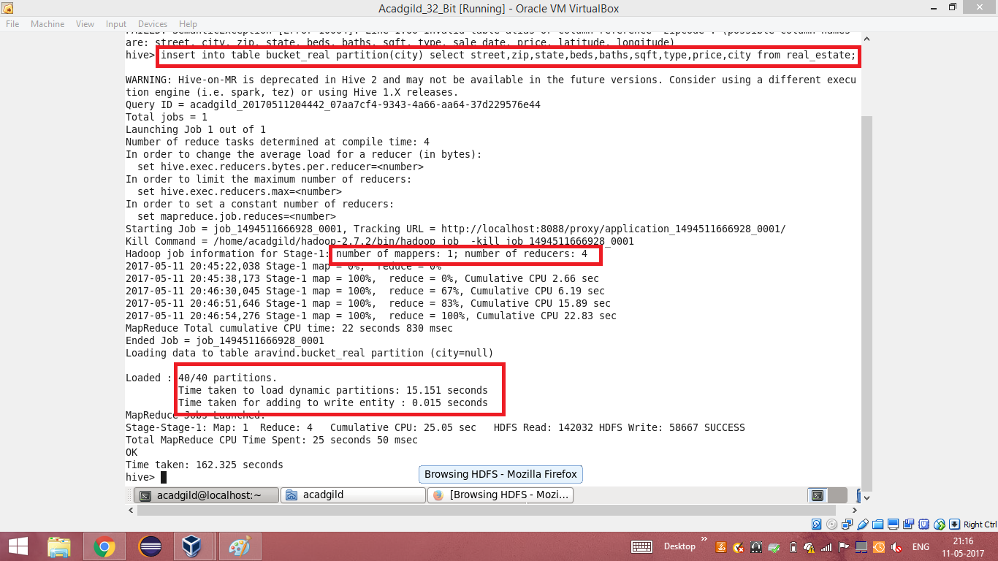

**Step 4: browsing the directory**

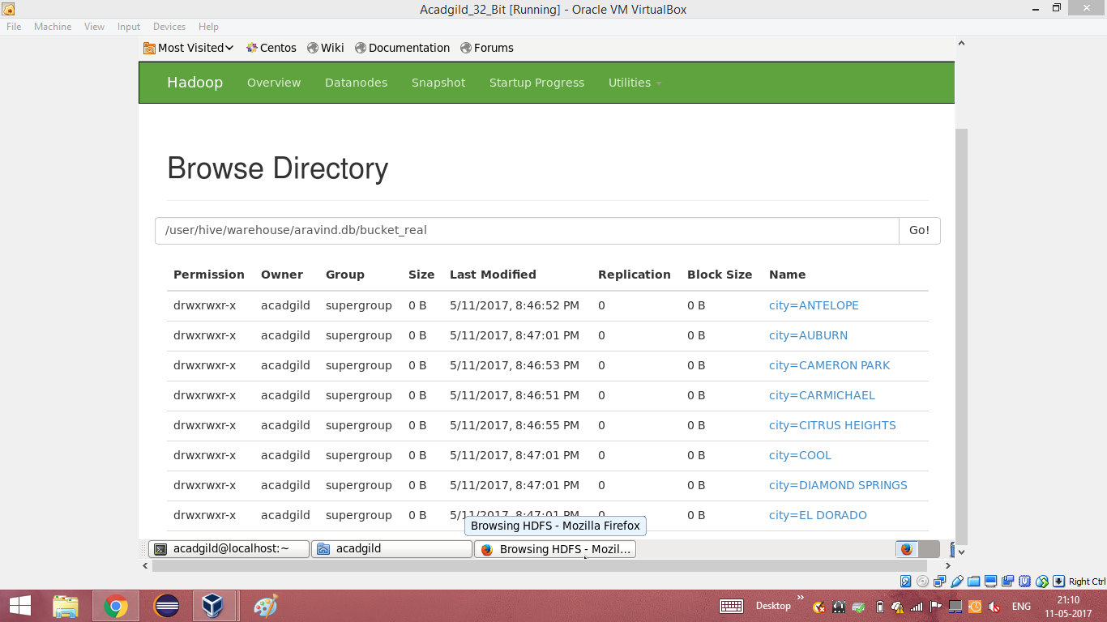

**Step 5: downloading the partitioned data**

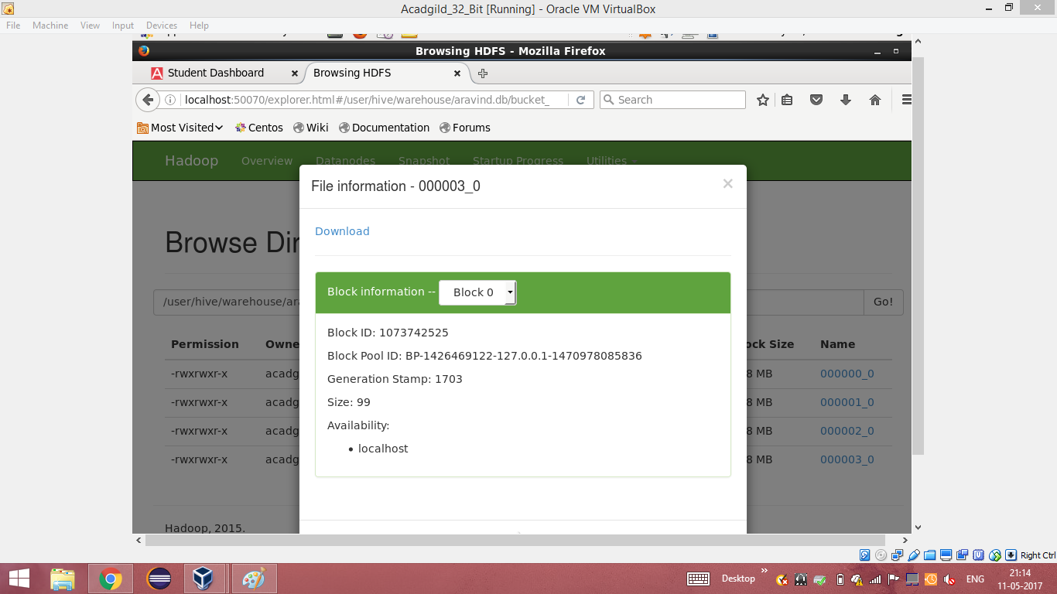

**Step 6: viewing the partitioned data**

