**Run parallel jobs in hive by following the steps in the below blog link**

<https://acadgild.com/blog/hive-parallel-jobs/>

Four tables were created.

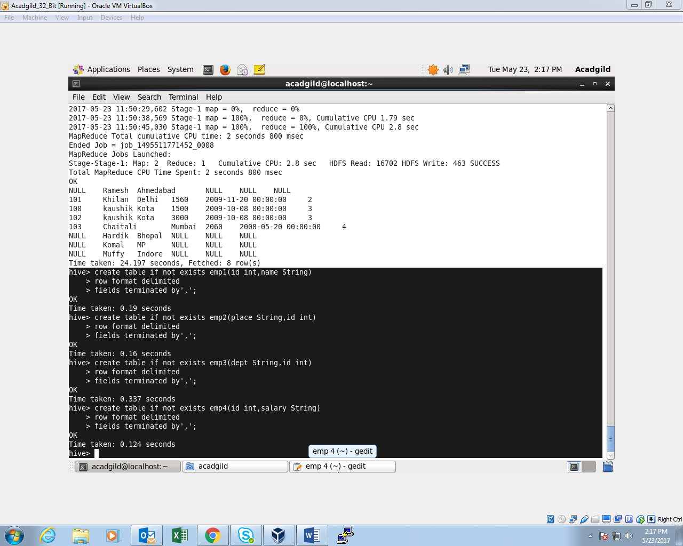

Data is loaded into respective tables.

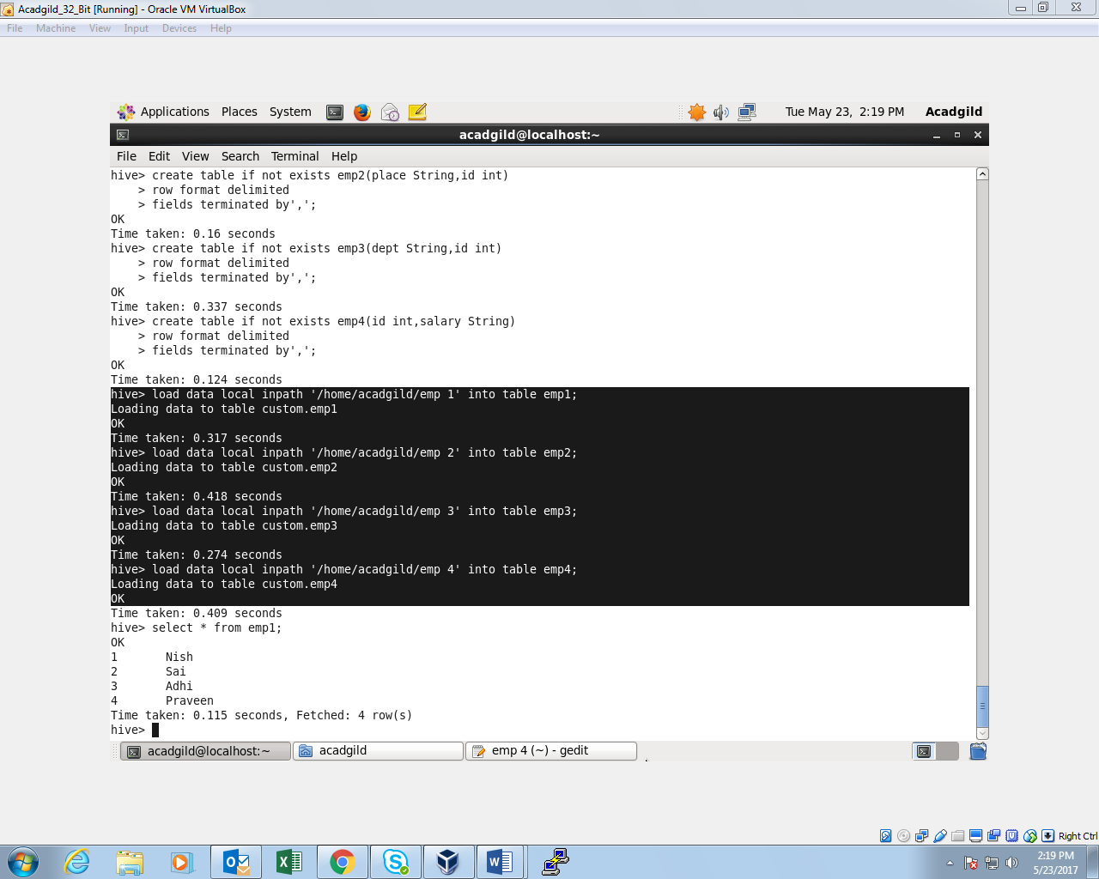

**NON-PARALLEL PROCESS:**

COMMAND:

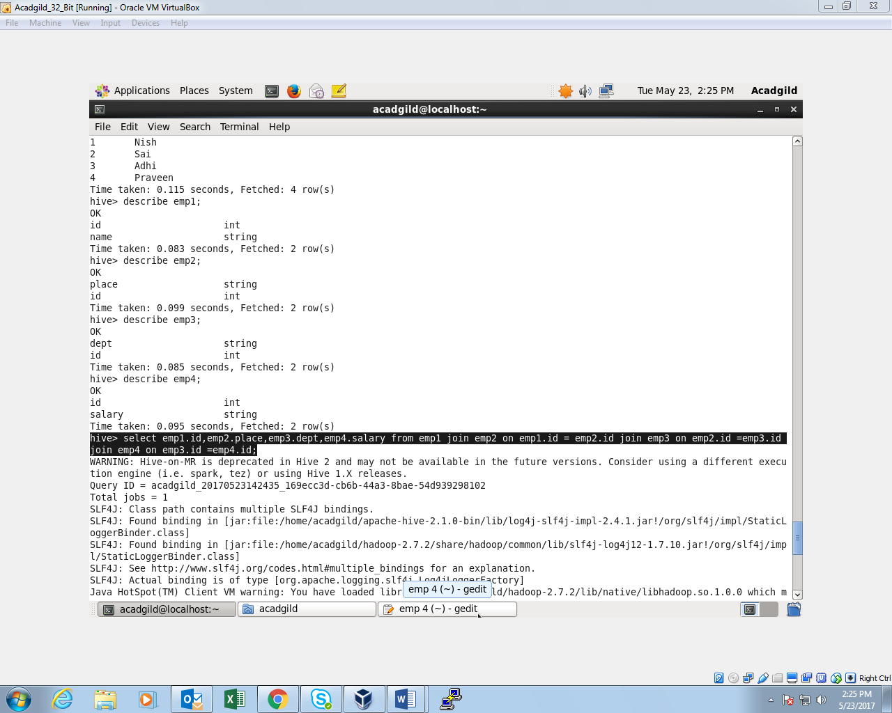

**OUTPUT:**

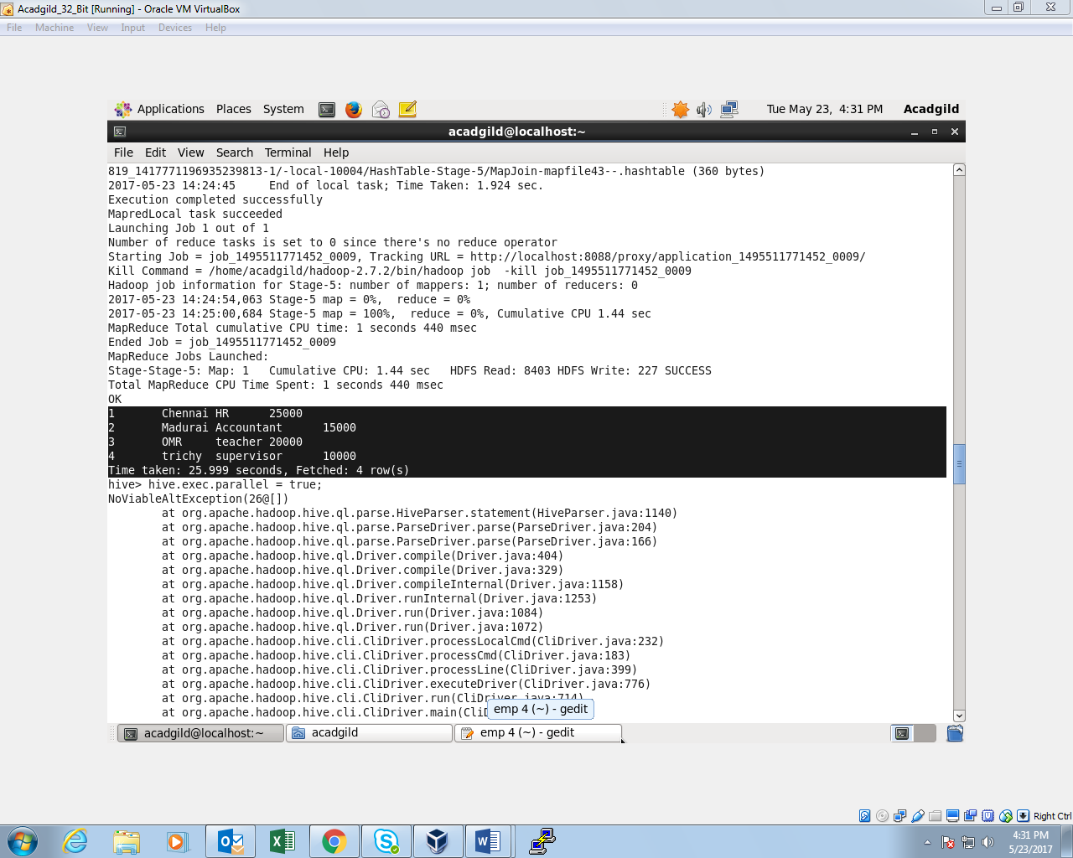

**PARALLEL PROCESSING:**

Initially we are **setting up the configuration** for parallel processing.

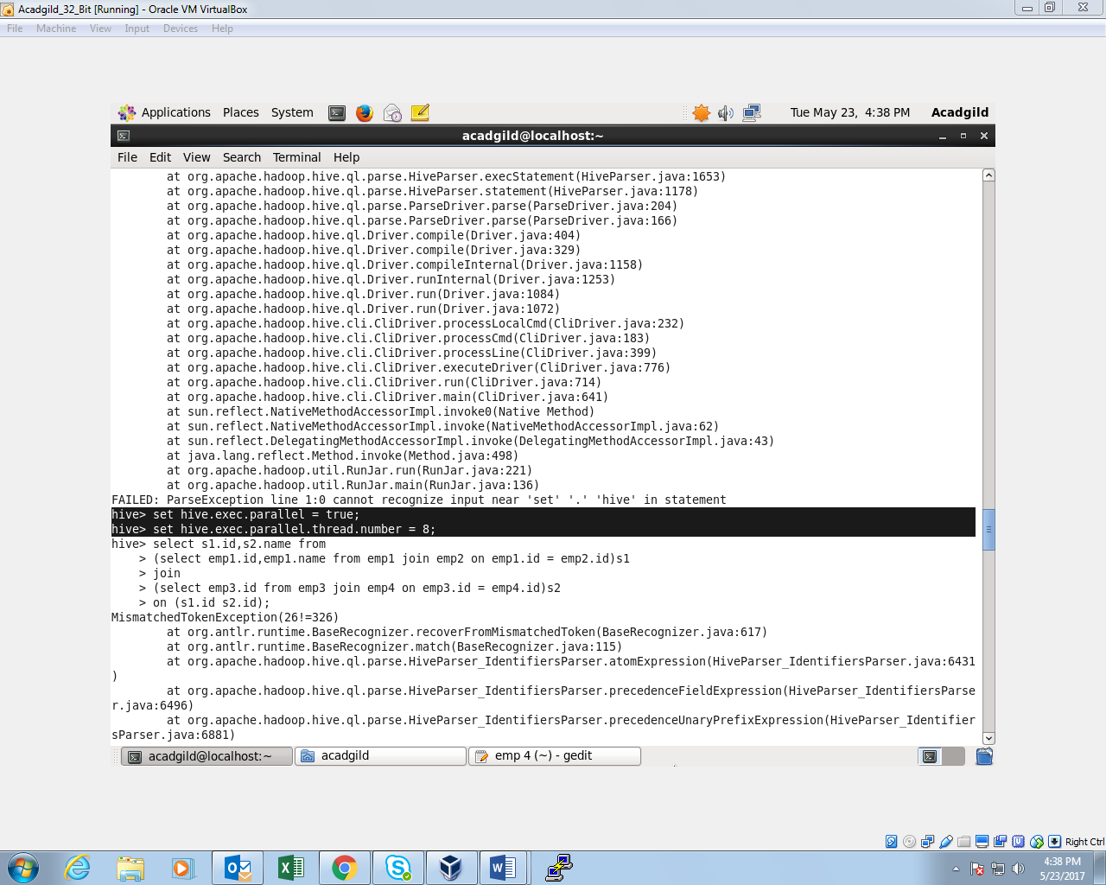

**COMMAND AND EXECUTION:**

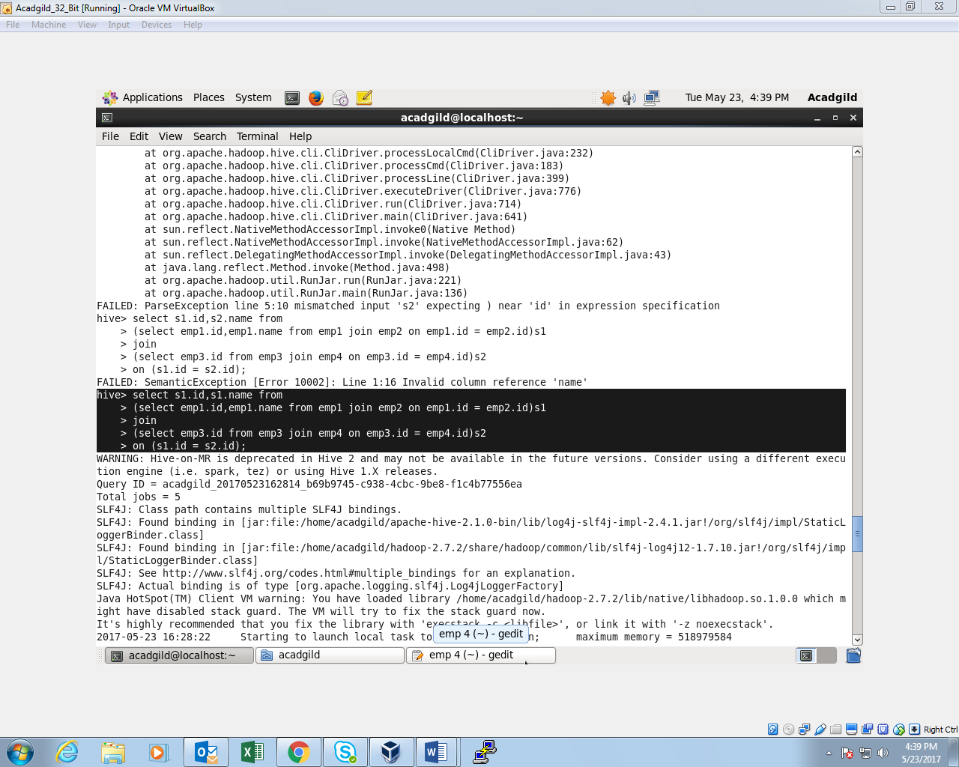

**OUTPUT:**

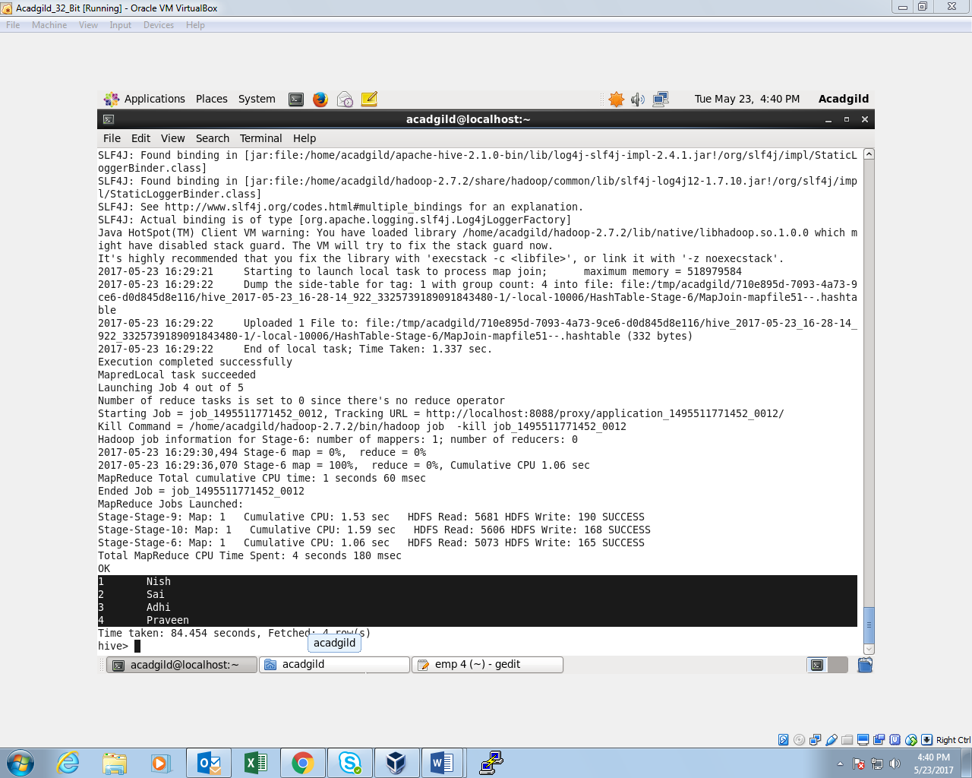

**Thus,the difference serialized execution and parallel execution is shown.**