**ASSIGNMENT 28.1**

**What are ACID properties and Explain Transactions in Hive .**

**ACID** stands for Atomicity, Consistency, Isolation, and Durability.

*Atomicity means, a transaction should complete successfully or else it should fail completely i.e. it should not be left partially.

*Consistency ensures that any transaction will bring the database from one valid state to another state.

*Isolation states that every transaction should be independent of each other i.e. one transaction should not affect another.

*And Durability states that if a transaction is completed, it should be preserved in the database even if the machine state is lost or a system failure might occur.

These ACID properties are essential for a transaction and every transaction should ensure that these properties are met.

**TRANSACTIONS IN HIVE:**

The different row-level transactions available in Hive 0.14 are as follows:

1. Insert
2. Delete
3. Update

Before Hive table is created they use to support transactions. But transaction features in Hive should be turned on .By default they are turned off. There are certain properties that need to be set in hive shell, in order to work transactions. If the properties are not properly set then ‘Insert’ operation will work. In parallel ‘Update’ and ‘Delete’ operation will not work.

**Creating a table that supports hive transactions**

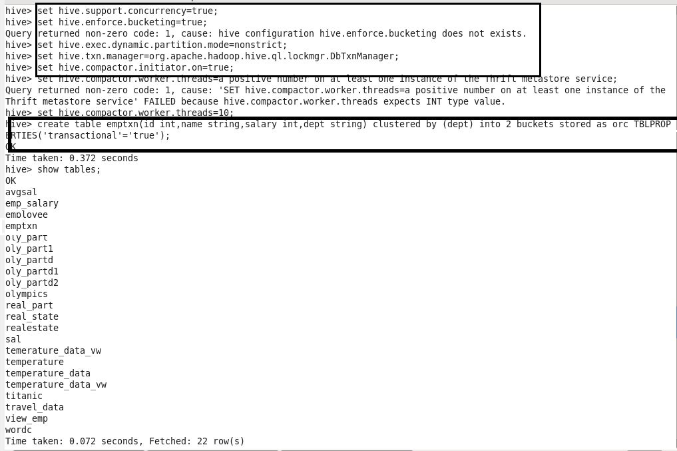

**Inserting values into table:**

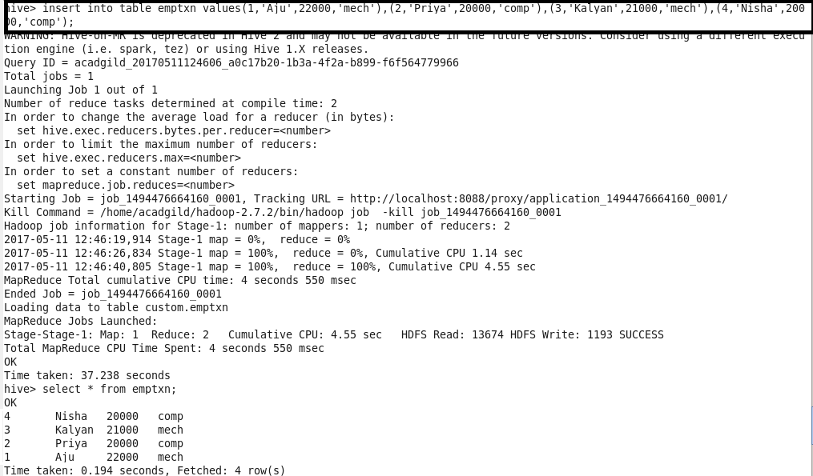

When a same value is inserted again then those will be appended to previous data as mentioned below:

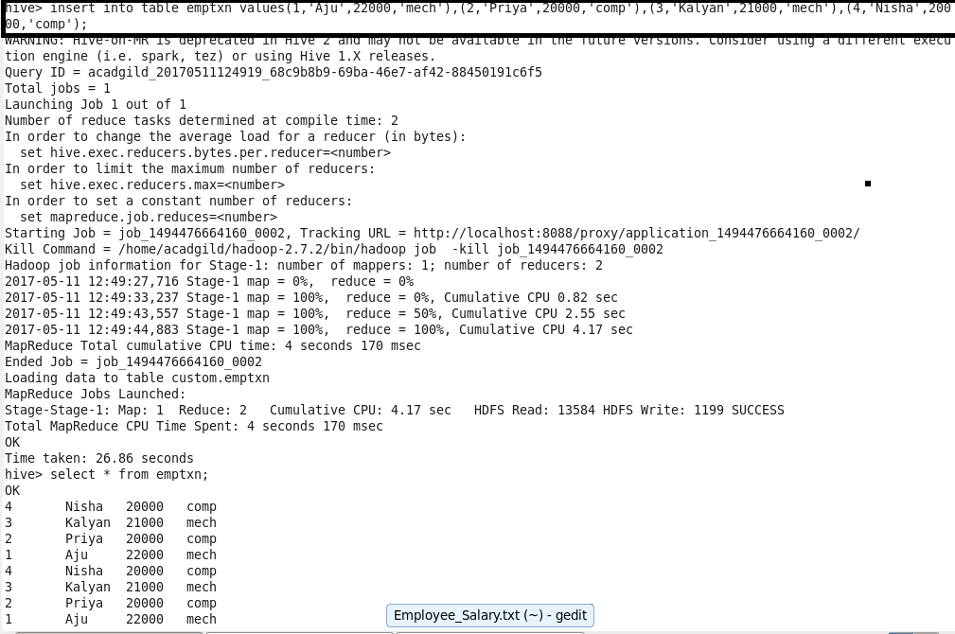

**Updating Data in Hive Table:**



**Non-bucketed columns:**

**Performing update operation on non-bucketed columns**

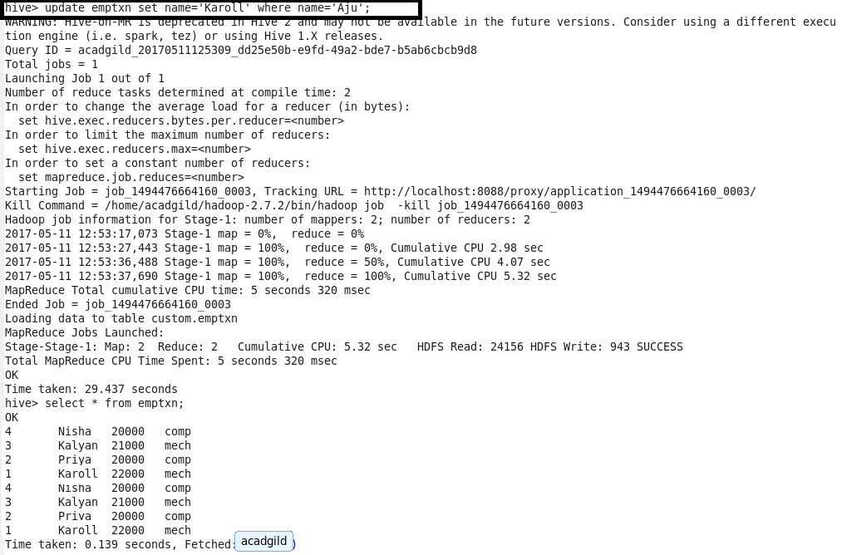

**Deleting a Row from Hive Table:**

