**ASSIGNMENT 29.1**

**Write a hive UDF that implements functionality of string concat_ws(string SEP, array). This UDF will accept two arguments, one string and one array of string. It will return a single string where all the elements of the array are separated by the SEP.**

**INPUT:**

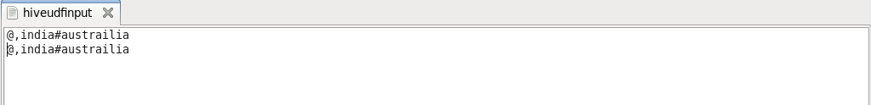

**UDF PROGRAM:**

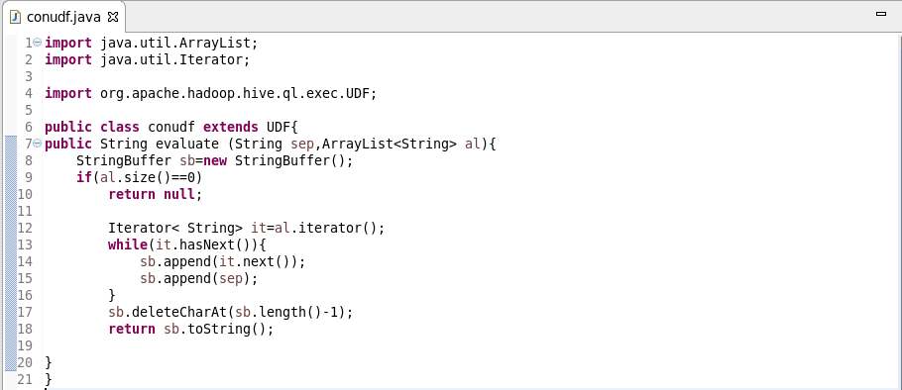

**HIVE:**

