**ASSIGNMENT 32.2**

**Problem Statement:**

Use Hbase shell for performing the following operations:

* Create the table customer with two column families.
* Personal details and order details as column families. Create a unique number as row key (ssn/Aadhar no.,etc)
* Insert at least 10 records to each column Insert following values for personal details column family Name, age, city, state.Insert following values for order details column family:Order no., order quantity, and order amount.
* Use put command to insert the values for each record. Use get command, to retrieve all the records of single customer.

**Output:**

Creating table ‘customer’ using **‘create’** command.

The table ‘customer’ has two column families as:

* Personal details and
* Order details

The syntax for creating table with column families:

Inserting the details using put command:

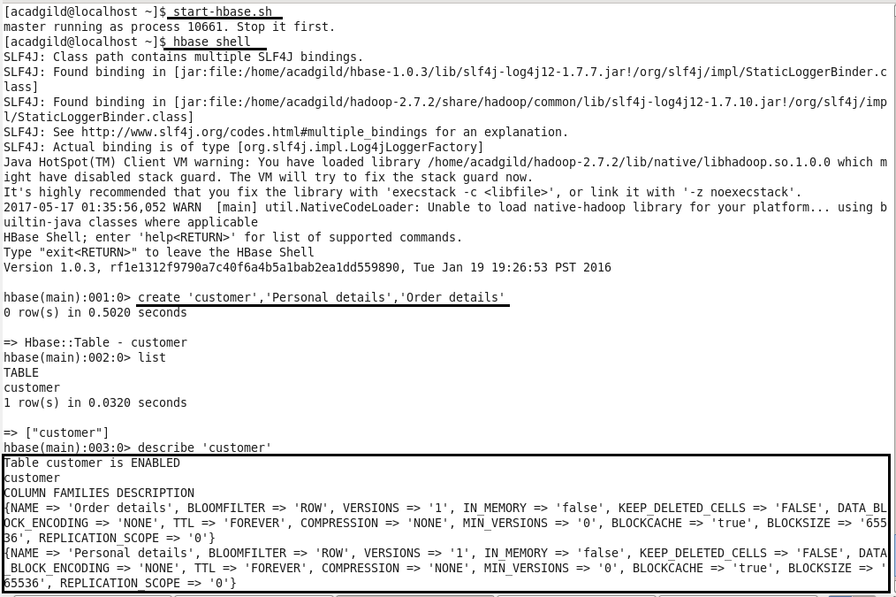

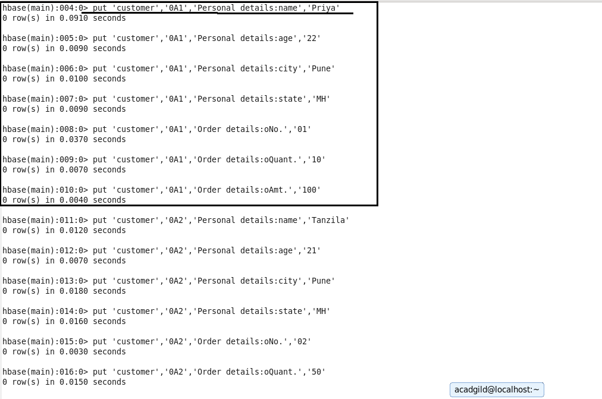

Retrieving using ‘get’ command:

