**● Create an employee table in Mysql and columns as Emp_id, Emp_name, Dept_name (Hadoop Developer), Emp_sal .**

**● Import the employee table contents into the HDFS directory using Sqoop**

***Initially,a emp table is created in mysql and the data is inserted***

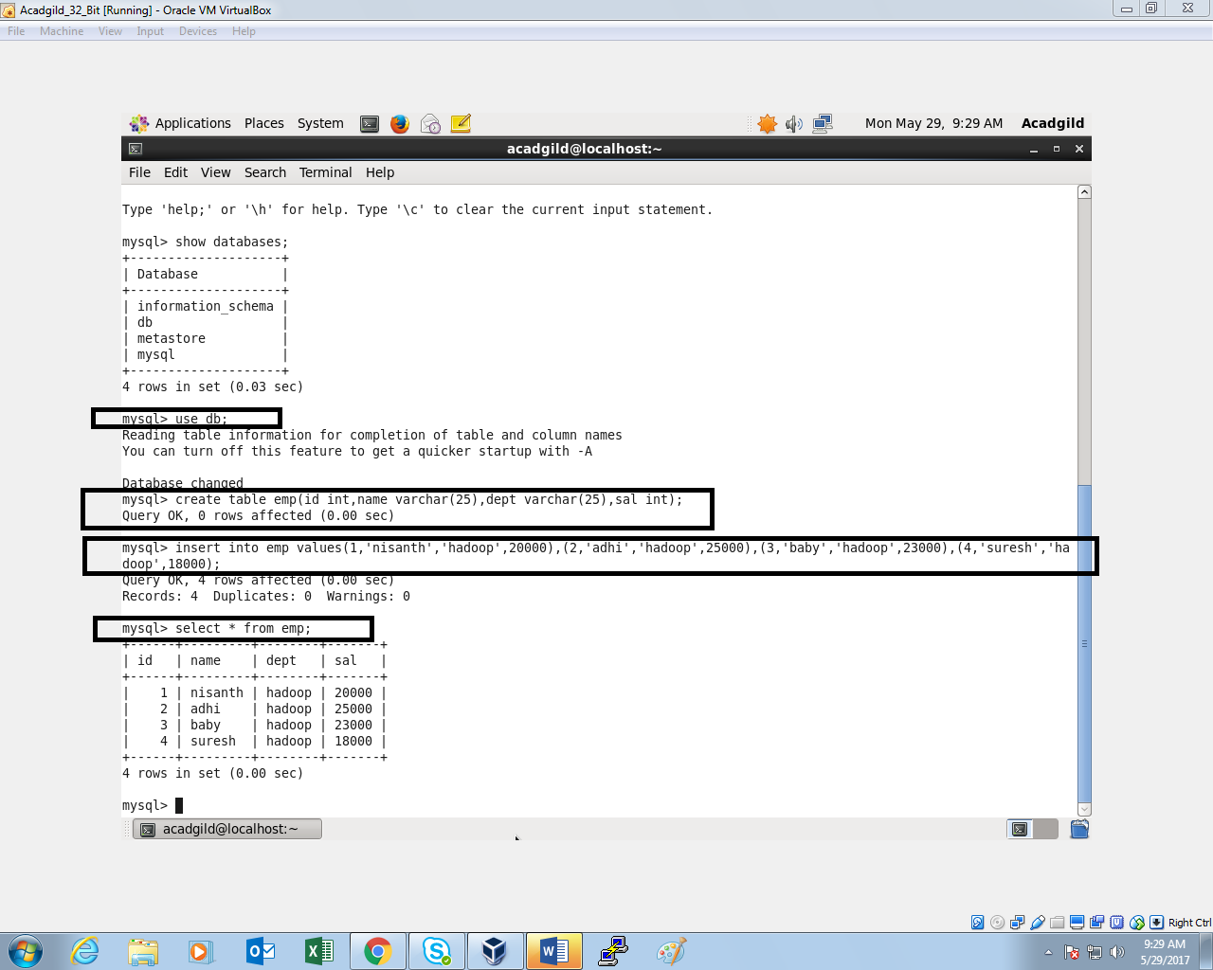

***Sqoop command is performed to move the file from mysql to HDFS:***

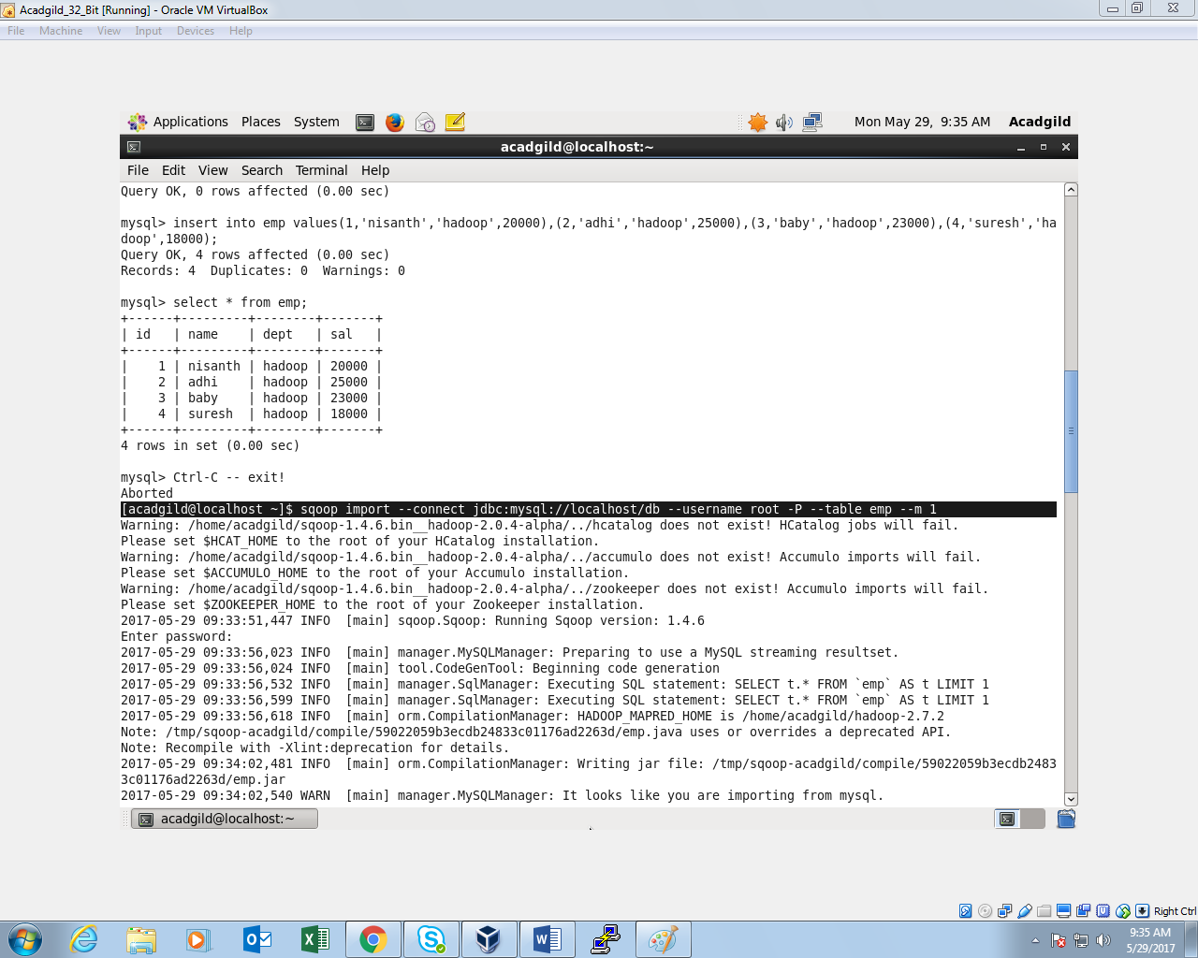

***OUTPUT:***

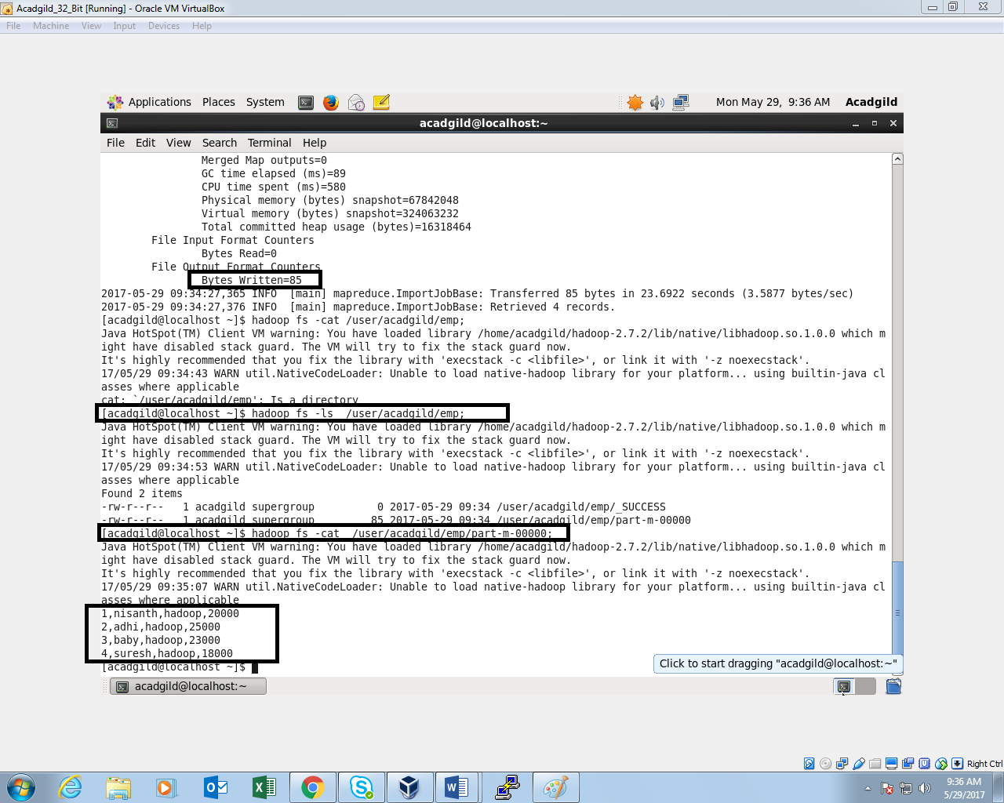

**Create a employee2 table in Mysql and Export employee details Emp_name and Emp_sal from HDFS directory to Mysql table employee2 using Sqoop.**

**● Explain the procedures performed, Share the screenshots of commands and results for the same.**

***Table emp2 is created and it is empty:***

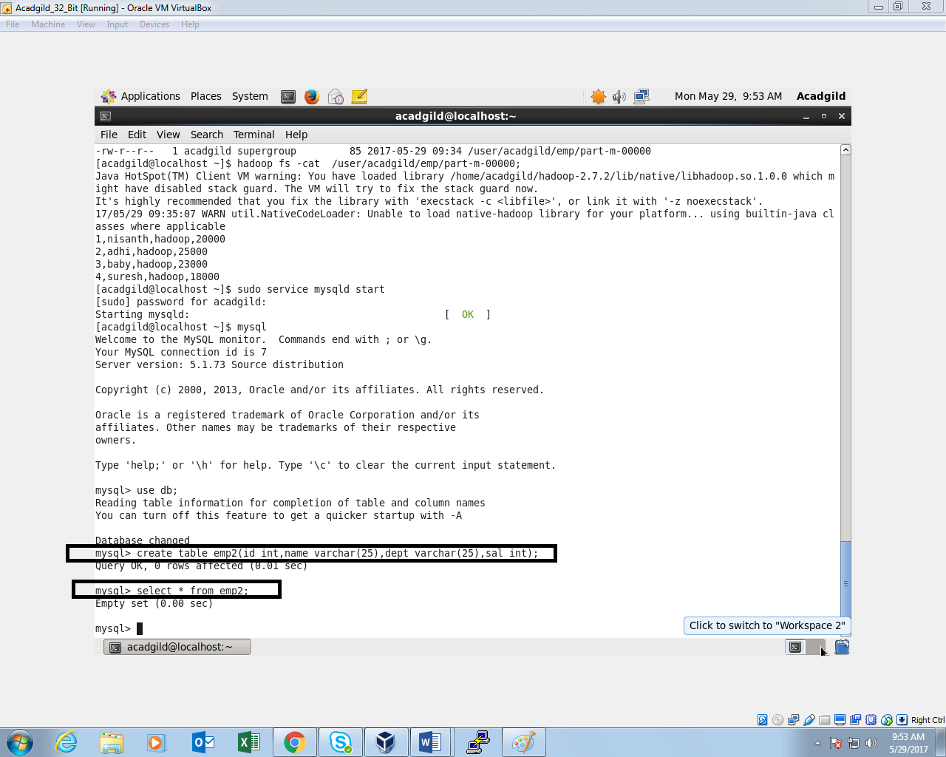

***Sqoop command is performed and data from HDFS is exported to MySql:***

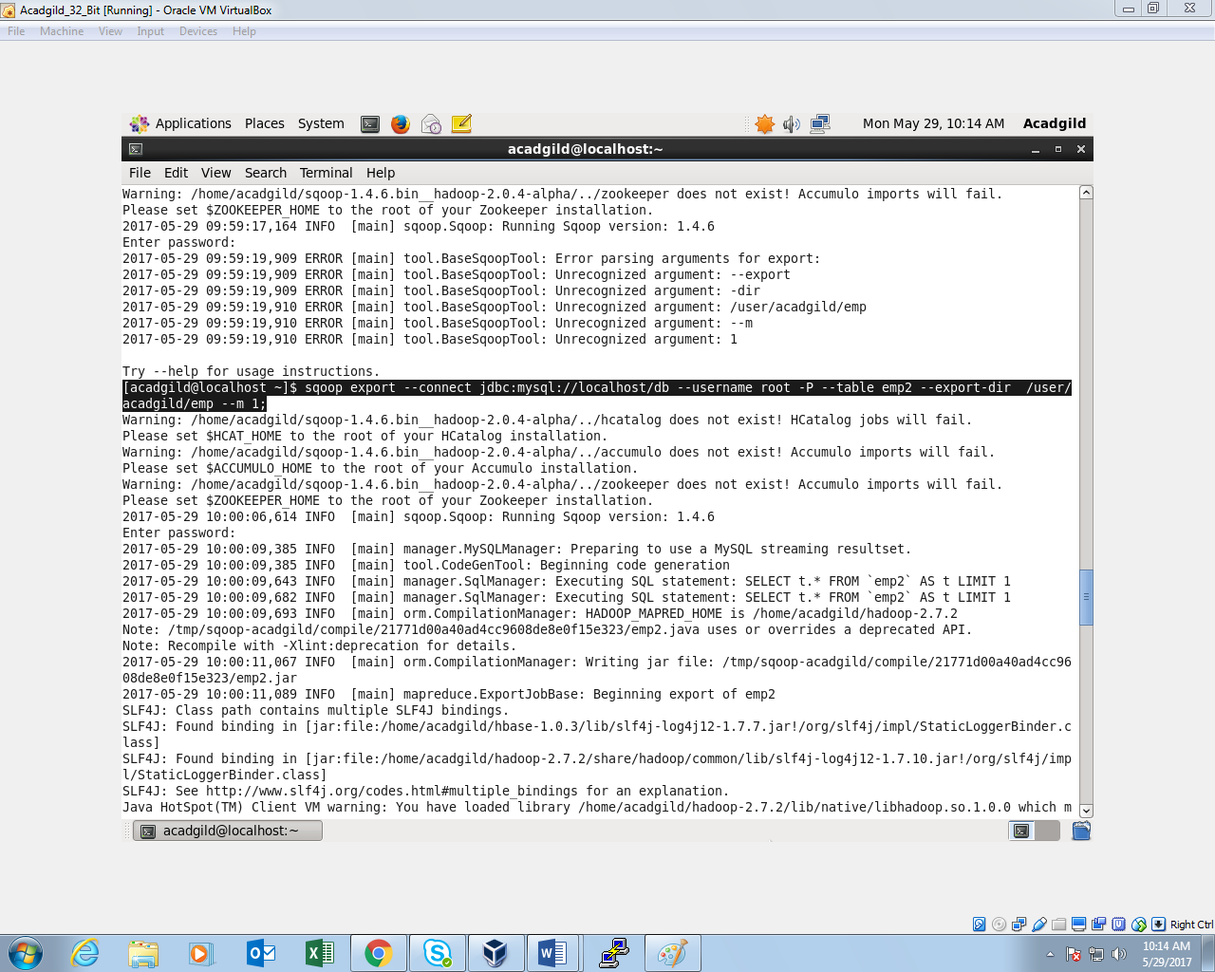

***Thus,the data is exported to mysql emp2 table:***

