**ASSIGNMENT 35.2**

* **Explain and perform Sqoop Incremental Import operation to load data from Mysql to HDFS using Sqoop.**
* **Explain the procedures performed, Share the screenshots of commands and results for the same.**

***Table is created and data is inserted into it:***

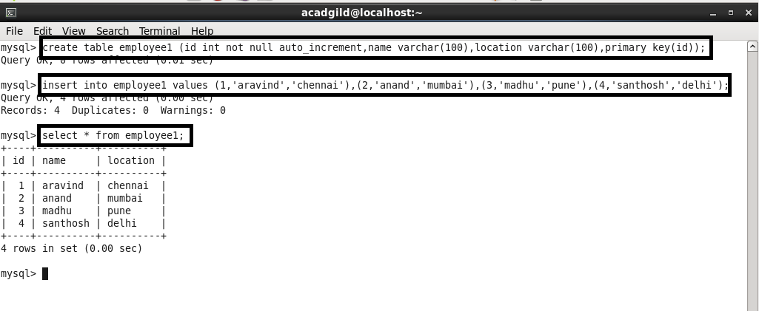

***Importing the table from mysql to HDFS:***

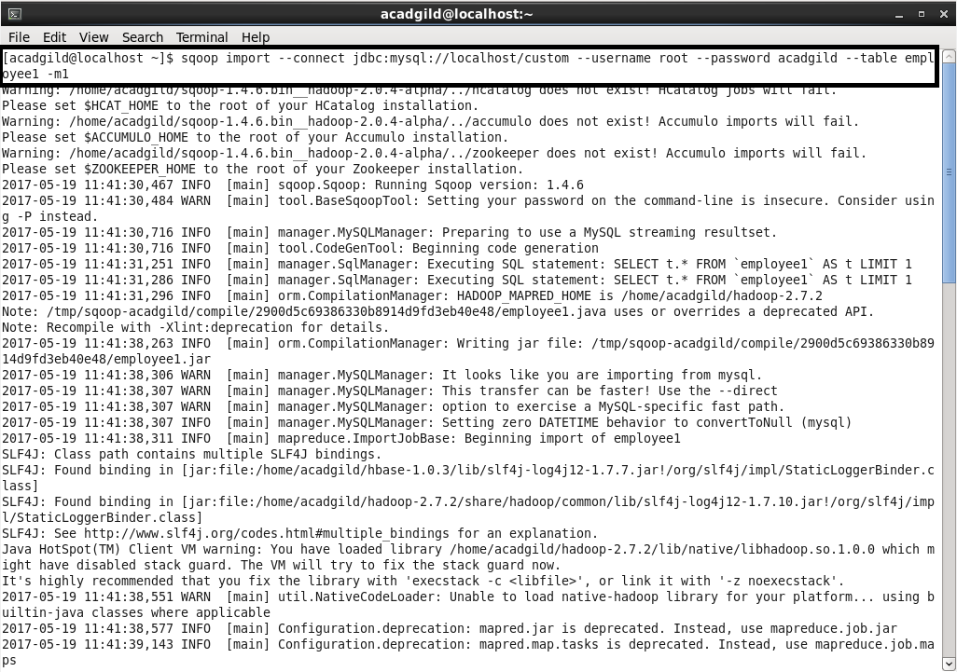

***Records are written and shown:***

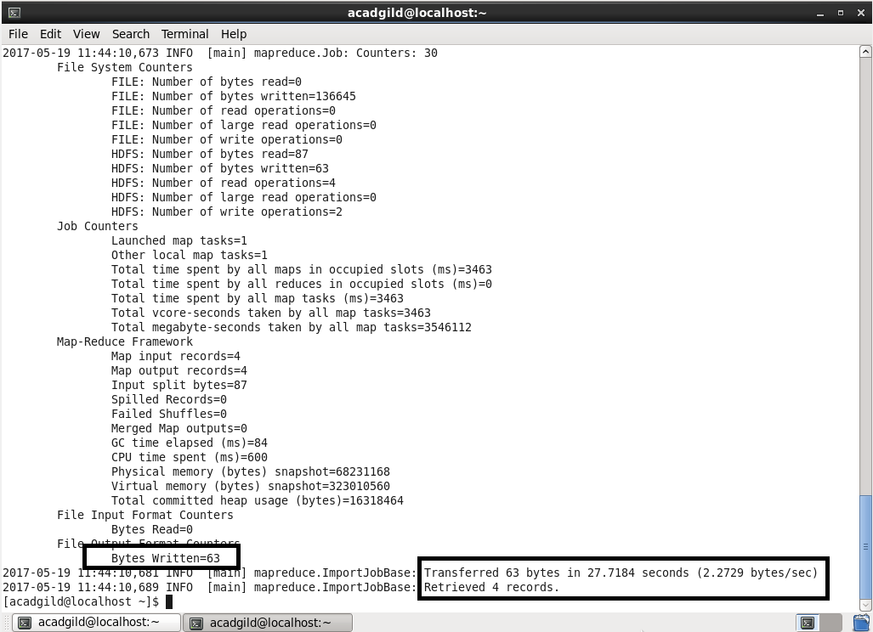

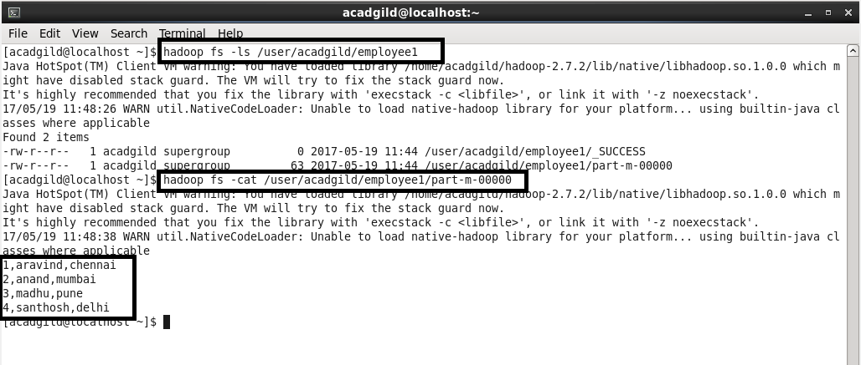

***Inserting few more rows into the table :***

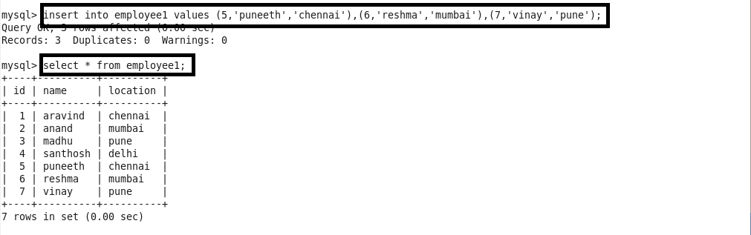

***Incremental append:***

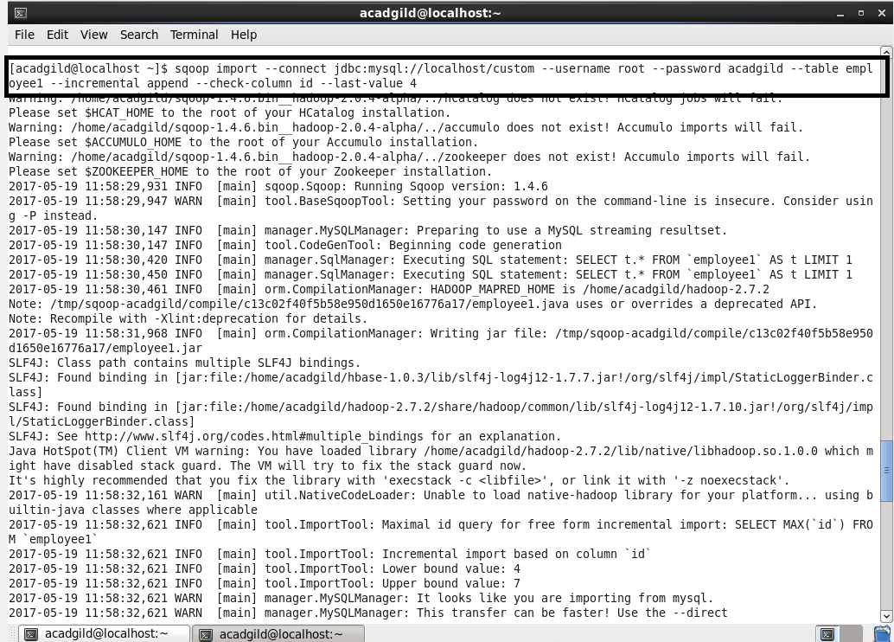

***Records are written and output is shown:***



