**ASSIGNMENT 35.3**

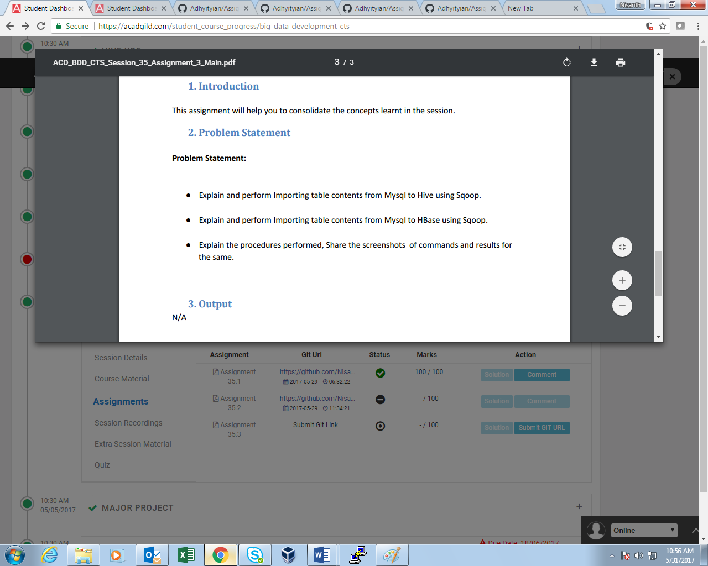

* **MySql to Hive:**

**Table is created and data is inserted into it:**

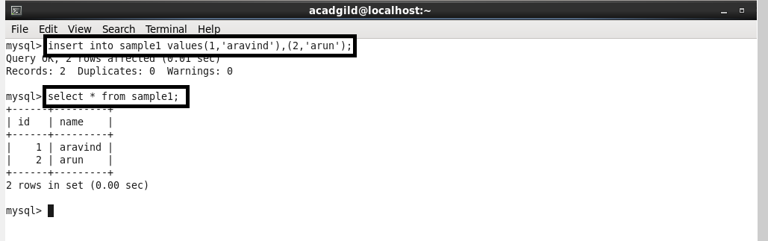

**Import operation is performed using sqoop:**

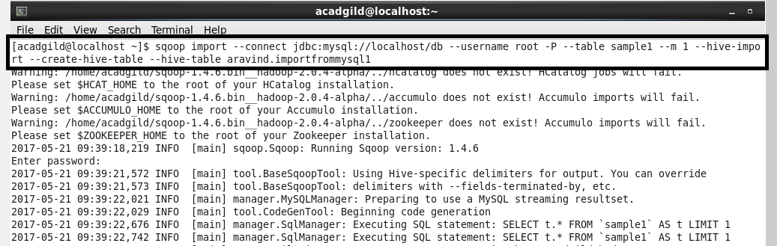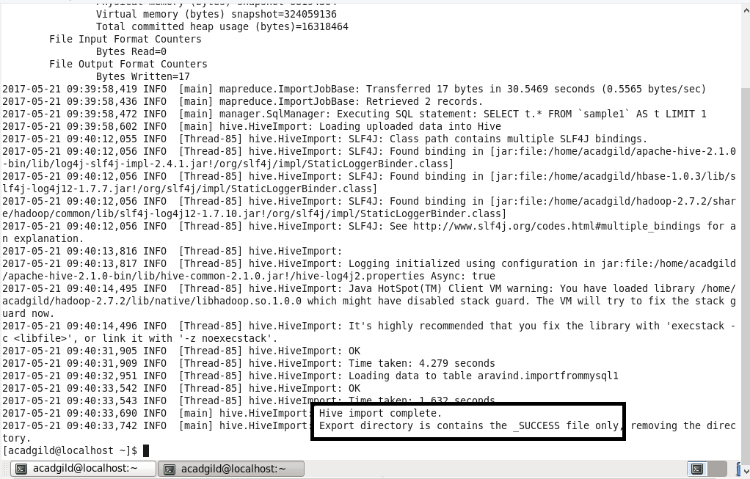

**File display(Output):**

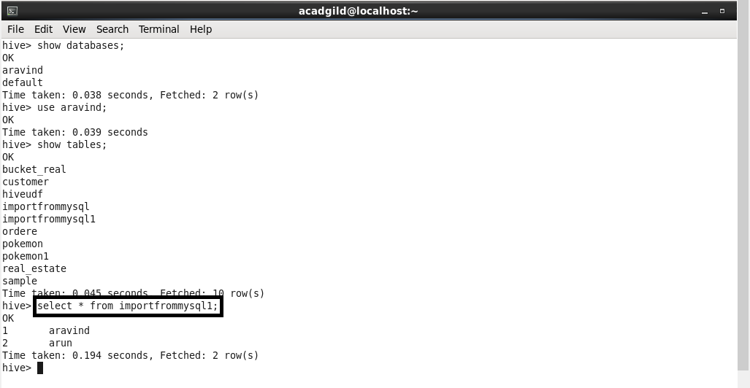

* **MySql to HBase using Sqoop:**

**Table is created and data is inserted**

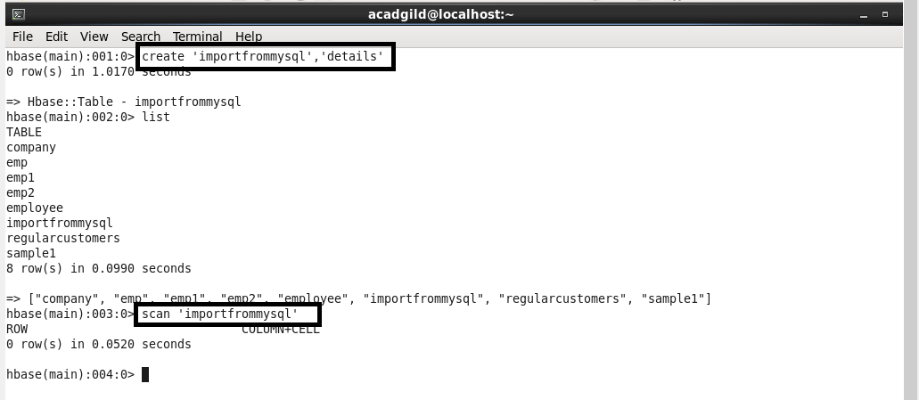

**Import operation is performed:**

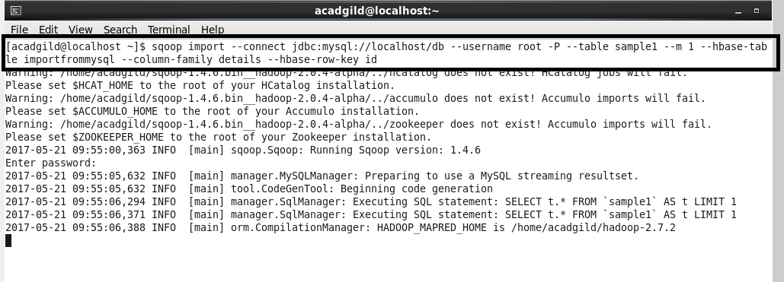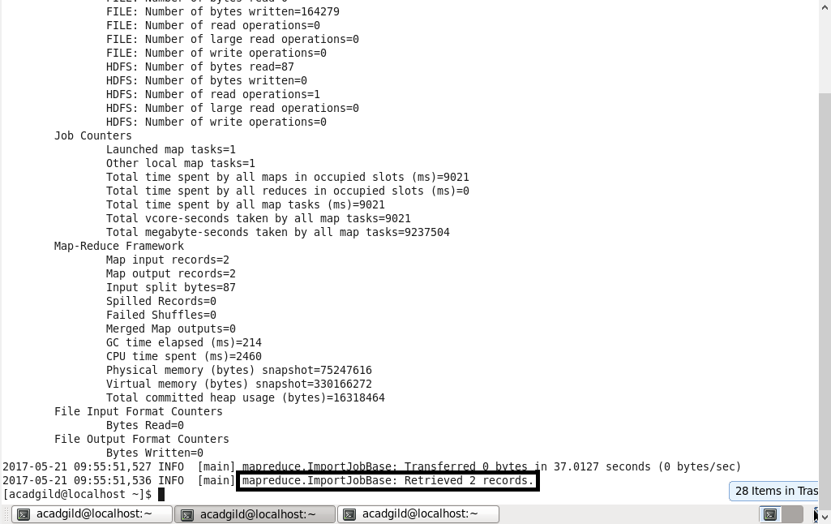

**File display(output):**

