**The first four pages contains solution for the first question and the next four pages contains solution for the second question**

**Driver class:**

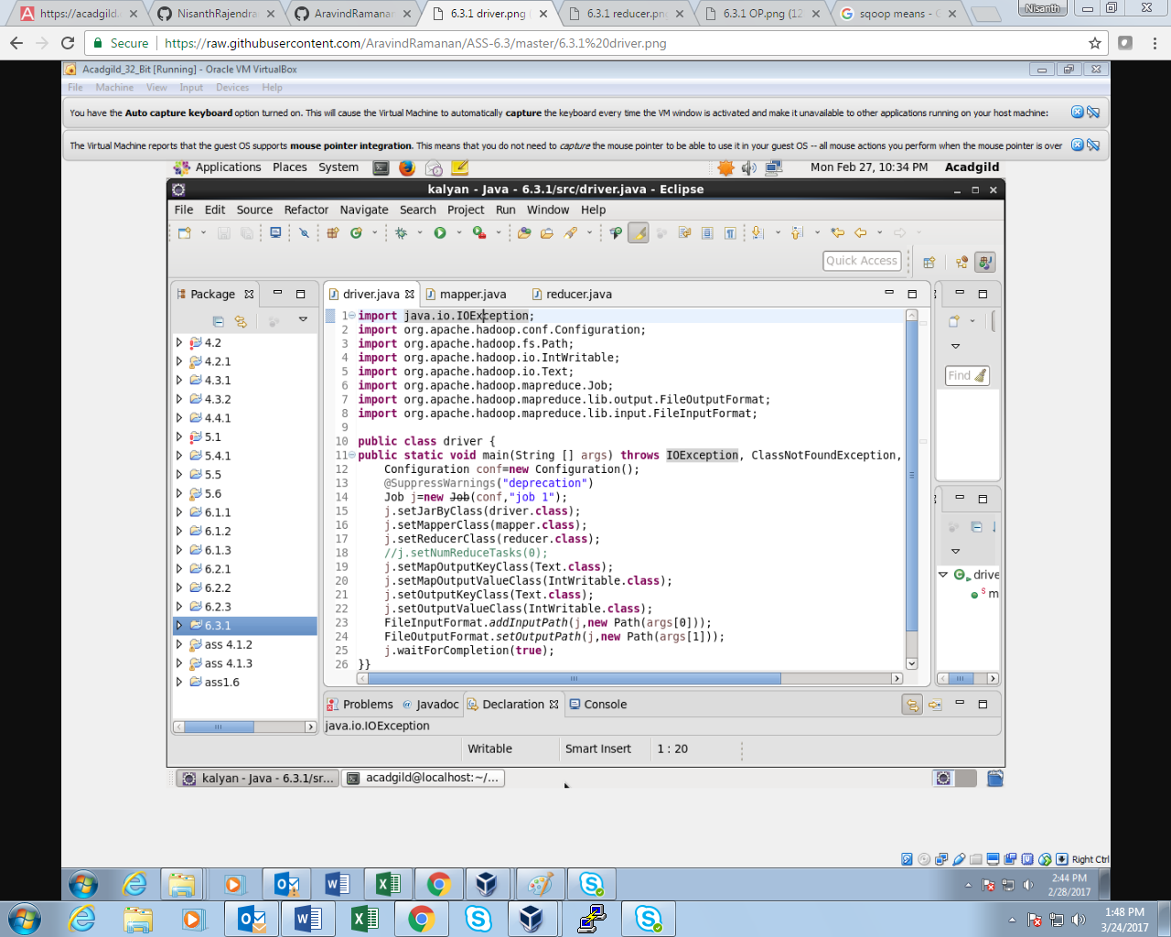

**Mapper class:**

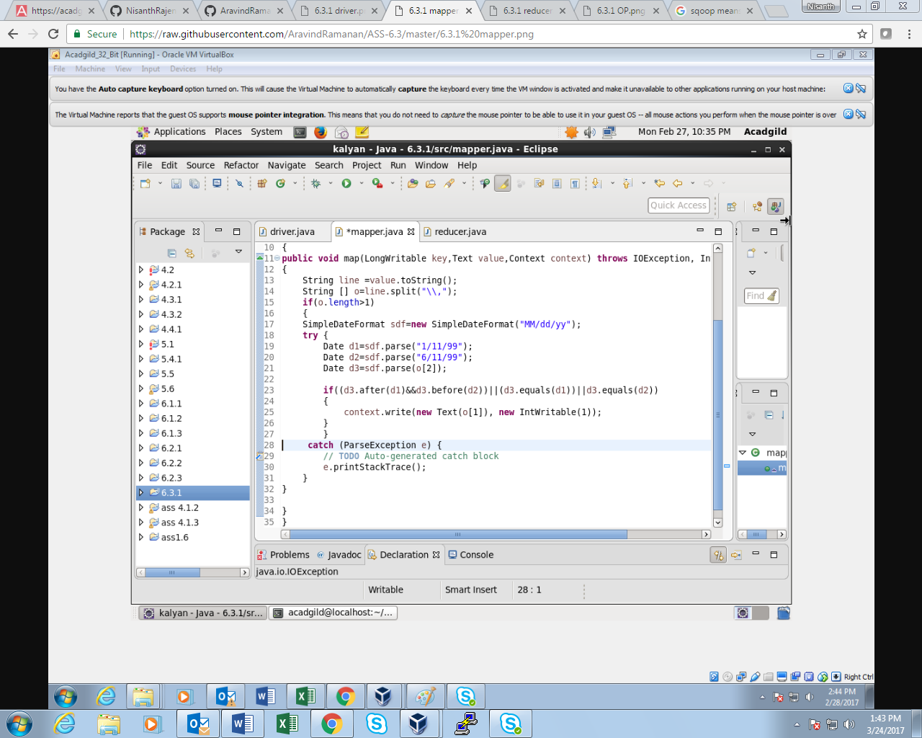

**Reducer class:**

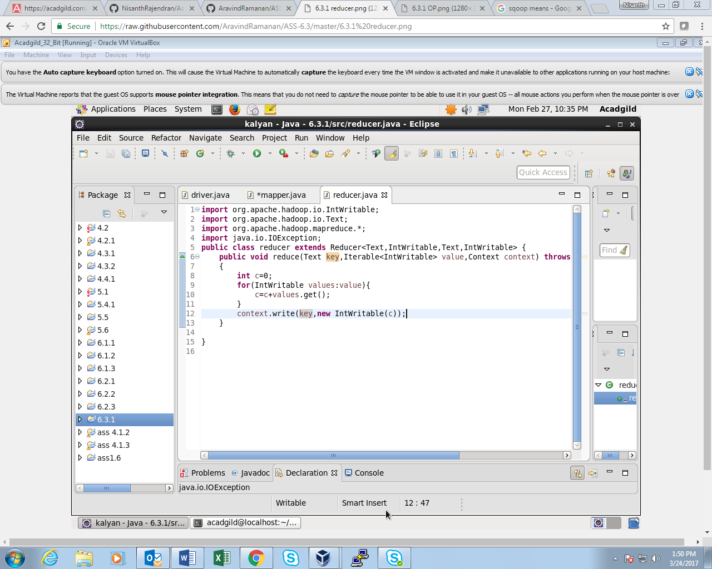

**OUTPUT:**

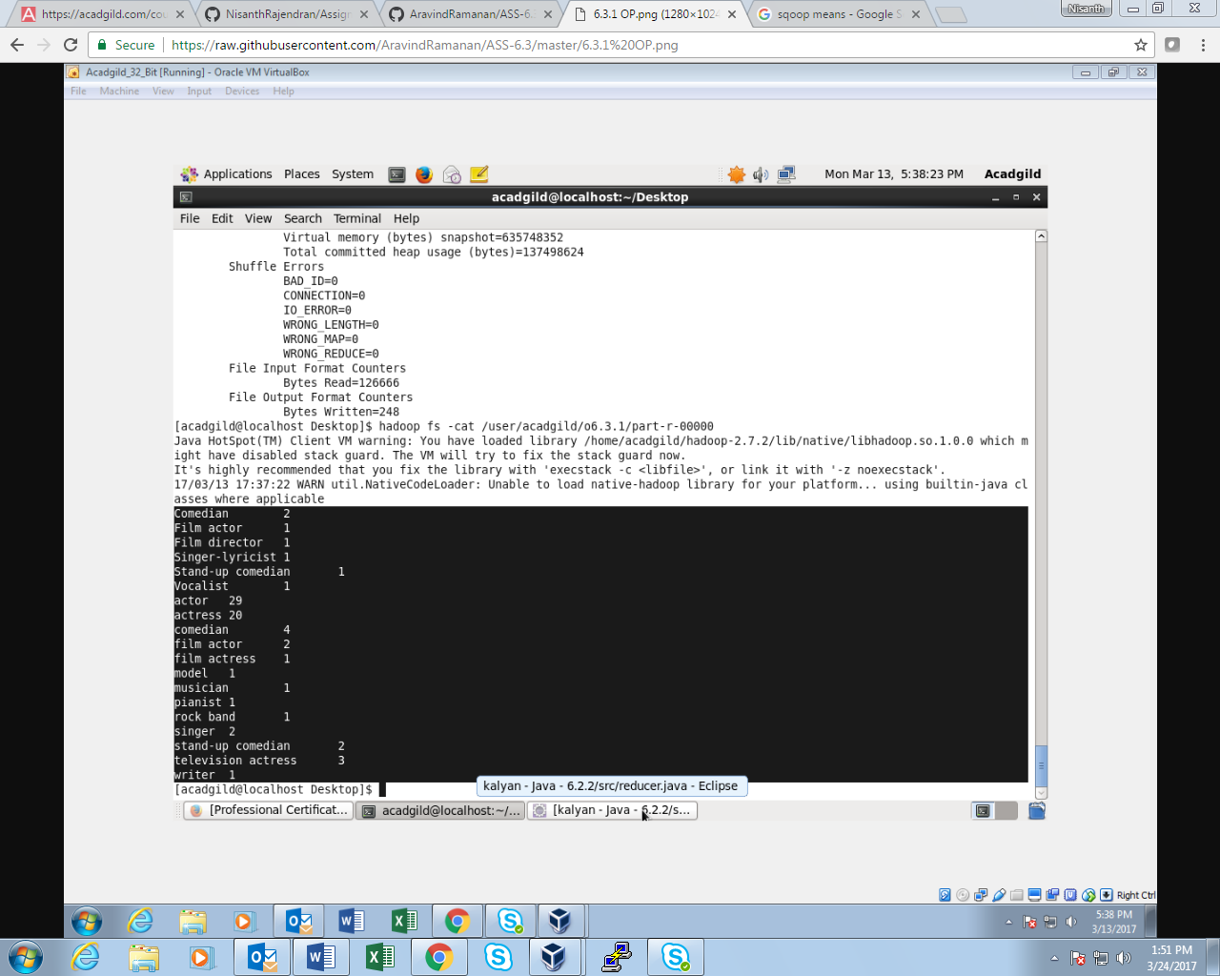

**SOLUTION FOR THE SECOND QUESTION:**

**Driver class:**

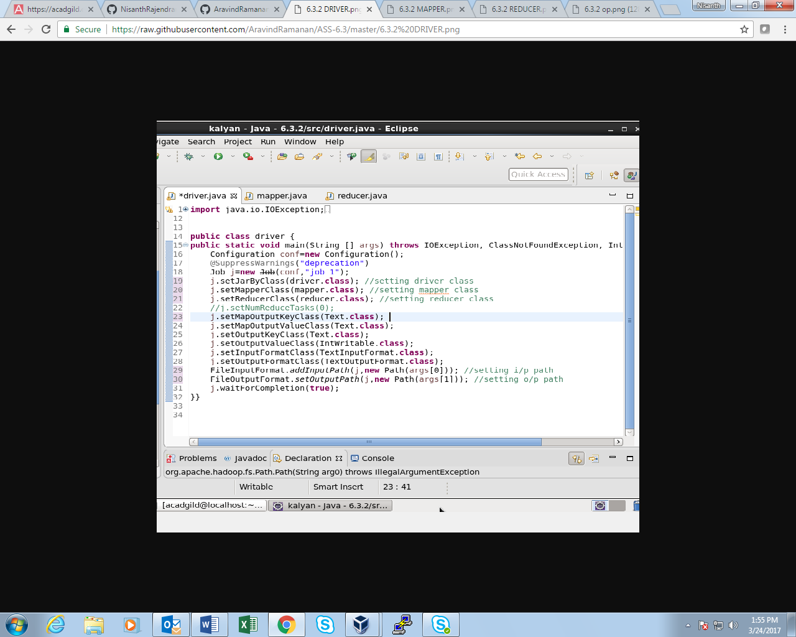

**Mapper Class:**

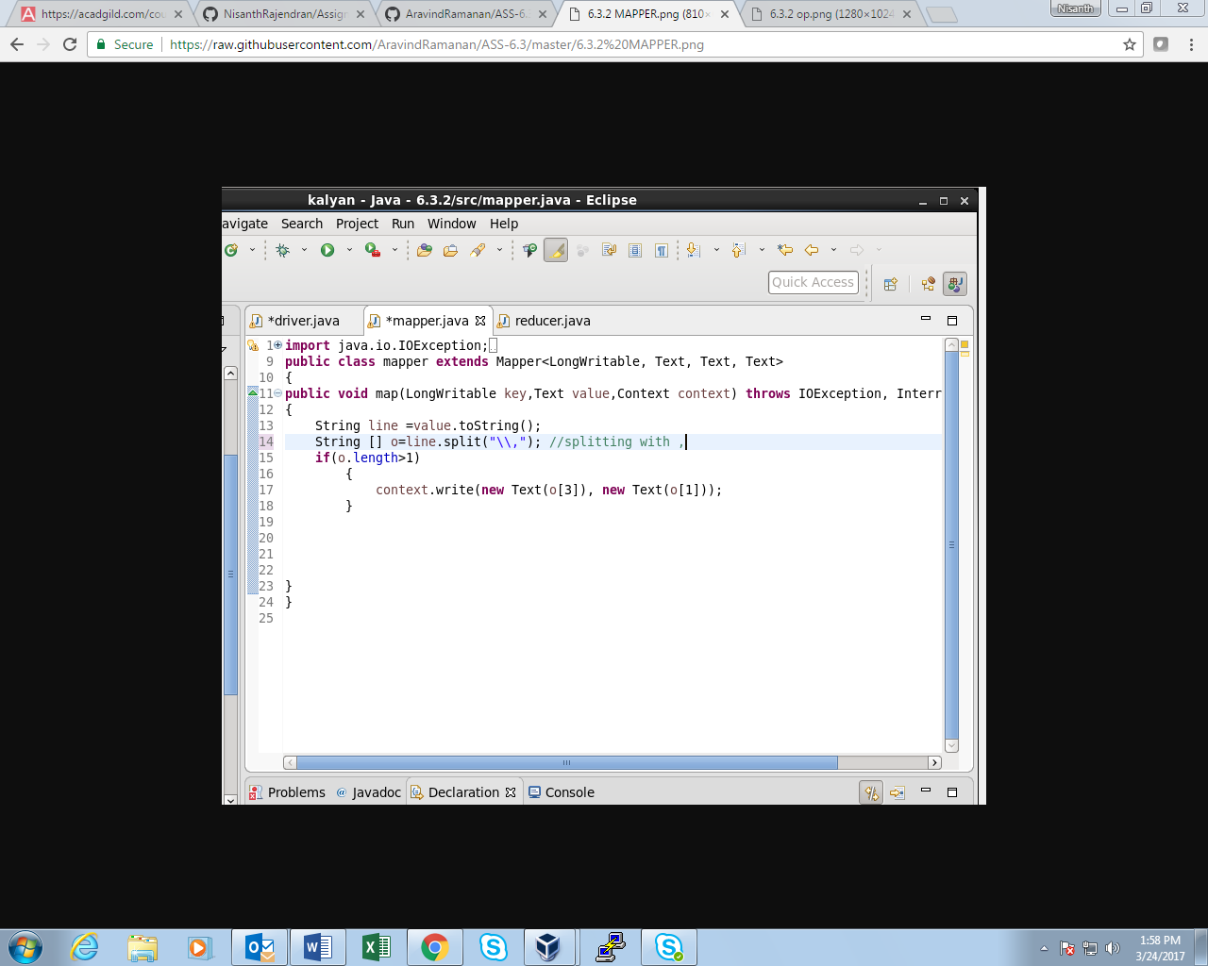

**Reducer Class:**

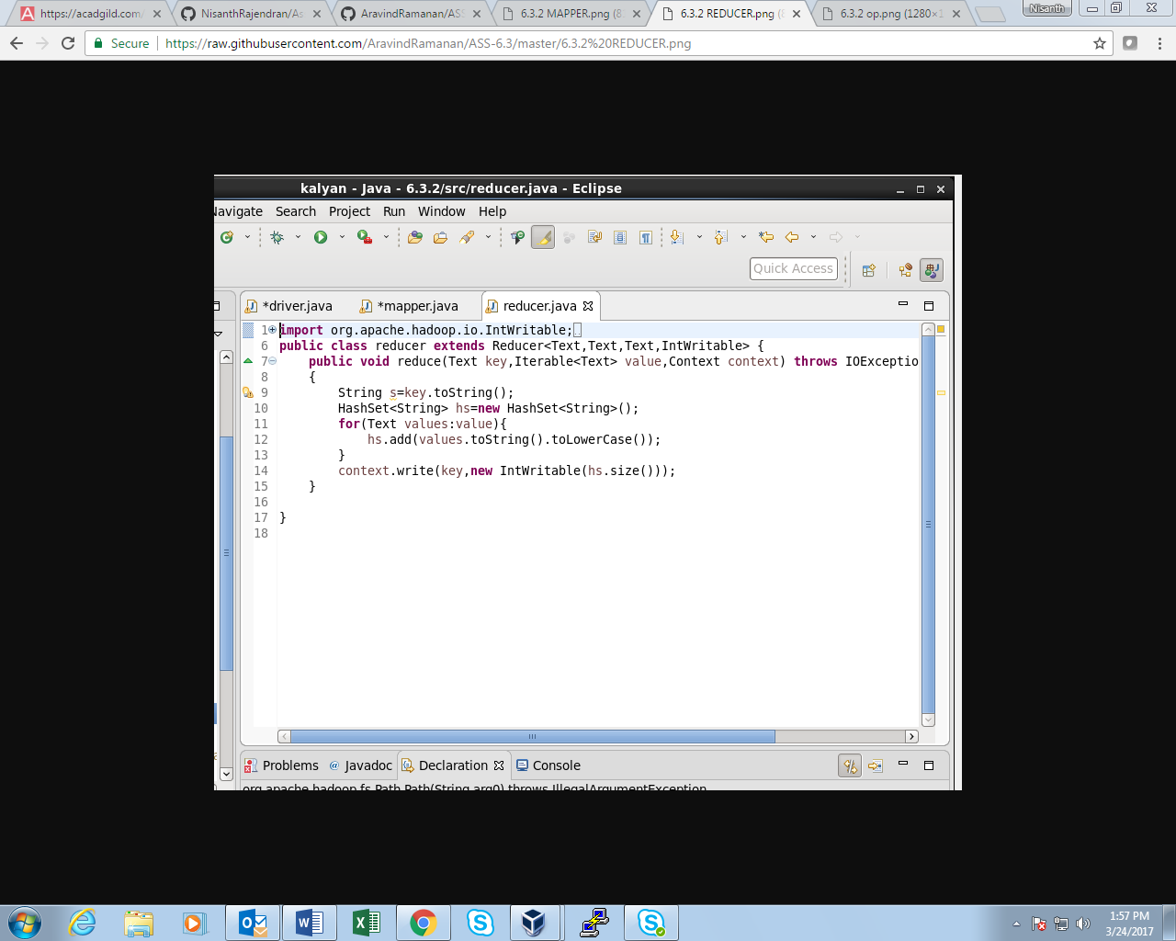

**OUTPUT:**

