**SOLUTION FOR ASSIGNMENT 6.5**

**DRIVER CLASS**

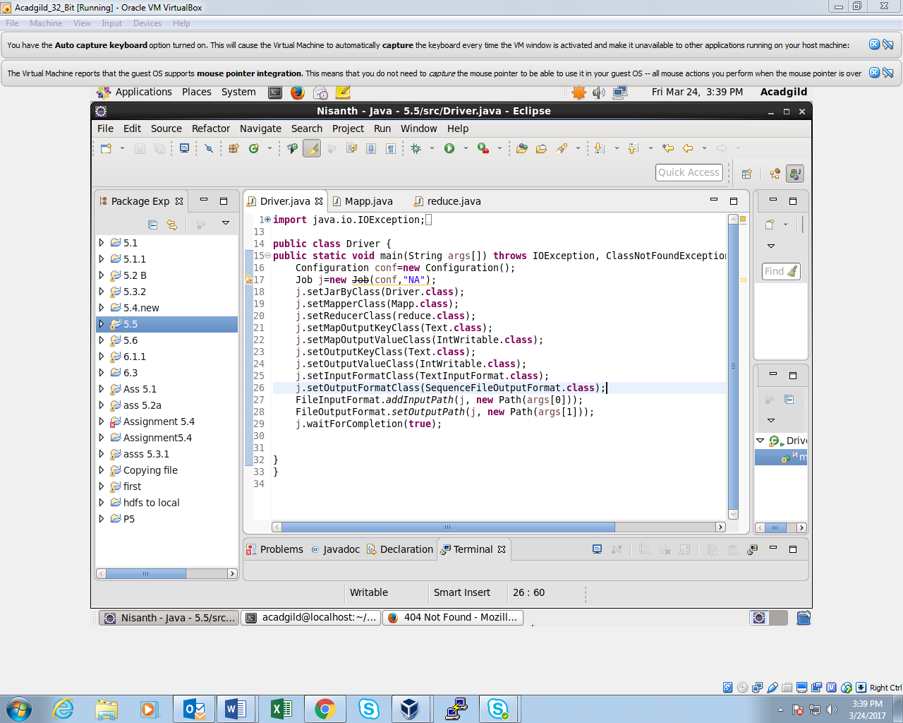

**MAPPER CLASS:**

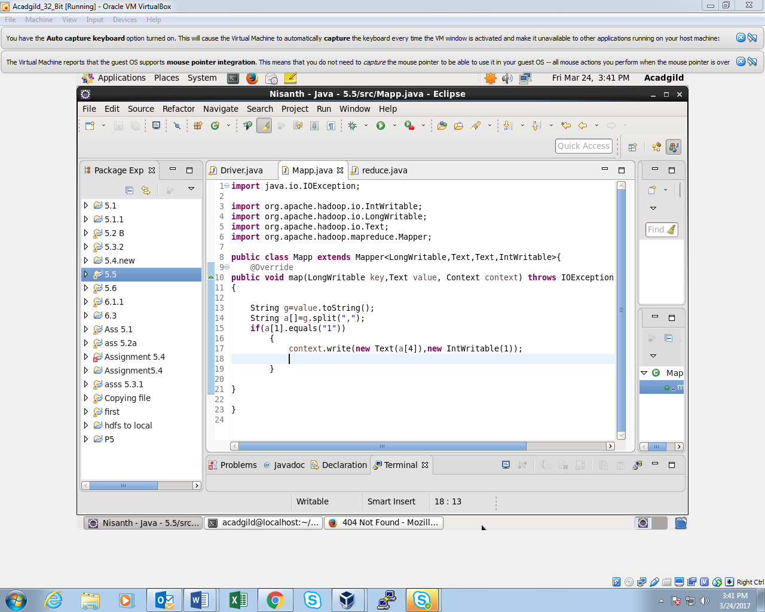

**REDUCER CLASS:**

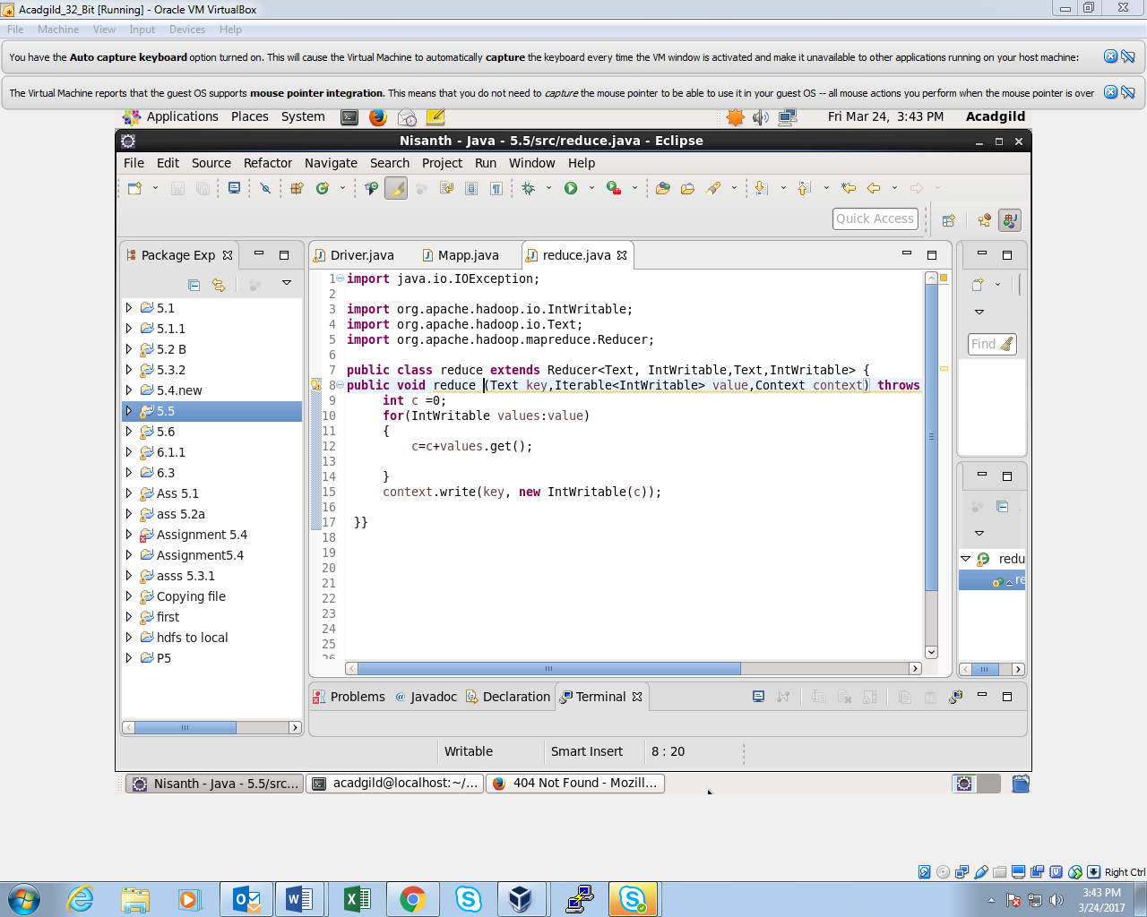

**OUTPUT:**

