**SOLUTION FOR ASSIGNMENT 6.6**

**DRIVER CLASS:**

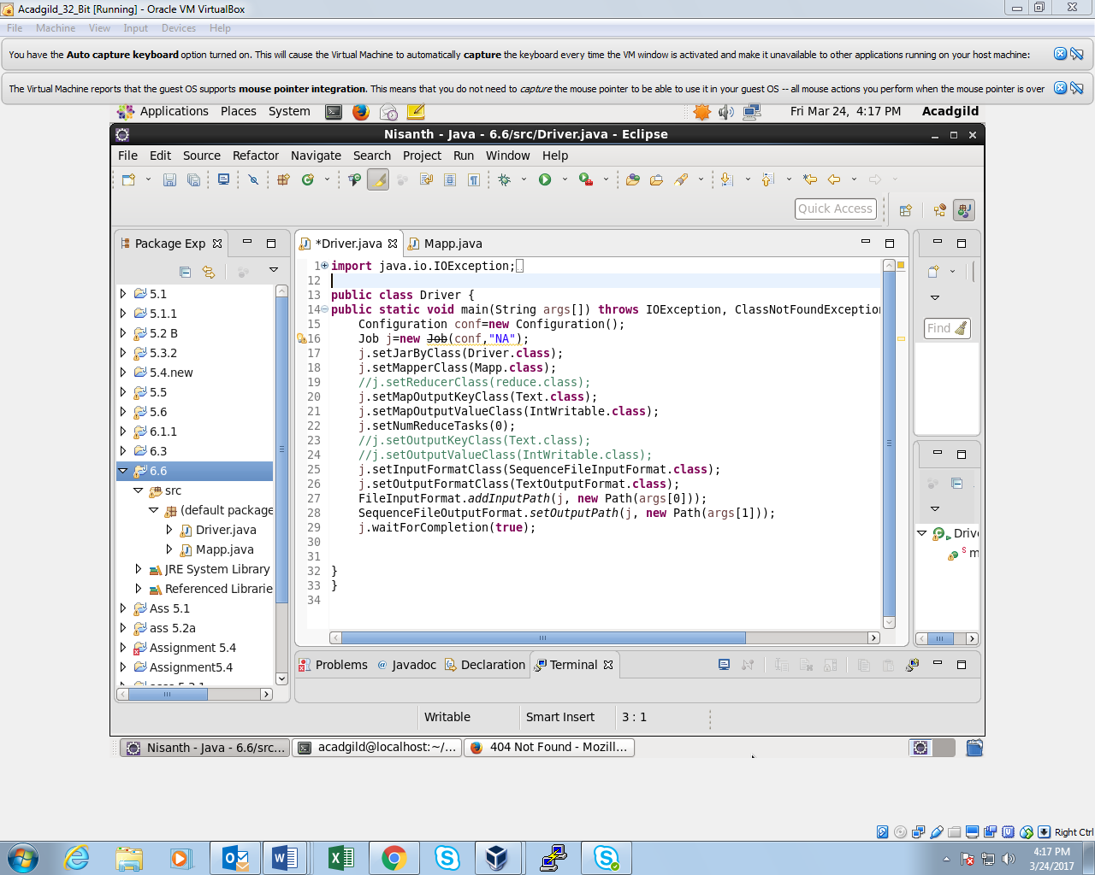

**MAPPER CLASS:**

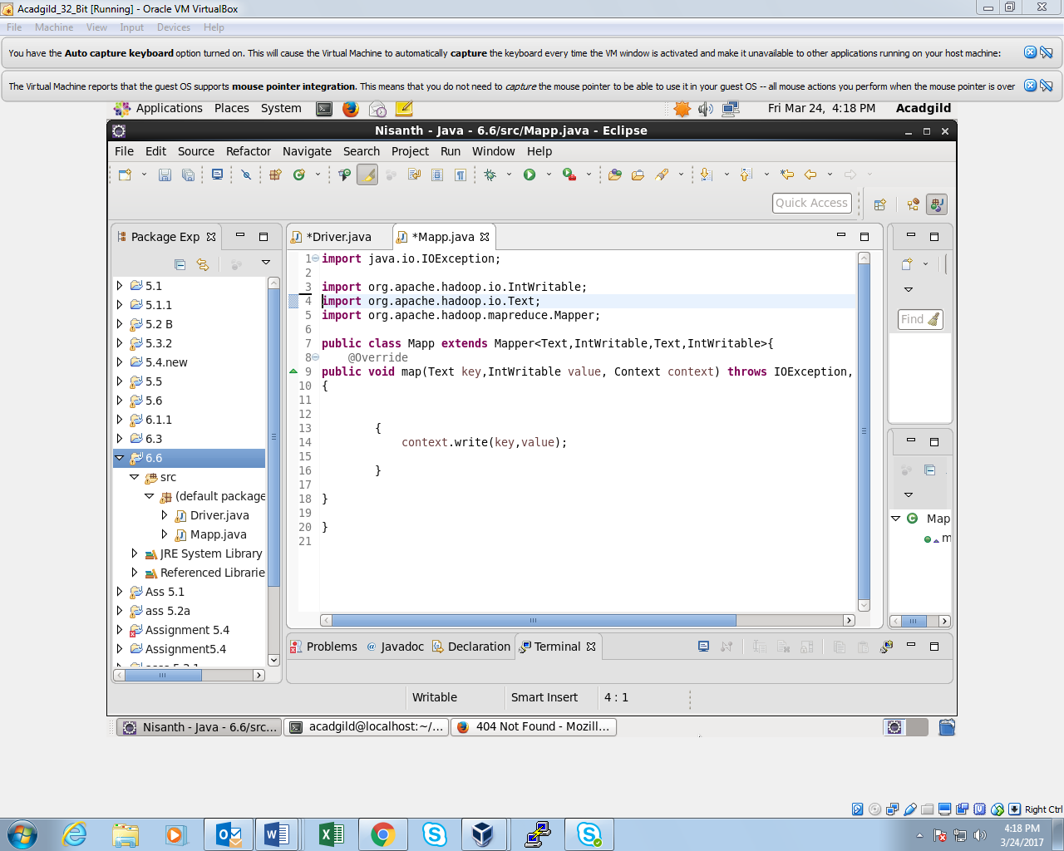

**OUTPUT:**

The given input is a sequence file

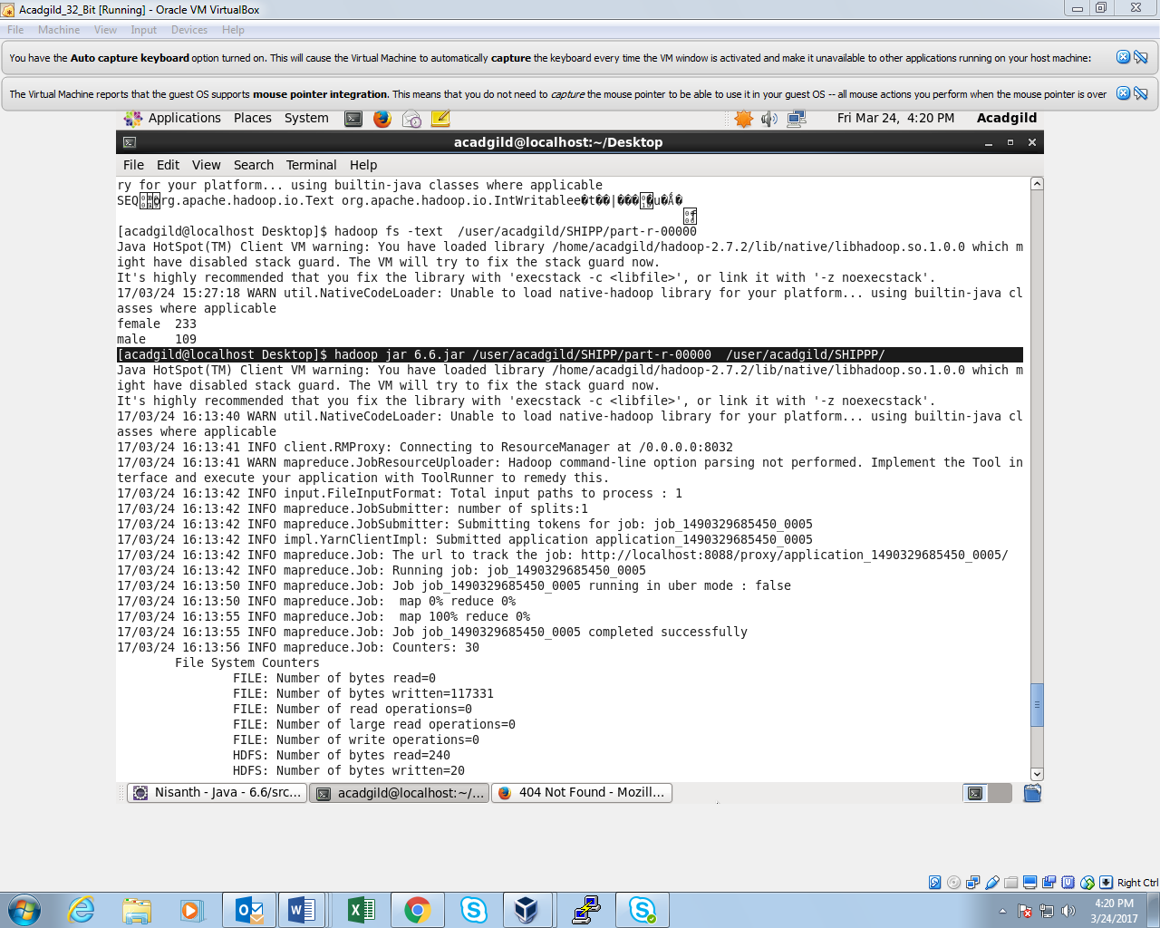

The output is in key value format

