**ASSIGNMENT 7.1:**

**Sales of different TV Task 4**: Write a Map reduce program to modify Sales of different TV Task 2 (refer session 5 assignment 2) to use a custom partitioner with 4 reducers. Make sure that all records whose company name starts with A-F (upper or lower case) should go to 1st reducer, those starting with G-L to 2nd reducer, those starting with M-R to 3rd reducer and others to 4th reducer.

**DRIVER CLASS:**

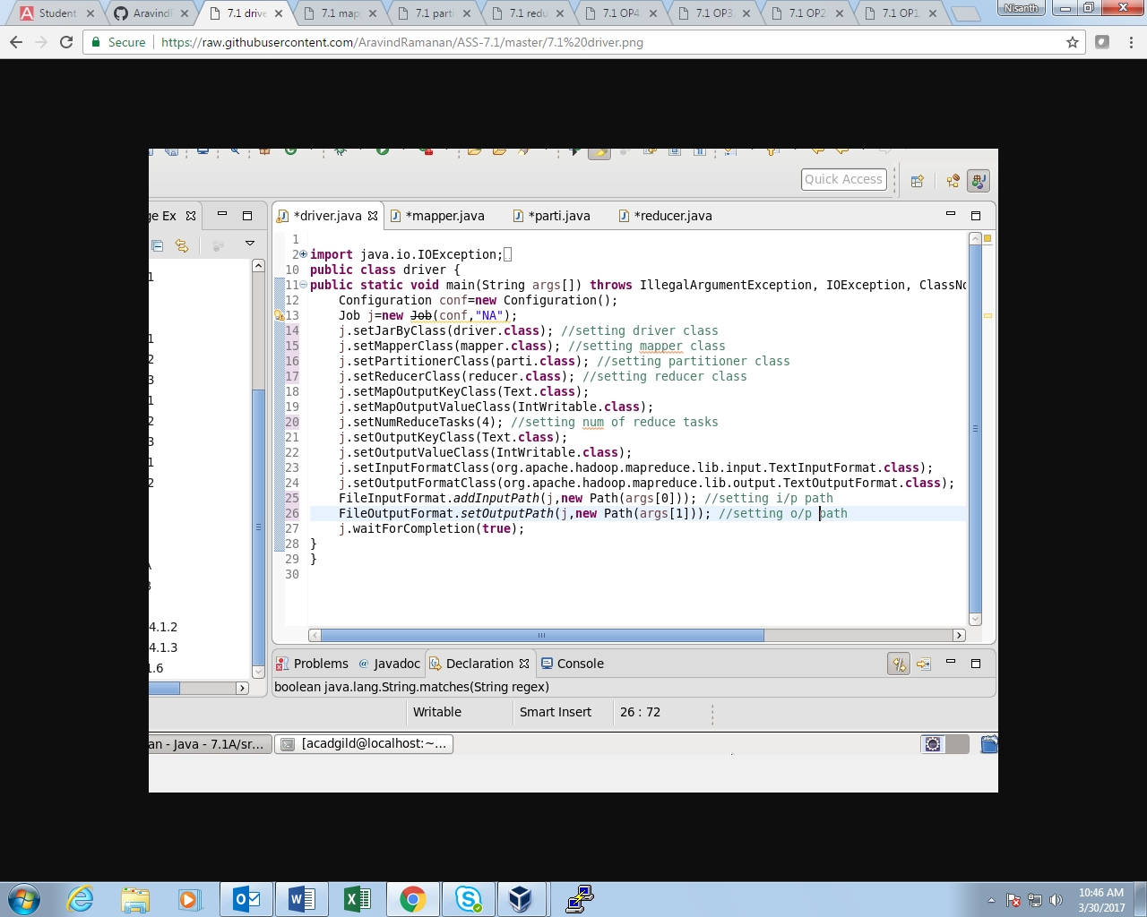

**MAPPER CLASS:**

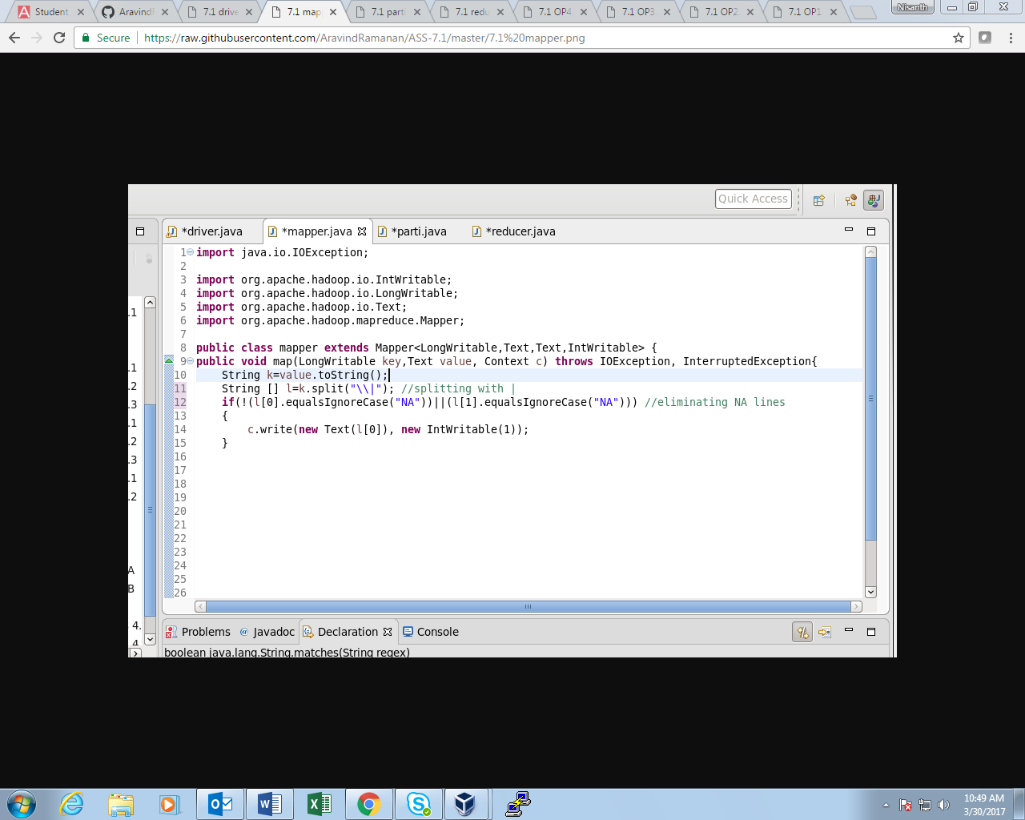

**PARTITIONER CLASS:**

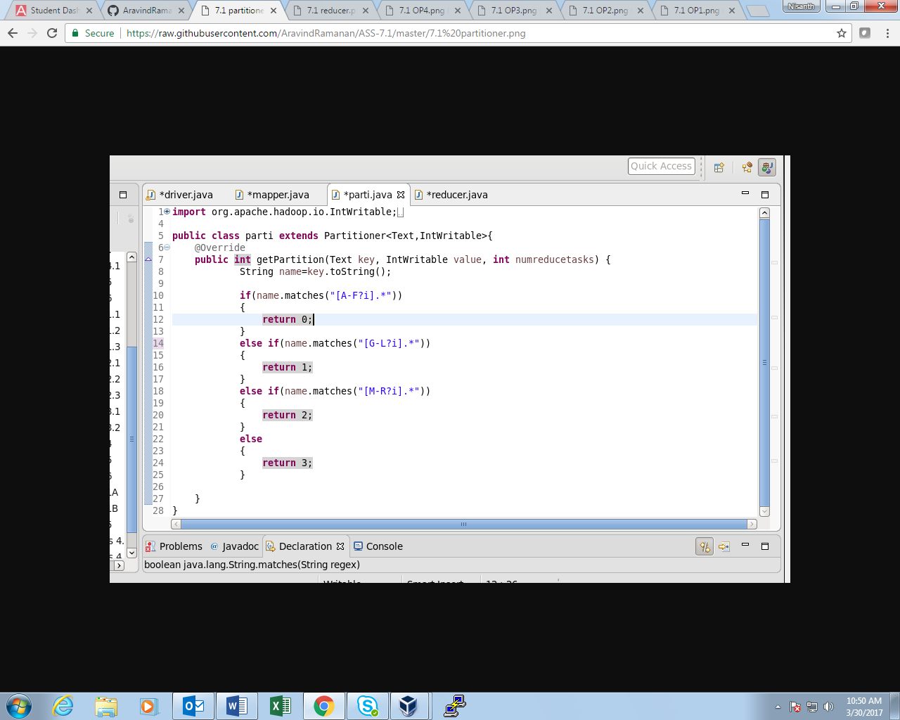

**REDUCER CLASS:**

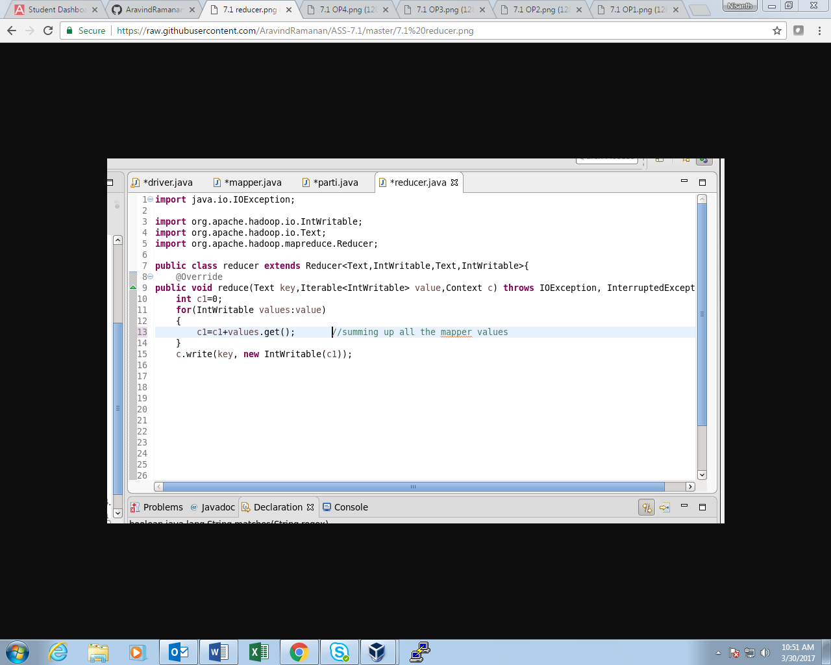

**OUTPUT 1:**

**FIRST REDUCER:**

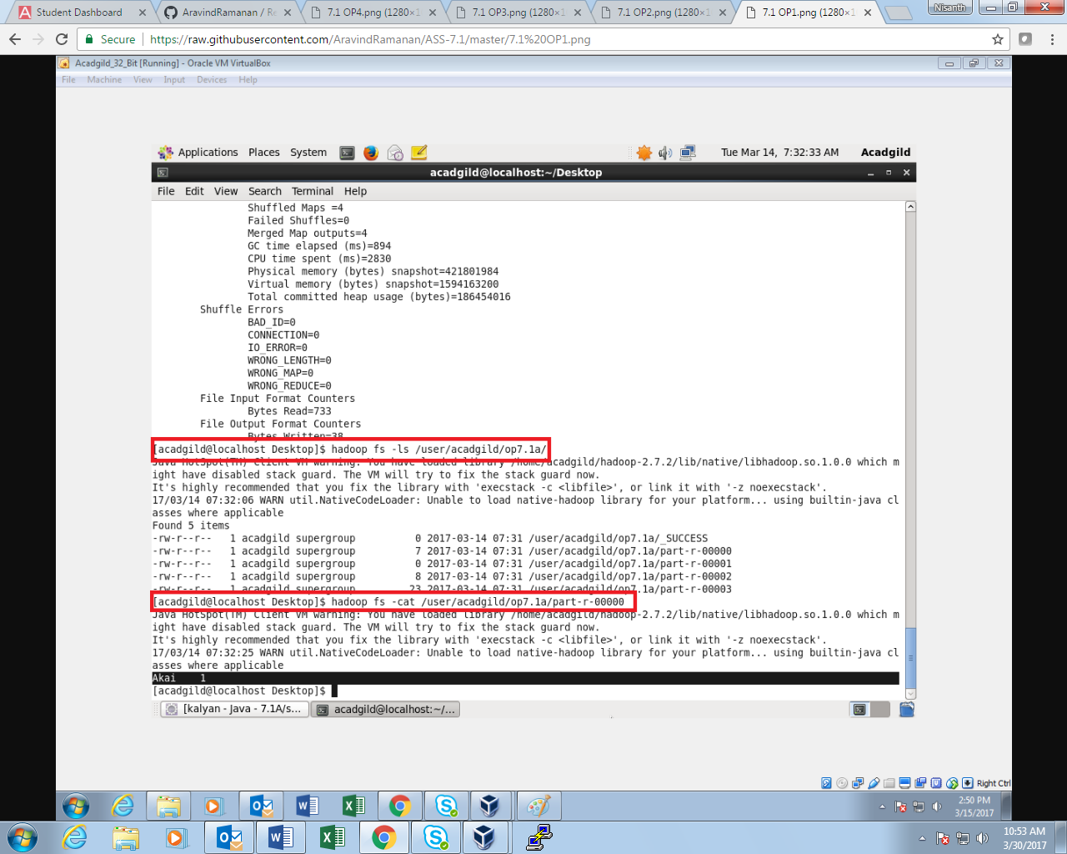

**OUTPUT 2:  
  
SECOND REDUCER:**

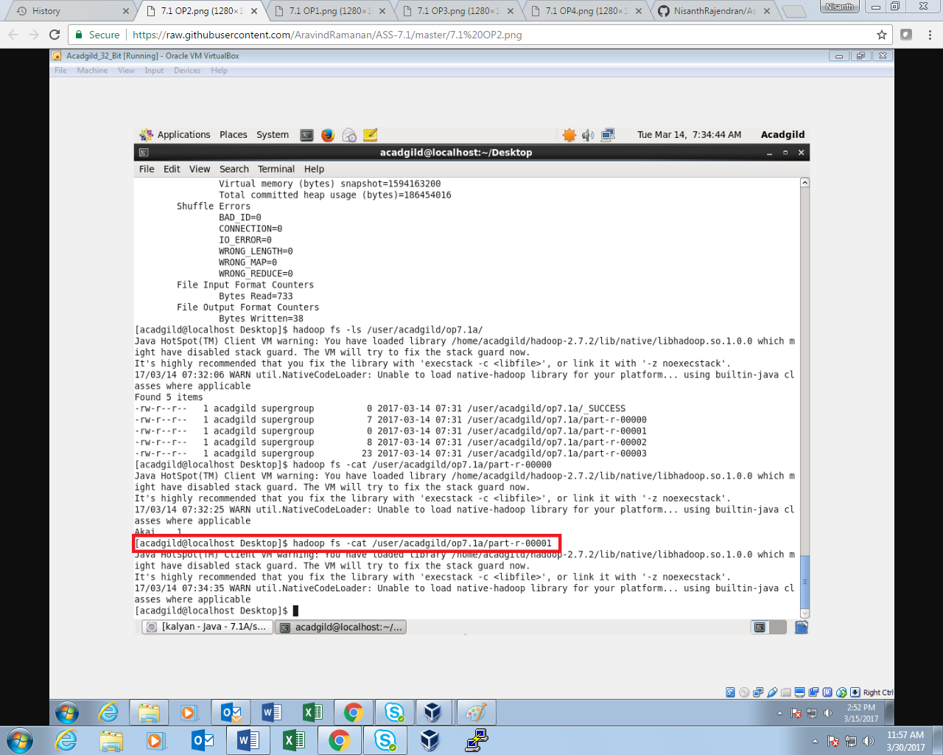

**OUTPUT 3**

**THIRD REDUCER:**

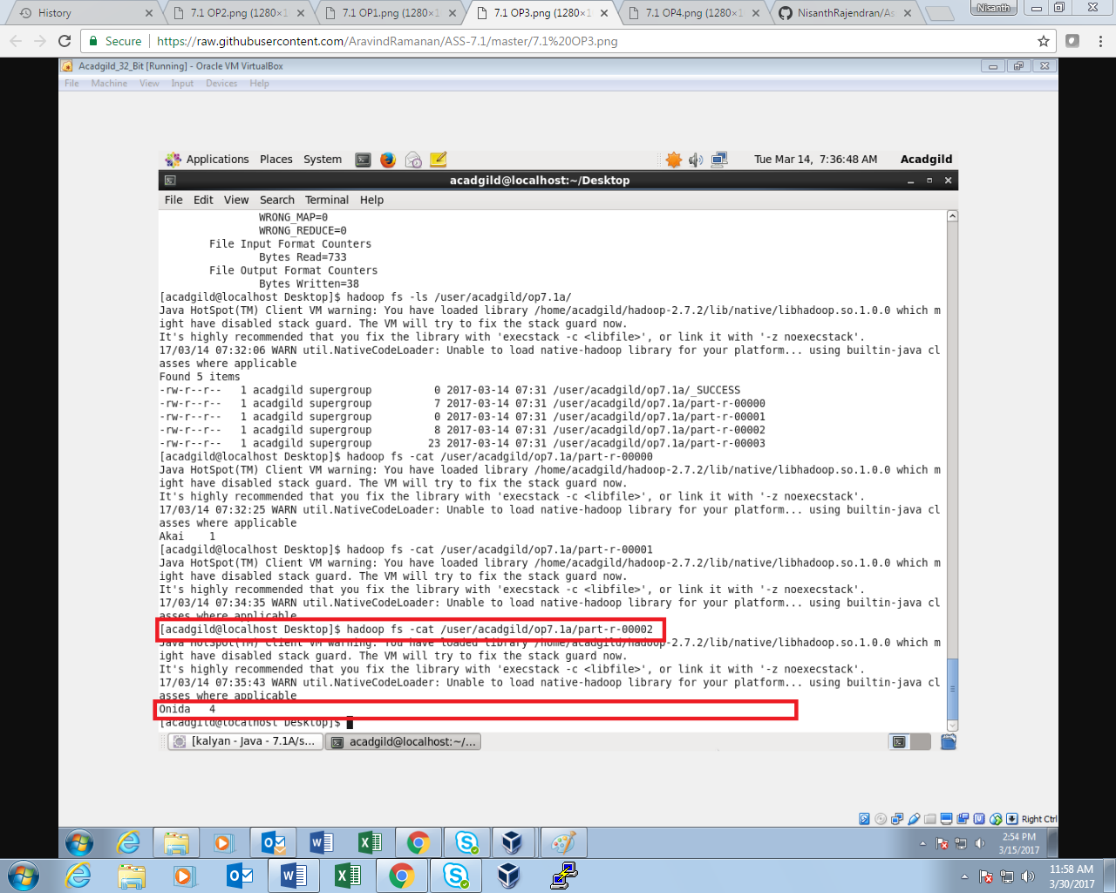

**OUTPUT 4  
  
FOURTH REDUCER:**

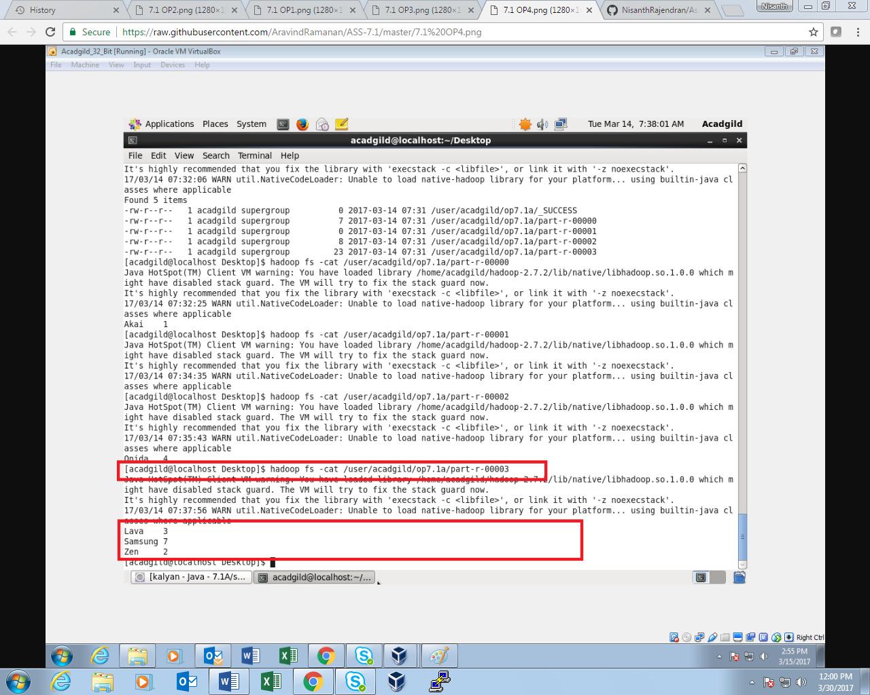

**Sales of different TV Task 5:** Modify Sales of different TV Task 2 (refer session 5, assignment 2) to take advantage of Combiner.

**DRIVER CLASS:**

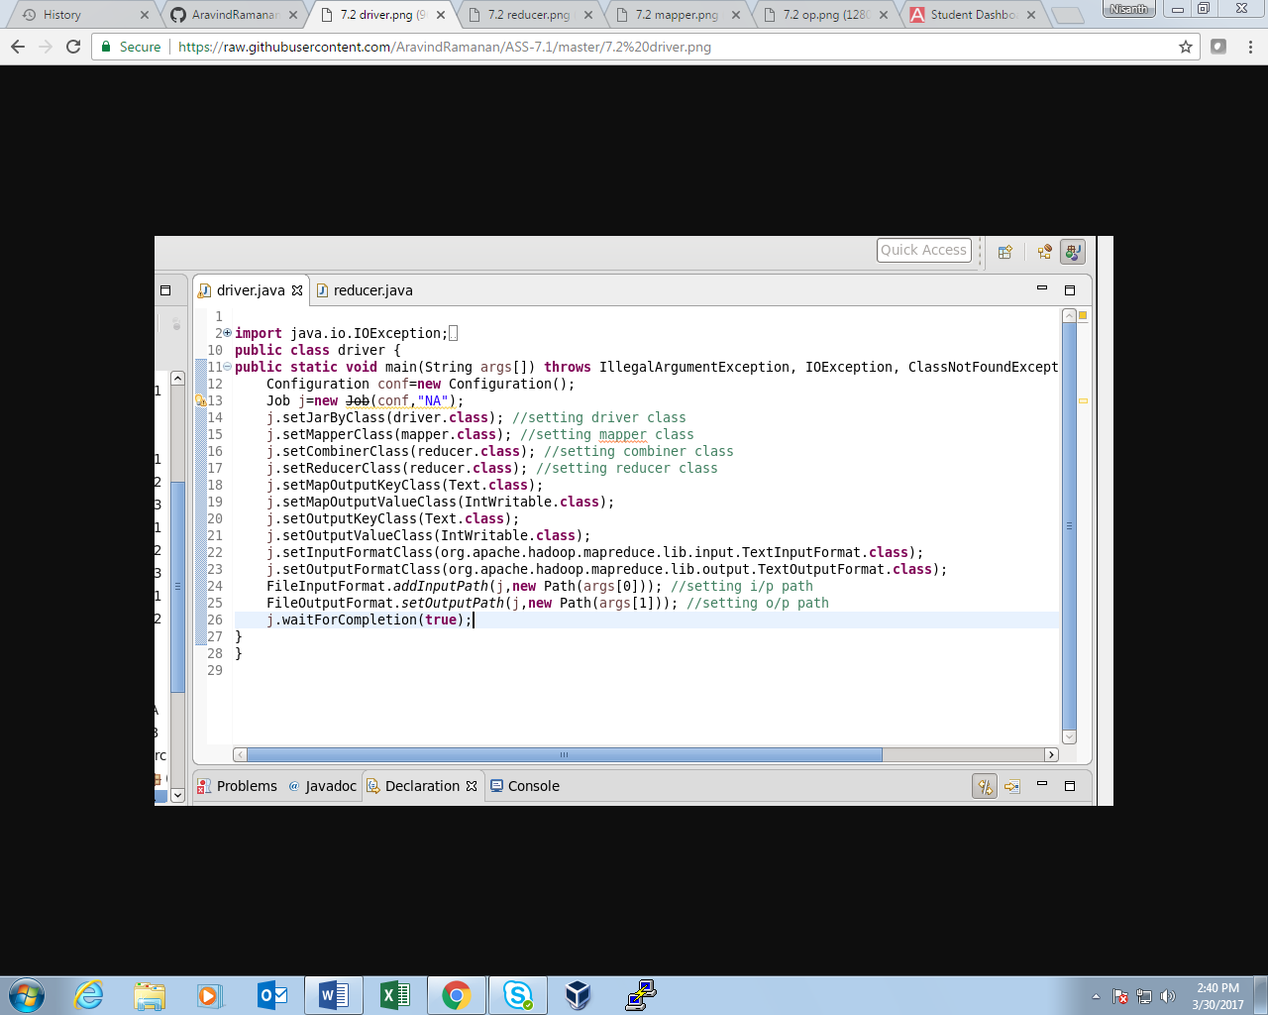

**MAPPER CLASS:**

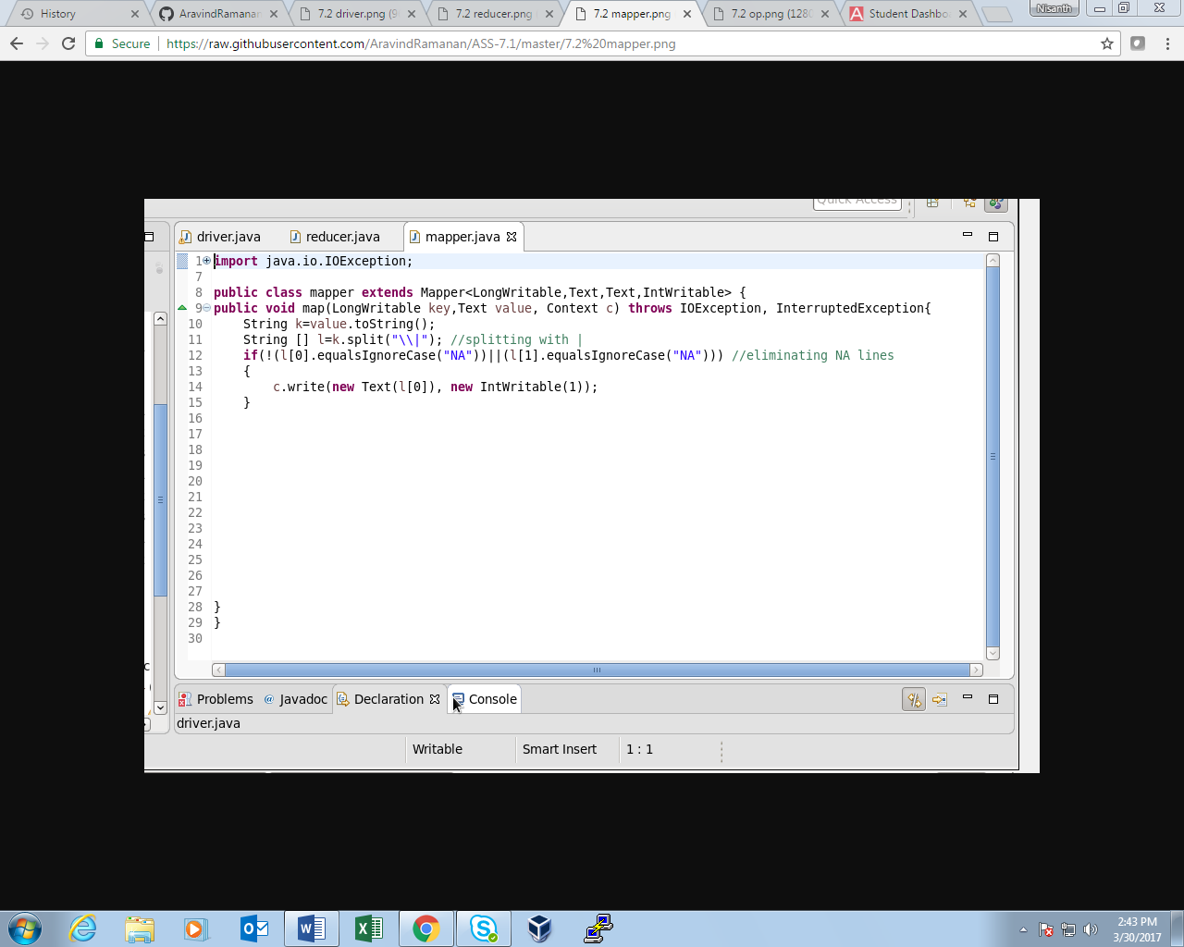

**REDUCER CLASS:**

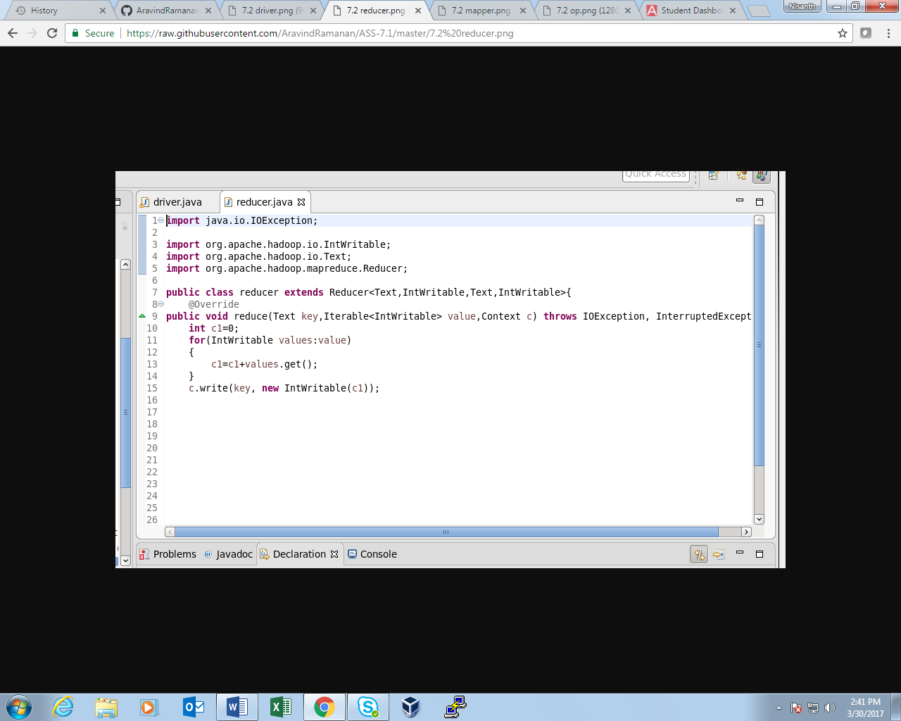

**OUTPUT:**

