**Sales of different TV Task 6: Modify Sales of different TV Task 3 (refer session 5, assignment 2) to take advantage of Combiner**

*DRIVER CLASS****:***

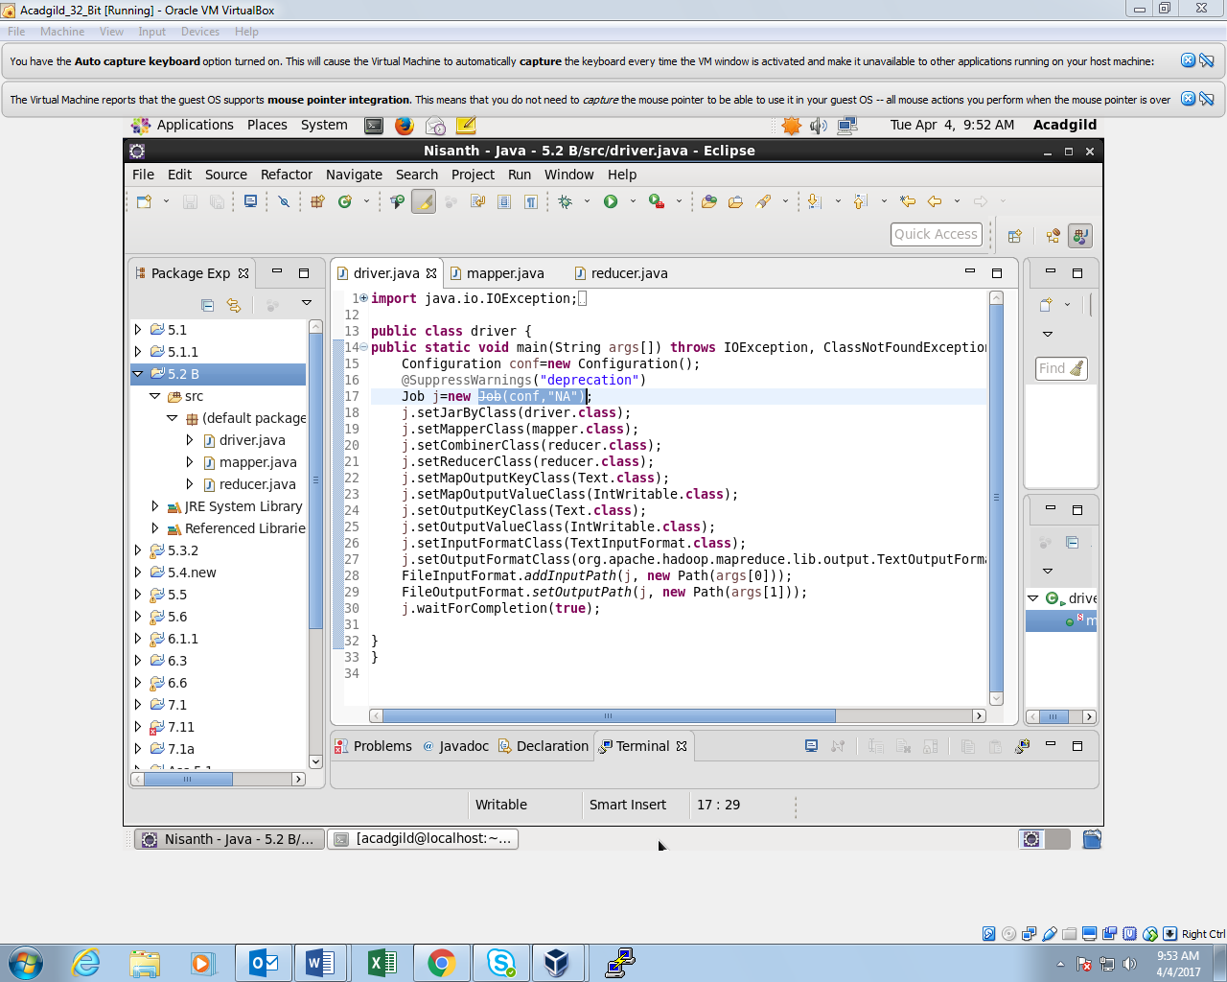

*MAPPER CLASS:*

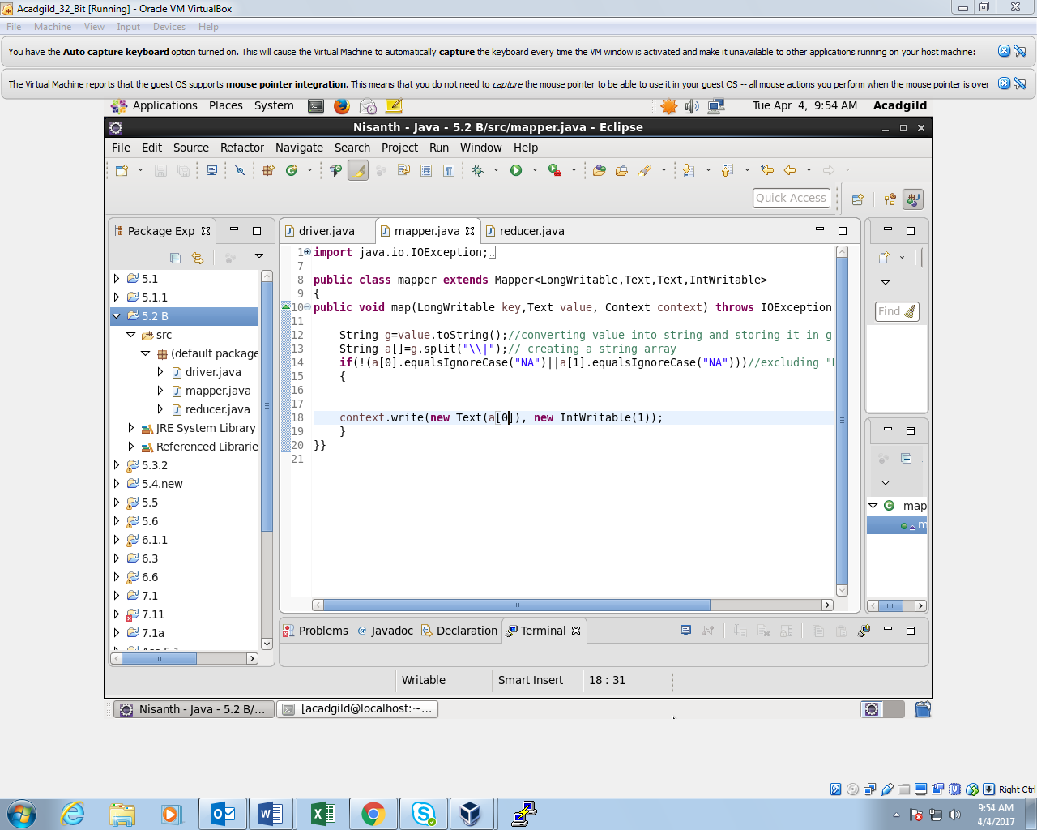

*REDUCER CLASS:*

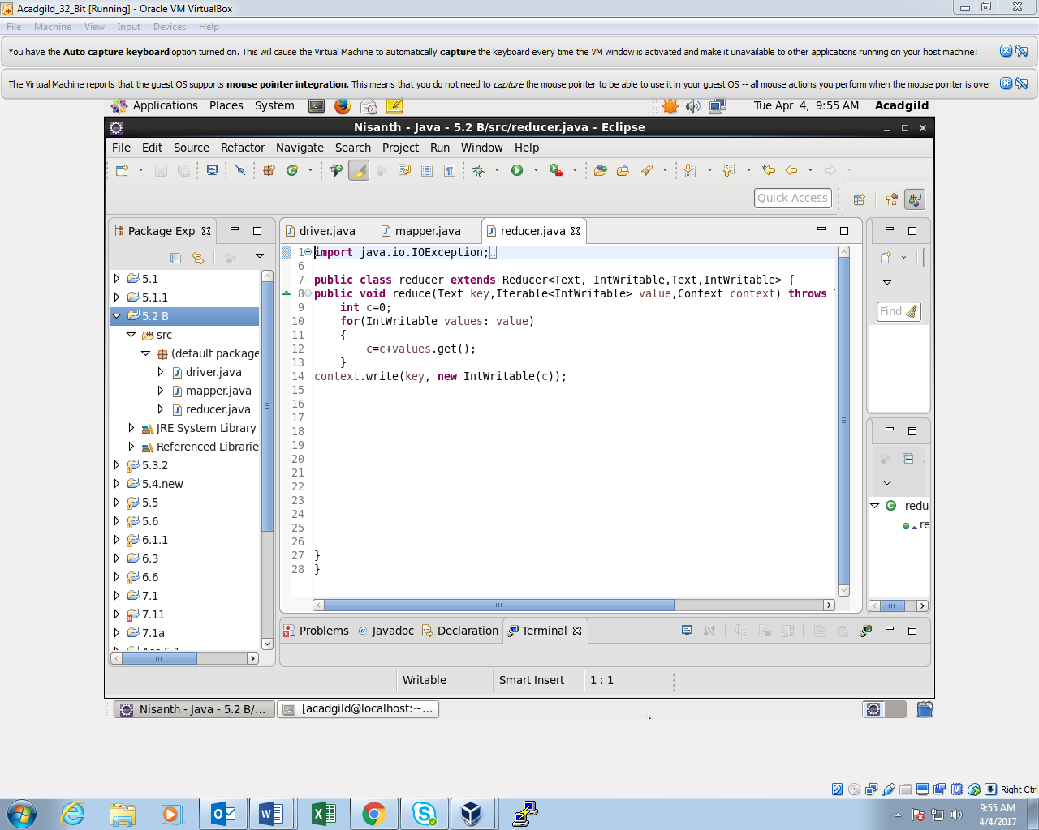

*OUTPUT:*

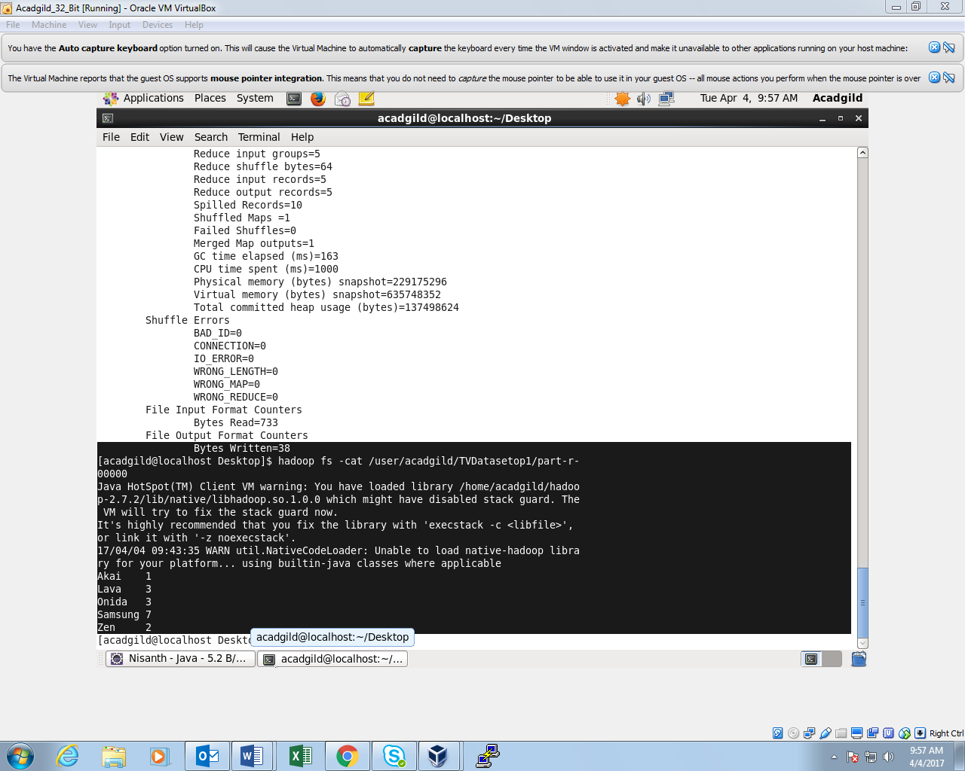

**Sales of different TV Task 7: Write a Map reduce program to view the total sales for each product for every Company corresponding to each size. Make sure that all records for a single company goes to a single reducer and inside every reducer, keys must be sorted in descending order of the size. You may write a custom Writable Comparable for this purpose.**

*DRIVER CLASS:*

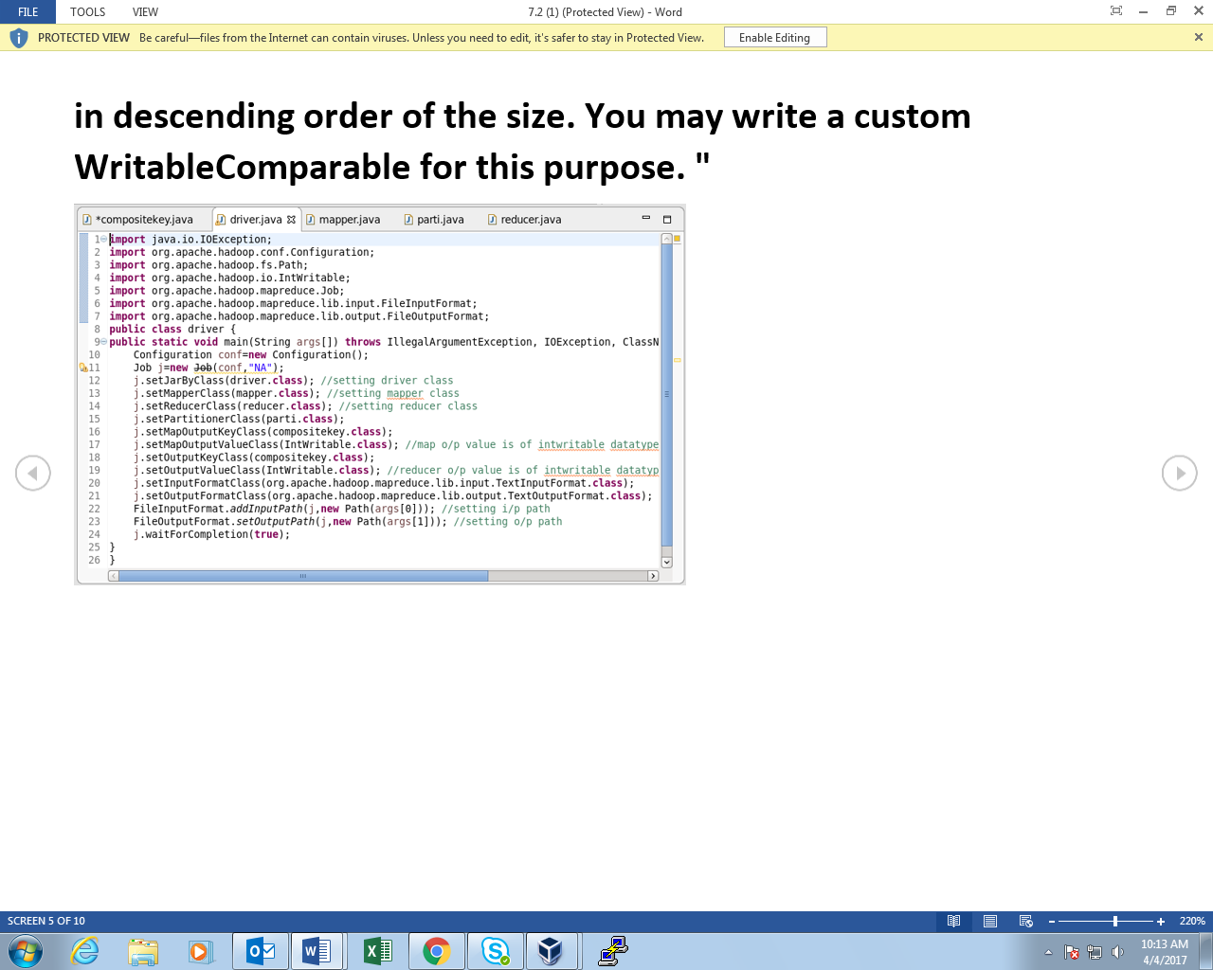

*COMPOSITE KEY CLASS:*

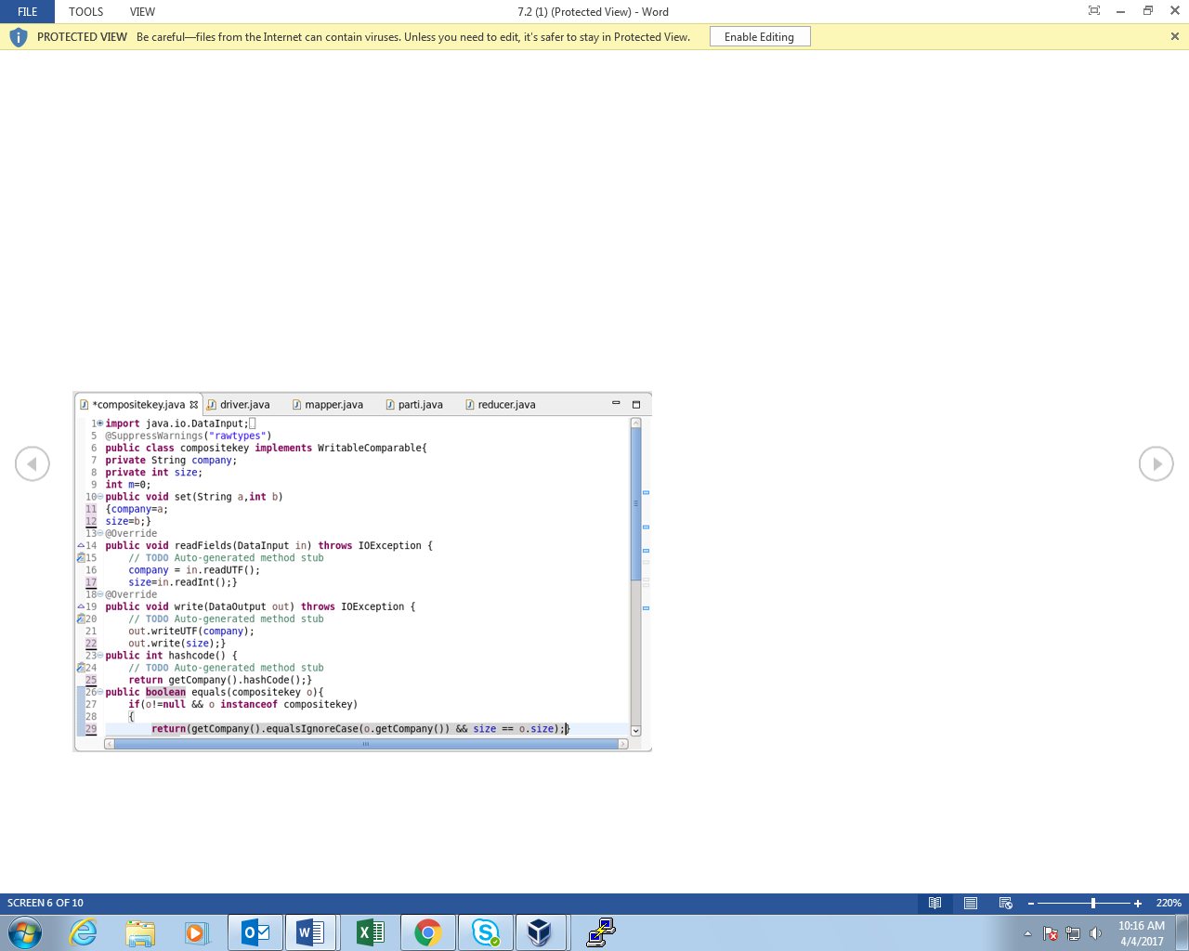

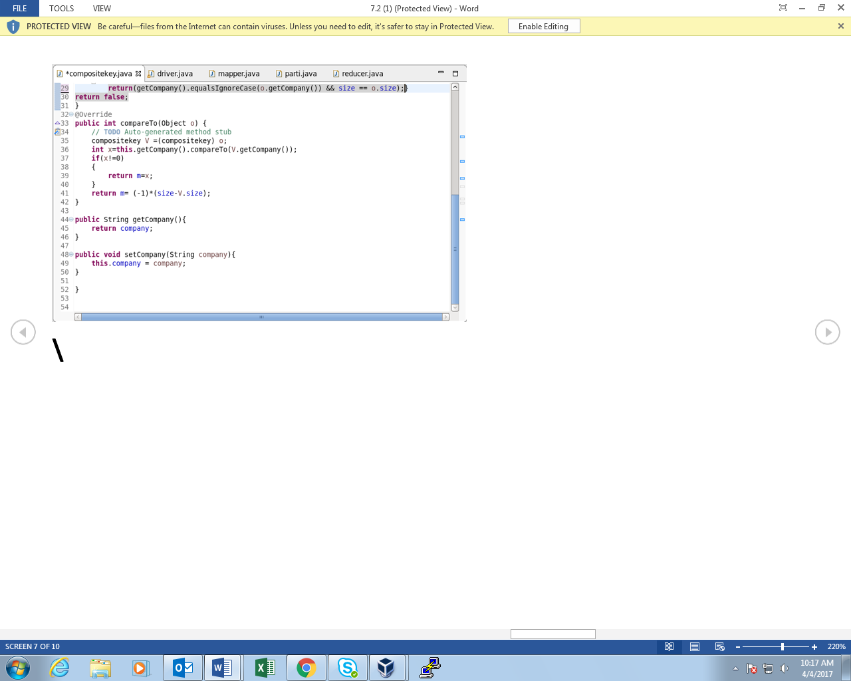

*MAPPER CLASS:*

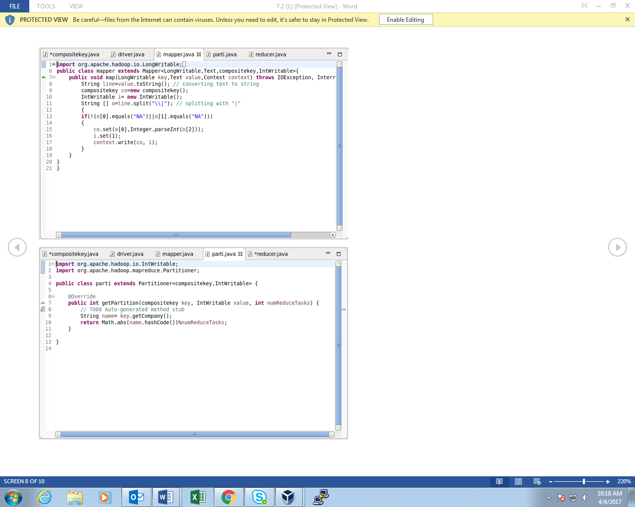

*REDUCER CLASS:*

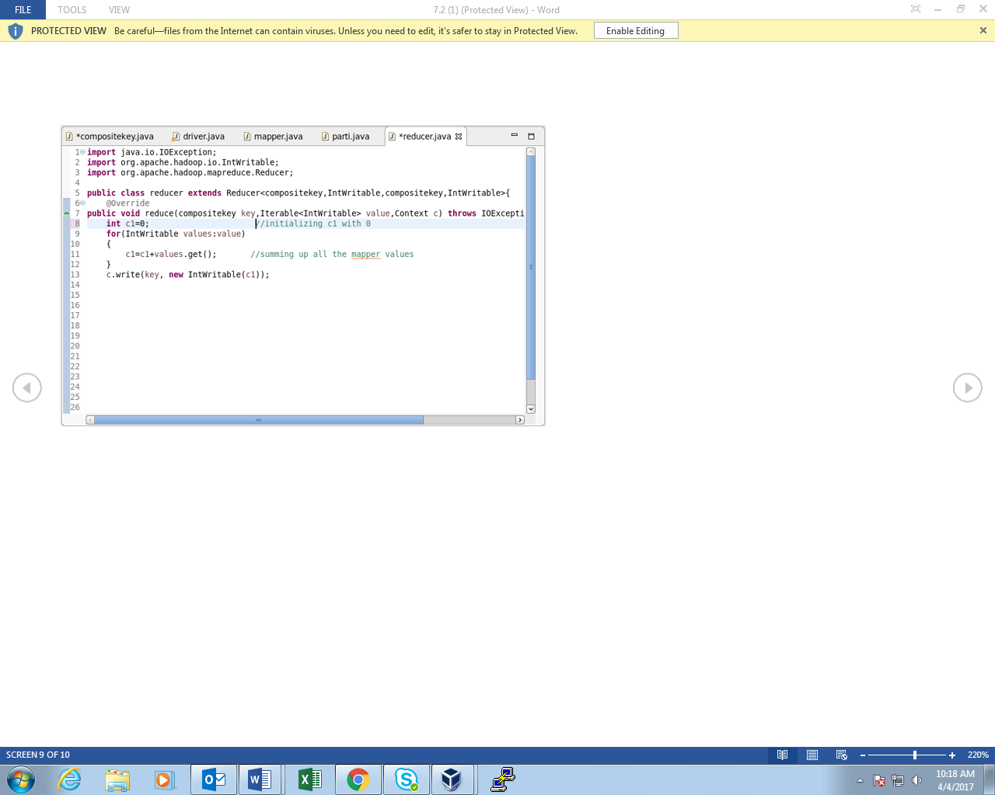

*PARTITIONER CLASS:*

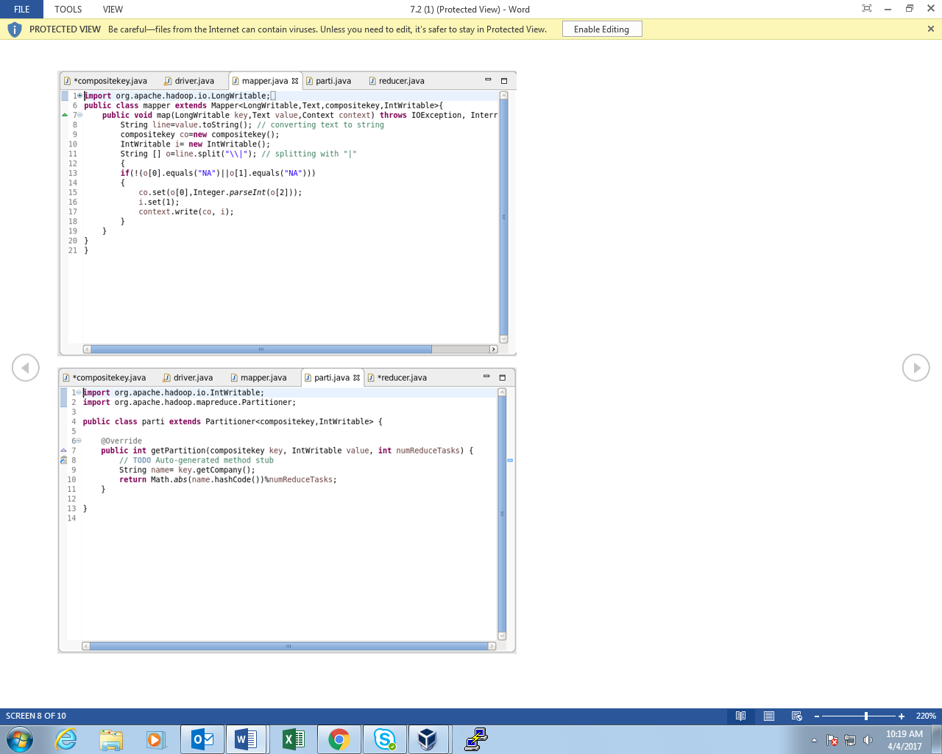

*OUTPUT:*

