**Write a custom key to evaluate the number of people who died and the number of people who survived, along with their gender**

*DRIVER CLASS:*

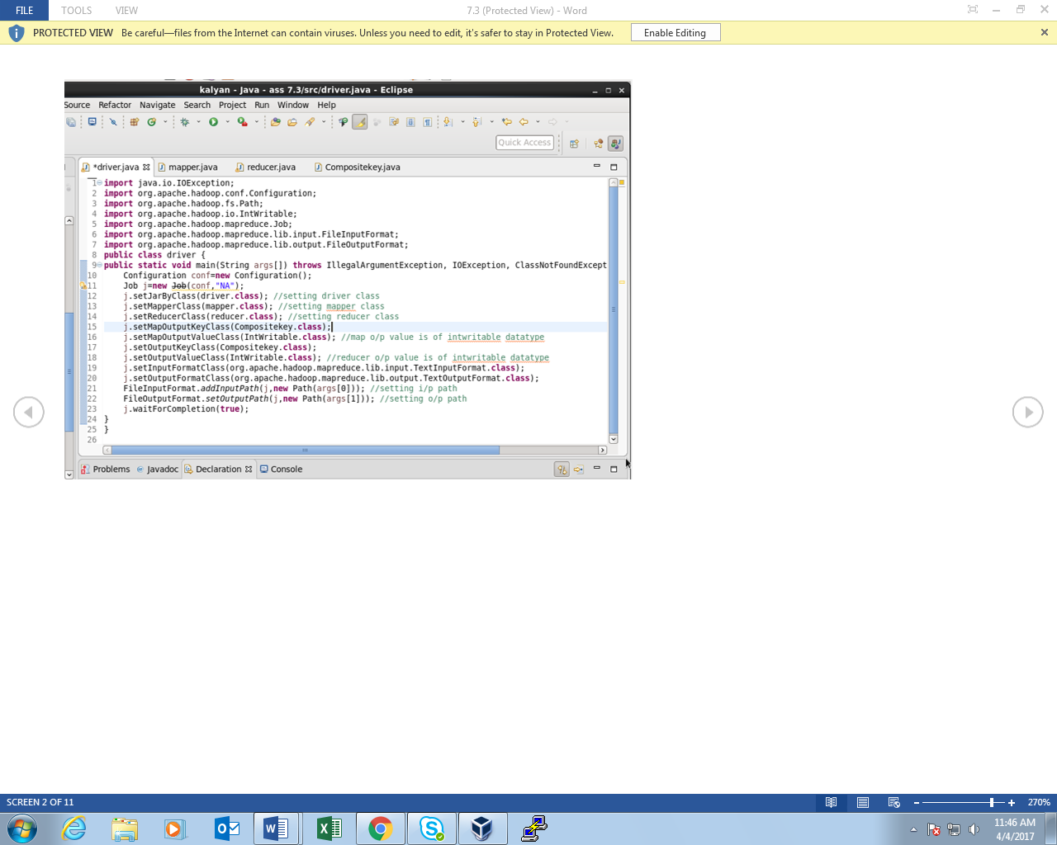

*MAPPER CLASS:*

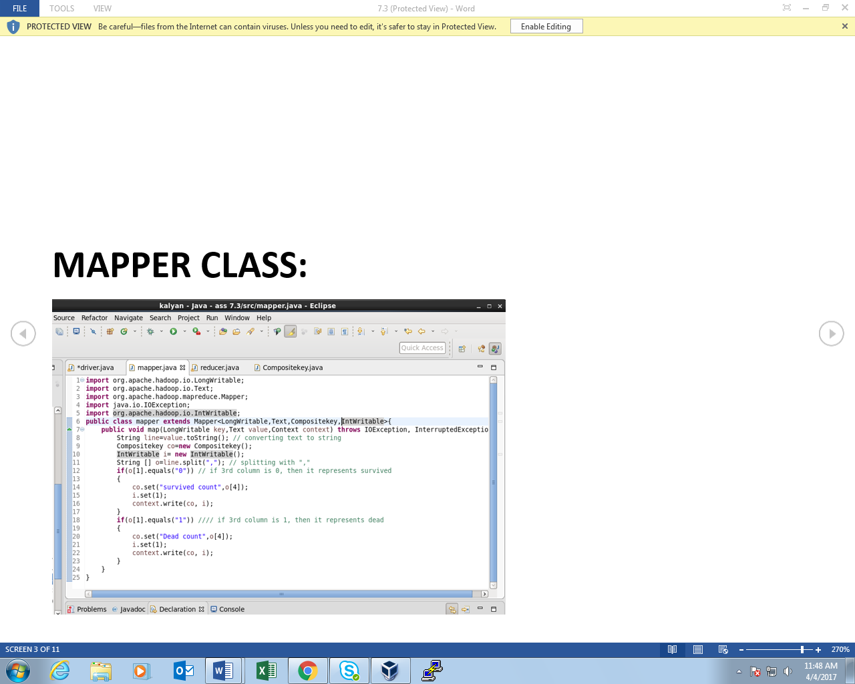

*COMPOSITE KEY CLASS:*

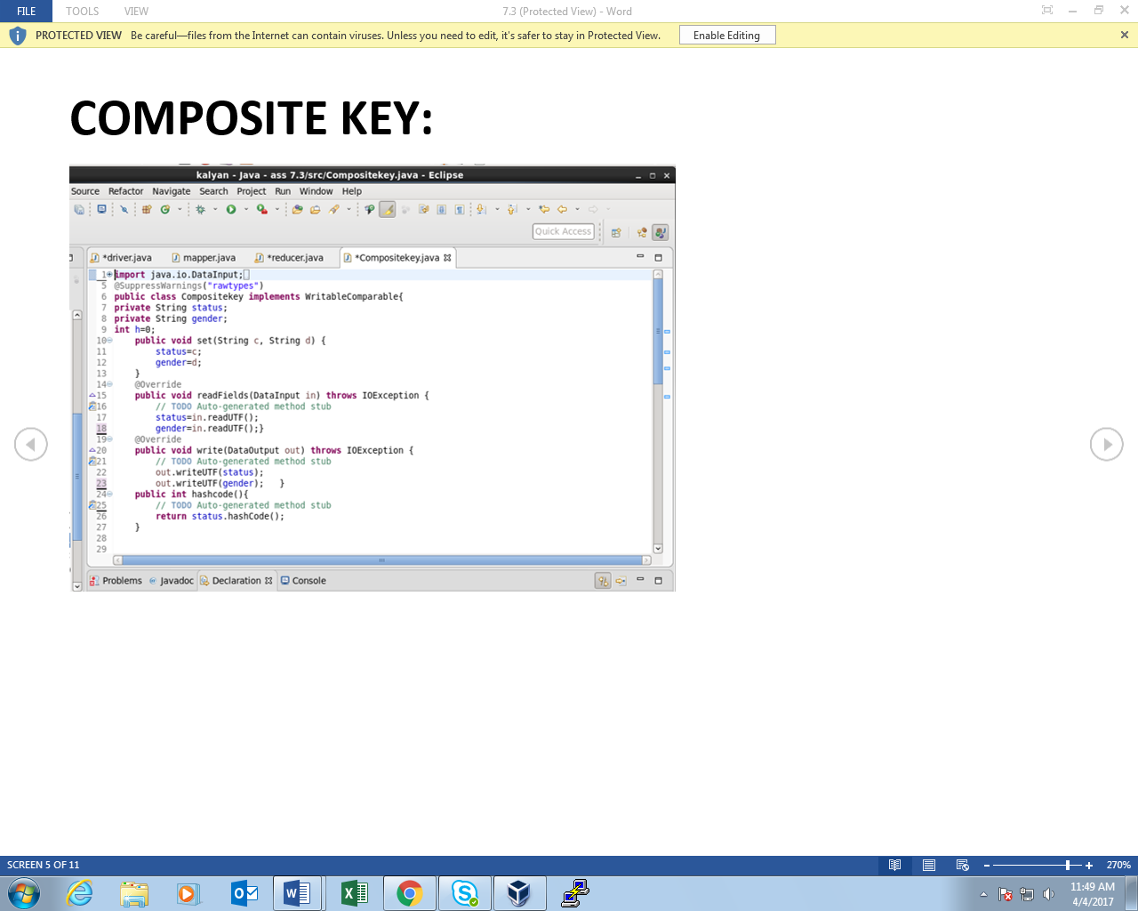

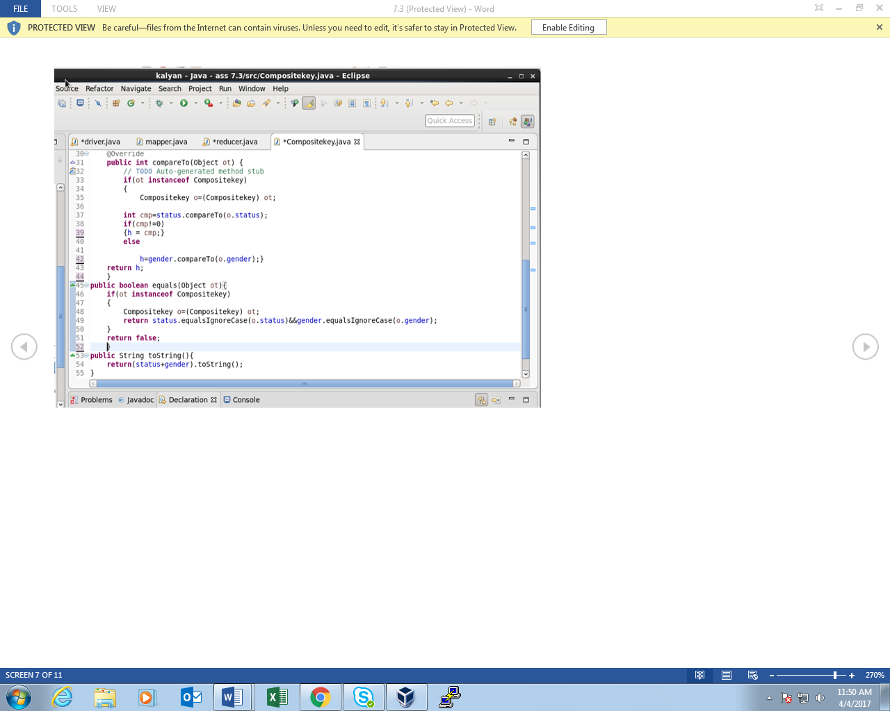

*REDUCER CLASS:*

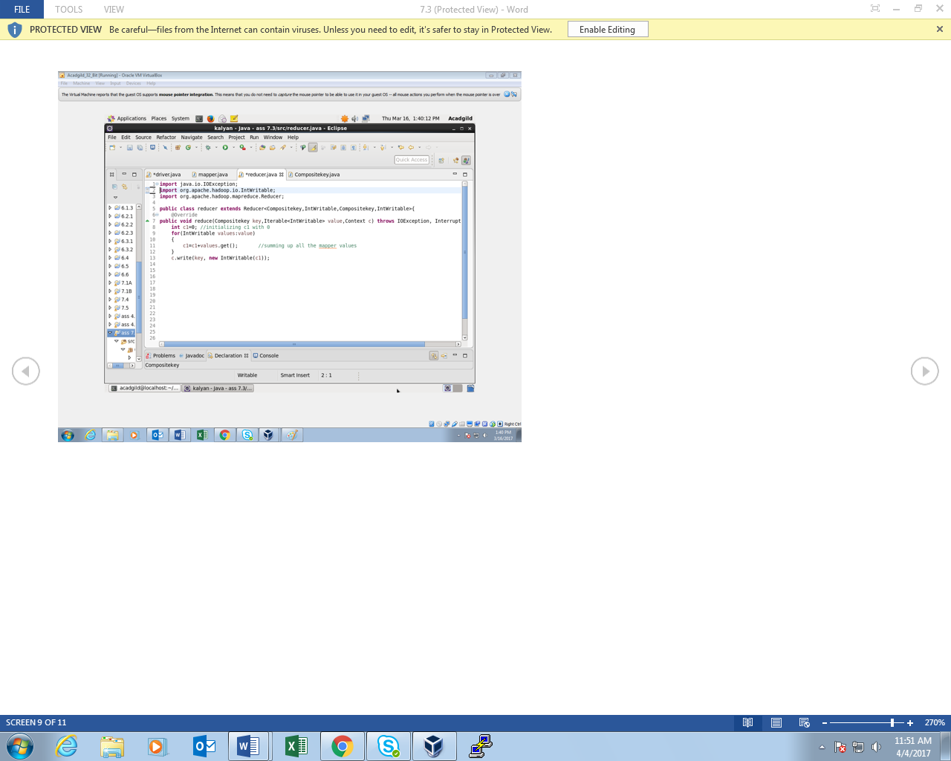*OUTPUT:*

