**Write a word count program using partitioner and implement the following logic in the partitioner words with length 5 should go into reducer 1 and words with length 6 should go into reducer 2 and the rest of the words should go into reducer 3.**

**Note: You can use the dataset of your choice**

*DRIVER CLASS:*

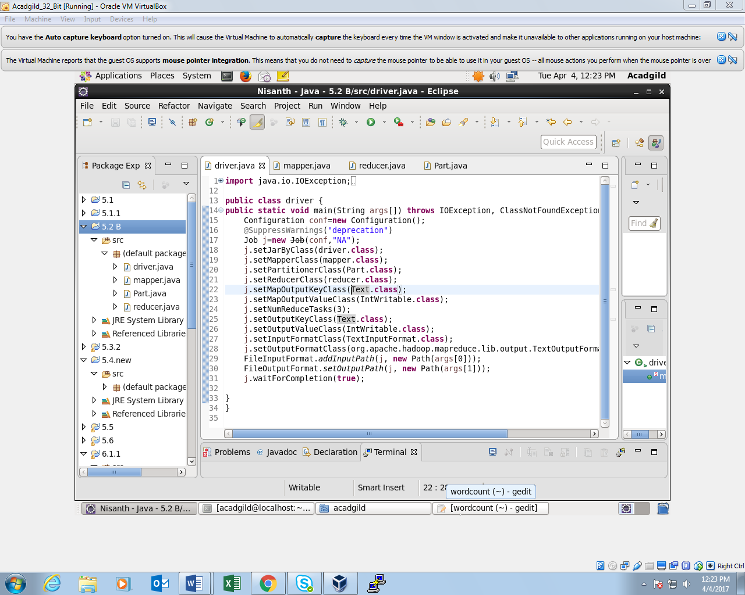

*MAPPER CLASS:*

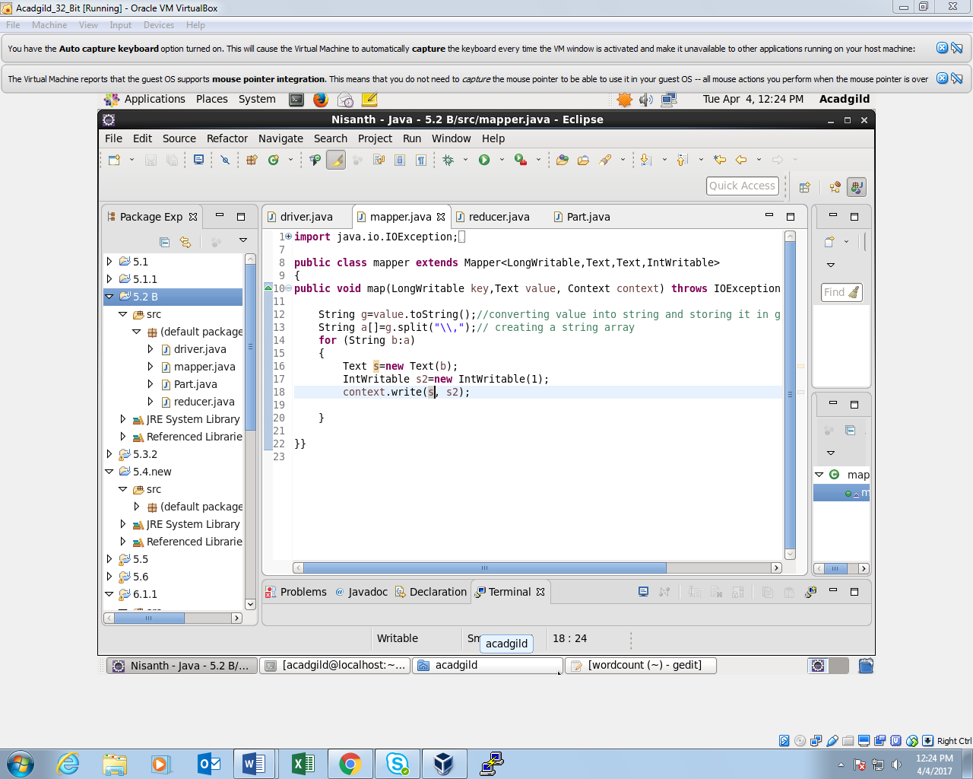

*PARTITIONER CLASS:*

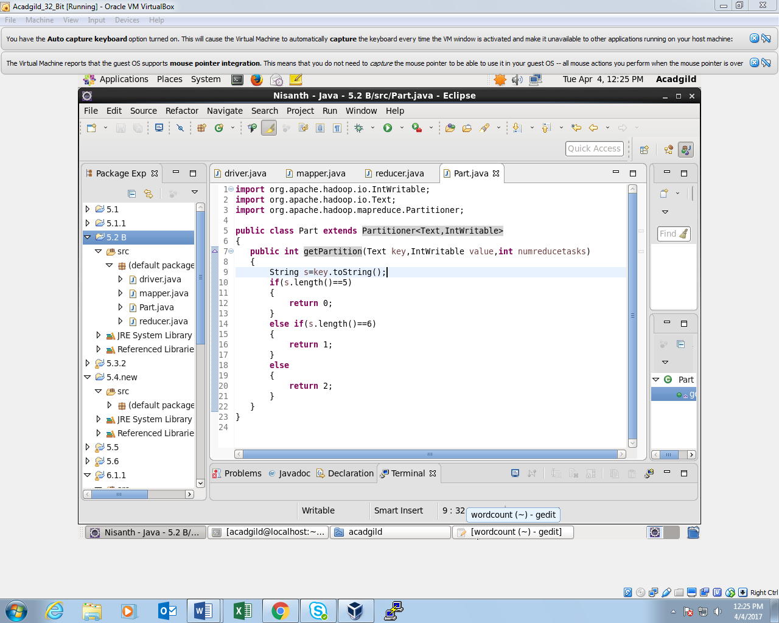

*REDUCER CLASS:*

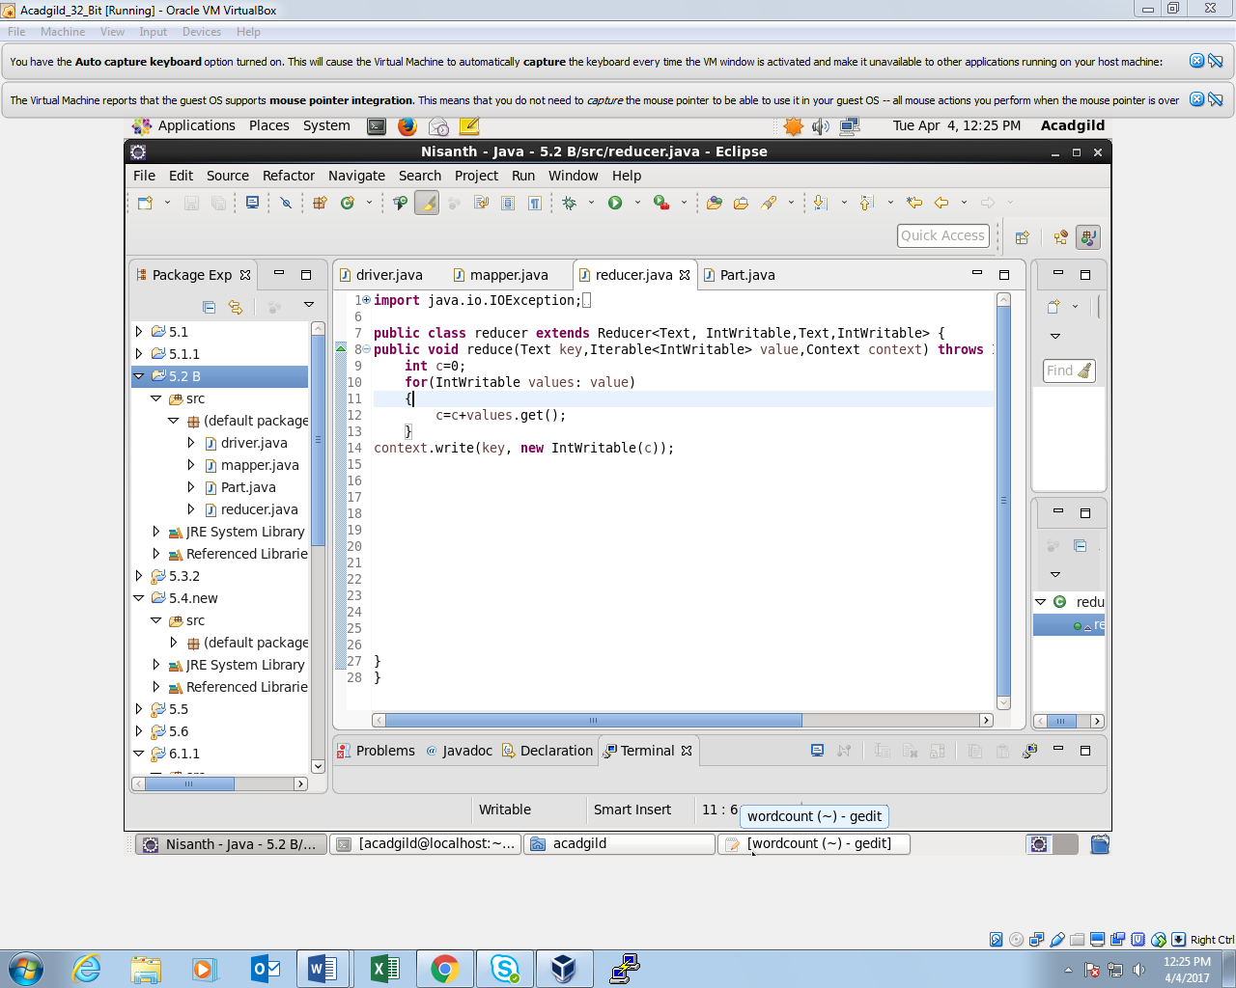

*FIRST REDUCER OUTPUT:*

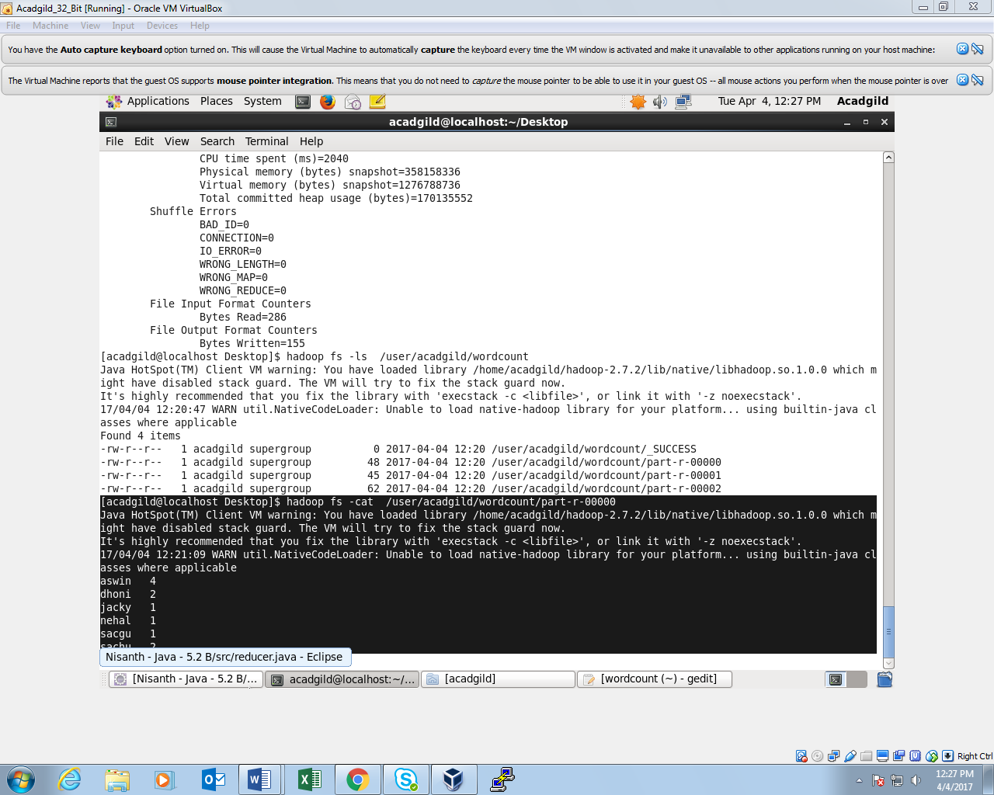

*SECOND REDUCER OUTPUT:*

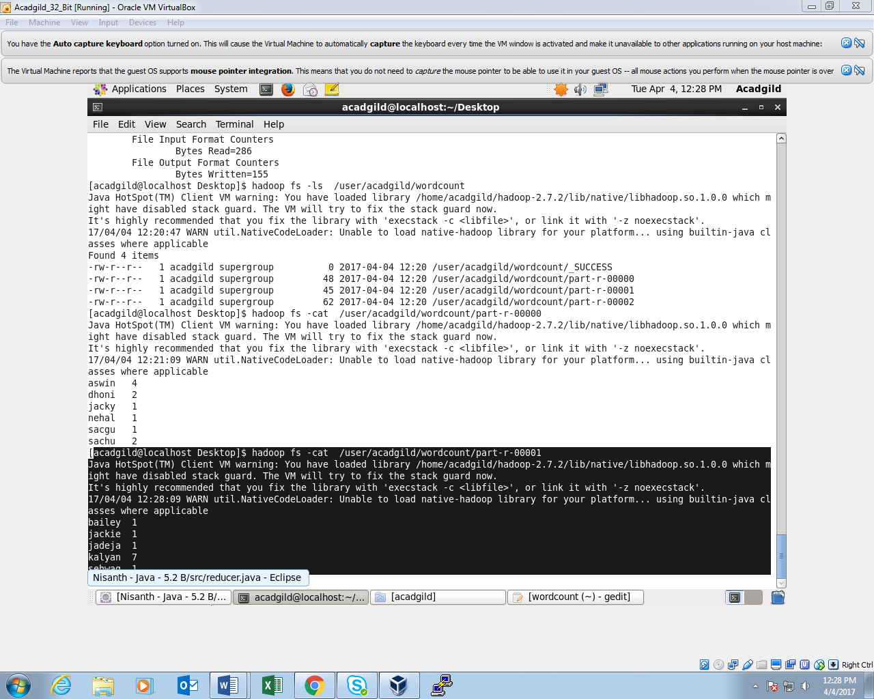

*THIRD REDUCER OUTPUT:*

