**Write a map only job for the word count program and set the output format as sequence file.**

**Note: You can use the dataset of your choice**

*DRIVER CLASS:*

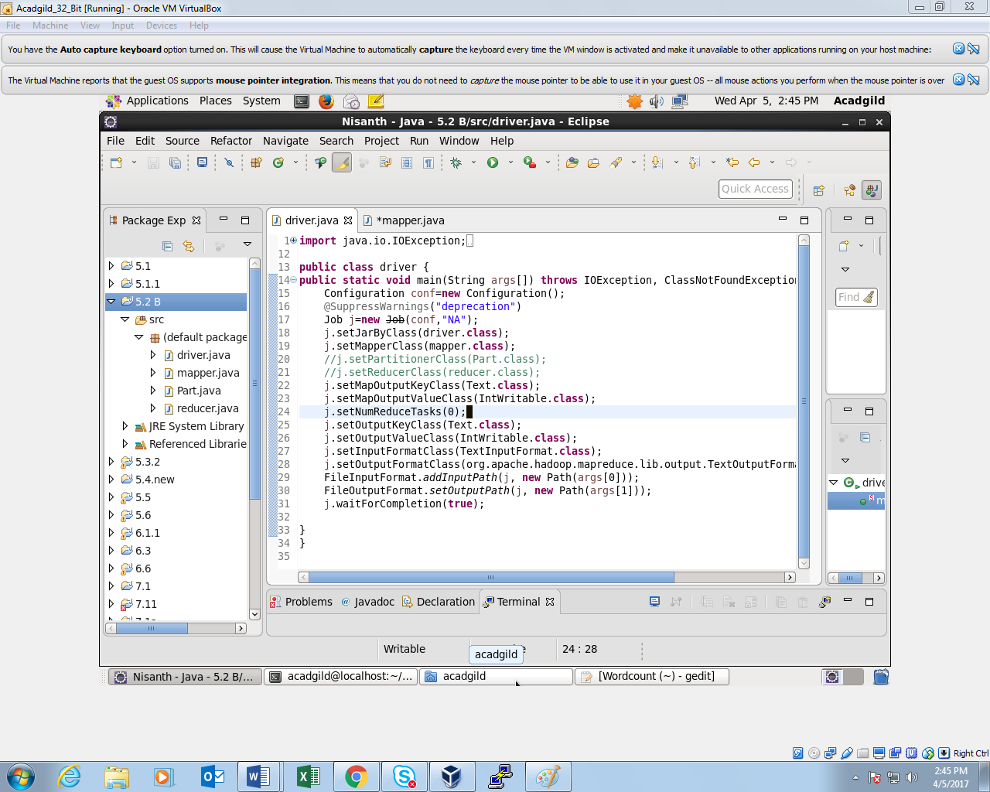

*MAPPER CLASS:*

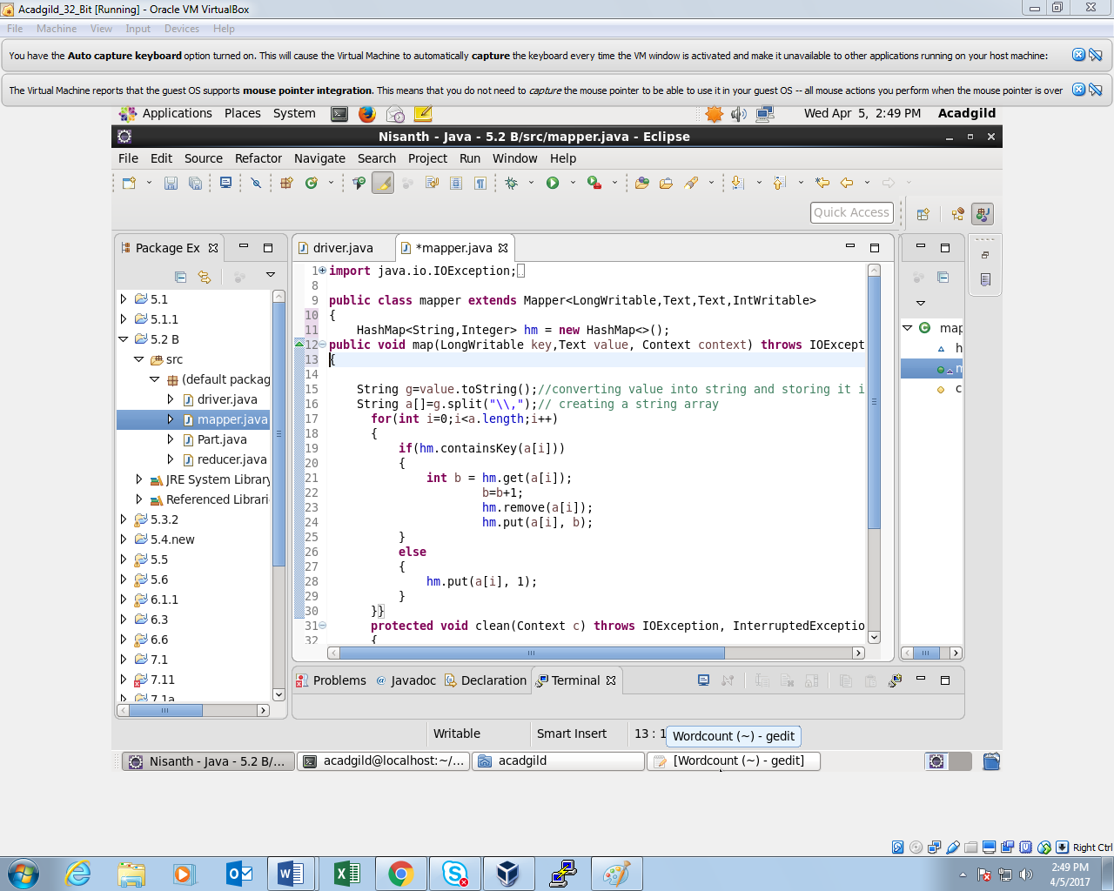

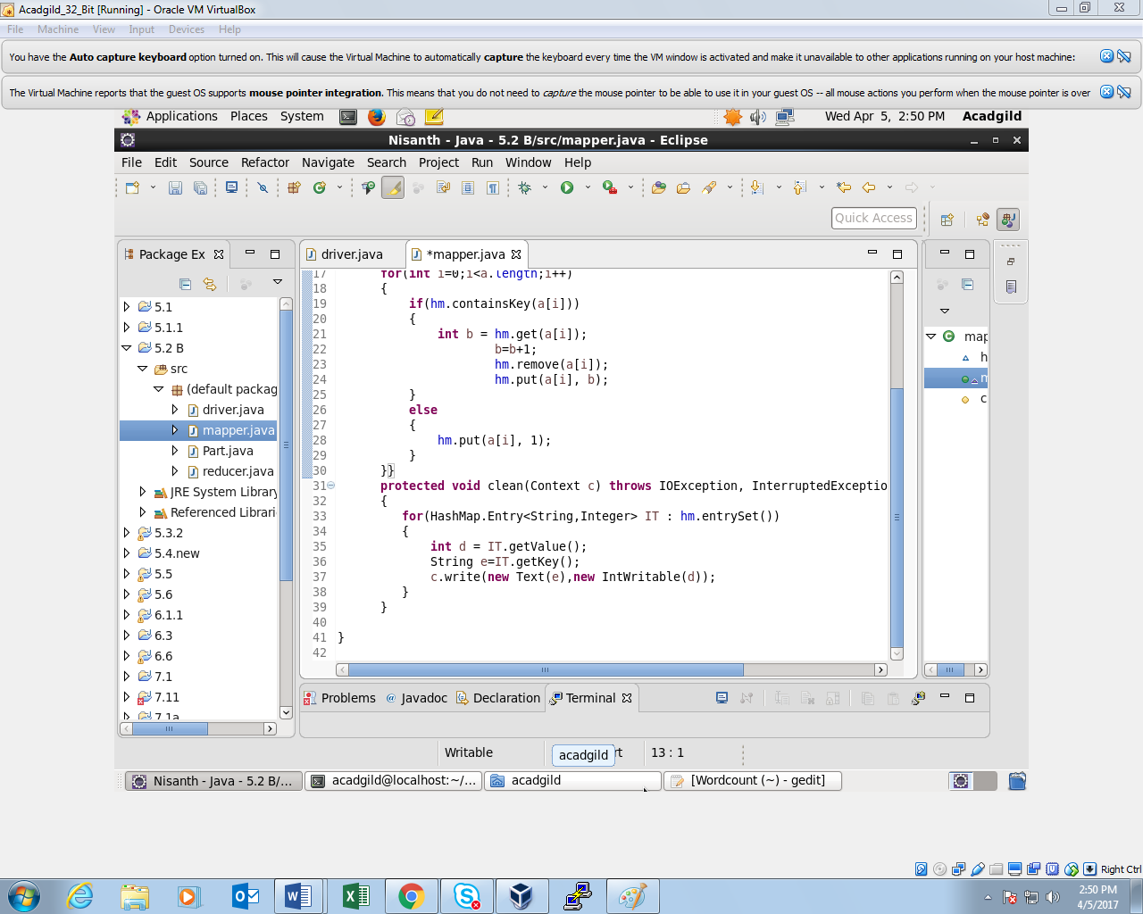

*OUTPUT:*

