**Write a map reduce program save the output of the word count program in XML format. You need to write a custom writable to save the output in XML format.**

**Note: You can use any data set of your choice for executing this program**

*DRIVER CLASS:*

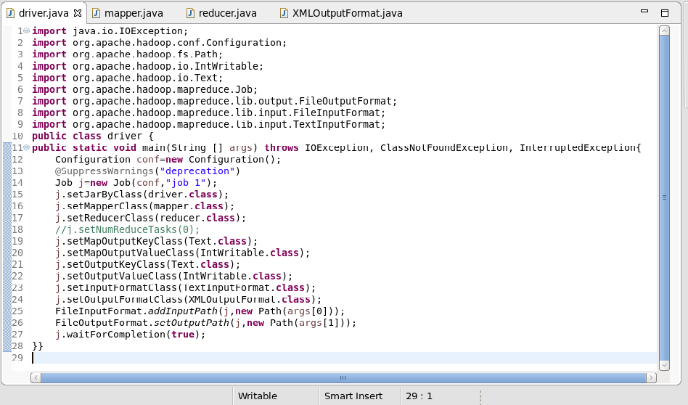

*MAPPER CLASS:*

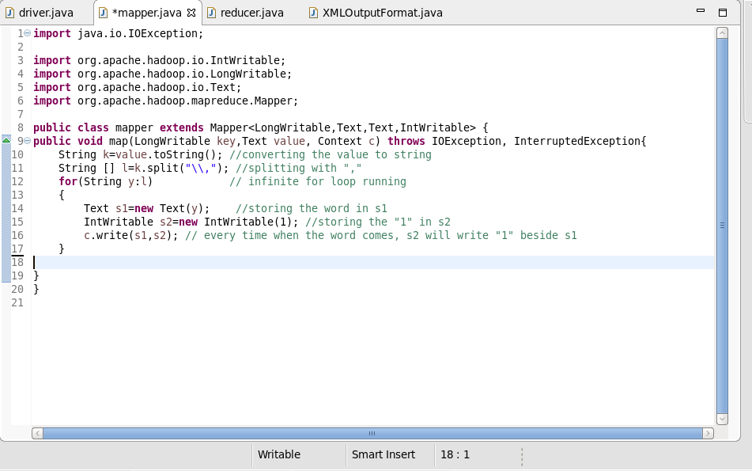

*REDUCER CLASS:*

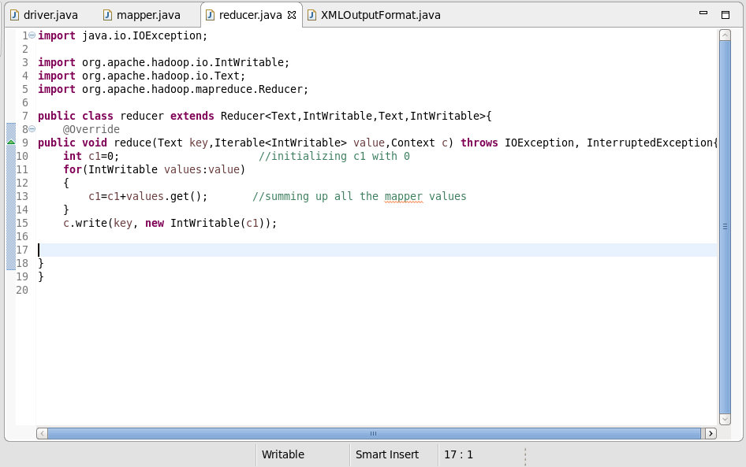

*XML CLASS:*

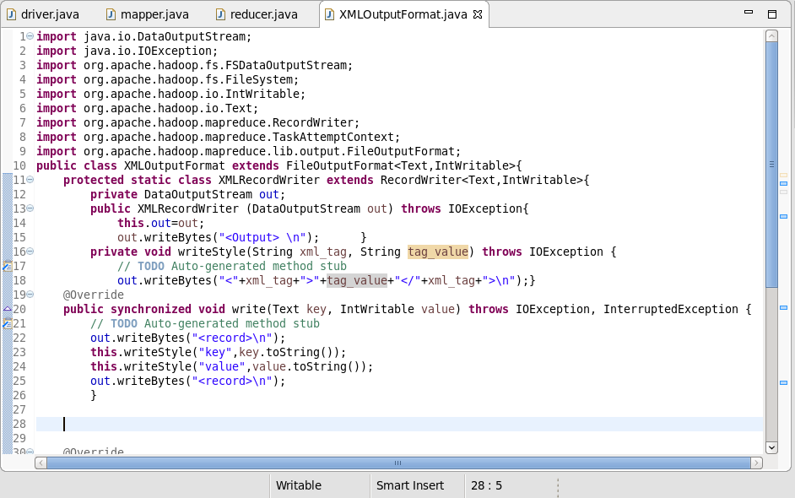

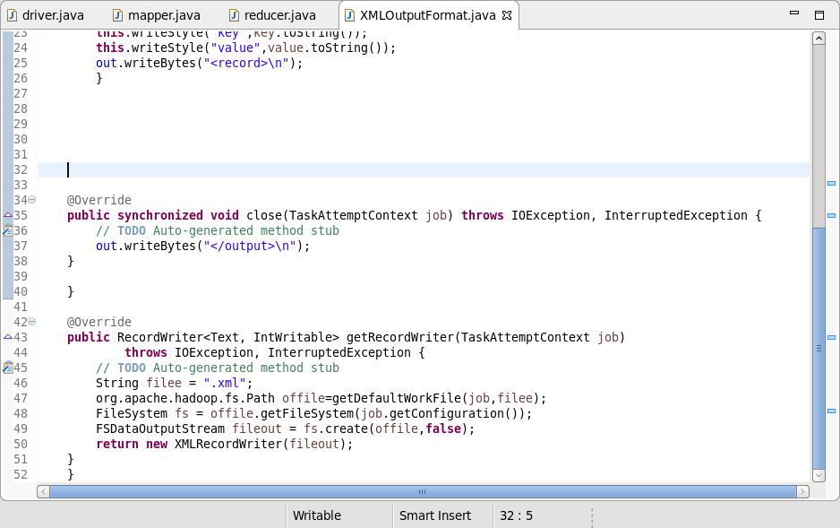

*OUTPUT:*

