**1. Write a map reduce program to find the total amount of petrol in volume sold by every distributor.**

*DRIVER CLASS:*

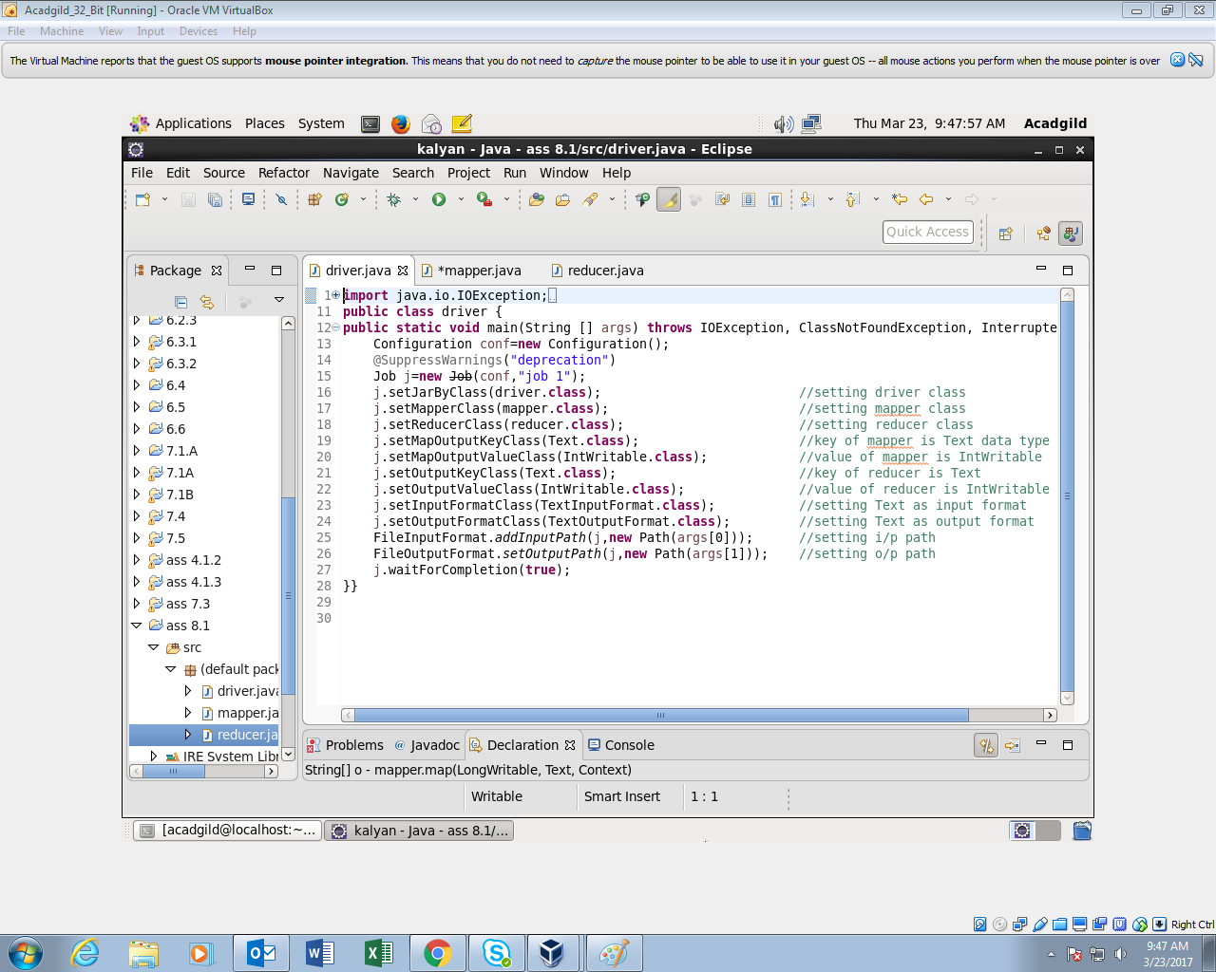

*MAPPER CLASS:*

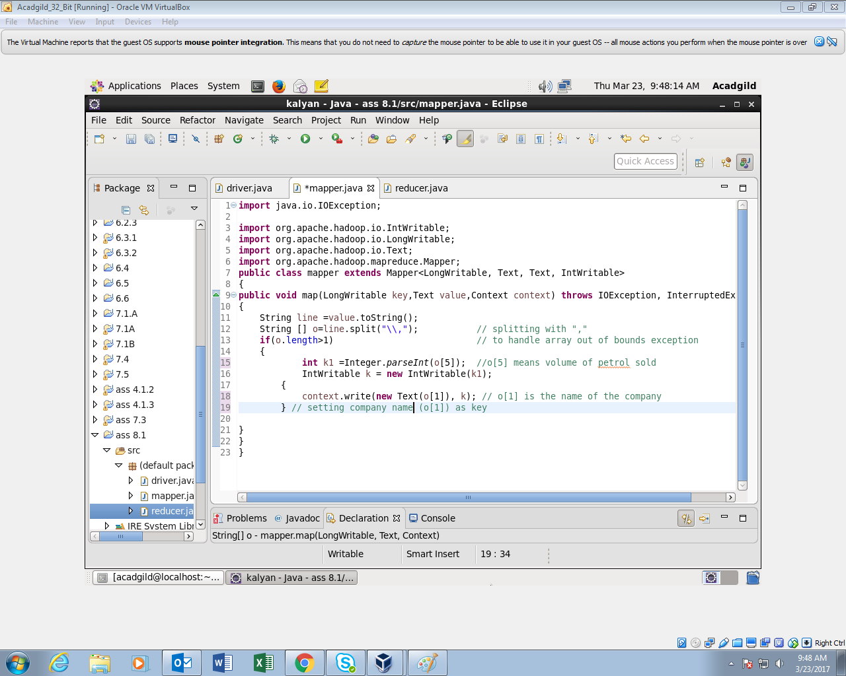

*REDUCER CLASS:*

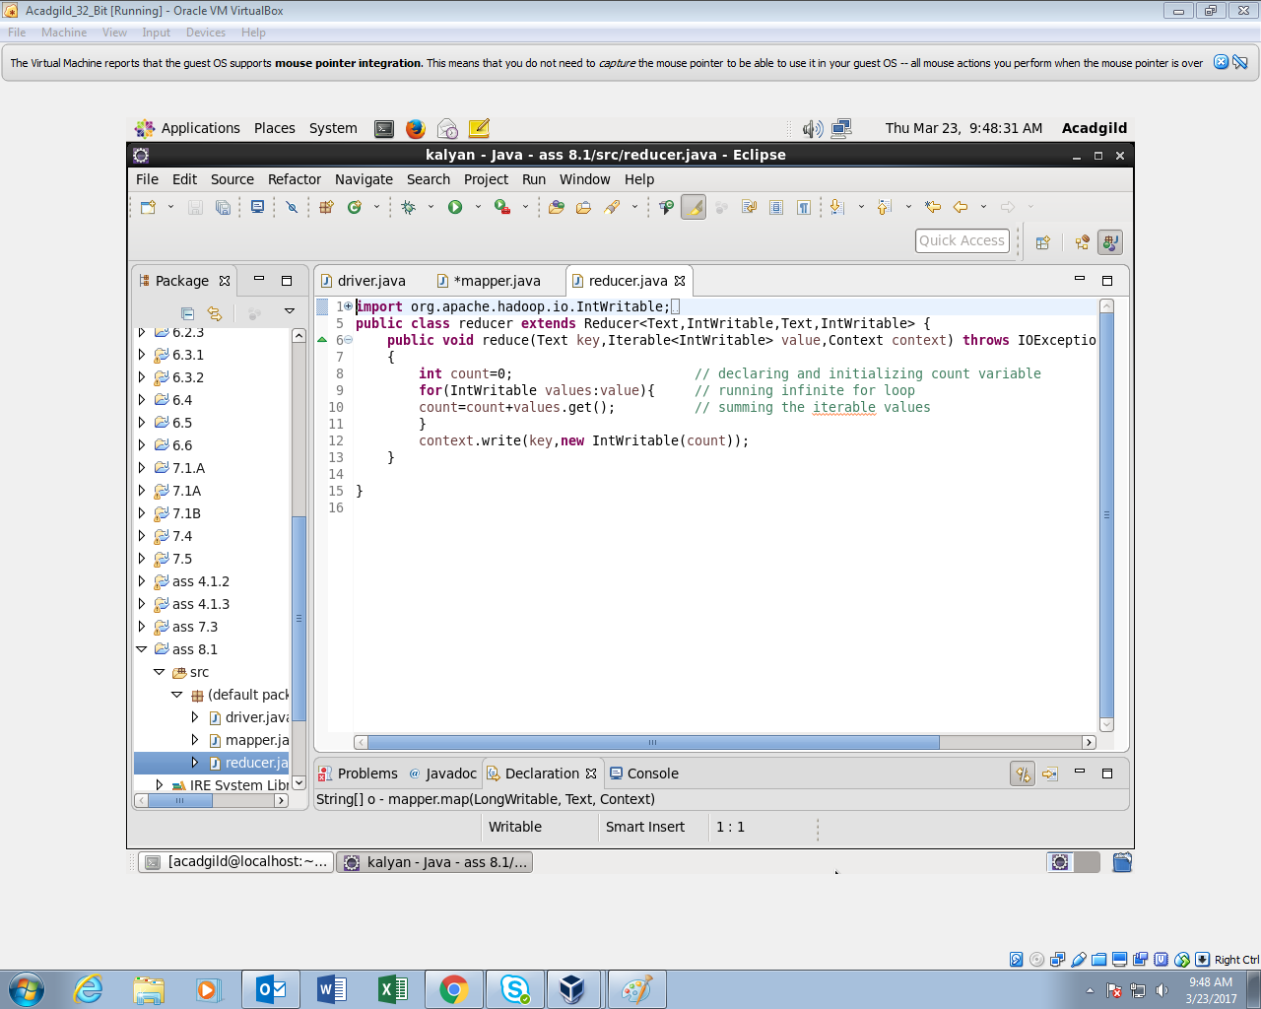

*OUTPUT:*

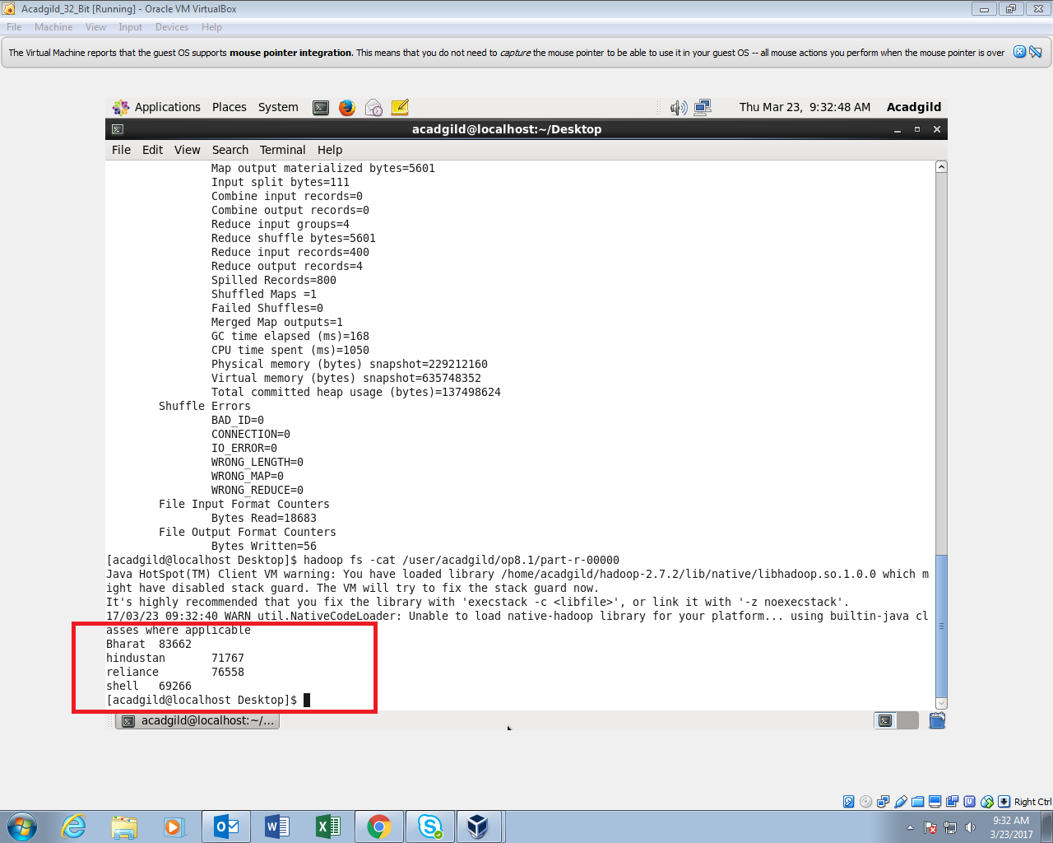

**2. Write a map reduce program to find which are the top 10 distributors ID's for selling petrol and also display the amount of petrol sold in volume**

*DRIVER CLASS:*

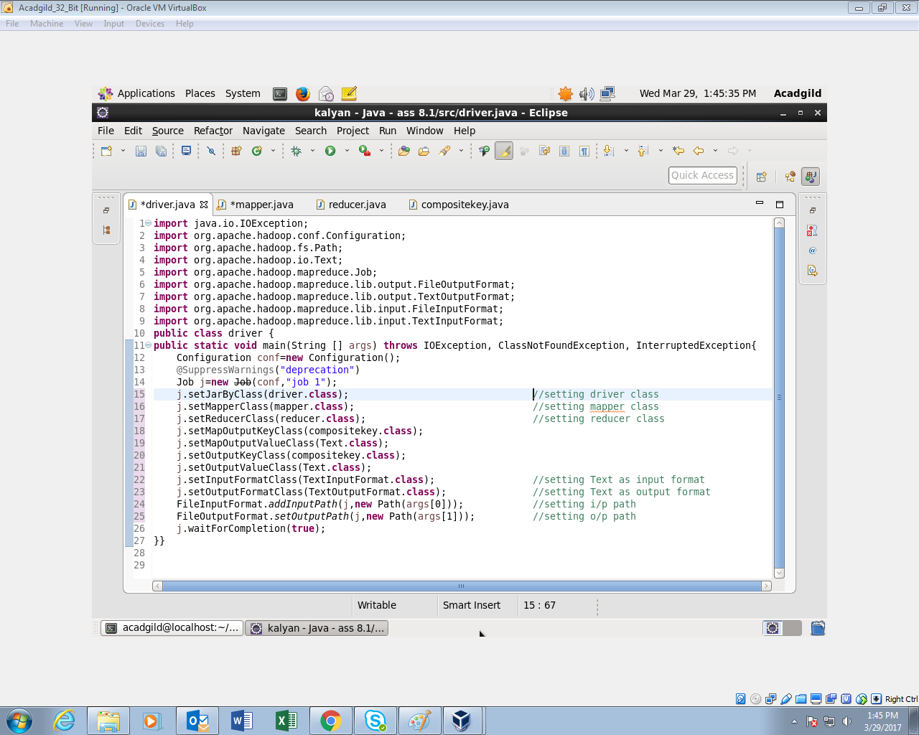

*MAPPER CLASS:*

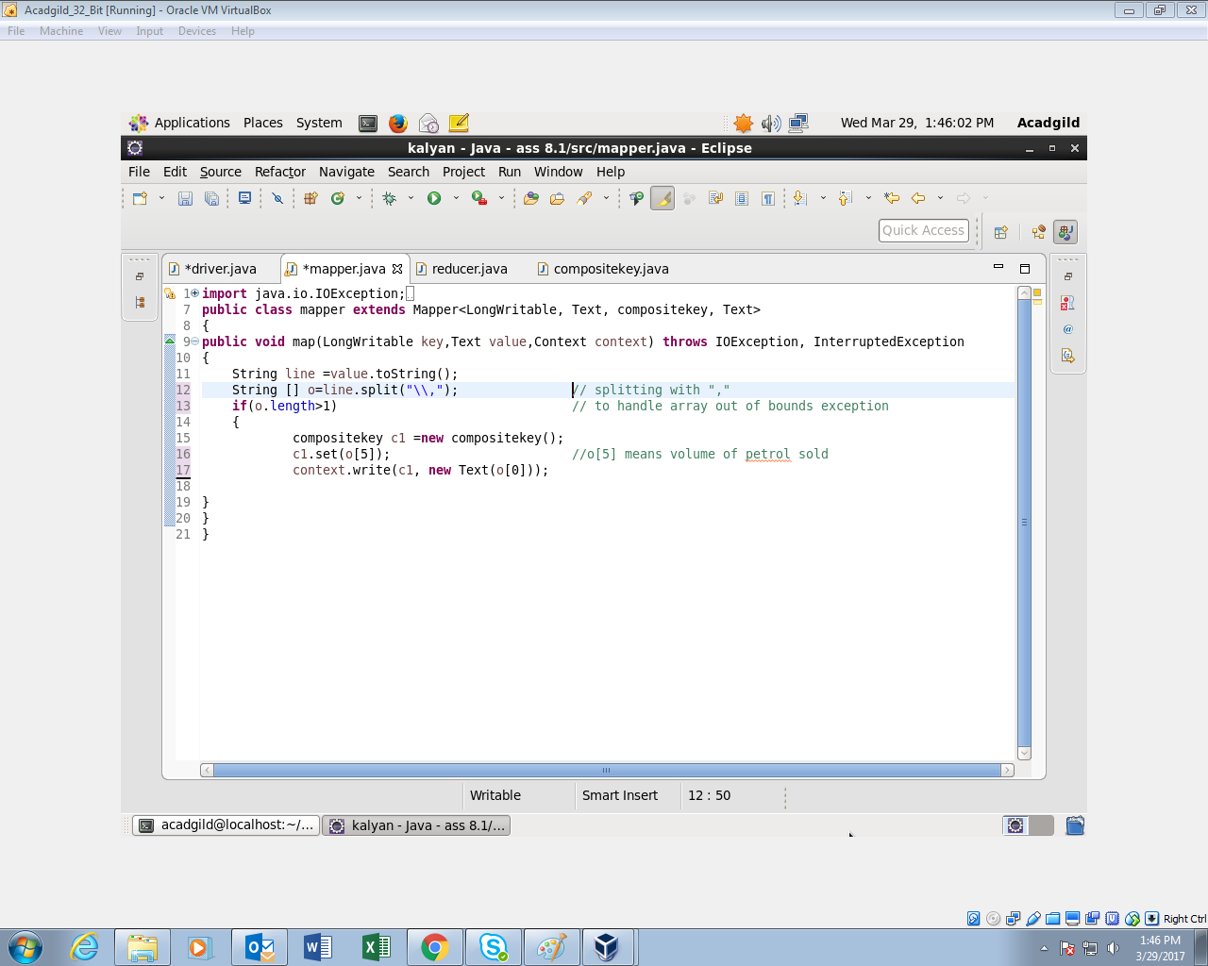

*COMPOSITE KEY CLASS:*

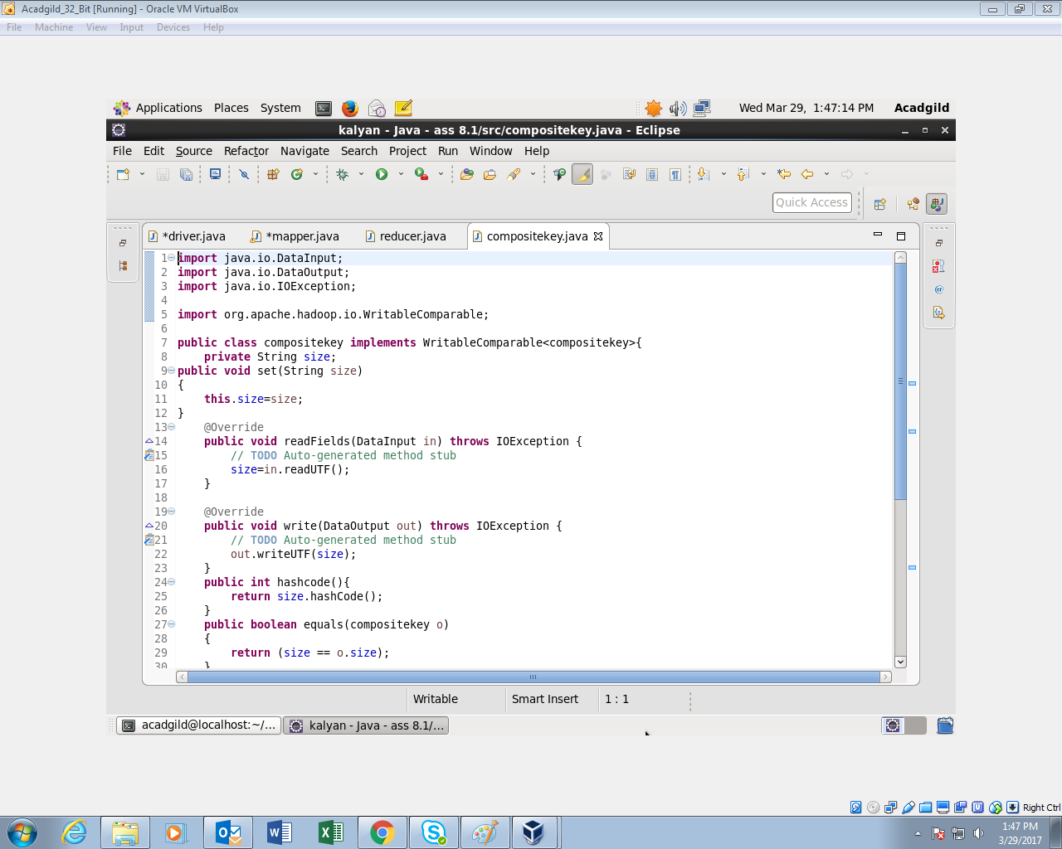

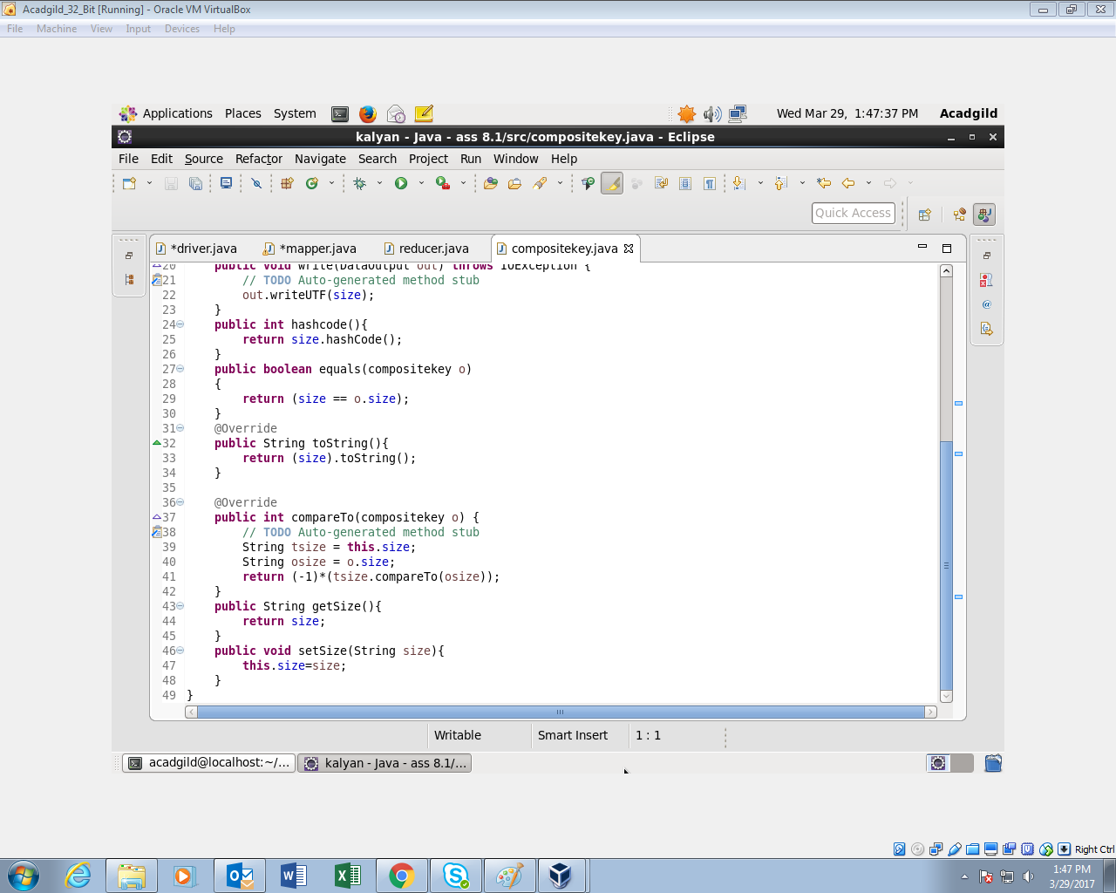

*REDUCER CLASS:*

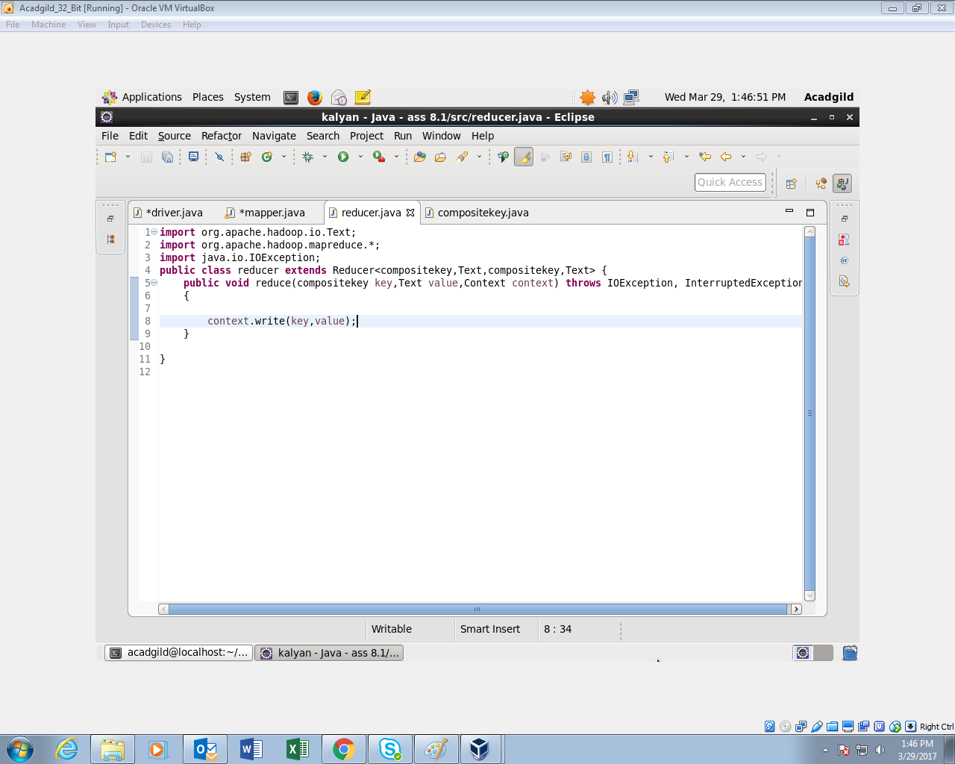

*OUTPUT:*

