**Create two datasets employee and department of file type text where the columns are delimited by tab (‘\t’), and use these datasets to perform below Join operations:**

*SELF JOIN COMMAND:*

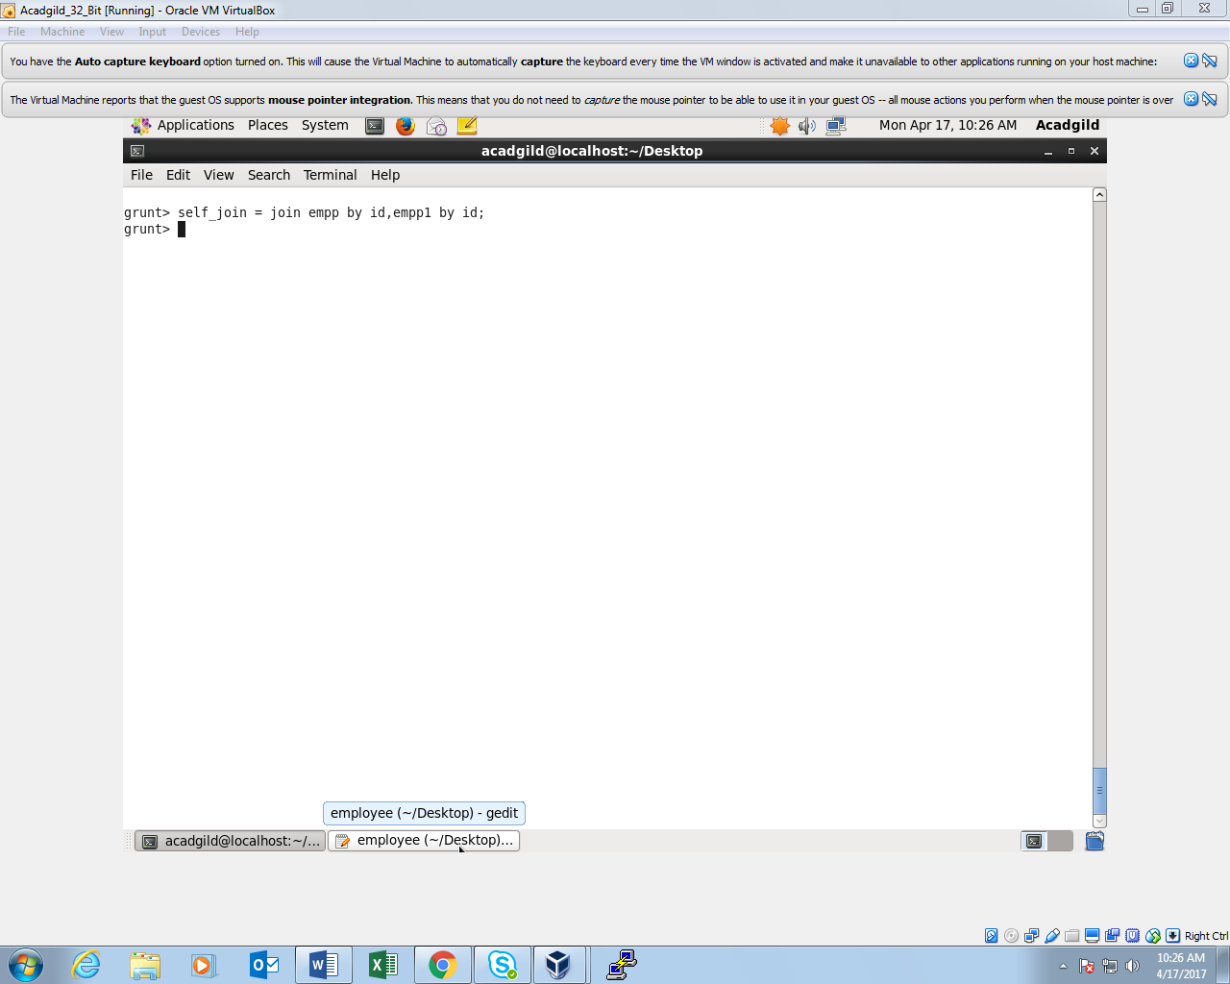

*SELF JOIN OUTPUT:*

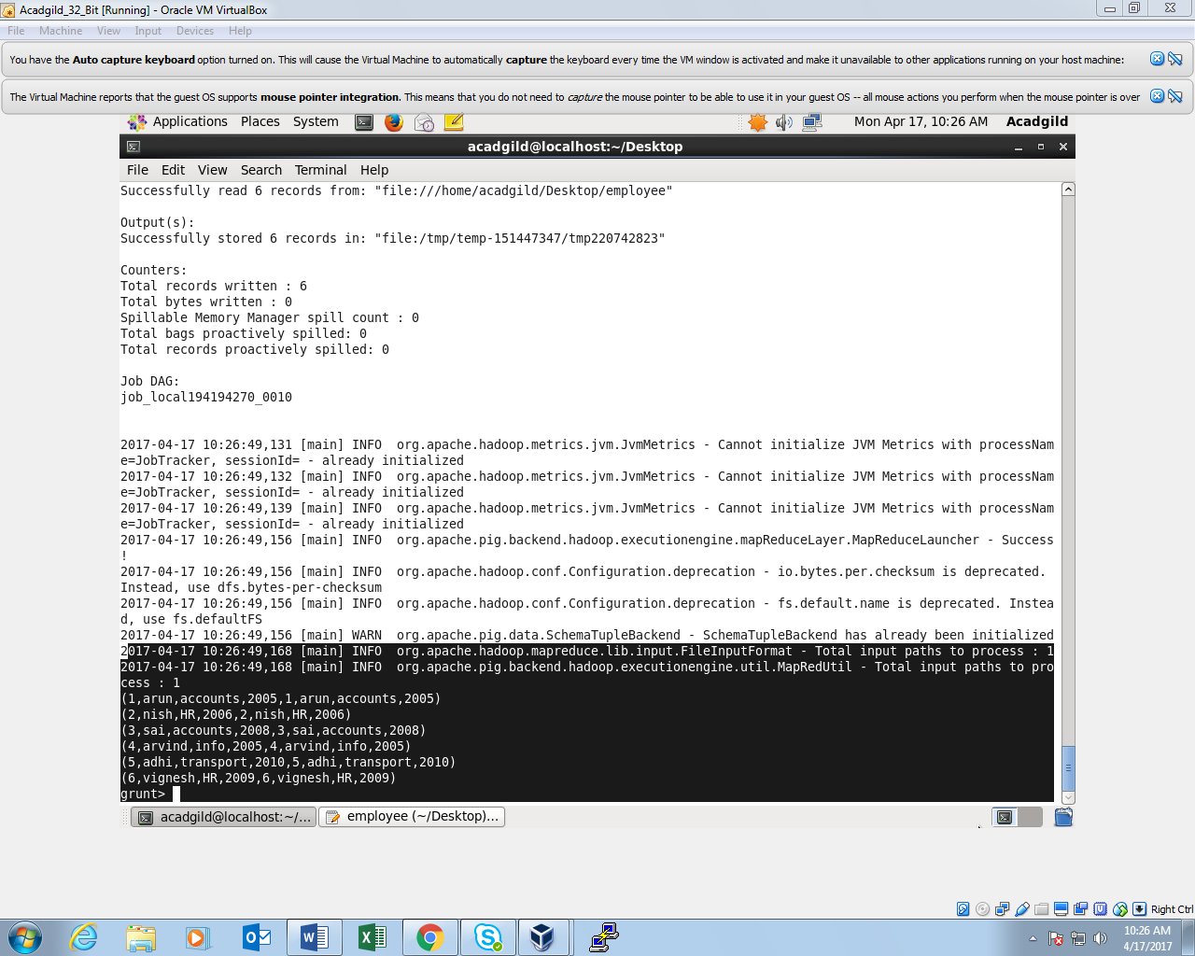

*INNER JOIN COMMAND:*

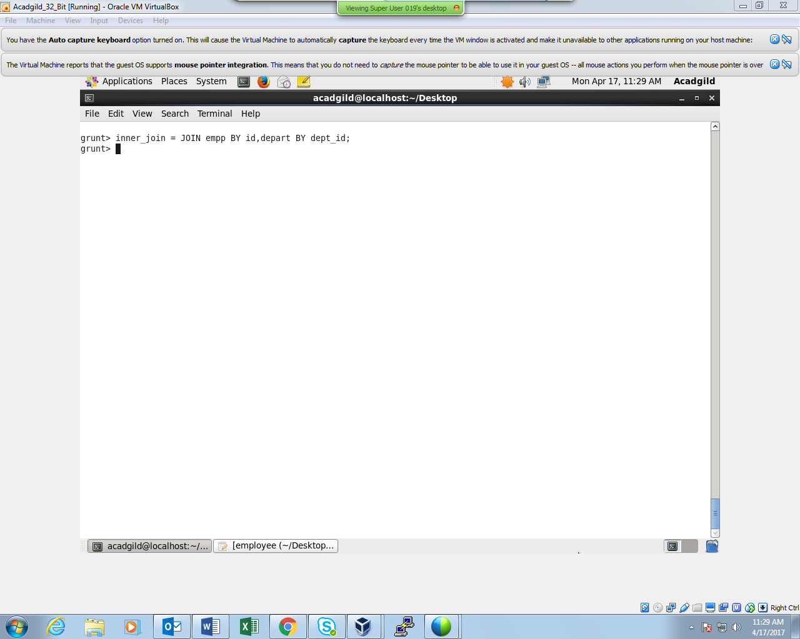

*OUTPUT:*

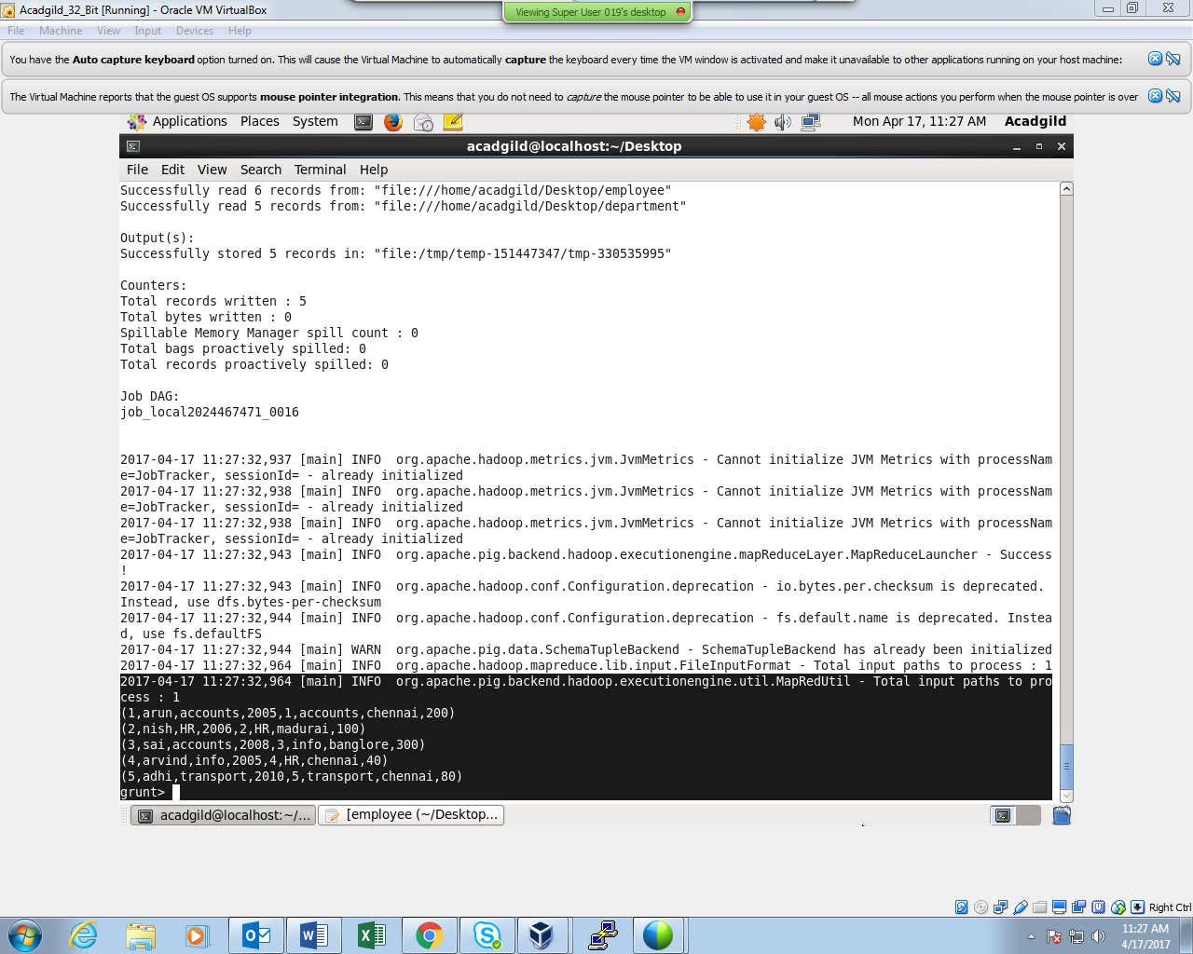

*LEFT OUTER JOIN COMMAND:*

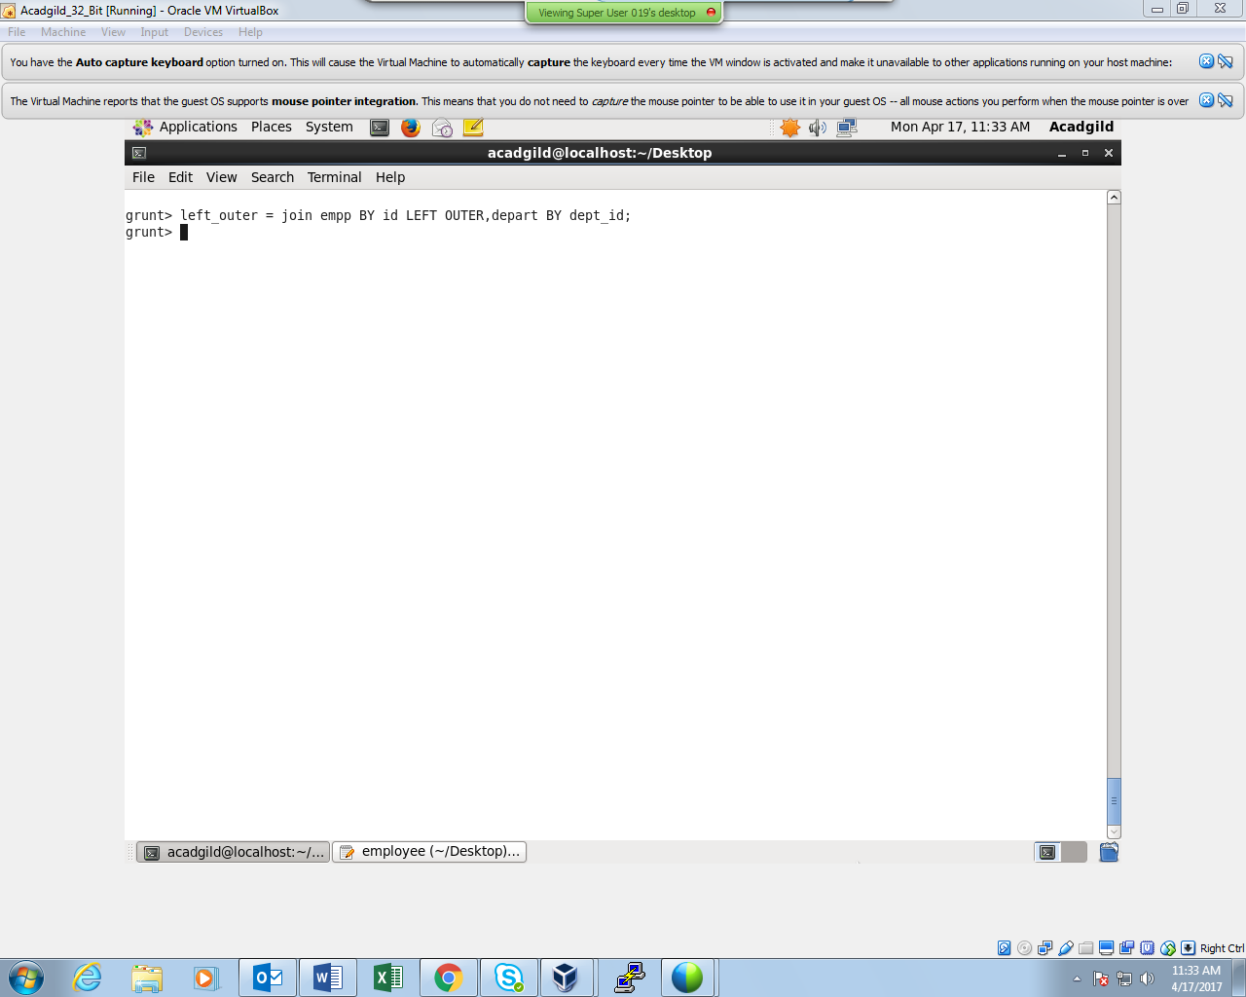

*OUTPUT:*

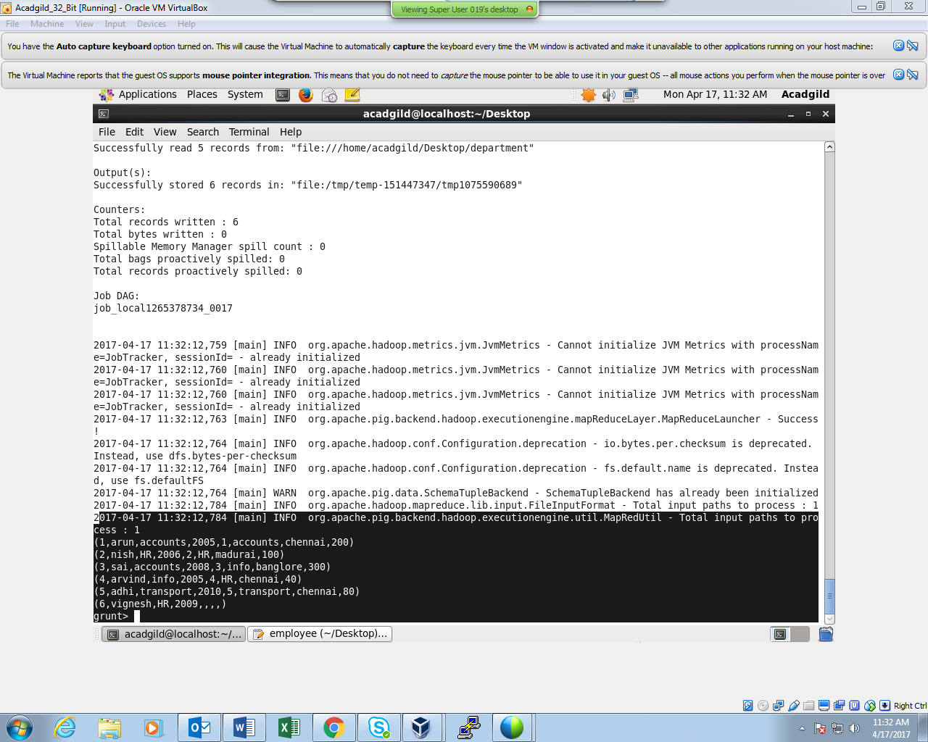

*RIGHT OUTER JOIN COMMAND:*

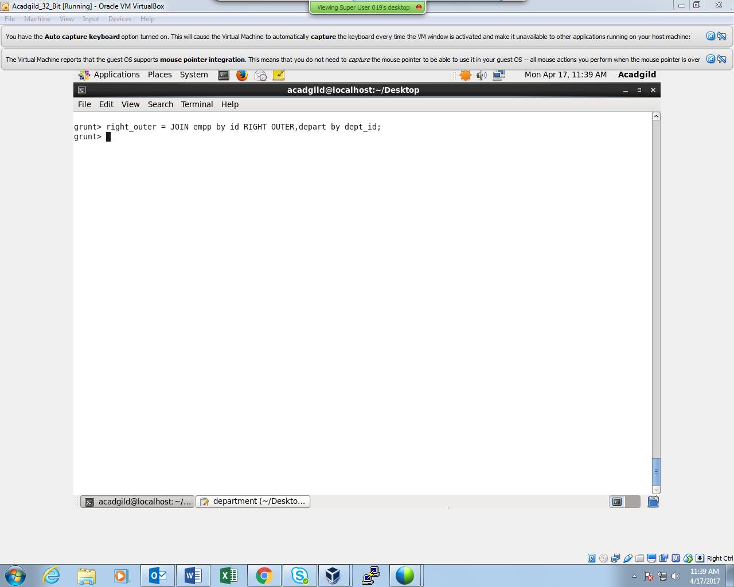

*OUTPUT:*

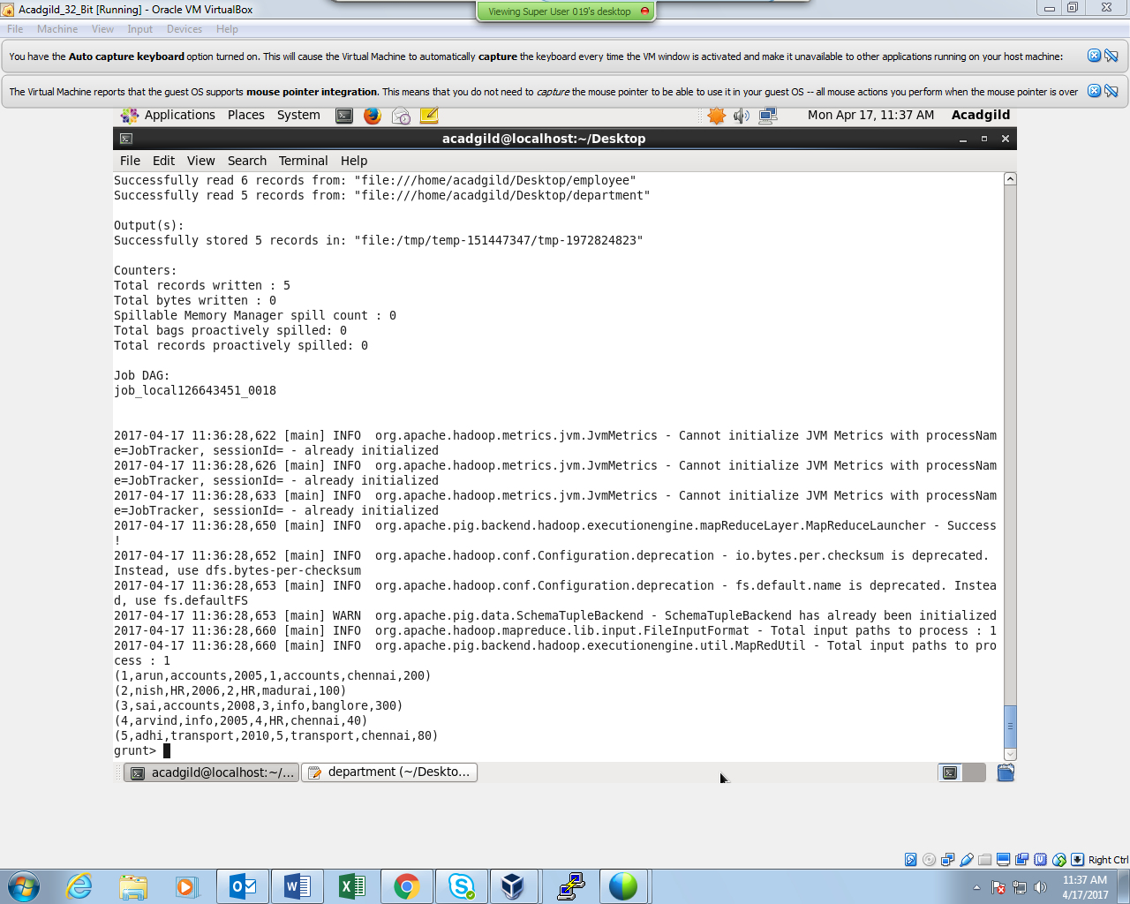

*FULL OUTER JOIN:*

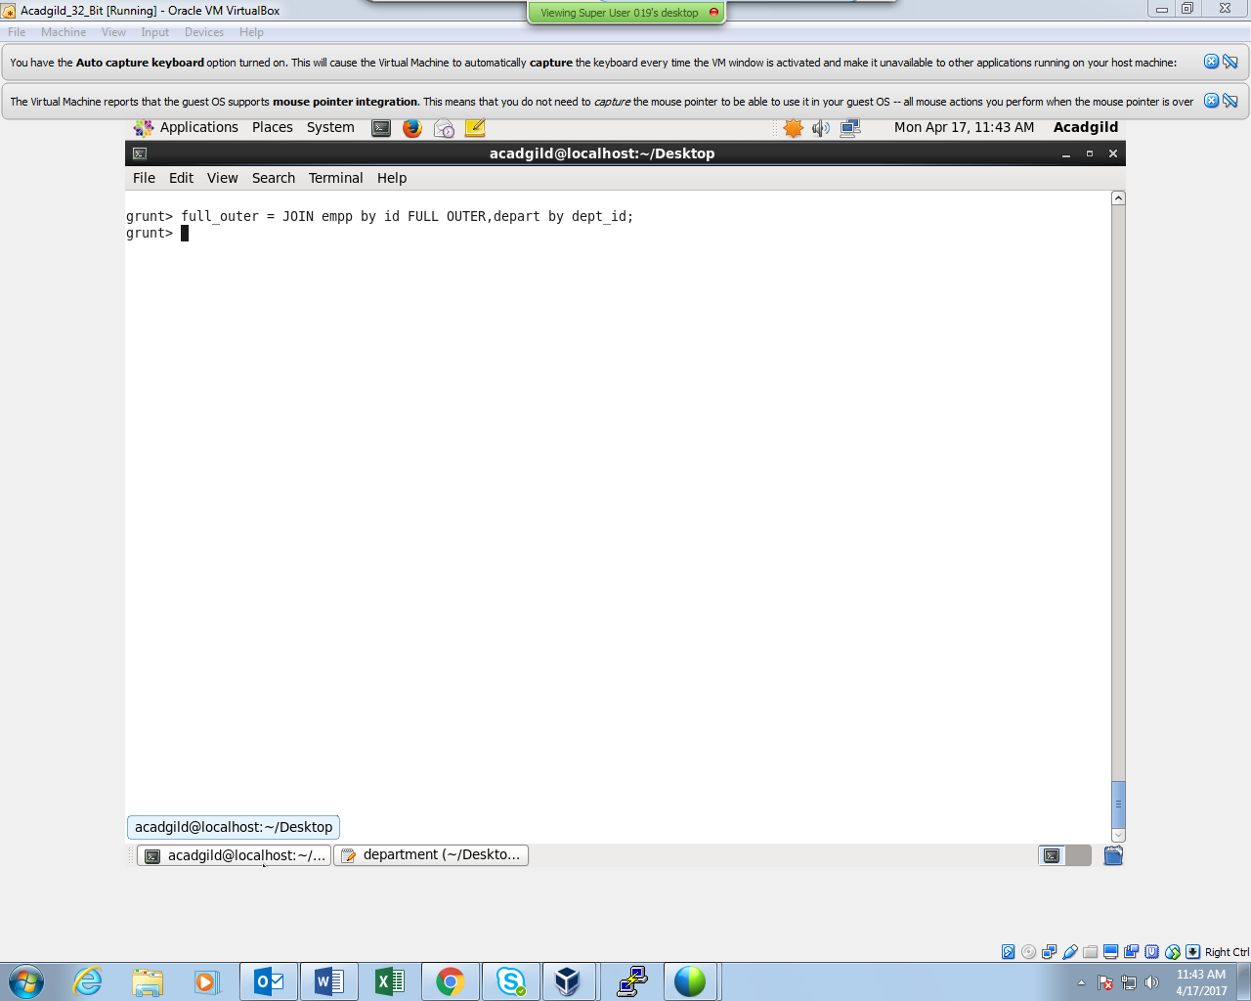

*OUTPUT:*

