**Explain the working of below pig script commands with an example:**

***LOAD COMMAND:***

To Load the data from the file system (local/HDFS) into a relation.

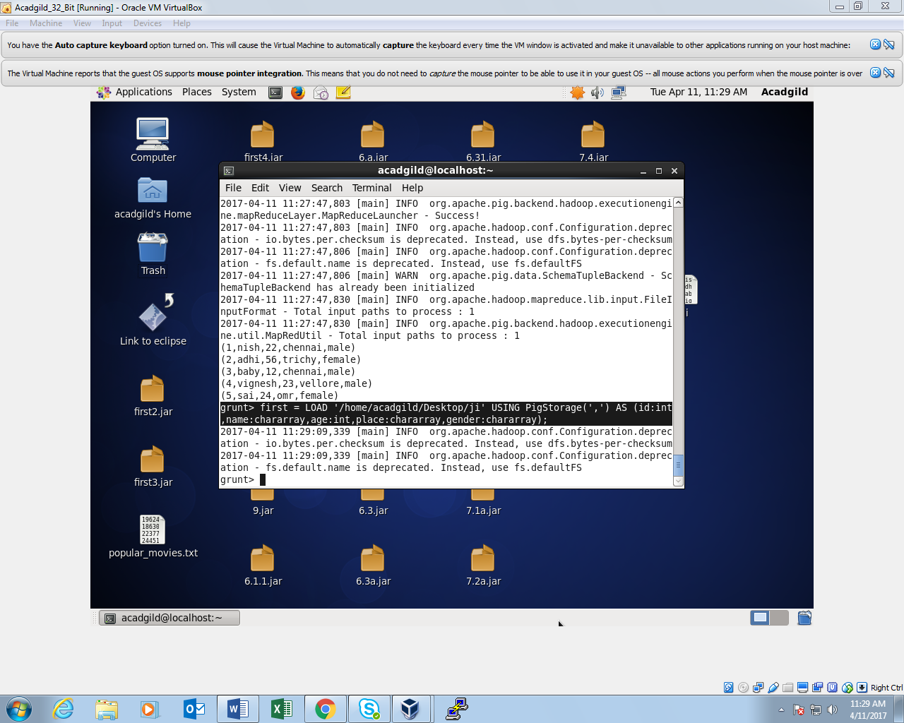

*LOAD COMMAND OUTPUT:*

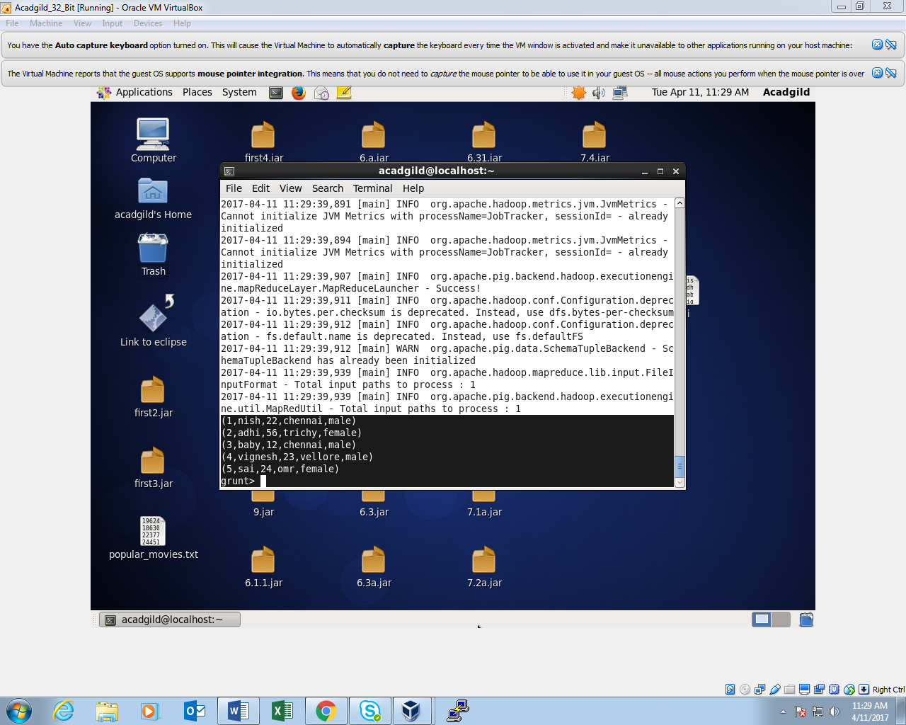

***DUMP COMMAND:***

To print the contents of a relation on the console.

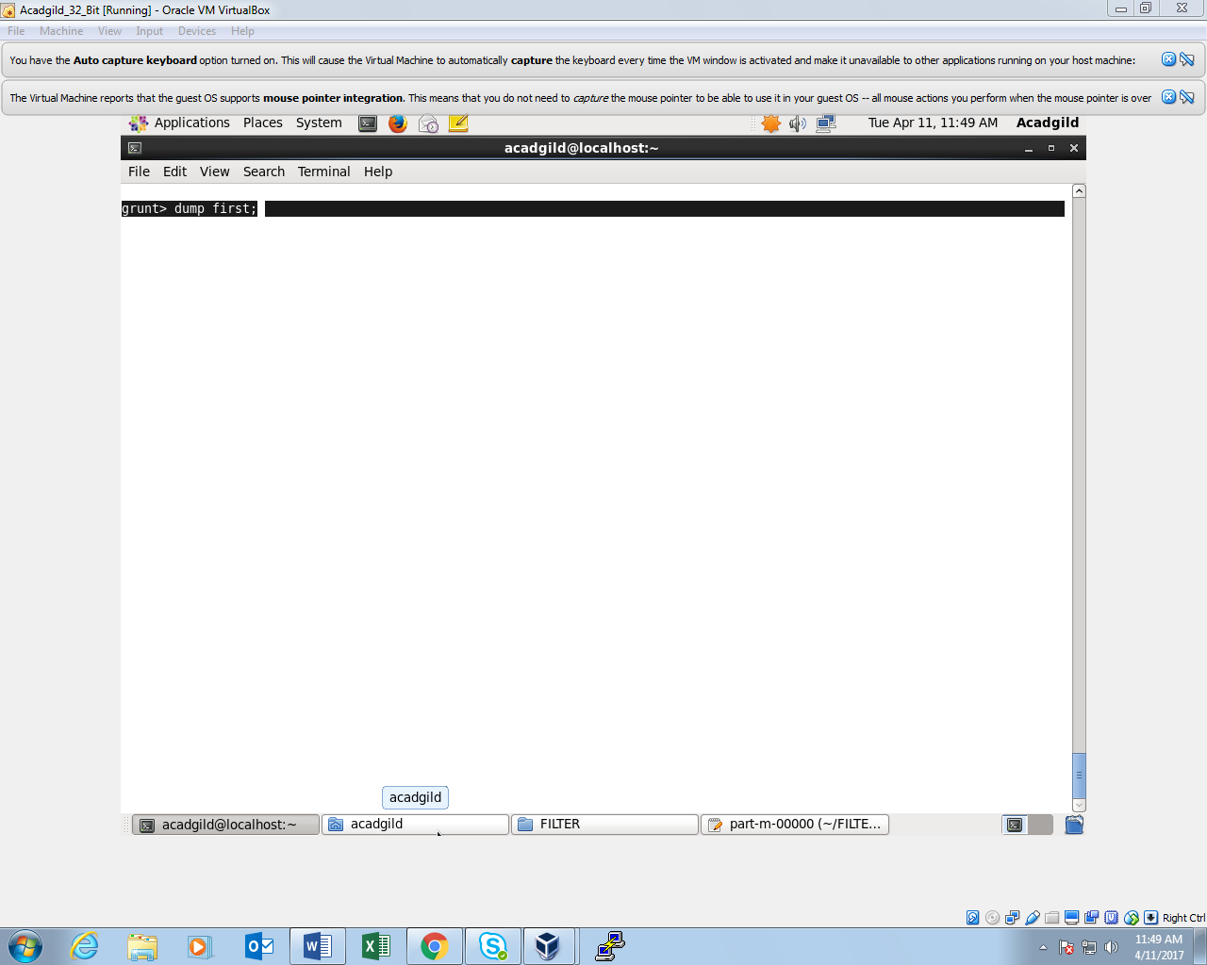

*DUMP COMMAND OUTPUT:*

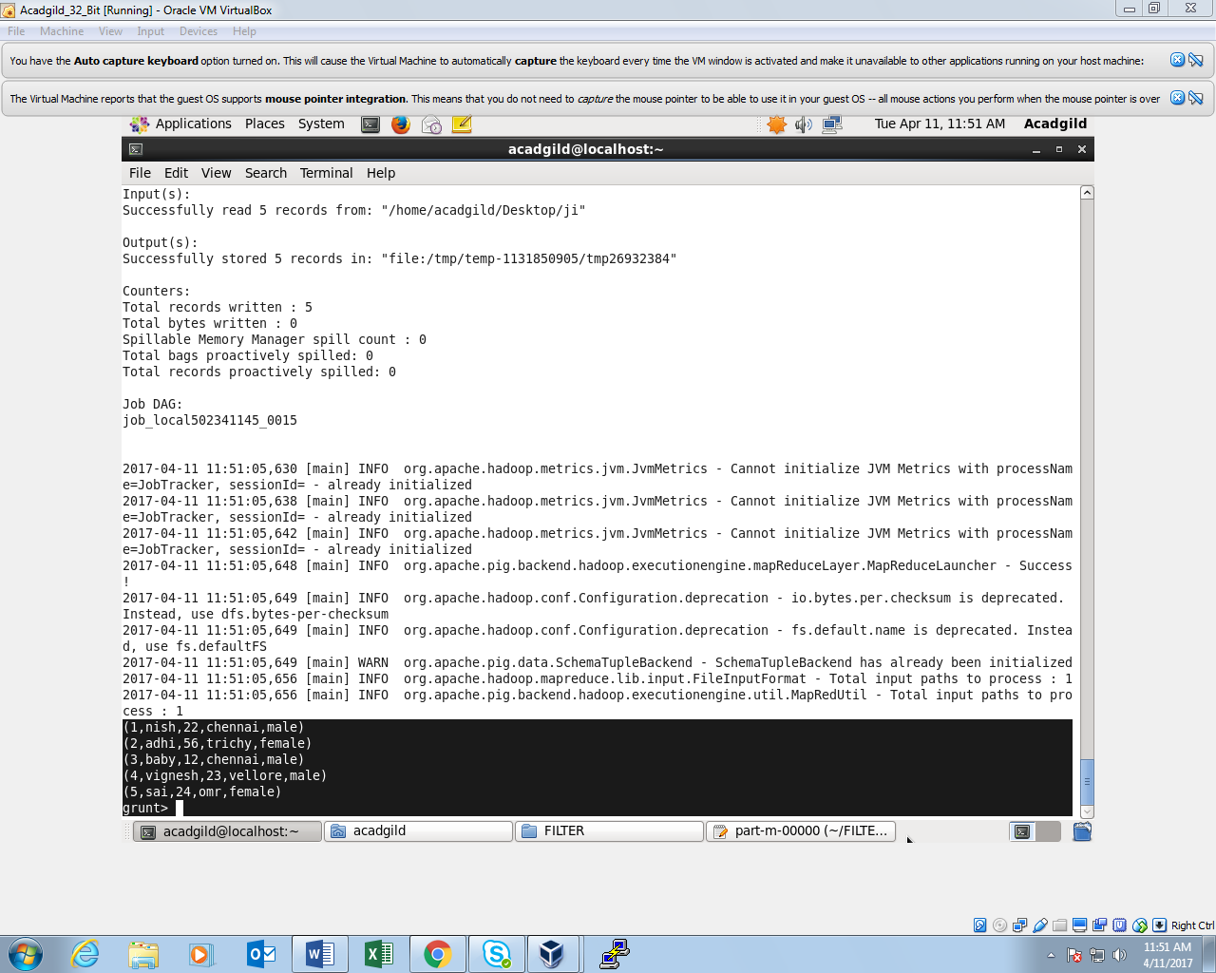

***FILTER COMMAND:***

To remove unwanted rows from a relation.

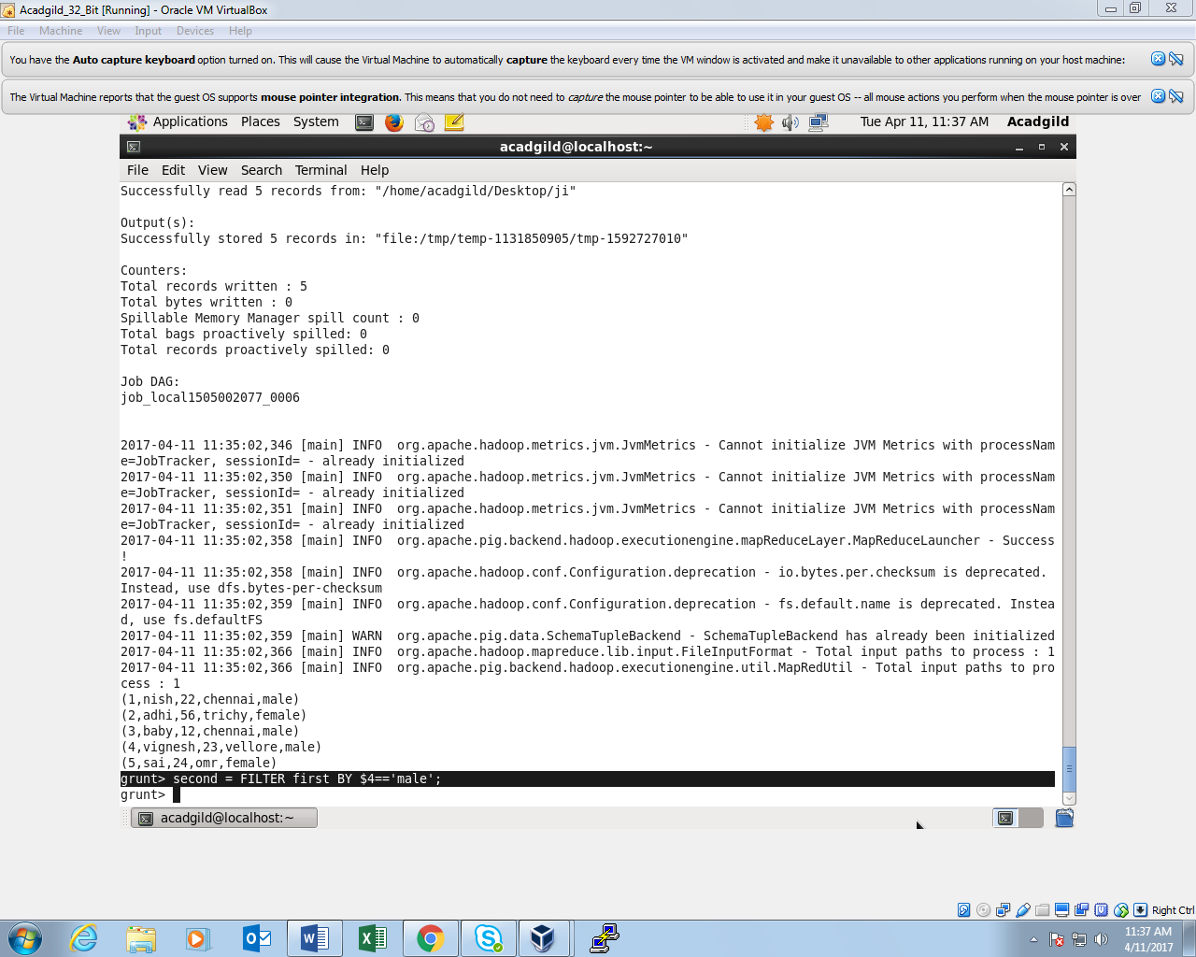

*FILTER COMMAND OUTPUT:*

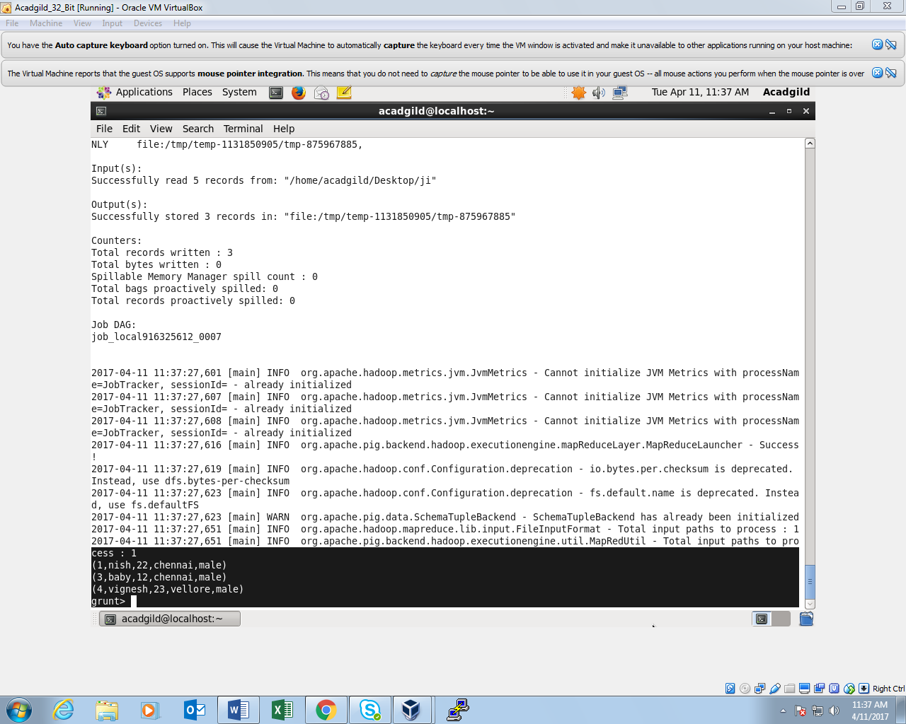

***STORE COMMAND:***

To save a relation to the file system (local/HDFS).

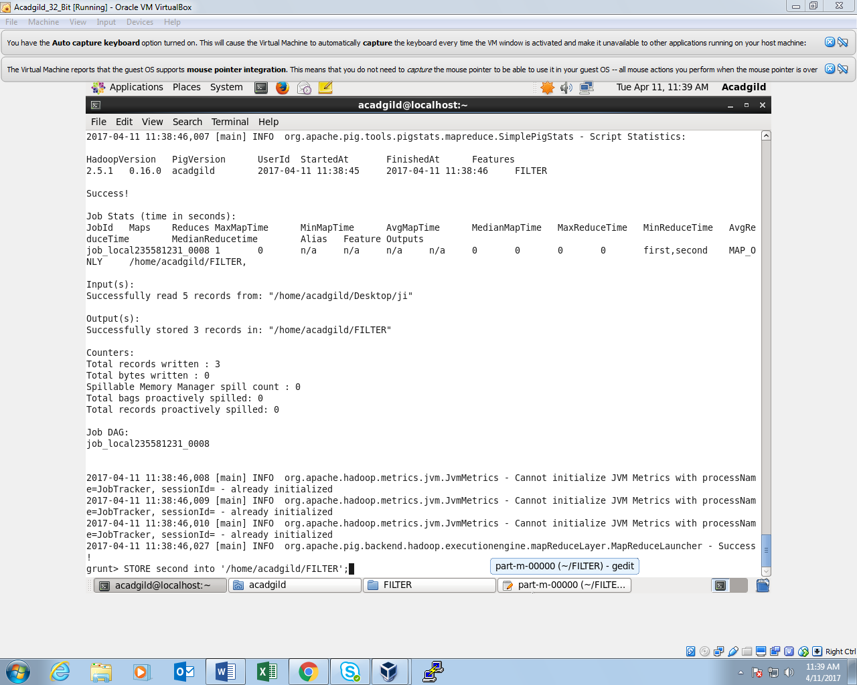

*STORE COMMAND OUTPUT:*

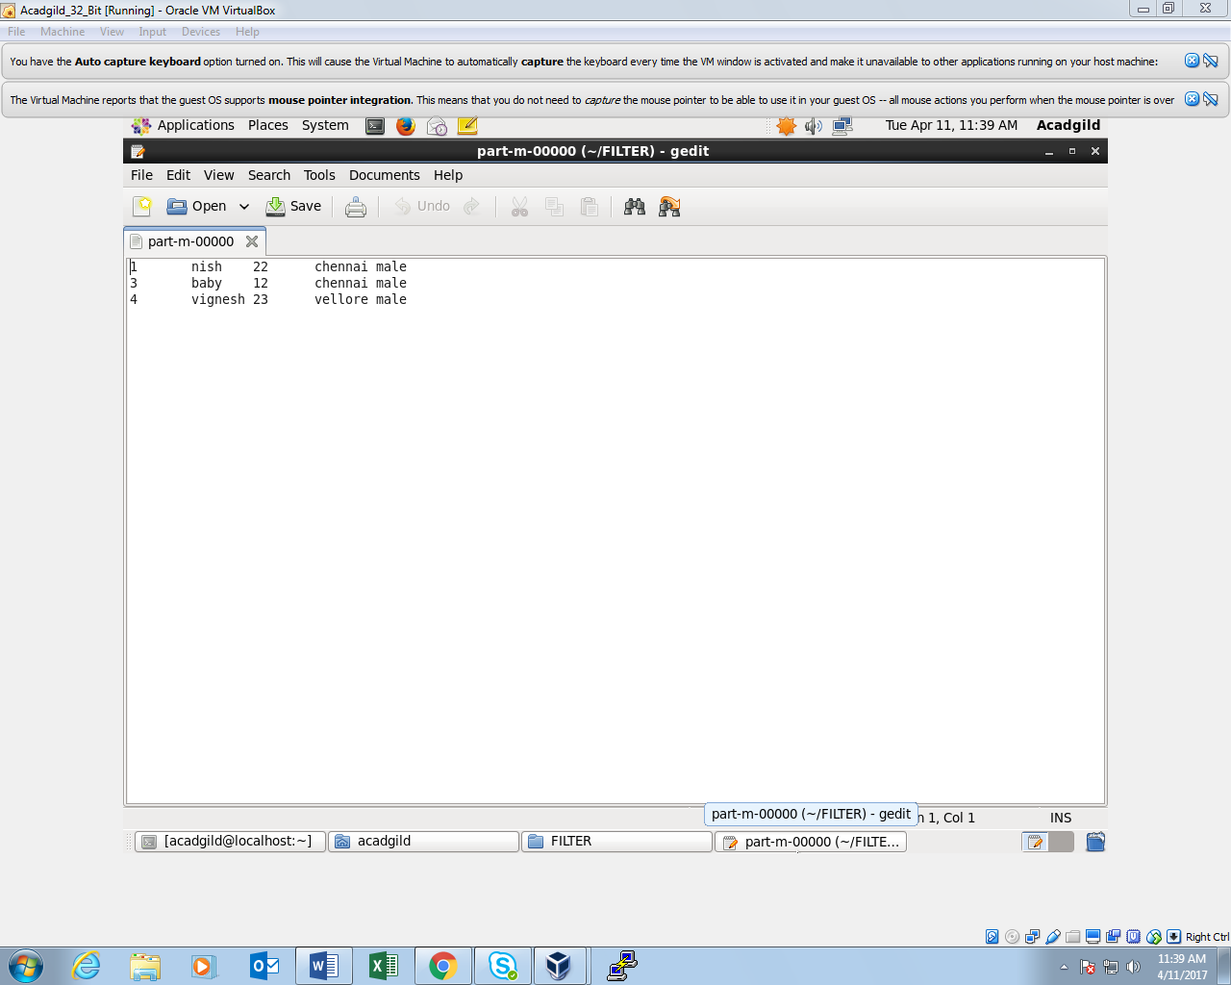

***FOREACH COMMAND:***

To generate data transformations based on columns of data.

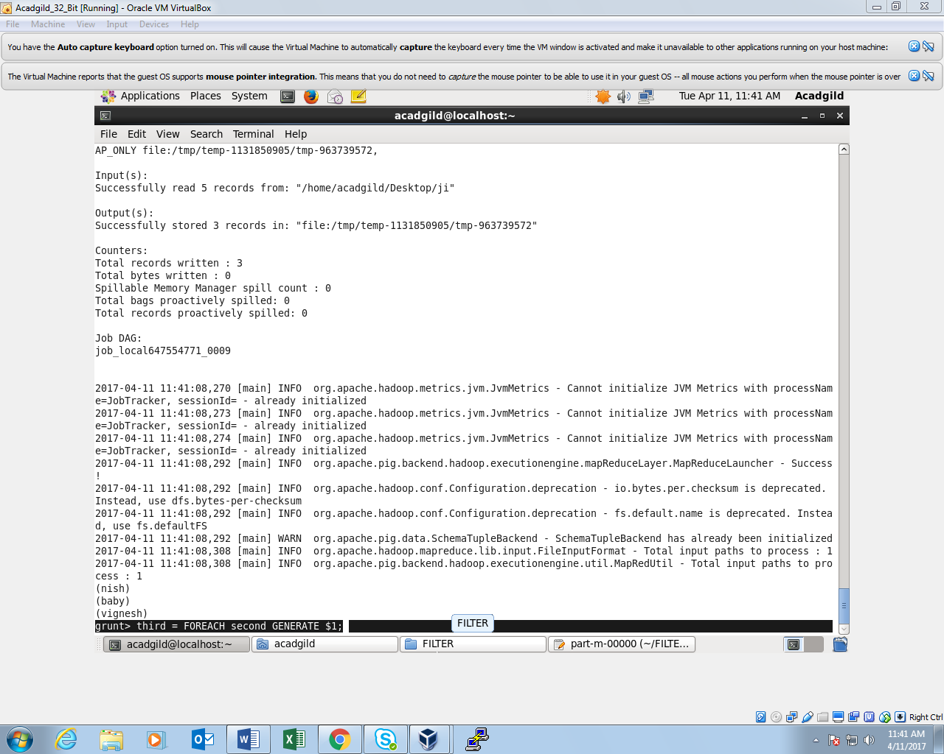*FOREACH COMMAND OUTPUT:*

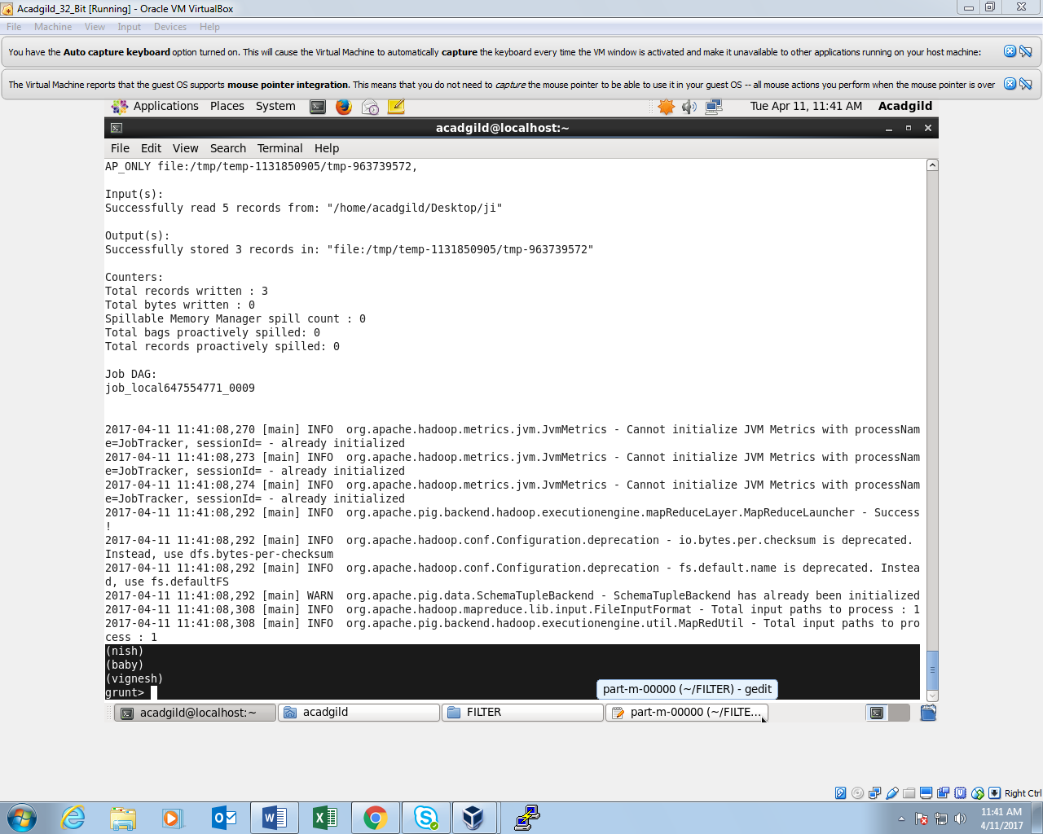

***DESCRIBE COMMAND:***

To describe the schema of a relation.

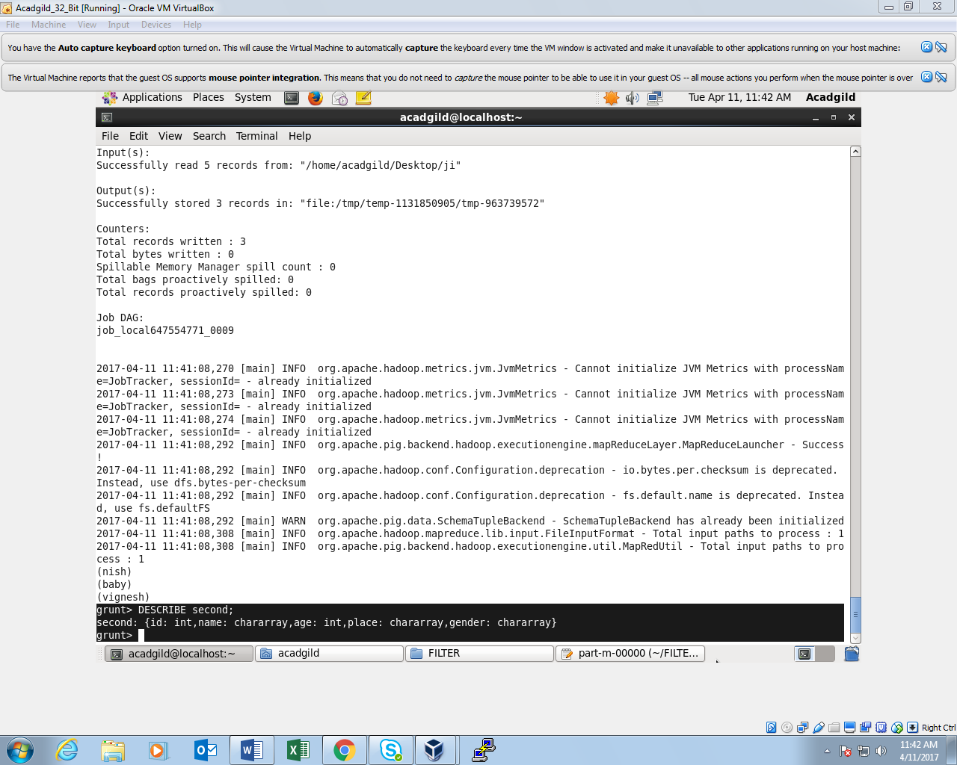

***ORDER BY COMMAND:***

To arrange a relation in a sorted order based on one or more fields (ascending or descending).

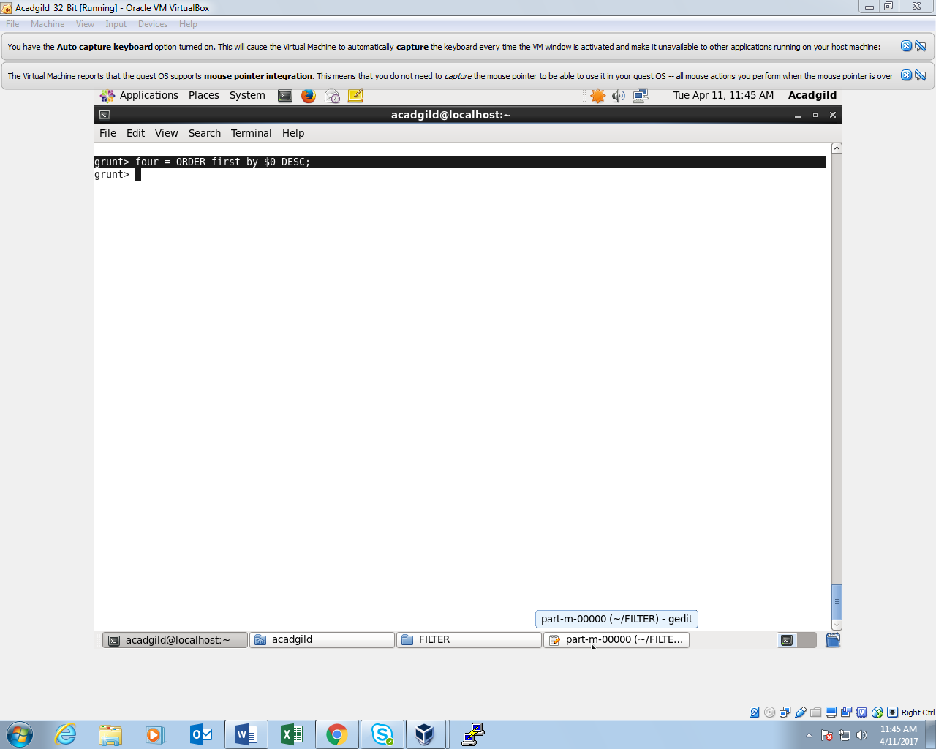

*ORDER BY COMMAND OUTPUT:*

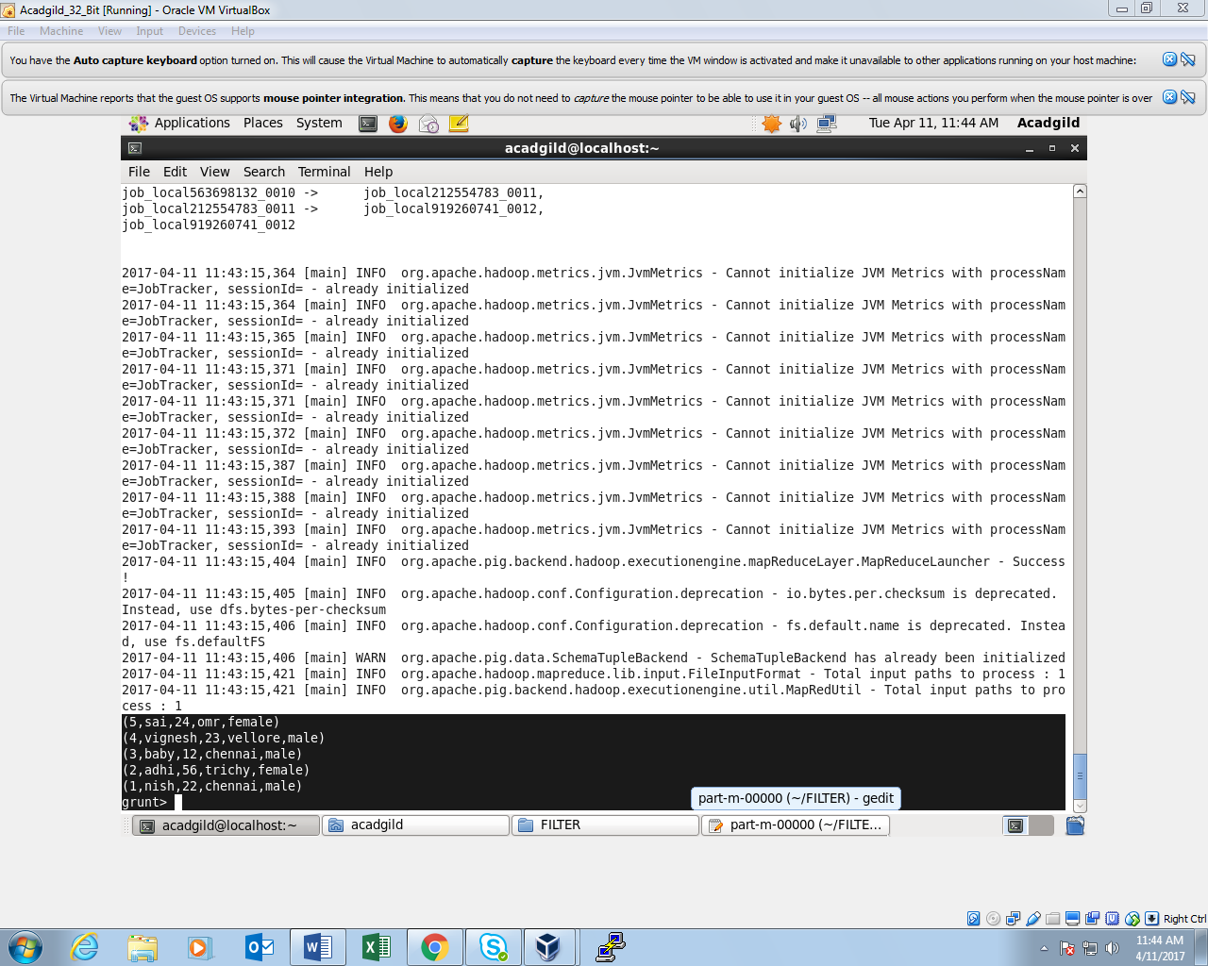

***GROUP BY COMMAND:***

To group the data in a single relation.

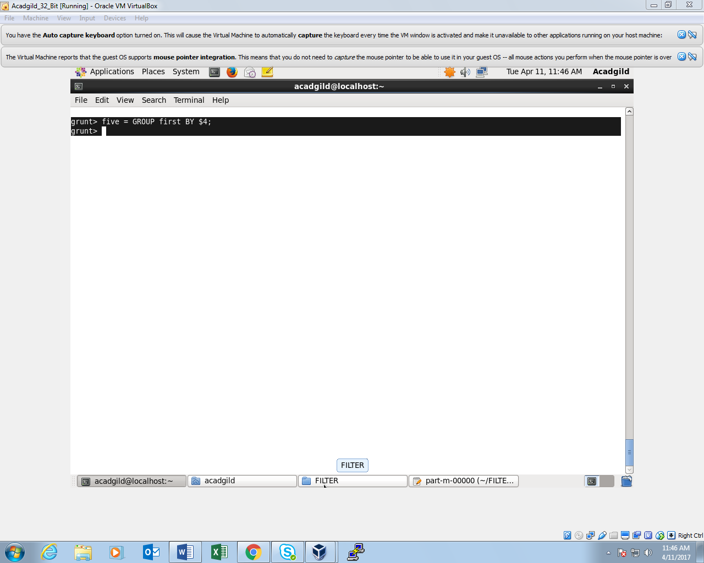

*GROUP BY COMMAND OUTPUT:*

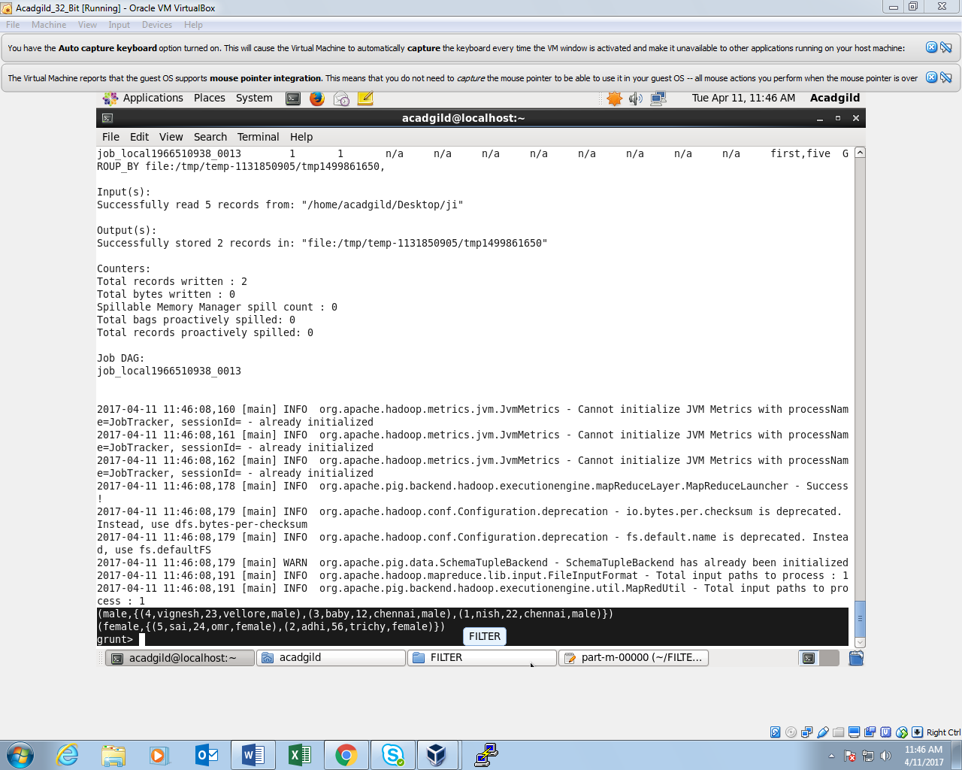

*LIMIT COMMAND AND OUTPUT:*

