Static Pipeline

Before Run

After Run

**Dynamic Pipeline with parameterization**

**Before Run**

**After Run**

**App Registration**

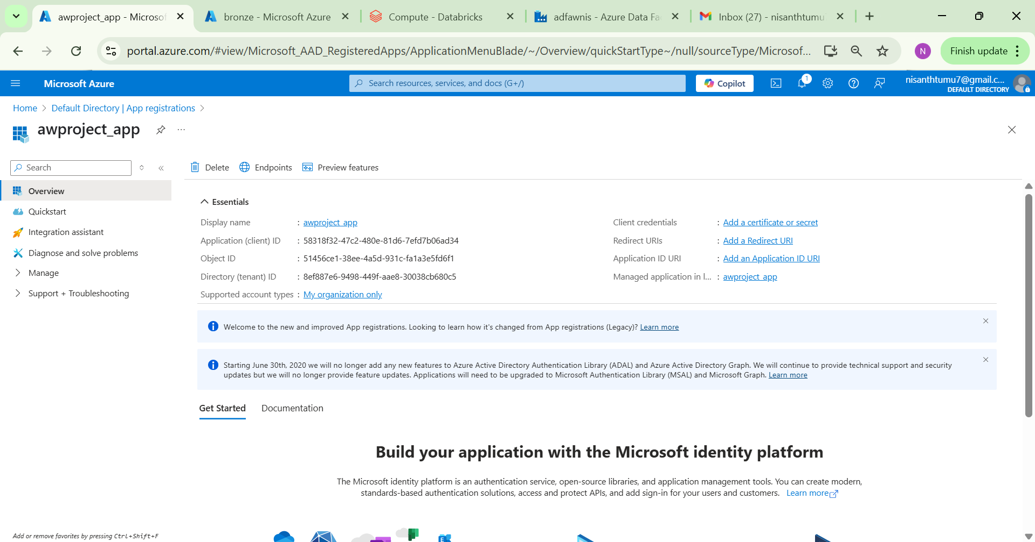

**Databricks**