Synopsis
On
Computer Vision-Based Body Weight Estimation of Dairy Cattle



Name: Nisarg Vakharia
Enroll. No.: ADT25SOCM0105
Class: FY MSc. (AI/ML)

Under the Guidance of
Dr. Jayashree Prasad

Department of Computer Science & Engineering
MIT School of Computing
Sem- 3 | A. Y. 2025-26

1. Title of the Project
Computer Vision-Based Body Weight Estimation of Dairy Cattle: A Deep Learning Approach for Indian Smallholder Dairy Systems

2. Abstract
Body weight is one of the most critical parameters in dairy cattle management, directly influencing feeding decisions, breeding readiness, and health monitoring. However, the majority of smallholder dairy farmers in India lack access to weighing scales or weighbridges, and manual measurement using girth tapes is labor-intensive, requires trained personnel, and can cause stress to the animal during physical restraint.
This project aims to develop a non-invasive, computer vision-based system that estimates the body weight of dairy cattle directly from a smartphone image. The primary objective is to eliminate the need for physical contact, specialized weighing equipment, or manual handling, while remaining deployable in real, resource-constrained field conditions.
The methodology involves capturing a smartphone image of the animal, segmenting the animal from the background using a deep learning-based segmentation model, extracting calibrated morphometric features (body length, height, girth, and area) from the segmented silhouette, and predicting body weight using a regression model trained on animals with known actual weight, collected via a pilot data collection process.
The expected outcome is a validated body weight prediction model achieving a strong correlation (targeted at 80–90%) with actual weighing-scale measurements, deployed through a simple web-based portal that allows field workers to upload an image and receive an instant weight estimate. This project demonstrates the feasibility of low-cost, smartphone-only computer vision as a practical solution for livestock weight monitoring in Indian smallholder dairy systems.

3. Introduction / Background
Dairy farming is an important livelihood in India, especially for smallholder farmers. Accurate cattle body weight is essential for proper feeding, breeding decisions, veterinary care, and determining animal value. However, most smallholder farms lack affordable weighing equipment and rely on inaccurate visual estimation. Traditional tape-based methods require animal restraint, are time-consuming, and may cause stress.
Advances in computer vision and deep learning offer a non-contact alternative by estimating body weight from images using body measurements such as length, height, and girth. This project aims to develop and validate a smartphone-based image system for cattle body weight estimation, specifically designed for Indian smallholder dairy farms without requiring specialized hardware.

4. Problem Definition
Smallholder dairy farmers in India lack reliable, low-cost access to body weight measurement for their cattle, as weighing scales are largely unavailable and manual measurement methods are labor-intensive, time-consuming, and stressful for the animal.
This project develops and validates a computer vision-based system that estimates dairy cattle body weight from a single smartphone image, using deep learning-based segmentation and morphometric feature extraction, without requiring manual handling, specialized equipment, or physical contact with the animal.

5. Objectives
- To develop a smartphone-based computer vision system for estimating the body weight of dairy cattle without requiring physical weighing equipment.
- To collect and develop a pilot dataset of approximately 50–100 dairy cattle containing smartphone images and corresponding actual body-weight measurements obtained using a weighing scale as ground truth.
- To identify and extract relevant cattle body features such as body length, height, girth, and body area from smartphone images using image processing and deep learning techniques.
- To develop and evaluate a machine learning/deep learning model that can learn the relationship between image-derived body features and actual cattle body weight.
- To provide a simple web-based system for field use, where a field worker can upload a cattle image and obtain an estimated body weight without manual measurement or specialized hardware.
6. Scope of the Project
What is covered:
The project focuses on developing and validating a non-contact, image-based body weight estimation system for dairy cows, particularly under Indian smallholder dairy farming conditions.
- Collection of approximately 50–100 dairy cattle with actual weighing-scale measurements as ground truth.
- Capturing smartphone-based images of the cattle.
- Image preprocessing and cattle segmentation.
- Extraction of image-based morphometric features such as length, height, girth, and body area.
- Development and training of a machine learning/deep learning regression model for body-weight prediction.
- Validation and testing of the developed model using actual measured body weights.
- Evaluation of prediction performance using suitable regression metrics.
- Development of a web-based interface/portal through which field workers can upload an image and obtain an estimated body weight.
- Use of open-source technologies such as OpenCV, PyTorch, and Scikit-learn for implementation.

What is not covered:
The following aspects are outside the scope of the current project:
- Estimation of body weight for buffaloes or other livestock species; these are considered future extensions.
- Use of 3D cameras, depth cameras, RGB-D sensors, or other specialized imaging hardware.
- Development of a large-scale dataset involving thousands of animals.
- Replacement of actual weighing scales for applications requiring certified or legally accurate weight measurements.
- Real-time continuous monitoring of cattle body weight.
- Integration with automated farm machinery, IoT devices, or smart weighing systems.
- Large-scale commercial deployment across multiple farms.
- Development of a dedicated mobile application; this is considered a future enhancement.
- Extensive field deployment beyond the pilot dataset of 50–100 animals.
7. Proposed System
The proposed solution is a computer vision-based smartphone system for non-contact body weight estimation of dairy cattle. It estimates cattle body weight from a smartphone image without requiring physical weighing scales, manual body measurements, or specialized depth/3D camera hardware. The system is designed particularly for Indian smallholder dairy farming conditions.
Overall Architecture / Workflow
The system follows these main steps:
Image Acquisition & Preprocessing
- Capture a dairy cattle image using a smartphone. The captured image is preprocessed to make it suitable for further computer vision analysis.
Cattle Segmentation
- Identify and segment the cattle from the captured image so that the animal's body can be analyzed separately from the surrounding background.
Feature Extraction
- Extract relevant body features from the segmented cattle image, including:
  - Body length
  - Body height
  - Body girth
  - Body area
These image-derived features are used as inputs for the weight prediction model.

Weight Prediction
The extracted features are provided to a trained machine learning/deep learning regression model. The model learns the relationship between the image-derived cattle features and the actual body weight obtained from weighing-scale measurements.
Model Training & Validation
A dataset of approximately 50–100 dairy cattle will be developed containing smartphone images and corresponding actual body-weight measurements as ground truth. The data will be used for model training, validation, and testing to evaluate the prediction performance.
Web-Based Output
The trained model will be integrated into a simple web-based portal. A field worker can upload a cattle image through the portal, after which the system processes the image and displays the estimated body weight.
Key Modules & Their Functions
- Image Acquisition Module – Captures or accepts smartphone images of dairy cattle.
- Image Preprocessing Module – Performs the required preprocessing of the captured images.
- Cattle Segmentation Module – Separates the cattle from the image background for further analysis.
- Feature Extraction Module – Extracts body length, height, girth, and area from the segmented cattle image.
- Weight Prediction Module – Uses a trained machine learning/deep learning model to estimate the cattle's body weight.
- Web Interface Module – Provides a simple interface for field workers to upload images and obtain the estimated body weight.
Advantages Over Existing Systems
- Non-contact estimation — Body weight can be estimated without physically restraining or handling the animal.
- Smartphone-based — Uses a commonly available smartphone for image capture.
- No specialized hardware — Does not require weighing scales, depth cameras, or 3D cameras.
- Reduced manual effort — Eliminates routine manual body measurements using a measuring tape.
- Field-worker friendly — The web-based portal provides a simple method for obtaining weight estimates.
- Low-cost and feasible — Uses open-source computer vision and machine learning technologies such as OpenCV, PyTorch, and Scikit-learn.

System Architecture Diagram
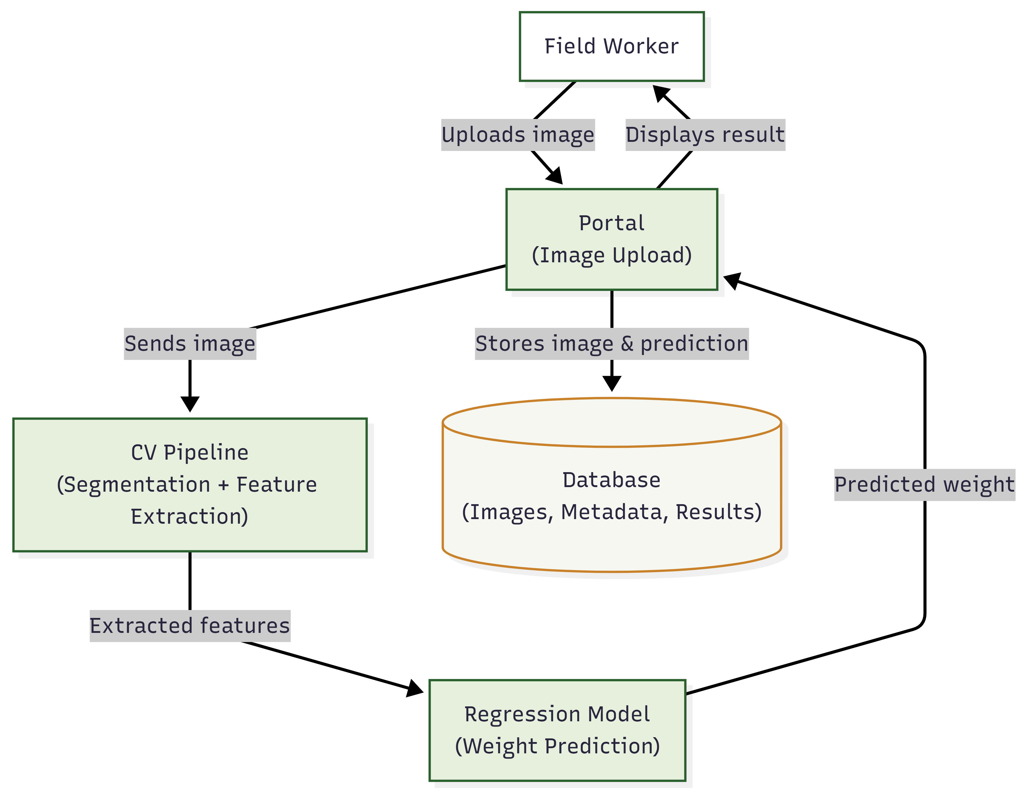

8. System Requirements
a. Hardware Requirements
The project is designed to be developed and trained using a standard academic or personal laptop, with access to a GPU or cloud GPU when required for deep learning model training. Image acquisition will be performed using a standard smartphone, eliminating the need for specialized depth or 3D camera hardware.
Minimum Configuration
  - Processor: Intel Core i5 / AMD Ryzen 5 or equivalent
  - RAM: 8 GB (16 GB recommended for model training and image processing)
  - Storage: 20–30 GB free space for images, datasets, trained models, and project files
  - Graphics: Integrated graphics sufficient for basic image processing; GPU recommended for deep learning training
  - Operating System: Windows 10/11, Linux, or macOS
  - Smartphone: Smartphone with a functional camera for cattle image capture
Recommended Configuration (for faster model development and training)
  - Processor: Intel Core i7 / AMD Ryzen 7 or higher
  - RAM: 16–32 GB
  - Storage: SSD with sufficient free space for dataset and model storage
  - Graphics: NVIDIA GPU or access to a cloud GPU for faster deep learning training
  - Smartphone: Smartphone with a good-quality camera for consistent image acquisition
b. Software Requirements
  - Programming Language
  - Python 3.8 or higher
Core Libraries & Frameworks
  - Image Processing & Computer Vision: OpenCV
  - Deep Learning: PyTorch
  - Machine Learning: Scikit-learn
  - Data Handling & Processing: Pandas, NumPy
  - Image Processing & Analysis: OpenCV and related Python imaging libraries
  - Visualization & Plotting: Matplotlib
  - Model Evaluation: Scikit-learn metrics and regression evaluation methods
Development Tools
  - IDE / Editor: VS Code, Jupyter Notebook / JupyterLab, or PyCharm
  - Package Manager: pip with virtual environment (venv or conda)
  - Version Control: Git (optional)
Dataset & Image Acquisition
  - Smartphone camera for cattle image collection
  - Actual weighing scale measurements for obtaining ground-truth body weight
  - Local storage or cloud storage for maintaining the collected image dataset and corresponding weight measurements
Deployment
  - Web-based portal for uploading cattle images and displaying estimated body weight
  - Laptop or cloud-based computing environment for hosting and running the trained prediction model
9. Methodology / Implementation Plan
a. Implementation Plan
- Data Collection & Preparation — Download and load TCGA-GBM clinical/genomic TSV and BraTS-TCGA-GBM MRI radiomics CSV/NIfTI files.
- Data Preprocessing & Feature Engineering — Clean, normalize, encode, fuse clinical/genomic/radiomics features by patient ID, and define survival targets.
- Dataset Partitioning — Split merged dataset into N virtual nodes (5–10) to simulate independent hospitals.
- Federated Learning Setup — Initialize global model (XGBoost/Cox) on central server and broadcast to nodes.
- Local Training & Aggregation — Each node trains locally on private data; send only model updates; aggregate via FedAvg on server; repeat rounds.
- Evaluation & Comparison — Test global model on held-out set; compute C-index, AUC, Kaplan-Meier curves; compare with centralized baseline.
- Visualization & Documentation — Generate survival curves, feature importance plots, and document code/results in notebooks.

b. Algorithms Used:
1. Machine Learning Models:
- XGBoost (gradient boosting) – primary model for tabular/multi-modal features
- Cox Proportional Hazards (lifelines library) – for survival regression
- Optional: simple feed-forward neural network (PyTorch) if needed
2. Federated Learning:
- FedAvg (Federated Averaging) algorithm for model aggregation
- Flower framework for easy simulation of federated rounds and client-server communication
3. Feature Processing:
- PyRadiomics (if re-extraction needed) for radiomics features
- Pandas & NumPy for data cleaning and fusion
- Scikit-learn for preprocessing (StandardScaler, OneHotEncoder)
4. Evaluation & Visualization:
- lifelines & scikit-survival for survival metrics
- Matplotlib & Seaborn for plots (Kaplan-Meier, feature importance, convergence)
10. Expected Outcome
The project is expected to deliver the following tangible outcomes:
- A functional smartphone-based cattle body weight estimation system that can estimate the body weight of dairy cattle from smartphone images without requiring physical weighing during routine use.
- A trained computer vision and machine learning/deep learning model capable of predicting cattle body weight using image-derived morphological features such as body length, height, girth, and body area.
- A validated pilot dataset containing approximately 50–100 dairy cattle, including smartphone images and corresponding actual weighing-scale measurements to serve as ground-truth values for model development and evaluation.
- Comprehensive model evaluation results including:
  - Prediction error metrics such as MAE, RMSE, and related regression performance measures.
  - Comparison between predicted and actual body weights.
  - Graphs showing model performance and prediction accuracy.
  - Analysis of the relationship between extracted cattle body features and estimated weight.
- A functional web-based portal through which a field worker can upload a cattle image and obtain an estimated body weight as output, providing a simple and practical interface for field-level use.
- A reproducible implementation developed using open-source technologies such as Python, OpenCV, PyTorch, and Scikit-learn, with documented preprocessing, feature extraction, model training, validation, and testing procedures.
- A proof-of-concept for low-cost, non-contact cattle weight estimation demonstrating the feasibility of using ordinary smartphone images instead of weighing scales or specialized 3D/depth cameras in Indian smallholder dairy farming conditions.
11. Applications / Use Cases
The smartphone-based computer vision system developed in this project has several potential practical applications in dairy farming, particularly for smallholder farmers and field workers:
- Dairy Farm Management
- Farmers and field workers can use estimated body weight to support routine livestock management decisions related to feeding, breeding, and health monitoring. Body weight is an important parameter for making these decisions.
- Smallholder Dairy Farming
- The system can provide an accessible alternative for smallholder farmers who have limited access to weighing scales. Smartphone-based estimation can reduce dependence on expensive weighing equipment and manual measurement methods.
- Field Worker Support
- BAIF field workers and livestock extension personnel can use the proposed web-based portal to capture or upload cattle images and obtain quick weight estimates during field visits, reducing the time and effort required for manual measurements.
- Cattle Health and Breeding Monitoring
- Estimated body weight can be recorded periodically to support monitoring of changes in an animal's physical condition and assist field personnel in making weight-related health and breeding decisions.
- Future Mobile and Large-Scale Deployment
- The proposed system can be extended to a dedicated mobile application, a larger cattle dataset, improved prediction accuracy, and broader field deployment. The current project also provides a foundation for extending the approach to buffaloes and other livestock in future work.
12. Future Enhancements / Future Scope
The proposed system can be extended in several ways to improve its accuracy, usability, and applicability in real-world dairy farming:
- Extension to Buffaloes and Other Livestock
Extend the body weight estimation approach from dairy cows to buffaloes and potentially other livestock species.
- Larger and More Diverse Dataset
Increase the dataset size beyond the initial 50–100 animals and include cattle from different breeds, ages, body conditions, and farming environments to improve model generalization.
- Improved Prediction Accuracy
Experiment with advanced computer vision and deep learning models, improved segmentation techniques, and additional image-derived features to reduce prediction errors.
- Dedicated Mobile Application
Develop a dedicated Android/iOS application that allows field workers to capture cattle images, process them, and receive weight estimates directly through their smartphones.
- Large-Scale Field Deployment
Deploy and evaluate the system across a larger number of farms and geographical locations to assess its performance under diverse real-world conditions.
- Integration with Livestock Management Systems
Integrate estimated body weight with digital livestock management systems to support long-term tracking of animal growth, feeding, health, and breeding-related records.
- Improved Image Acquisition and Calibration
Future versions can incorporate standardized image-capture guidance or camera calibration techniques to improve the consistency and reliability of measurements obtained from smartphone images.
- Real-Time and Automated Estimation
The system can be further developed to provide faster and more automated weight estimation directly from images captured in field conditions.
13. References
[1] X. Song, E. A. M. Bokkers, P. P. J. van der Tol, P. W. G. Groot Koerkamp, and S. van Mourik, "Automated body weight prediction of dairy cows using 3-dimensional vision," Journal of Dairy Science, vol. 101, no. 5, pp. 4448-4459, May 2018, doi: 10.3168/jds.2017-13094.
[2] D. H. Jang, C. Kim, Y.-G. Ko, and Y. H. Kim, "Estimation of body weight for Korean cattle using three-dimensional image," Journal of Biosystems Engineering, vol. 45, no. 4, pp. 325-332, 2020, doi: 10.1007/s42853-020-00073-8.
[3] V. A. M. Weber, F. de L. Weber, A. da S. Oliveira, G. Astolfi, G. V. Menezes, J. V. de A. Porto, F. P. C. Rezende, P. H. de Moraes, E. T. Matsubara, R. G. Mateus, T. L. A. C. de Araújo, L. O. C. da Silva, E. Q. A. de Queiroz, U. G. P. de Abreu, R. da C. Gomes, and H. Pistori, "Cattle weight estimation using active contour models and regression trees Bagging," Computers and Electronics in Agriculture, vol. 179, art. no. 105804, 2020, doi: 10.1016/j.compag.2020.105804.
[4] M. Gjergji, V. A. de Moraes Weber, L. O. C. Silva, R. da Costa Gomes, T. L. A. C. de Araújo, H. Pistori, and M. Alvarez, "Deep learning techniques for beef cattle body weight prediction," in Proc. 2020 International Joint Conference on Neural Networks (IJCNN), 2020, doi: 10.1109/IJCNN48605.2020.9207624.
[5] A. Cominotte, A. F. A. Fernandes, J. R. R. Dorea, G. J. M. Rosa, M. M. Ladeira, E. H. C. B. van Cleef, G. L. Pereira, W. A. Baldassini, and O. R. Machado Neto, "Automated computer vision system to predict body weight and average daily gain in beef cattle during growing and finishing phases," Livestock Science, vol. 232, art. no. 103904, 2020, doi: 10.1016/j.livsci.2019.103904.
[6] V. A. de M. Weber, F. de L. Weber, R. da C. Gomes, A. da S. Oliveira Junior, G. V. Menezes, U. G. P. de Abreu, N. A. de S. Belete, and H. Pistori, "Prediction of Girolando cattle weight by means of body measurements extracted from images," Revista Brasileira de Zootecnia, vol. 49, art. no. e20190110, 2020, doi: 10.37496/rbz4920190110.
[7] R. Dohmen, C. Catal, and Q. Liu, "Computer vision-based weight estimation of livestock: A systematic literature review," New Zealand Journal of Agricultural Research, vol. 65, no. 2-3, pp. 227-247, 2022, doi: 10.1080/00288233.2021.1876107.
[8] A. Ruchay, V. Kober, K. Dorofeev, V. Kolpakov, A. Gladkov, and H. Guo, "Live weight prediction of cattle based on deep regression of RGB-D images," Agriculture, vol. 12, no. 11, art. no. 1794, 2022, doi: 10.3390/agriculture12111794.
[9] A. Ruchay, V. Kober, K. Dorofeev, V. Kolpakov, K. Dzhulamanov, V. Kalschikov, and H. Guo, "Comparative analysis of machine learning algorithms for predicting live weight of Hereford cows," Computers and Electronics in Agriculture, vol. 195, art. no. 106837, 2022, doi: 10.1016/j.compag.2022.106837.
[10] "Feature extraction using multi-view video analytics for dairy cattle body weight estimation," Smart Agricultural Technology, vol. 6, art. no. 100359, 2023, doi: 10.1016/j.atech.2023.100359.
[11] G. Gebreyesus, V. Milkevych, J. Lassen, and G. Sahana, "Supervised learning techniques for dairy cattle body weight prediction from 3D digital images," Frontiers in Genetics, vol. 13, art. no. 947176, 2023, doi: 10.3389/fgene.2022.947176.
[12] S. Gritsenko, A. Ruchay, V. Kolpakov, S. Lebedev, H. Guo, and A. Pezzuolo, "On-barn forecasting beef cattle production based on automated non-contact body measurement system," Animals, vol. 13, no. 4, art. no. 611, 2023, doi: 10.3390/ani13040611.
[13] Y. Xiong, I. C. F. S. Condotta, J. A. Musgrave, T. M. Brown-Brandl, and J. T. Mulliniks, "Estimating body weight and body condition score of mature beef cows using depth images," Translational Animal Science, vol. 7, no. 1, art. no. txad085, 2023, doi: 10.1093/tas/txad085.
[14] "Point cloud-based deep learning for cattle body weight prediction," 2023.
[15] H. Afridi, M. Ullah, Ø. Nordbø, S. C. Hoff, S. Furre, A. G. Larsgard, and F. A. Cheikh, "Analyzing data modalities for cattle weight estimation using deep learning models," Journal of Imaging, vol. 10, no. 3, art. no. 72, 2024, doi: 10.3390/jimaging10030072.
[16] B. Xu, Y. Mao, W. Wang, and G. Chen, "Intelligent weight prediction of cows based on semantic segmentation and back propagation neural network," Frontiers in Artificial Intelligence, vol. 7, art. no. 1299169, 2024, doi: 10.3389/frai.2024.1299169.
[17] M. Liao, G. Morota, Y. Bi, and R. R. Cockrum, "Predicting dairy calf body weight from depth images using deep learning (YOLOv8) and threshold segmentation with cross-validation and longitudinal analysis," Animals, vol. 15, no. 6, art. no. 868, 2025, doi: 10.3390/ani15060868.
[18] J. Wang, A. De Castro, Y. Zhang, L. B. Borsatto, Y. Guo, V. B. Primo, A. B. M. Bernardino, G. Morota, R. C. Chebel, and H. Yu, "Evaluating transfer learning strategies for improving dairy cattle body weight prediction in small farms using depth-image and point-cloud data," arXiv preprint arXiv:2601.01044, 2026.
[19] Y. Zhao, Q. Xiao, J. Li, K. Tian, L. Yang, P. Shan, X. Lv, L. Li, and Z. Zhan, "Review on image-based animals weight weighing," Computers and Electronics in Agriculture, vol. 215, art. no. 108456, 2023, doi: 10.1016/j.compag.2023.108456.
[20] F. Firdaus, B. A. Atmoko, A. Ibrahim, T. Nugroho, E. Baliarti, and P. Panjono, "A first meta-analysis study on body weight prediction method for beef cattle based on digital image processing," Journal of Advanced Veterinary and Animal Research, vol. 11, no. 1, pp. 153-160, 2024, doi: 10.5455/javar.2024.k760.

