**Deploying 3-tier architecture using CloudFormation**

We are going to deploy the 3-tier application using a CloudFormation Template.

I am going to use two file.

1. Vpc-alb-app-db.yml
   1. Purpose: Creates **the entire network infrastructure** needed to run applications in AWS.
   2. **What it creates:**
      1. **VPC** (Virtual Private Cloud) — a private network in AWS.
      2. **Subnets**:
         1. Application subnets (for your EC2 app servers)
         2. Load Balancer (ALB) subnets (for internet-facing traffic)
         3. Database subnets (for backend databases)
         4. Shared services subnets (for NAT gateways etc.)
      3. **Internet Gateway** and **Egress Only Gateway** (for IPv6 traffic).
      4. **Route tables** and **routes** (for routing traffic inside the VPC).
      5. **Network ACLs** (for extra network-level security rules).
      6. **VPC Flow Logs** (for capturing network traffic information).
      7. **PrivateLink Endpoints** (optional endpoints for services like S3, DynamoDB without needing NAT Gateway).
2. Staticwebapp.yml
   1. Purpose: Deploys a **highly-available, auto-scaling web application** inside the VPC created above.
   2. **What it creates:**
      1. **DynamoDB Table** for mock service storage.
      2. **Application Load Balancer (ALB)** to distribute traffic to servers.
      3. **Security Groups** for ALB and EC2 instances.
      4. **Auto Scaling Group** with EC2 instances (Web servers):
         1. Uses **Launch Template** for EC2 settings.
         2. Runs a Python-based simple web server (server_basic.py).
      5. **IAM Roles and Policies** for EC2 and Lambda functions.
      6. **Lambda Function**:
         1. Pre-loads data into DynamoDB table during CloudFormation stack creation.
      7. **SSM Parameters** to flag configuration.

Now let’s deploy the infrastructure first.

* Open CloudFormation and create a new stack.
* Choose the existing temaplte.
* Upload the template file from local machine.
* Click next.

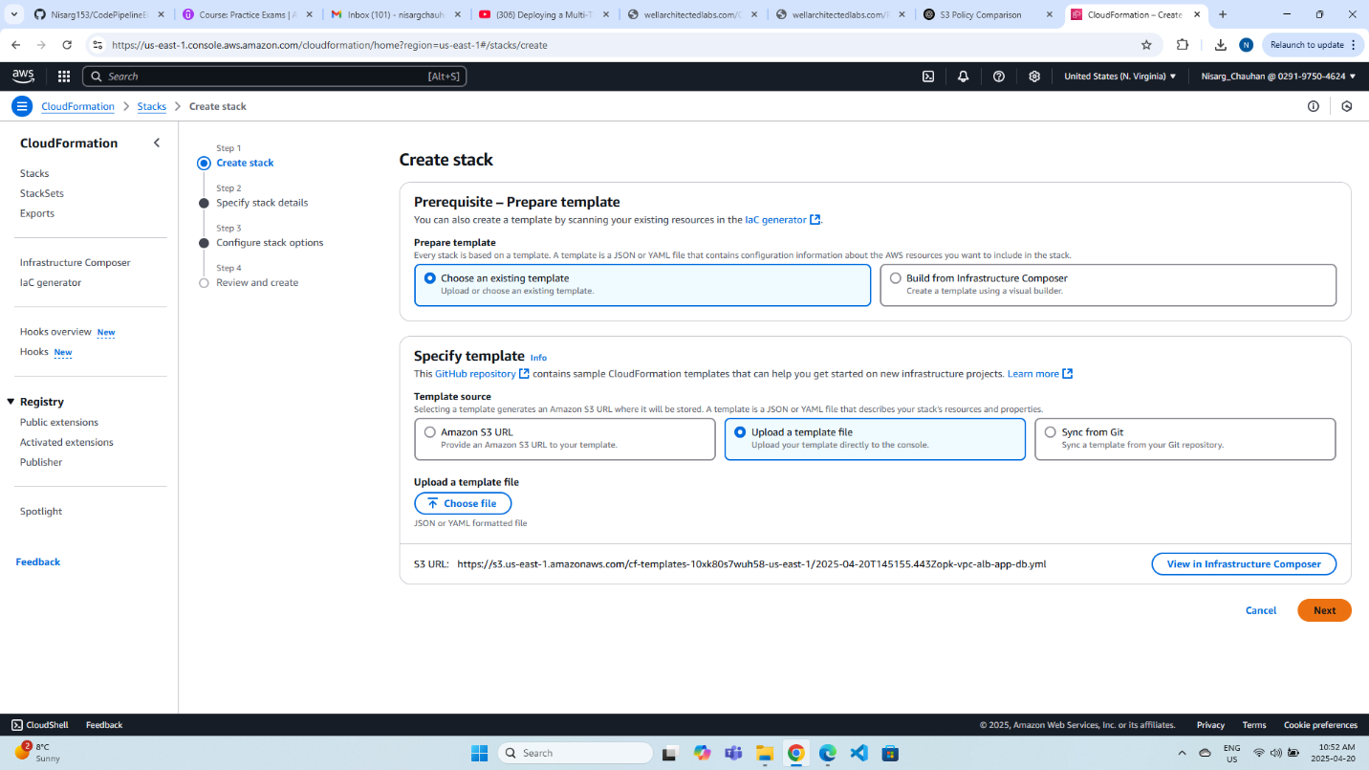

* Name the Infrastructure as WebApp1-VPC.

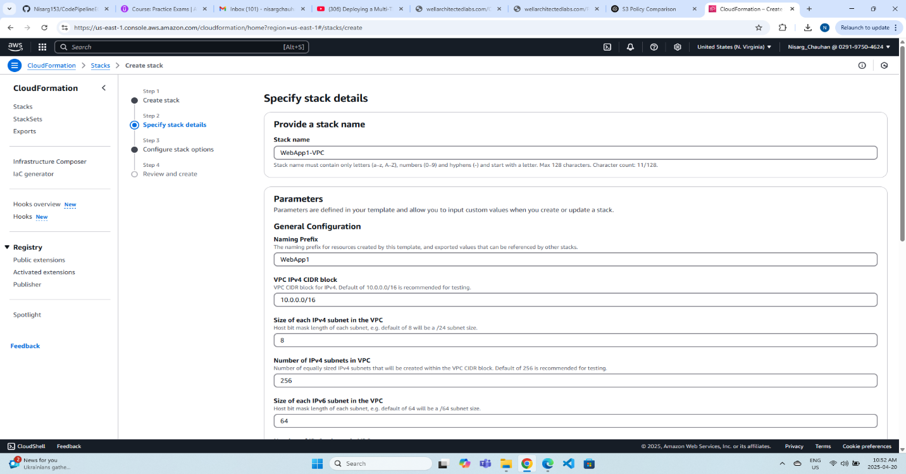

* Acknowledge the message and click next.
* Review the stack and click on submit.

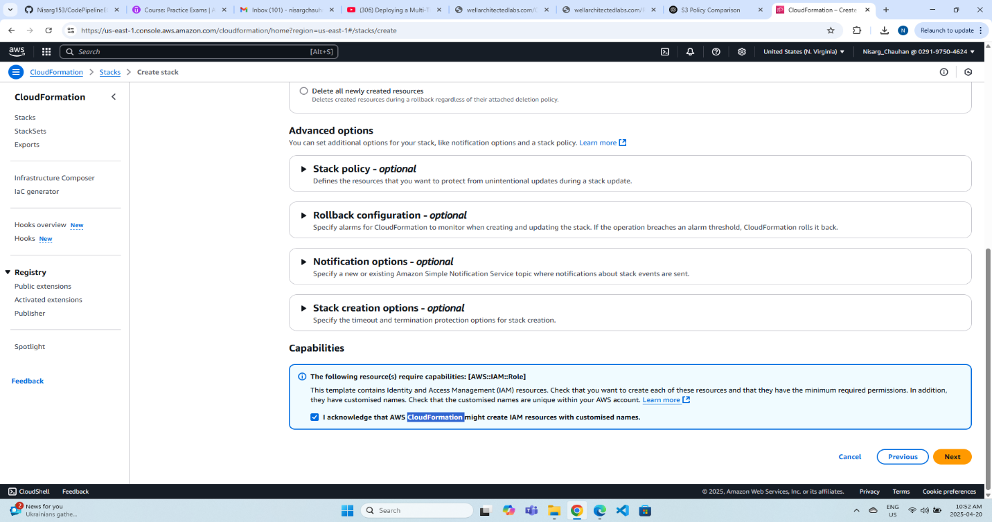

* Wait for 5 minutes and once the infrastructure is deployed, you will see the following message.

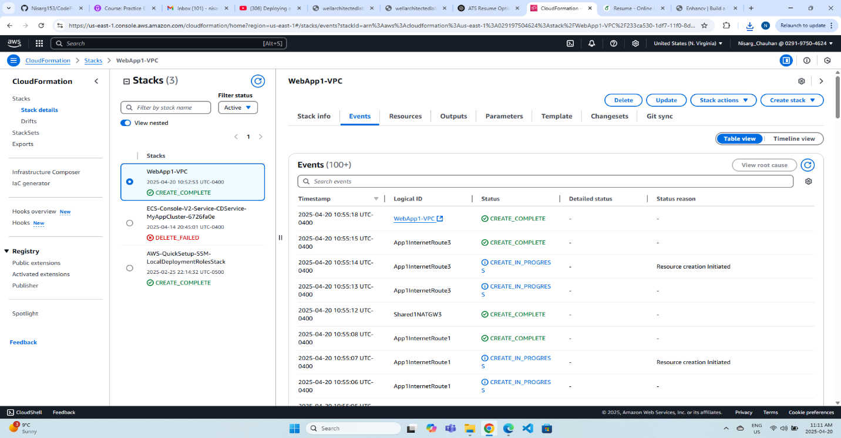

* Review the infrastructure manually.

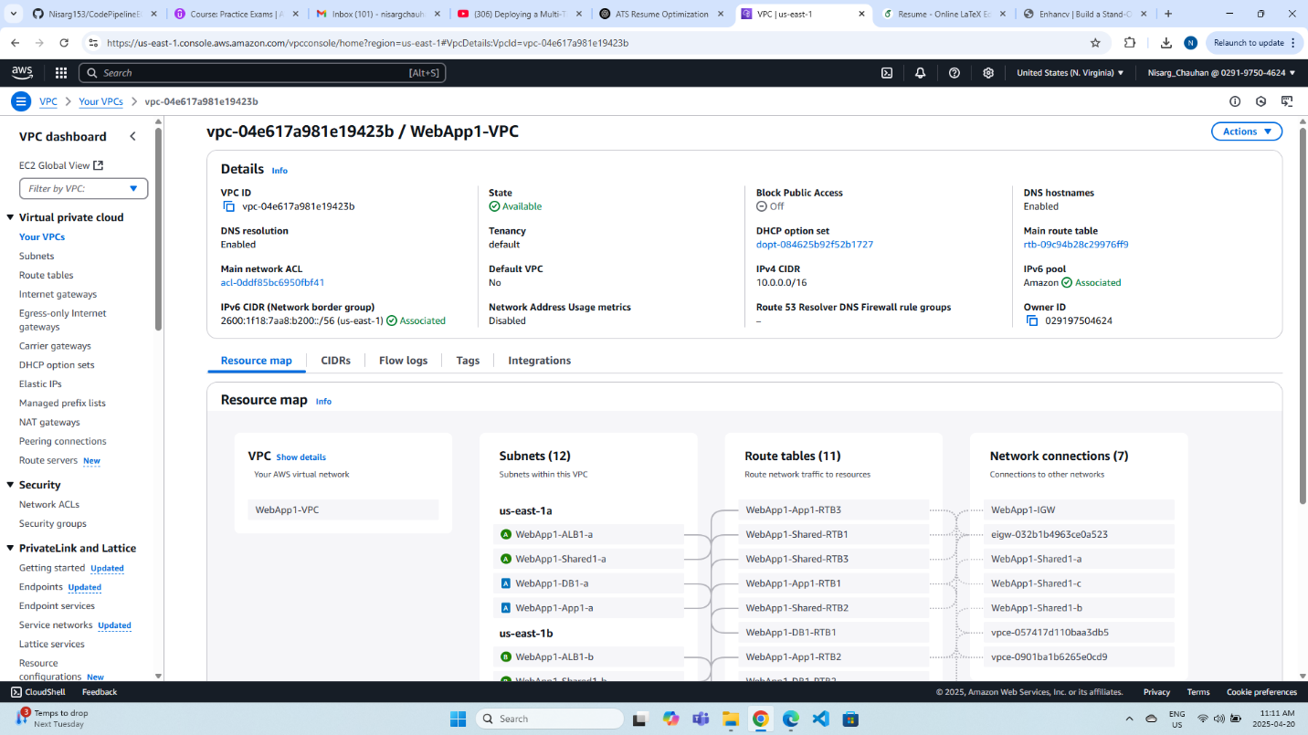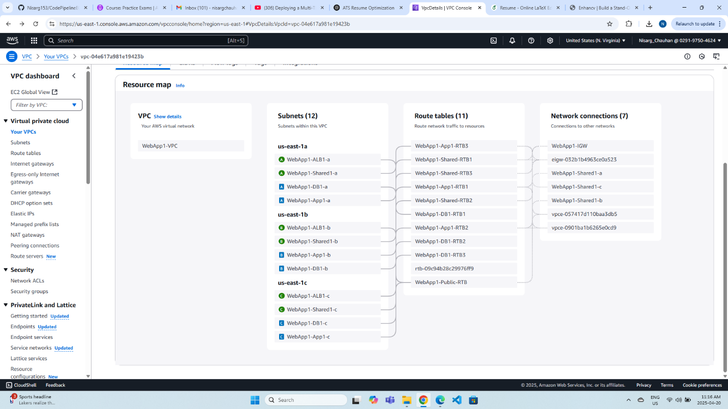

Now lets deploy the static web app using staticwebapp.yml file. Here for the deployment you have to follow the same steps as when you deployed the vpc-alb-app-db.yml file.

* Create a new stack in CloudFormation.
* Choose from an existing template.
* Upload a template.
* Click next.
* Name it as WebSampleApp.
* Click next.
* Acknowledge the message click next.
* Review the stack and click submit.

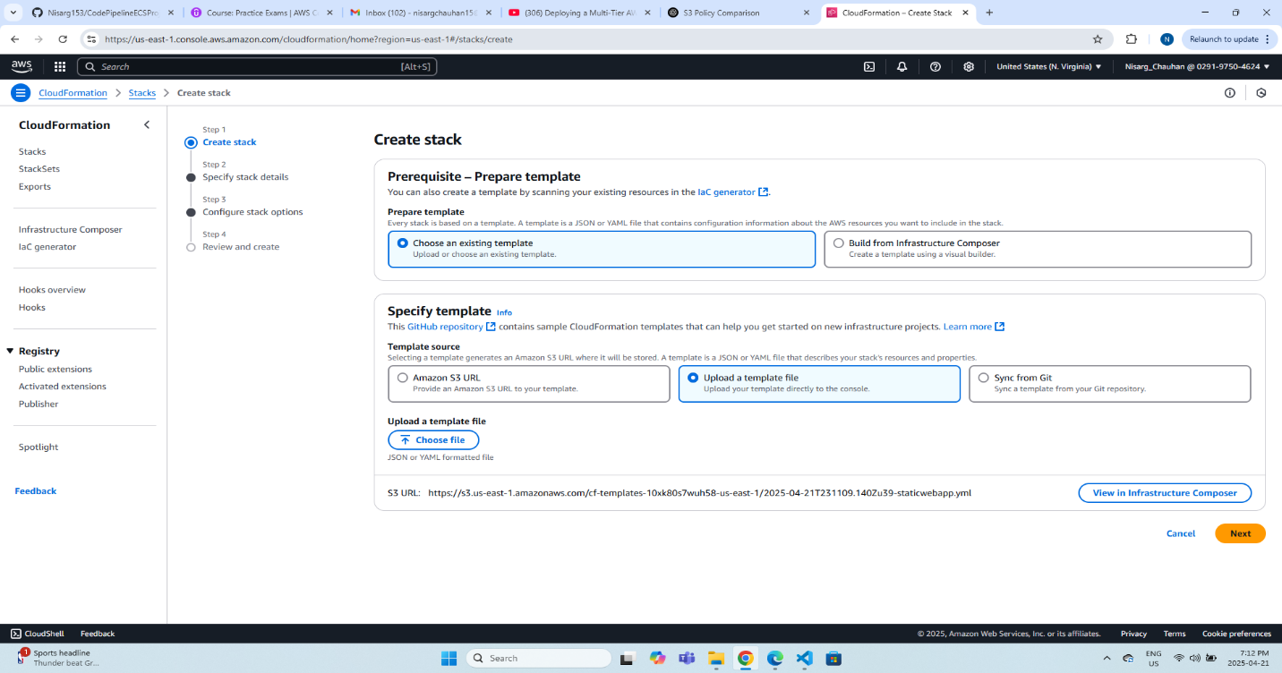

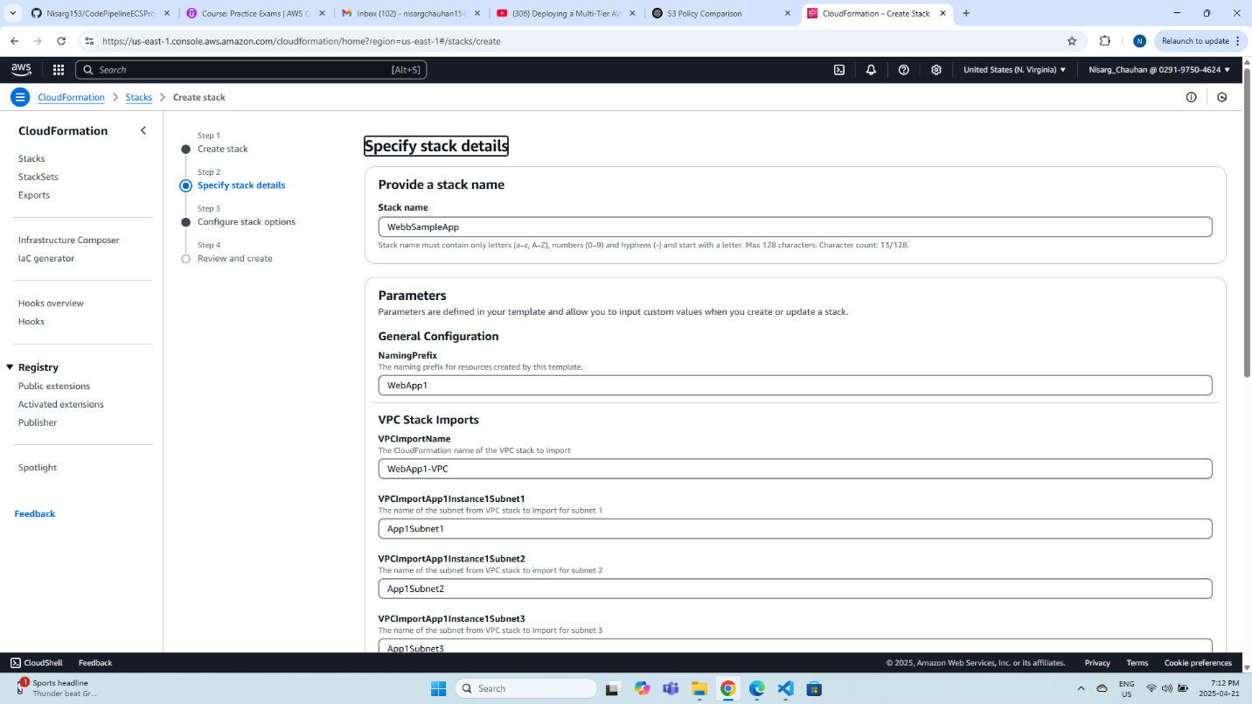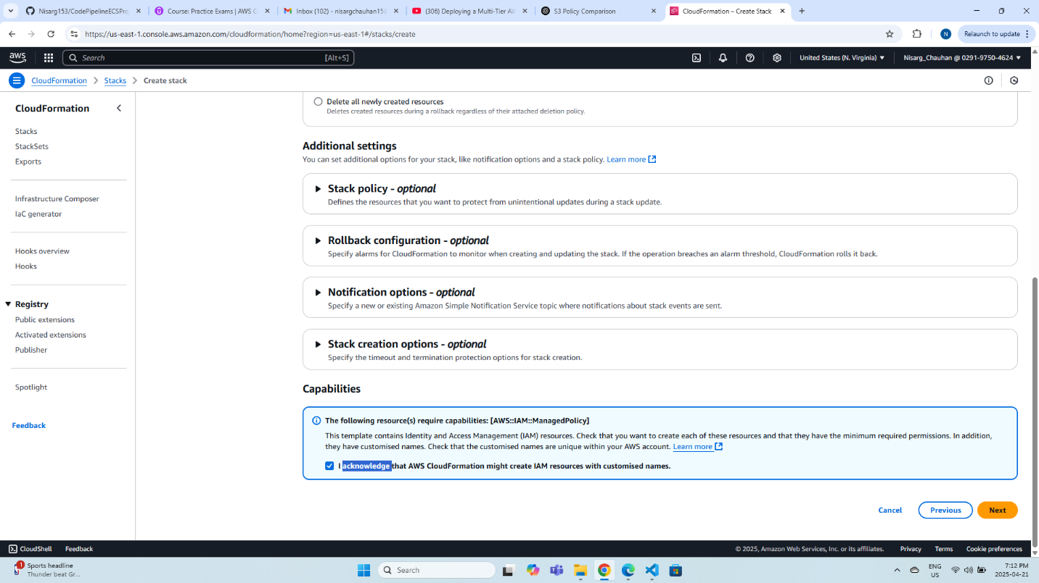

You will get the following output.

