**A Laboratory Manual for**

Computer Networks

**(3150710)**

**B.E. Semester 5**

**(Computer Engineering)**





**Directorate of Technical Education, Gandhinagar, Gujarat**

**Vishwakarma Government Engineering College Chandkheda**

**Computer Engineering Department**

**Certificate**



***This is to certify that***

***Mr./Ms. ………………………………………………………….. of class ………. Division ………, Enrollment No. ………………………. Has satisfactorily completed his/her term work in …………………………………. Subject for the term ending in ……………2023.***

***Date: -***

**Signature of Teacher Head of Department**

**Preface**

Main motto of any laboratory/practical/field work is for enhancing required skills as well as creating ability amongst students to solve real time problem by developing relevant competencies in psychomotor domain. By keeping in view, GTU has designed competency focused outcome-based curriculum for engineering degree programs where sufficient weightage is given to practical work. It shows importance of enhancement of skills amongst the students and it pays attention to utilize every second of time allotted for practical amongst students, instructors and faculty members to achieve relevant outcomes by performing the experiments rather than having merely study type experiments. It is must for effective implementation of competency focused outcome-based curriculum that every practical is keenly designed to serve as a tool to develop and enhance relevant competency required by the various industry among every student. These psychomotor skills are very difficult to develop through traditional chalk and board content delivery method in the classroom. Accordingly, this lab manual is designed to focus on the industry defined relevant outcomes, rather than old practice of conducting practical to prove concept and theory.

By using this lab manual students can go through the relevant theory and procedure in advance before the actual performance which creates an interest and students can have basic idea prior to performance. This in turn enhances pre-determined outcomes amongst students. Each experiment in this manual begins with competency, industry relevant skills, course outcomes as well as practical outcomes (objectives). The students will also achieve safety and necessary precautions to be taken while performing practical.

This manual also provides guidelines to faculty members to facilitate student centric lab activities through each experiment by arranging and managing necessary resources in order that the students follow the procedures with required safety and necessary precautions to achieve the outcomes. It also gives an idea that how students will be assessed by providing rubrics.

Utmost care has been taken while preparing this lab manual however always there is chances of improvement. Therefore, we welcome constructive suggestions for improvement and removal of errors if any.

**Practical – Course Outcome matrix**

|  |  |  |  |  |  |  |  |
| --- | --- | --- | --- | --- | --- | --- | --- |
| **Course Outcomes (COs):**   1. Familiarize with the basic taxonomy - terminologies used in networking and the layered architecture of computer networks. 2. Explain work of layers of OSI and TCP/IP model according to how they can be used to assist in network design and implementation. 3. Examine work of protocols of TCP/IP protocol suite. 4. Design network architecture, assign IP addressing and applyvarious networking algorithms 5. Implement different types of network using different tools and simulators. | | | | | | | |
| **Sr. No.** | **Objective(s) of Experiment** | **Platform to be used** | **CO**  **1** | **CO**  **2** | **CO**  **3** | **CO**  **4** | **CO**  **5** |
| 1. | Study of different network devices in detail | Network Devices | **√** |  |  |  |  |
| 2. | Study of different types of network cables and practically implement the cross-wired cable and straight through cable using clamping tool. | Cables, Clamping tool, Connectors | **√** |  |  |  | **√** |
| 3. | Perform basic network command and Network configuration commands | Computer | **√** |  |  |  |  |
| 4. | Implement different LAN topologies using Network Simulator | Cisco Packet tracer |  |  |  |  | **√** |
| 5. | Implement the concept of VLAN using Network Simulator. | Cisco Packet tracer |  |  |  |  | **√** |
| 6. | Implement the concept of static routing. | Cisco Packet tracer |  |  |  | **√** |  |
| 7. | Implement the concept of dynamic routing (RIP, OSPF, BGP). | Cisco Packet tracer |  |  |  | **√** |  |
| 8. | To Simulate Web Server configuration using Cisco Packet tracer emulator. | Cisco Packet tracer |  | **√** |  |  |  |
| 9. | To Simulate Email Server configuration using Cisco Packet tracer emulator. | Cisco Packet tracer |  | **√** |  |  |  |
| 10. | Packet capture and header analysis by wire-shark (TCP,UDP,IP) | Wireshark |  |  | **√** |  |  |

**Industry Relevant Skills**

The following industry relevant competencies are expected to be developed in the student by undertaking the practical work of this laboratory.

1. Identify, connect various network devices.
2. Prepare LAN cable
3. Configuration network and understand protocols behaviors on simulator.

**Guidelines for Faculty members**

1. Teacher should provide the guideline with demonstration of practical to the students with all features.
2. Teacher shall explain basic concepts/theory related to the experiment to the students before starting of each practical
3. Involve all the students in performance of each experiment.
4. Teacher is expected to share the skills and competencies to be developed in the students and ensure that the respective skills and competencies are developed in the students after the completion of the experimentation.
5. Teachers should give opportunity to students for hands-on experience after the demonstration.
6. Teacher may provide additional knowledge and skills to the students even though not covered in the manual but are expected from the students by concerned industry.
7. Give practical assignment and assess the performance of students based on task assigned to check whether it is as per the instructions or not.
8. Teacher is expected to refer complete curriculum of the course and follow the guidelines for implementation.

**Instructions for Students**

1. Students are expected to carefully listen to all the theory classes delivered by the faculty members and understand the COs, content of the course, teaching and examination scheme, skill set to be developed etc.
2. Students shall organize the work in the group and make record of all observations.
3. Students shall develop maintenance skill as expected by industries.
4. Student shall attempt to develop related hand-on skills and build confidence.
5. Student shall develop the habits of evolving more ideas, innovations, skills etc. apart from those included in scope of manual.
6. Student shall refer technical magazines and data books.
7. Student should develop a habit of submitting the experimentation work as per the schedule and s/he should be well prepared for the same.

**Index**

**(Progressive Assessment Sheet)**

|  |  |  |  |  |  |  |  |
| --- | --- | --- | --- | --- | --- | --- | --- |
| **Sr. No.** | **Objective(s) of Experiment** | **Page No.** | **Date of performance** | **Date of submission** | **Assessment**  **Marks** | **Sign. of**  **Teacher with date** | **Remarks** |
| 1. | Study of different network devices in detail | 1 |  |  |  |  |  |
| 2. | Study of different types of network cables and practically implement the cross-wired cable and straight through cable using clamping tool. | 13 |  |  |  |  |  |
| 3. | Perform basic network command and Network configuration commands | 21 |  |  |  |  |  |
| 4. | Implement different LAN topologies using Network Simulator | 31 |  |  |  |  |  |
| 5. | Implement the concept of VLAN using Network Simulator. | 39 |  |  |  |  |  |
| 6. | Implement the concept of static routing. | 47 |  |  |  |  |  |
| 7. | Implement the concept of dynamic routing (RIP, OSPF, BGP). | 55 |  |  |  |  |  |
| 8. | To Simulate Web Server configuration using Cisco Packet tracer emulator. | 76 |  |  |  |  |  |
| 9. | To Simulate Email Server configuration using Cisco Packet tracer emulator. | 82 |  |  |  |  |  |
| 10. | Packet capture and header analysis by wire-shark (TCP,UDP,IP) | 89 |  |  |  |  |  |
| Total | | | | |  |  |  |

**Experiment No: 1**

**AIM :** **Study of different Network devices**

**Date:** 1/8/23

**Competency and Practical Skills:** Identify, connect various network devices.

**Relevant CO: CO1:** Familiarize with the basic taxonomy - terminologies used in networking and the layered architecture of computer networks

**Objectives:** (a) to observe various network devices

(b) Find out usage of each in different case with advantage and disadvantage

(c) Connect devices to establish network of two or more devices

**Equipment/Instruments:** Desktop/laptop, Hub, Switch, Router, Bridge, Gateway, Modem, Repeater, NIC

**Theory:**

Ref: http://swayam.gov.in/

Computer Networking- A Top-Down approach (6th edition), Kurose and Ross, Pearson

**Observations: (Give detailed answer of each question with required figure)**

1. **Hub:**

A hub is a physical layer networking device which is used to connect multiple devices in a network. They are generally used to connect computers in a LAN.

A hub has many ports in it. A computer which intends to be connected to the network is plugged in to one of these ports. When a data frame arrives at a port, it is broadcast to every other port, without considering whether it is destined for a particular destination or not.

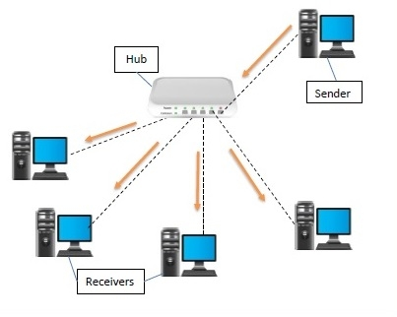

* Features of Hub:
* A hub operates in the physical layer of the OSI model.
* A hub cannot filter data. It is a non-intelligent network device that sends message to all ports.
* It primarily broadcasts messages. So, the collision domain of all nodes connected through the hub stays one.
* Transmission mode is half duplex.
* Collisions may occurs during setup of transmission when more than one computers place data simultaneously in the corresponding ports.
* Since they lack intelligence to compute best path for transmission of data packets, inefficiencies and wastage occur.
* They are passive devices, they don’t have any software associated with it.
* They generally have fewer ports of 4/12.

* Applications of Hub:
* Hub is used to create small home networks.
* It is used for network monitoring.
* They are also used in organizations to provide connectivity.
* It can be used to create a device that is available thought out of the network.
* Types of Hub:

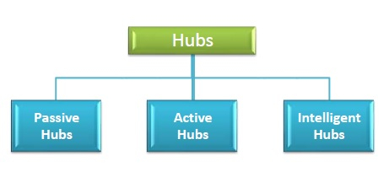

* Passive Hubs − Passive hubs connects nodes in a star configuration by collecting wiring from nodes. They broadcast signals onto the network without amplifying or regenerating them. As they cannot extend the distance between nodes, they limit the size of the LAN.
* Active Hubs − Active hubs amplify and regenerate the incoming electrical signals before broadcasting them. They have their own power supply and serves both as a repeater as well as connecting centre. Due to their regenerating capabilities, they can extend the maximum distance between nodes, thus increasing the size of LAN.
* Intelligent Hubs − Intelligent hubs are active hubs that provide additional network management facilities. They can perform a variety of functions of more intelligent network devices like network management, switching, providing flexible data rates etc.

1. **Router**:

The router is a physical or virtual internetworking device that is designed to receive, analyze, and forward data packets between computer networks.

A router examines a destination IP address of a given data packet, and it uses the headers and forwarding tables to decide the best way to transfer the packets. A router is used in LAN (Local Area Network) and WAN (Wide Area Network) environments.

A router works on the third layer of the OSI model, and it is based on the IP address of a computer. It uses protocols such as ICMP to communicate between two or more networks.

It is also known as an intelligent device as it can calculate the best route to pass the network packets from source to the destination automatically.

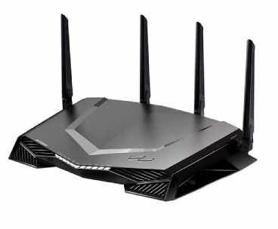

* Features of Router:
* A router works on the 3rd layer (Network Layer) of the OSI model, and it is able to communicate with its adjacent devices with the help of IP addresses and subnet.
* A router provides high-speed internet connectivity with the different types of ports like gigabit, fast-Ethernet, and STM link port.
* It allows the users to configure the port as per their requirements in the network.
* Routers' main components are central processing unit (CPU), flash memory, RAM, Non-Volatile RAM, console, network, and interface card.
* Routers are capable of routing the traffic in a large networking system by considering the sub-network as an intact network.
* Routers filter out the unwanted interference, as well as carry out the data encapsulation and decapsulation process.
* Applications of Router:
* Routers are used to connect hardware equipment with remote location networks like BSC, MGW, IN, SGSN, and other servers.
* It provides support for a fast rate of data transmission because it uses high STM links for connectivity; that's why it is used in both wired or wireless communication.
* Internet service providers widely use routers to send the data from source to destination in the form of e-mail, a web page, image, voice, or a video file. Furthermore, it can send data all over the world with the help of an IP address of the destination.
* Routers offer access restrictions. It can be configured in a way that allows for few users to access the overall data and allows others to access the few data only, which is defined for them.
* Types of Router:

**1.** **Wireless Router:** Wireless routers are used to offer Wi-Fi connectivity to laptops, smartphones, and other devices with Wi-Fi network capabilities, and it can also provide standard ethernet routing for a small number of wired network systems.

**2. Brouter:** A brouter is a combination of the bridge and a router. It allows transferring the data between networks like a bridge. And like a router, it can also route the data within a network to the individual systems. Thus, it combines these two functions of bridge and router by routing some incoming data to the correct systems while transferring the other data to another network.

**3. Core router:** A core router is a type of router that can route the data within a network, but it is not able to route the data between the networks. It is a computer communication system device and the backbone of networks, as it helps to link all network devices. It is used by internet service providers (ISPs), and it also provides various types of fast and powerful data communication interfaces.

**4. Edge router:** An edge router is a lower-capacity device that is placed at the boundary of a network. It allows an internal network to connect with the external networks. It is also called as an access router. It uses an External BGP (Border Gateway Protocol) to provides connectivity with remote networks over the internet.

**5. Broadband routers:** Broadband routers are mainly used to provide high-speed internet access to computers. It is needed when you connect to the internet through phone and use voice over IP technology (VOIP).

1. **Bridge**

Bridges are used to connect two subnetworks that use interchangeable protocols. It combines two LANs to form an extended LAN. The main difference between the bridge and repeater is that the bridge has a penetrating efficiency.

A bridge accepts all the packets and amplifies all of them to the other side. The bridges are intelligent devices that allow the passing of only selective packets from them.

A bridge only passes those packets addressed from a node in one network to another node in the other network.

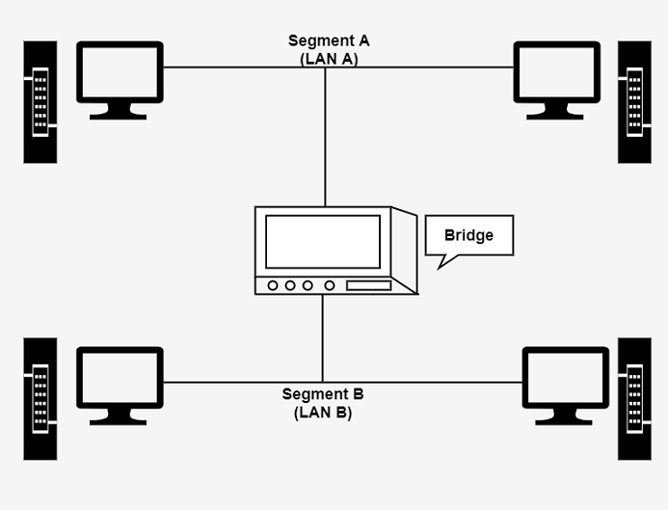

* **Features of Bridge**:

* **Network Expansion**– Increases the number of attached workstations and network segments.
* **Frame Buffering**– Enables to interconnect different segments which use different MAC protocols as frames are buffered.
* **Transparency**– Works at the MAC layer and hence are transparent to higher level protocols.
* **Reliability**– Increases network reliability and makes the network easier to maintain by subdividing LAN into smaller segments which reduces congestion.
* **Speed**– Is slow as compared to a repeater as it introduces delays due to buffering of frames.
* **Overload**– Overloads during periods of high traffic.
* **Expensive**– More expensive than repeaters.
* **No filtering**– Provides no filtering of the [broadcast](http://www.learnabhi.com/difference-between-unicast-multicast-broadcast/) frames.
* **Applications of Bridge:**
* Bridges are used to divide large networks into smaller groups, networks or segments which helps to reduce traffic in each segment.
* Bridges are used to extend the range of the network by connecting two or more physically separated segments.
* Bridges provide security as it separates different parts of networks from each other.
* Bridges provide network redundancy by connecting two or more paths between different network segments.
* Bridges are used to forward frames without changing the source or destination addresses.
* **Types of Bridge:**

There are generally three types of Bridges in Computer networks:

* + - 1. **Transparent Bridge:** It's an invisible computer network bridge, as the name implies. This bridge's primary function is to block or forward data based on the MAC address. The other devices in the network are entirely unaware that bridges exist. These are the most common bridges, and they work transparently for all networks connected to hosts.
      2. **Source-Route Bridge:** It decides the route between two hosts. The entire frame route is contained within a single frame in this bridge. As a result, the bridge will make precise decisions about how the structure will be forwarded over the network.
      3. **Translational bridge:** Translational bridges are a type of network bridge that can translate between various network protocols. This enables devices on different networks to communicate with one another, even if they are using different protocols.

1. **Gateway:**

A gateway is a network node that forms a passage between two networks operating with different transmission protocols. The most common type of gateways, the network gateway operates at layer 3, i.e. network layer of the OSI (open systems interconnection) model.

However, depending upon the functionality, a gateway can operate at any of the seven layers of OSI model. It acts as the entry – exit point for a network since all traffic that flows across the networks should pass through the gateway.

* **Features of Gateway:**
* Gateway is located at the boundary of a network and manages all data that inflows or outflows from that network.
* It forms a passage between two different networks operating with different transmission protocols.
* A gateway operates as a protocol converter, providing compatibility between the different protocols used in the two different networks.
* The feature that differentiates a gateway from other network devices is that it can operate at any layer of the OSI model.
* It also stores information about the routing paths of the communicating networks.

* **Applications of Gateway:**
* Internet Connectivity
* Enterprise Networks
* Protocol Conversion
* IoT Connectivity
* **Types of Gateway:**

1. **Unidirectional Gateways −** They allow data to flow in only one direction. Changes made in the source node are replicated in the destination node, but not vice versa. They can be used as archiving tools.
2. **Bidirectional Gateways −** They allow data to flow in both directions. They can be used as synchronization tools.
3. **Modem**

* Modem stands for Modulator and Demodulator. It is a device that modulates signals to encode digital information for transmission and demodulates signals to decode the transmitted information.
* A modem transmits data in bits per second (bps).It is necessary for communication between digital devices and Analog devices.
* Modem is necessary because it acts as a translator between the devices and rapidly transmits the information.It converts the digital signal to Analog and vice versa to communicate between devices.
* It encodes the signal and decodes at the other end and vice versa between the devices.

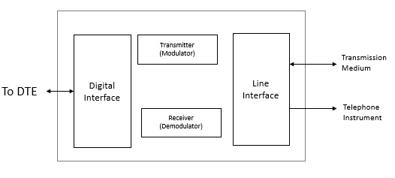

* **Features of Modem:**
* They have high uploading and communication rates. An X2 modem provides an uploading bandwidth between 28.8 to 56 Kbps.
* They are upgradeable through a software patch to meet almost any universal standard.
* They can detect callers originating telephone number, and thus they can serve as caller ID.
* Some modems provide advanced voice mail features, and those modems serve as intelligent, answering machines or digital information systems.
* **Applications of Modem:**
  + - * **Data transfer:** Dial modems provide secure connections for smoothly transferring the data. These come along with the redial functionality in case a call is dropped.
      * **Reliable backup:** Modems act as a backup in the absence of stable broadband or server connection. With modems, data can be retrieved and servers can be configured even if the status of the broadband connection is not known.
      * **Remote management:** These networking devices can be installed at remote or sensitive locations. Along with that, modems help in remotely controlling certain applications. This helps in a quick resolution to issues that will otherwise require physical assessment.

* **Types of modem:**

**1. Cable Modems:** Cable modems help in establishing communication between computer and ISP over landline connection. These modems allow the access to high-speed data with the help of a cable TV (CATV) network.

**2. Telephone Modems:** These modems are network devices that allow data communication between two computers over voice-grade telephone lines. Telephone modems convert bits to analog signals for transmission through physical channels.

**3. Satellite Modems:** These modems provide an internet connection with the help of satellite dishes. They transfer input bits into output radio signals. It then executes the vice versa. These modems are more reliable for providing an internet network in comparison with other modems.

**4. Digital Subscriber Line (DSL):** DSL are used for transmission of the digital data over telephone lines. These modems offer high-speed internet connection through telephone lines.

1. **Repeater:**

Repeaters are network devices operating at physical layer of the OSI model that amplify or regenerate an incoming signal before retransmitting it. They are incorporated in networks to expand its coverage area. They are also known as signal boosters.

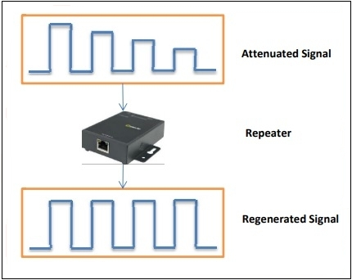

* **Types of repeaters:**

According to the types of signals that they regenerate, repeaters can be classified into two categories −

* + - 1. Analog Repeaters − They can only amplify the analog signal.
      2. Digital Repeaters − They can reconstruct a distorted signal.

According to the types of networks that they connect, repeaters can be categorized into two types −

* + - 1. Wired Repeaters − They are used in wired LANs.
      2. Wireless Repeaters − They are used in wireless LANs and cellular networks.

According to the domain of LANs they connect, repeaters can be divided into two categories −

* + - 1. Local Repeaters − They connect LAN segments separated by small distance.
      2. Remote Repeaters − They connect LANs that are far from each other.
* **Features of repeater:**
* These repeaters are linked to each other at the physical layer.
* It sends the signals for the unsteady areas to enlarge the system signals.
* These receptors linked the various network signals to convert the data between the two devices.
* These repeaters can eliminate the distance between the two devices.
* The repeaters can frequently monitor the signals that are created between the two LANs.
* Repeaters can support dynamic networking.
* Multi-site connection solutions provide the 30 repeaters linked to it.
* The IP network links all the repeaters with an IP site relation network.
* This IP network can support a fast response to any issue in the repeater network.
* These receptors can support 100 % digital communication so that they do not require to wait for analog voice calls.
* **Advantages and disadvantages of repeater:**

**Advantages of Repeaters:**

1. Repeaters are simple to install and can easily extend the length or the coverage area of networks.
2. They are cost effective.
3. Repeaters don’t require any processing overhead. The only time they need to be investigated is in case of degradation of performance.
4. They can connect signals using different types of cables.

**Disadvantages of Repeaters:**

1. Repeaters cannot connect dissimilar networks.
2. They cannot differentiate between actual signal and noise.
3. They cannot reduce network traffic or congestion.
4. Most networks have limitations upon the number of repeaters that can be deployed.
5. **NIC:**

A network interface card (NIC) is a hardware component without which a computer cannot be connected over a network. It is a circuit board installed in a computer that provides a dedicated network connection to the computer. It is also called network interface controller, network adapter, or LAN adapter.

NIC allows both wired and wireless communications.NIC allows communications between computers connected via local area network (LAN) as well as communications over large-scale network through Internet Protocol (IP).

NIC is both a physical layer and a data link layer device, i.e. it provides the necessary hardware circuitry so that the physical layer processes and some data link layer processes can run on it.

* **Types of NIC:**

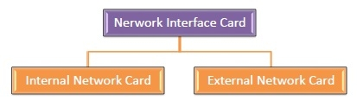

### Internal Network Cards:

### In internal networks cards, motherboard has a slot for the network card where it can be inserted. It requires network cables to provide network access.

### Internal network cards are of two types. The first type uses Peripheral Component Interconnect (PCI) connection, while the second type uses Industry Standard Architecture (ISA).

**External Network Cards:**

In desktops and laptops that do not have an internal NIC, external NICs are used. External network cards are of two types: Wireless and USB based.

Wireless network card needs to be inserted into the motherboard, however no network cable is required to connect to the network. They are useful while traveling or accessing a wireless signal.

* **Features of NIC:**
* Share bulk data among many users
* Connect peripheral devices using many ports
* Connect a remote computer
* Enable data flow
* **Applications of NIC:**
* Exchanging data over a network, such as documents, images, and
* files
* Connecting to wireless communication devices, such as firewalls,
* bridges, and repeaters
* Connecting to wired communication devices, such as hubs,
* switches, routers, and smartphones

**Quiz:**

1. Find out the cases where above devices are used?

2. Differentiate each device?

3. Give approximate cost of each device with name of 2 manufactures.

# References used by the students:

* Tutorialspoint:

<https://www.tutorialspoint.com/communication_technologies/communication_technologies_network_devices>

* GeeksForGeeks:

<https://www.geeksforgeeks.org/network-devices-hub-repeater-bridge-switch-router-gateways/>

# Rubric wise marks obtained:

|  |  |  |  |  |  |  |  |  |  |  |  |
| --- | --- | --- | --- | --- | --- | --- | --- | --- | --- | --- | --- |
| Rubrics | Practical Understanding | | Problem Solving | | Task Execution | | Documentation and Reporting | | Ethical and Professional Conduct | | Total |
| Good (2) | Avg.(1) | Good (2) | Avg. (1) | Good (2) | Avg. (1) | Good (2) | Avg.(1) | Good (2) | Avg. (1) |
| Marks |  |  |  |  |  |  |  |  |  |  |  |