INVENTORY PLANNING FOR COVID-19 SUPPLIES

Project for the degree of

MSc (Integrated) AIML/DS

Sem -6

by

LEUVA NISARG HIMANSHUKUMAR

SHASTRI MOHIT PRAVINKUMAR

Under the guidance of

DR. NITA H.SHAH

Submitted to

|  |  |
| --- | --- |
|  |  |

Department of AIML/DS

School of Emerging Science & Technology

Gujarat University

April - 2025

* **Table of Contents:**

|  |  |
| --- | --- |
| Title: | Page Number: |
| Abstract | 3 |
| Introduction | 4 |
| Objective | 5 |
| Constrains | 6 |
| Literature Review | 7 |
| Methodology | 9 |
| Conclusion | 16 |
| References | 17 |

* **Abstract:**

This study represents an Inventory Problem Method to maintain stock levels as efficiently as possible. The model is based on the analysis of Re-order Point (ROP) and Economic Order Quantity (EOQ). EOQ determines how many units to order in each cycle of replenishment in order to keep overall inventory costs as low as possible. While Re-order Point (ROP) determines when inventory should be replenished to maintain stock levels and prevent shortages, Visual tools such as pie and bar charts were used to manage inventory effectively.

* **Introduction:**
* The COVID-19 Virus led to a sudden rise in demand for critical supplies like Personal Protective Equipment (PPE) and Ventilators.
* Managing these supplies became difficult due to unexpected demand and limited resources.
* During the pandemic, hospitals struggled with severe shortages of PPE for healthcare workers and had to ration ventilators, putting lives at risk. This showed how important it is to manage inventory efficiently, especially in emergencies.
* Traditional inventory methods, which depend on steady demand and predictable delivery times, couldn’t keep up with the sudden changes.
* This study aims to solve that problem by using Re-order Point (ROP) and Economic Order Quantity (EOQ) methods to create a more flexible inventory system.
* The goal is to ensure a steady supply of essential medical equipment, reduce shortages, and make sure resources are distributed fairly, all while keeping costs and storage limitations in check.
* **Objective:**
* The goal of this project is to minimize stock shortage for a hospital by calculating Re-order Point (ROP) and Economic Order Quantity (EOQ) using Inventory Problems Method. Focused on minimizing inventory cost by finding optimal order quantities and timing to balance supply with demand fluctuations.
* Minimizing stock shortage ensures that:

1. **Reliable Supplies:** Doctors, nurses and patients always have the equipment they need.
2. **Efficient Workflow:** Fewer rush orders keep operations smooth.
3. **Cost Savings:** Avoiding emergency orders reduces extra expenses.
4. **Ready for Crises:** A flexible system adjusts to unexpected situations, preventing shortages when it matters most.

* **Constrains:**

**1.Unpredictable Demand:**

The need for PPE kits and ventilators keeps changing because of the COVID-19 outbreak, making it hard to predict how much stock is needed.

**2.Delivery Delays:**

Lockdowns and restrictions cause delays in getting new supplies, making it difficult to restock on time.

**3. Limited Storage Space:**

Hospitals don’t have unlimited storage. Keeping too much stock increases storage costs, while keeping too little can lead to shortages.

**4. Managing Costs:**

Ordering too often increases costs, but ordering in bulk can lead to high storage expenses. Finding the right balance is key.

* **Literature Review:**
* The problem of minimizing stock shortages has been a critical area of study in Inventory Problems.
* Many studies and reports have looked at how healthcare supplies are managed during pandemics. They provide useful insights on predicting demand, keeping supply chains strong, and making sure there’s enough stock when it’s needed. Here are the main points:

1. **Global Experiences:** Research on how the supply chains worked in the U.S., Europe, and Asia during COVID-19 shows that keeping control in one place, tracking supplies in real time, and being flexible in purchasing are all very important.
2. **Predicting Needs:** Studies have found that using data and artificial intelligence to predict how much PPE, ventilators, and other supplies will be needed can really help avoid shortages during a crisis.
3. **Keeping the Supply Chain Strong:** Other research emphasizes that having several suppliers, setting up emergency stockpiles, and distributing supplies through different channels can make the supply chain more robust.
4. **Facing Challenges:** Finally, reports also mention some challenges, like dealing with transportation issues, navigating regulations, and handling tough ethical decisions about who gets supplies first.

* **Methodology:**

1. **Data Input:**

* Data Sources:
* Two CSV files are used:
  1. **PPE KIT data**
  2. **Ventilator data**
  3. These CSV files were obtained from **[Solar hospital records]**.Each file contains monthly records with fields such as **stock level**, **demand**, **lead time**, and **safety stock**.
* Data Fields:
* **Stock Levels**: Represents the current inventory of each item (PPE kits and ventilators).
* **Demand**: Monthly demand for each item.
* **Lead Time**: The number of weeks required from placing an order to receiving it.
* **Safety Stock**: Calculated based on Google, which is 20% of RE-order without safety stock for PPE and Ventilator.
* **Data Source:**
* **PPE KIT DATA:**

|  |  |  |  |  |  |
| --- | --- | --- | --- | --- | --- |
| **Month** | **Stock (PPE)** | **Demand (PPE)** | **Lead Time (PPE)** | **Safety Stock (PPE)** | **RE-order without safety stock** |
| April | 50000 | 12500 | 2 | 5000 | 25000 |
| May | 37500 | 7550 | 1 | 1510 | 7550 |
| June | 29950 | 5000 | 1 | 1000 | 5000 |
| July | 44950 | 7000 | 1 | 1400 | 7000 |
| August | 37950 | 4000 | 2 | 1600 | 8000 |
| September | 62390 | 10000 | 2 | 4000 | 20000 |
| October | 52390 | 6000 | 2 | 2400 | 12000 |
| **1:re order without=demand * lead time** | | | |  |  |
| **2:ss=(0.2*re-order without)** | | |  |  |  |

* **Ventilator Data:**

|  |  |  |  |  |  |
| --- | --- | --- | --- | --- | --- |
| **Month** | **Stock** | **Demand** | **Lead Time** | **Safety Stock** | **RE-order without safety stock** |
| April | 25000 | 7000 | 2 | 2800 | 14000 |
| May | 18000 | 5000 | 1 | 1000 | 5000 |
| June | 13000 | 8000 | 1 | 1600 | 8000 |
| July | 19000 | 1000 | 1 | 2000 | 10000 |
| August | 14000 | 4000 | 2 | 1600 | 8000 |
| September | 10000 | 6000 | 2 | 2400 | 12000 |
| October | 12000 | 2000 | 2 | 4000 | 20000 |

1. **Inventory Calculations:**

**I. Total Demand, Stock, and Safety Stock:**

* Sum the relevant columns for each item (PPE and Ventilators) to obtain **Total Stock**, **Total Demand**, and **Total Safety Stock** over the period.
* For PPE:

Total PPE Stock: 315130.0 Units Total Ventilator Stock: 111000 Units.

Total Ventilator Demand:(R) 33000 Units.

Total Ventilator Safety Stock: 15400 Units.

Ordering Cost (A): Rs 25000 Per Order.

Holding Cost(h): Rs 0.24 Per Unit.

Lead Time: 2 Days.

* For Ventilators:

Total PPE Demand(R): 52050.0 Units

Total PPE Safety Stock: 16910.0 Units

Ordering Cost (A): Rs 800 Per Order

Holding Cost(h): Rs 0.22 Per Unit

Lead Time: 4 Days

**II. Calculates EOQ with the formula:**

where, EOQ = $\sqrt{\frac{2AR}{h}}$

**R = Total Demand**

**A = Ordering Cost**

**h = Holding Cost**

* This determines the Economic Order Quantity (EOQ) that minimizes the cost of ordering and holding inventory.

**III. Calculates Re-Order Point (ROP) with the formula:**

$$\text{ROP}=\left(Total Demand * Lead Time\right)+ Total Safety Stock$$

* This indicates when to place a new order to restock the inventory.
* ROP and EOQ for PPE:

Reorder Point (ROP): 225110 units

The inventory should be replenished when the stock level drops to 225110 units of PPE kits.

The Economic Order Quantity (EOQ) is Approximately 19456 Units

We should order approximately 19456 units of PPE in each replenishment cycle to

minimize total inventory costs.

* ROP and EOQ for Ventilators:

Reorder Point (ROP): 81400 units

The inventory should be replenished when the stock level drops to 81400 units of Ventilators.

EOQ (Economic Order Quantity): 82915 Units

We should order approximately 82915 units of Ventilator in each replenishment cycle

to minimize total inventory costs.

1. **Visualization:**

**I. Pie Chart:**

* **Purpose:** The pie chart visually represents the proportion of total stock between PPE and Ventilators in inventory. This helps in understanding the allocation of resources and ensuring balanced stock levels.
* **Data Representation:**

1. One segment represents PPE.
2. Another segment represents ventilators.
3. Each segment’s size is proportional to its share of the total inventory.

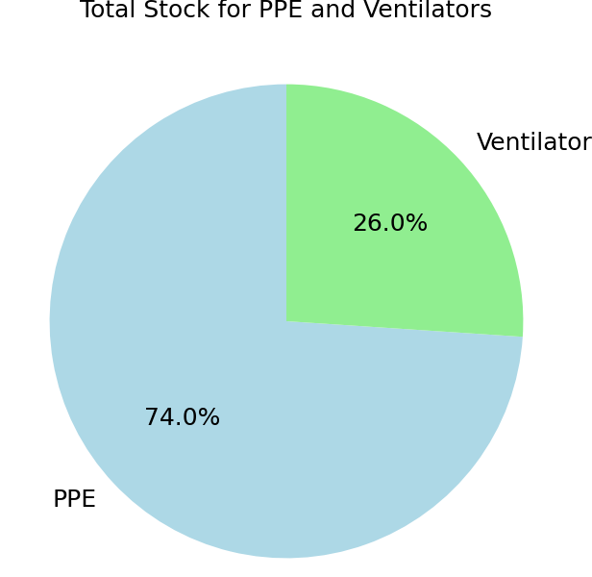

**II. Bar Chart:**  
• **Purpose:** This chart makes it easy to see if you're running low on stock. It compares the current amount of inventory with the level at which you need to order more.  
• **Data Representation:**

1. One bar shows the total stock you have for each item.
2. A matching bar shows the reorder point, which is the minimum stock level before you need to restock.
3. By looking at the chart, you can quickly tell if the current stock is below the reorder level, indicating that it is time to order more.
4. 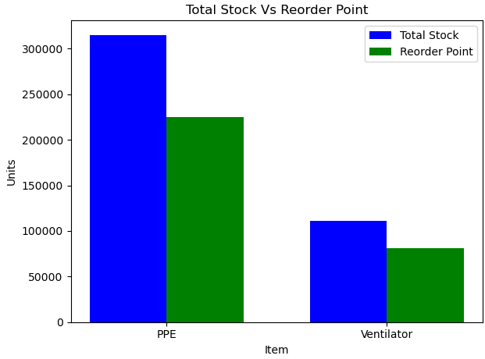Different colours are used for each category, making it easy to distinguish them at a glance.

**4. Code Structure:**

* **Data Loading –** In this step, data is gathered from Local Hospital and prepared for processing.
* **Calculate Total –** After loading, the system calculates a Total (**Demand, Stock, and Safety Stock**) to get a quick overview of the data.
* **Computation –** The data is then processed further, calculating Re-order Point (ROP) and Economic Order Quantity (EOQ).
* **Display Results –** In the final step, the results are shown as reports and charts, making it easy to understand the data and make decisions early.
* **Conclusion:**
* This study makes managing inventory for PPE and ventilators easier. It uses simple methods like calculating the reorder point (ROP) and the economic order quantity (EOQ) to help ensure there is always enough stock, so shortages are avoided.
* **Visual Insights:**
* **Pie Chart:** Clearly shows how the total stock is split between PPE and ventilators.
* **Bar Chart:** Compares current stock levels with the reorder point, making it easy to see when more supplies are needed.
* Overall, this study offers a straightforward approach to keep important supplies available while managing costs effectively.
* **References:**

1. **Istiningrum, A. A., Sono, S., & Putri, V. A.** (2021). Inventory Cost Reduction and EOQ for Personal Protective Equipment

**Retrieved from:**

[10.31334/logistik.v5i2.1880](https://doi.org/10.31334/logistik.v5i2.1880)

1. **Holistiquetraining.com.** (2024). Economic Order Quantity (EOQ): Definition, Formula & Benefits. Retrieved from:

<https://holistiquetraining.com/en/news/economic-order-quantity-eoq-definition-formula-benefits>

**3.TheSafetySourceLLC.** (2023).

Inventory Management for PPE.

Retrieved from:

<https://safetysourcellc.com/blog/inventorymanagementfor-ppe>