Mini Project Report
on
Movie Recommendation System Using Autoencoders
Submitted
by

Name of Student | Reg. No. | Roll No.
Mr. Mayank Patel | 22070760 | 45
Mr. Nayan Bhute | 22070343 | 46
Mr. Nilesh Thamke | 23030118 | 47
Mr. Nisarg Mathure | 22070331 | 48

Under the Guidance of

Prof. Shubhangi Shambarkar



October, 2025-26
Department of Artificial Intelligence and Data Science
YESHWANTRAO CHAVAN COLLEGE OF ENGINEERING, Nagpur
(An Autonomous Institution Affiliated to Rashtrasant Tukadoji Maharaj Nagpur University)
Movie Recommendation System Using Autoencoders

Problem Definition:
The goal of this mini-project is to build a Movie Recommendation System that suggests movies to users based on their preferences. The system analyzes movie features, ratings, and user interactions to generate personalized recommendations. Using machine learning techniques such as collaborative filtering, content-based filtering, or a hybrid approach, the project aims to improve user experience on streaming or review platforms.
Theory:
A Recommendation System is an intelligent system that predicts a user's preferences and suggests relevant items. Such systems are widely used in e-commerce, streaming platforms, and social media.

Types of Recommendation Systems:
- Content-Based Filtering (CBF):
  - Recommends movies similar to those a user liked before.
  - Works by comparing item features such as genre, director, cast, etc.
  - Uses similarity measures like cosine similarity or TF-IDF vectors.
- Collaborative Filtering (CF):
  - Based on the assumption that users with similar interests will rate items similarly.
  - Uses User–User or Item–Item similarity.
  - Can be implemented with Matrix Factorization (e.g., SVD).
- Hybrid Recommendation System:
  - Combines content-based and collaborative filtering for improved accuracy.
  - Reduces limitations like cold-start problems.

Key Concepts and Libraries:
- Pandas, NumPy: Data handling and preprocessing.
- Scikit-learn: Similarity measures and model building.
- Surprise or RecommenderLib: For collaborative filtering models.
- Matplotlib, Seaborn: For visualization of user ratings and recommendations.
Procedure & Execution:
- Import Libraries:
Load required Python libraries such as pandas, numpy, sklearn, and matplotlib.
- Load Dataset:
Import the dataset (e.g., movies.csv, ratings.csv) from sources like MovieLens or IMDb.
- Preprocess Data:
  - Handle missing values and duplicates.
  - Merge datasets (movies + ratings).
  - Convert categorical data into numerical form if needed.
  - Normalize rating values.
- Exploratory Data Analysis (EDA):
  - Analyze user activity, rating distribution, and popular genres.
  - Visualize with histograms and heatmaps.
- Build Recommendation Model:
  - Implement content-based filtering using cosine similarity on TF-IDF vectors of movie descriptions or genres.
  - Implement collaborative filtering using user-item matrix and SVD (Singular Value Decomposition).
  - Optionally, combine both in a hybrid model.
- Generate Recommendations:
  - Input: User ID or movie title.
  - Output: List of recommended movies with similarity scores.
- Evaluate Model:
  - Use metrics like RMSE (Root Mean Square Error) and Precision@K.
  - Visualize results with rating prediction vs. actual ratings.

Code:
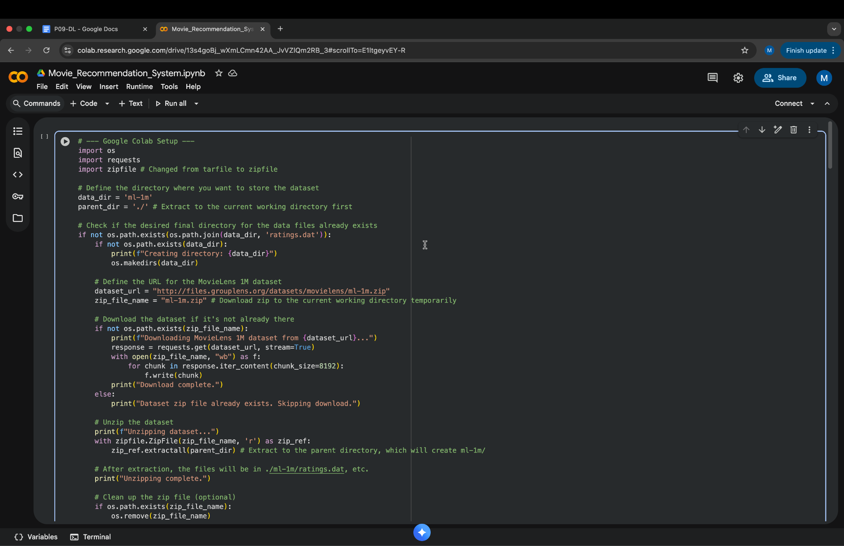
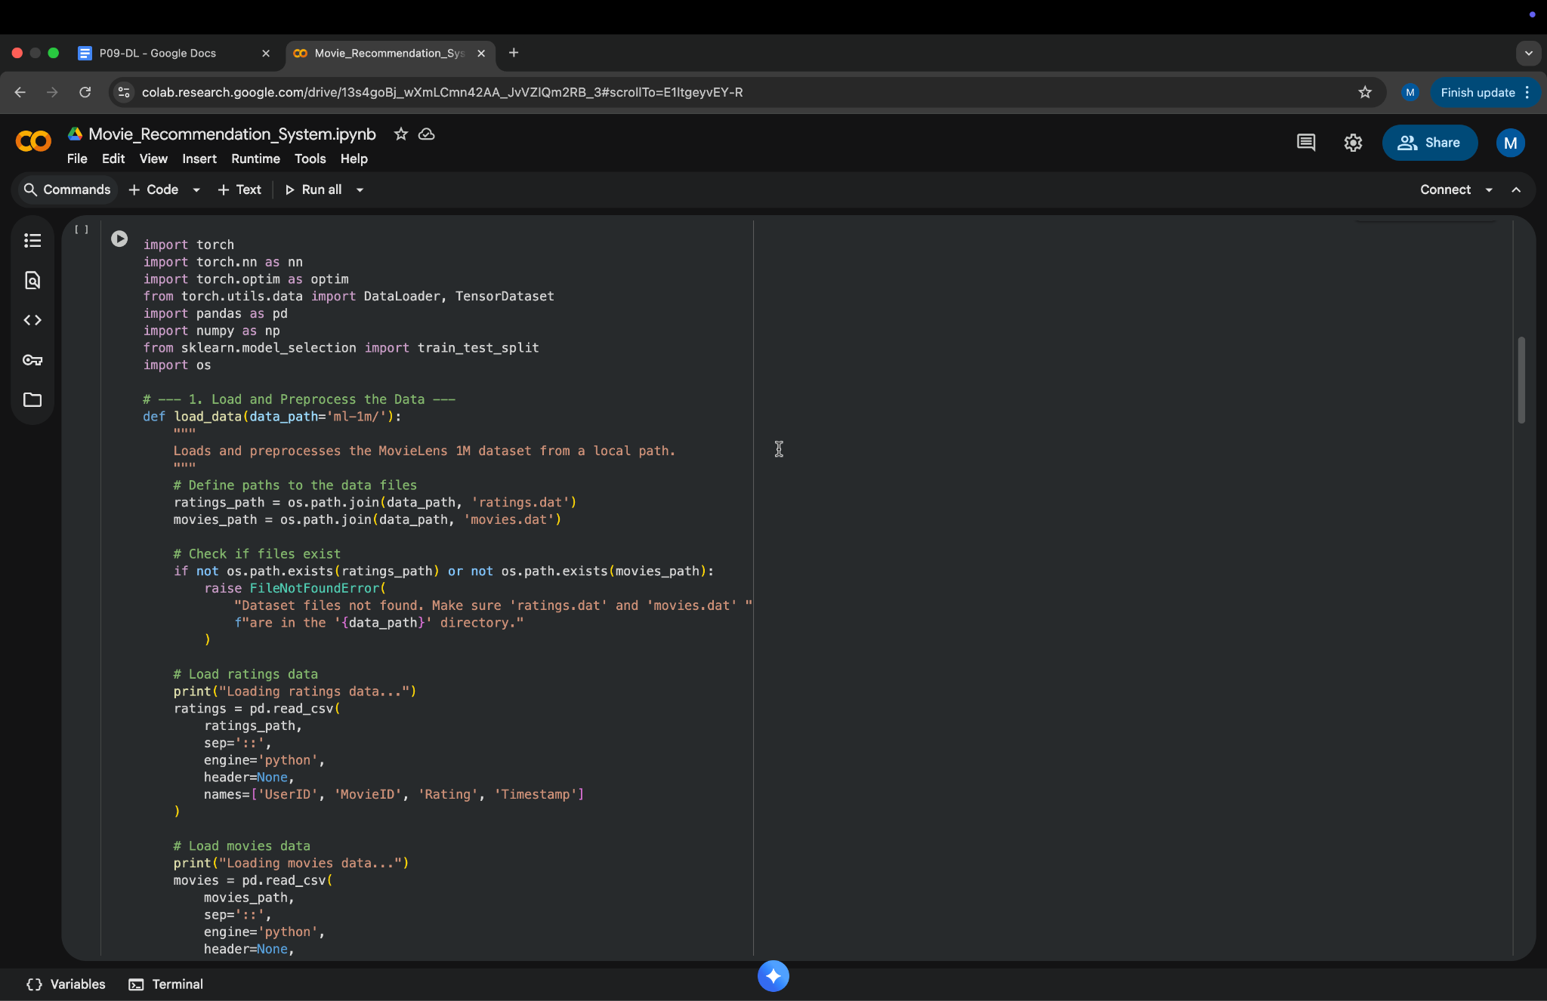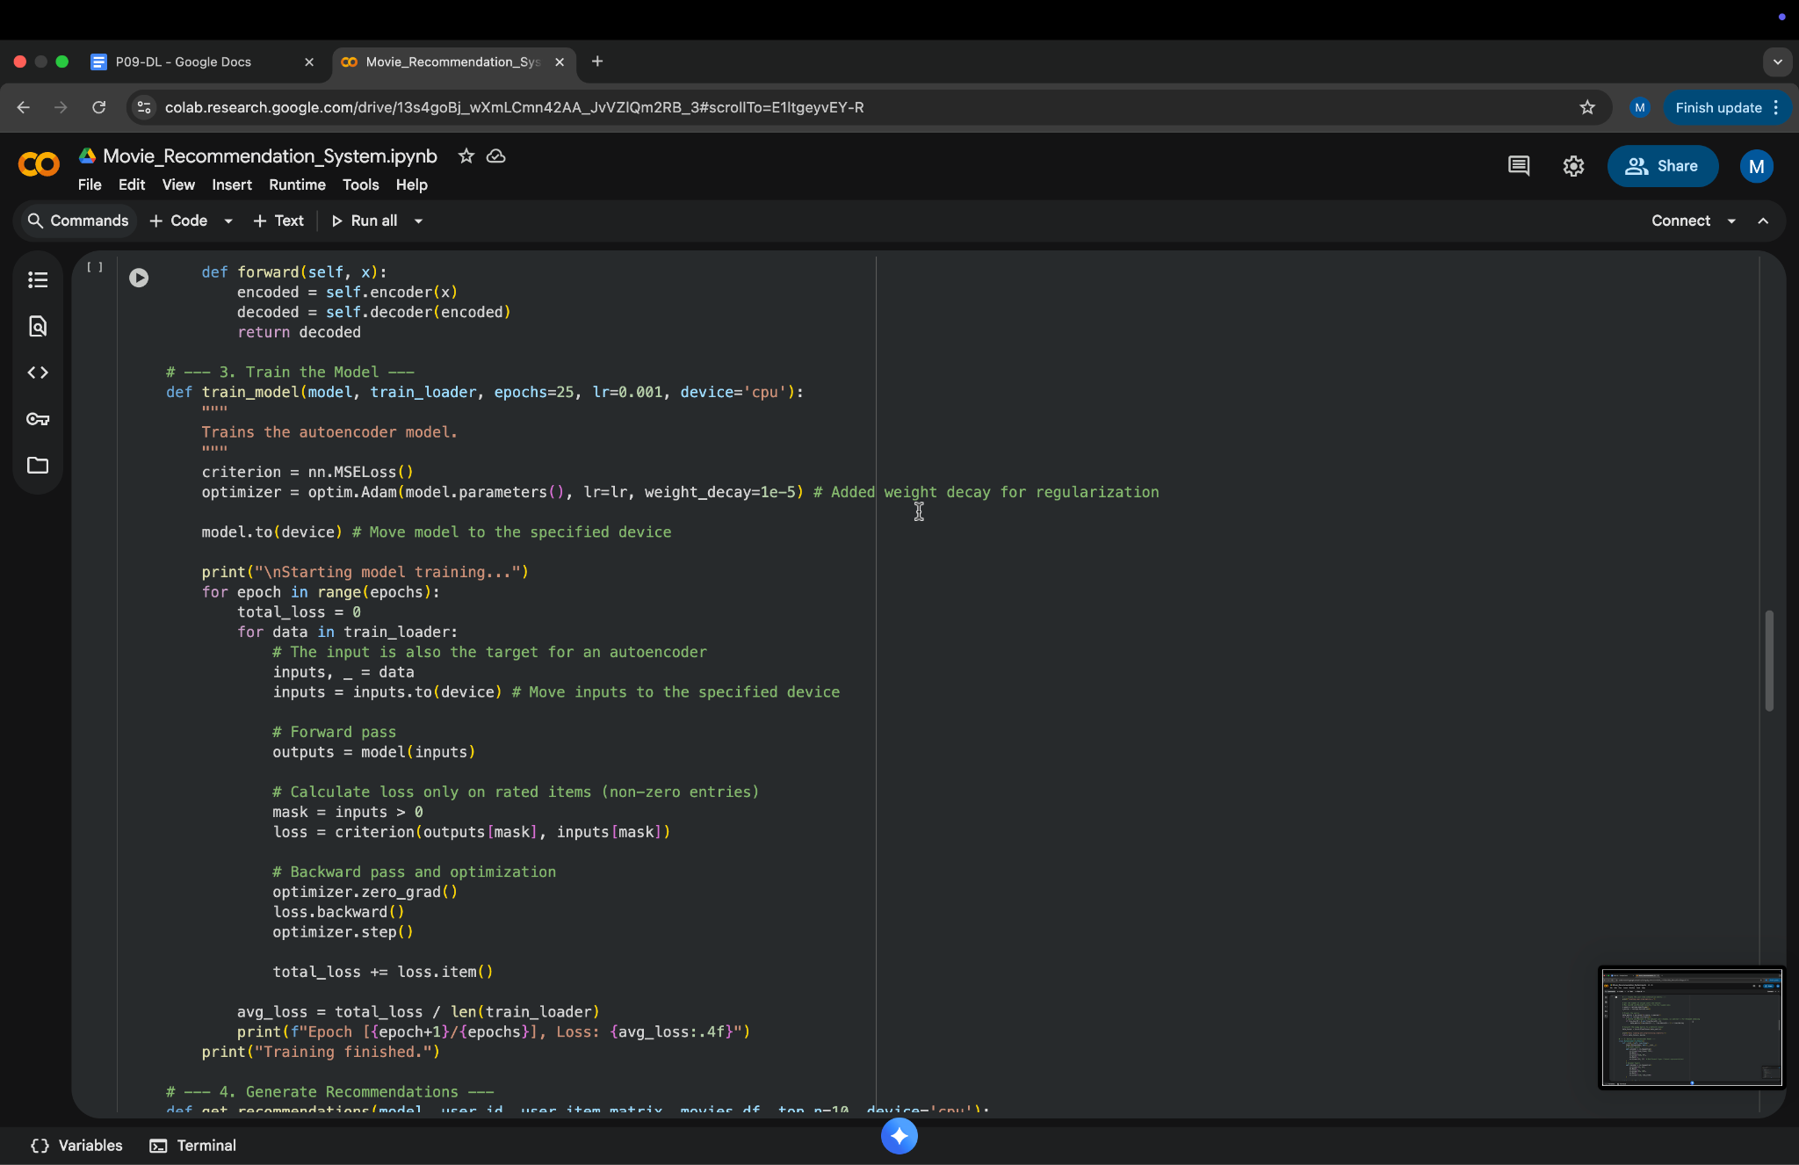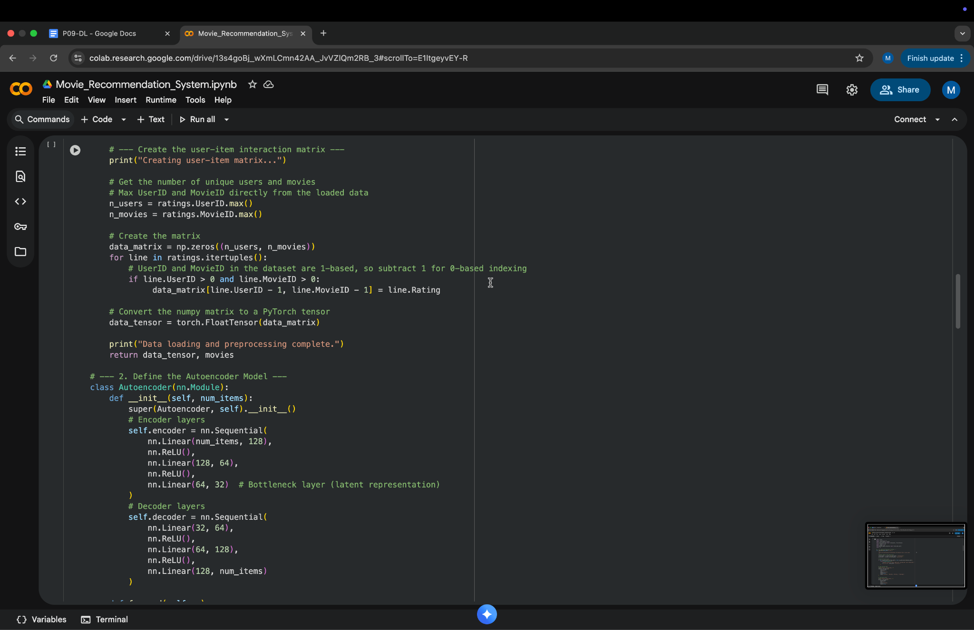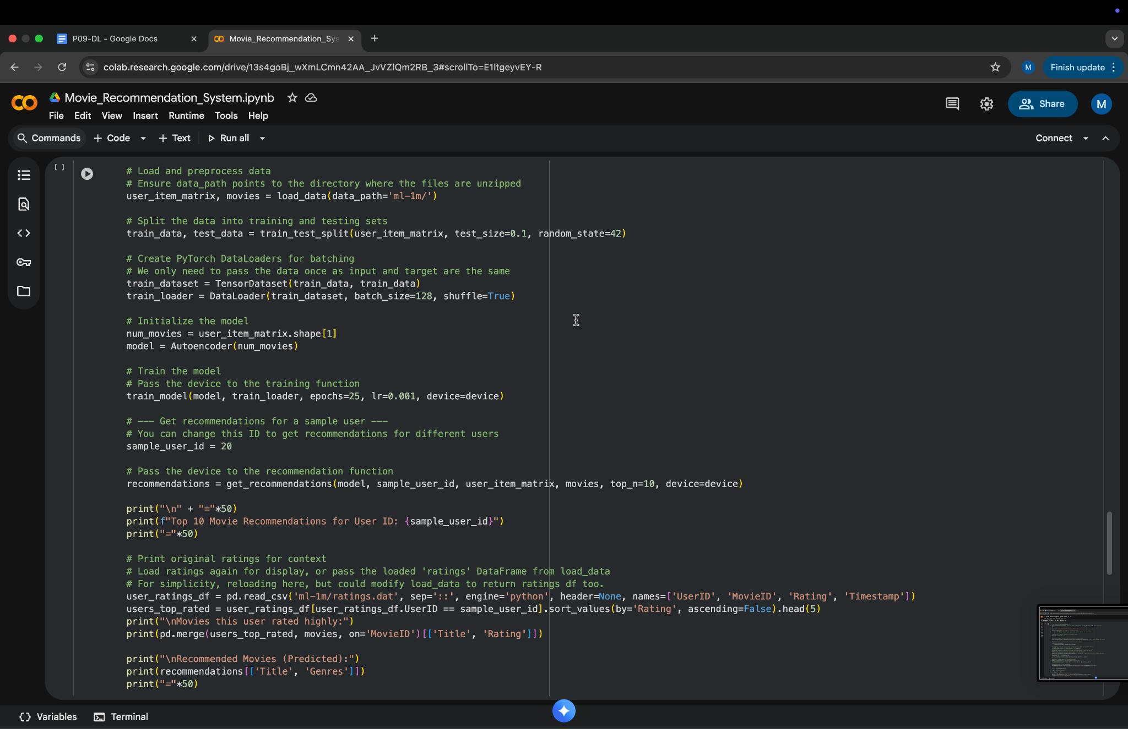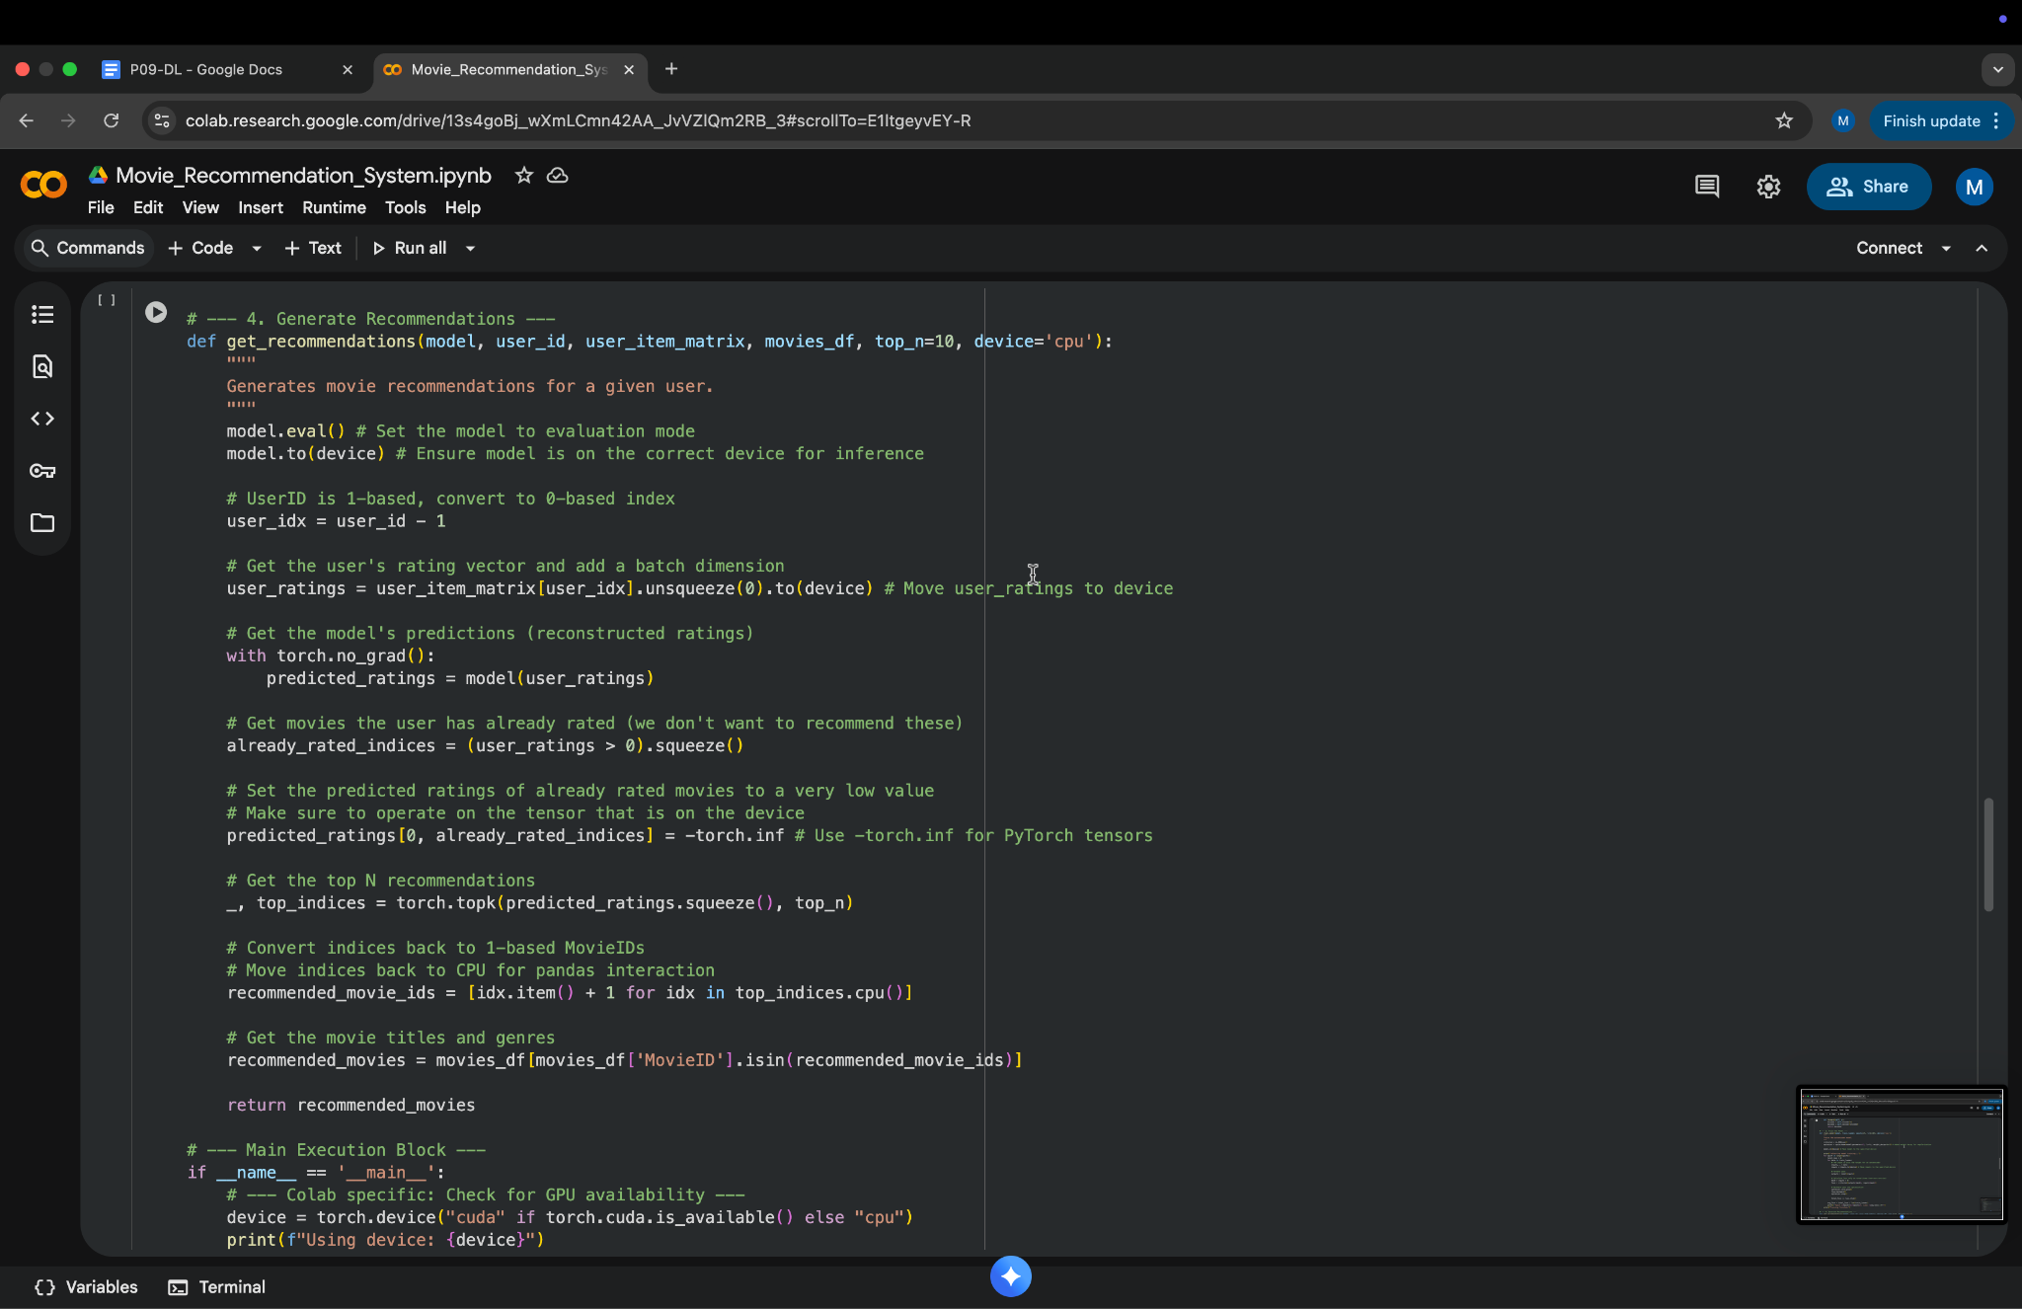

Output:
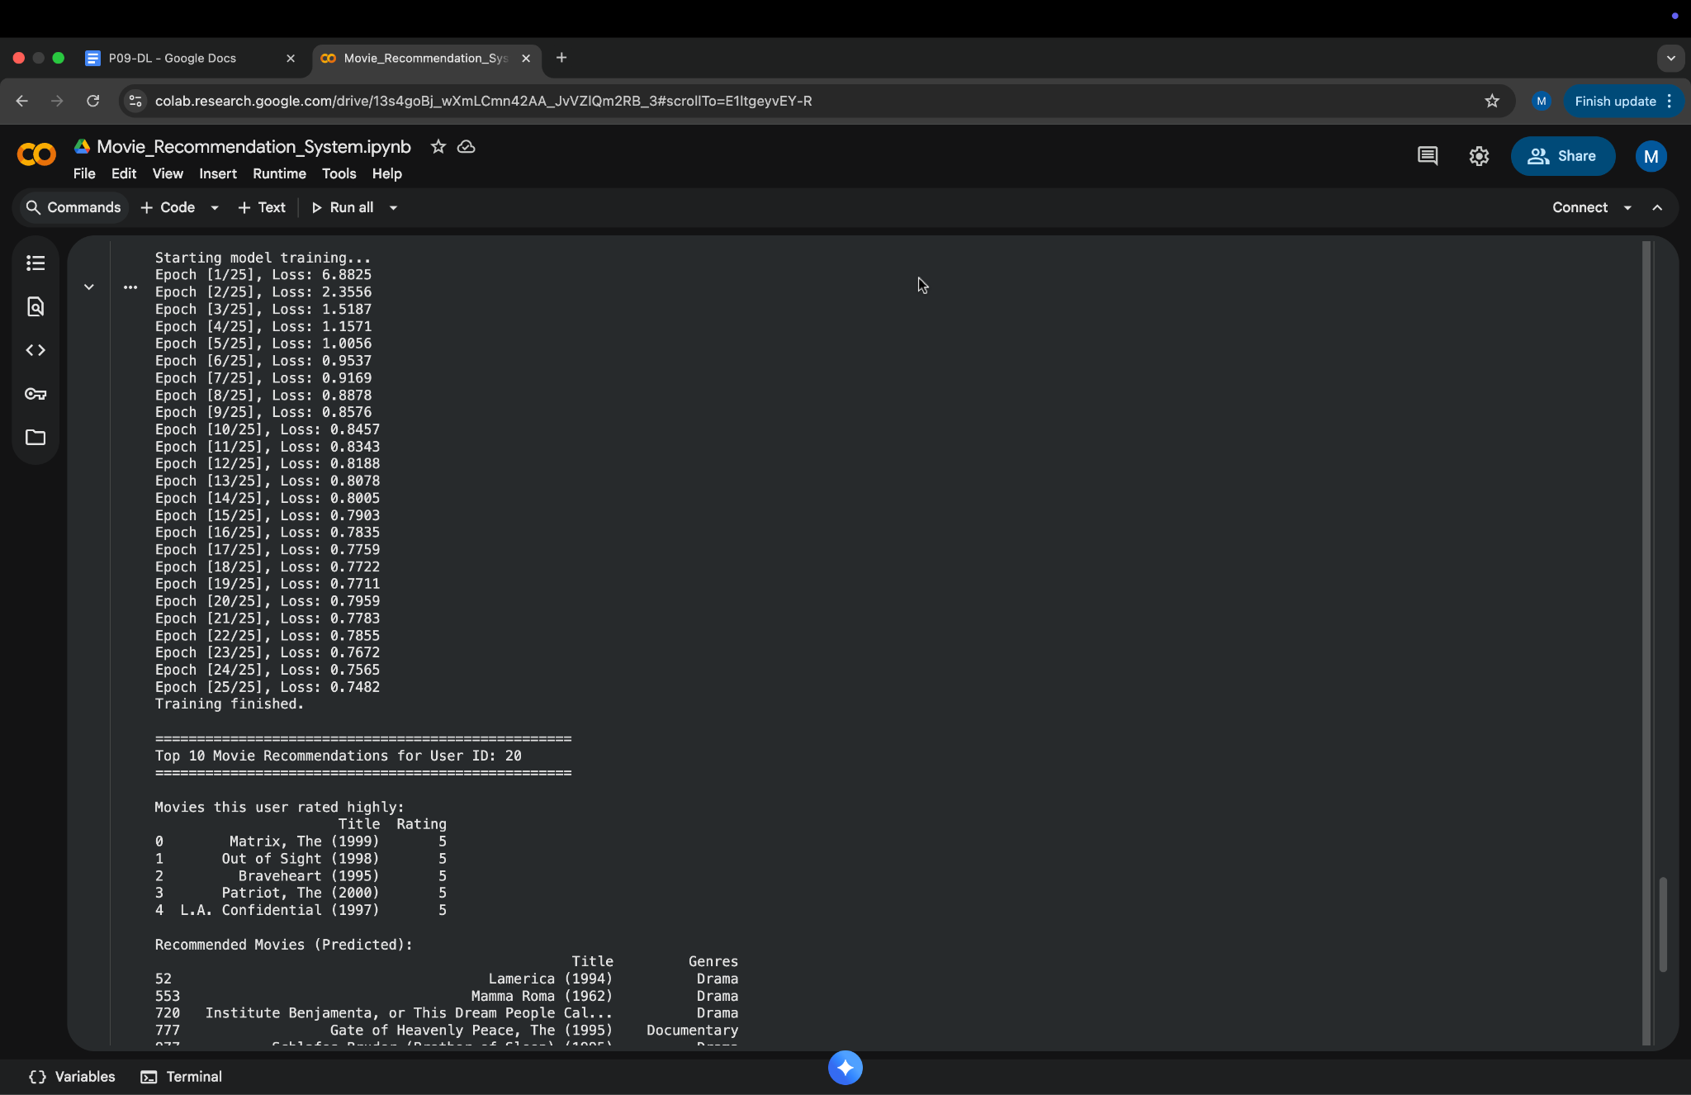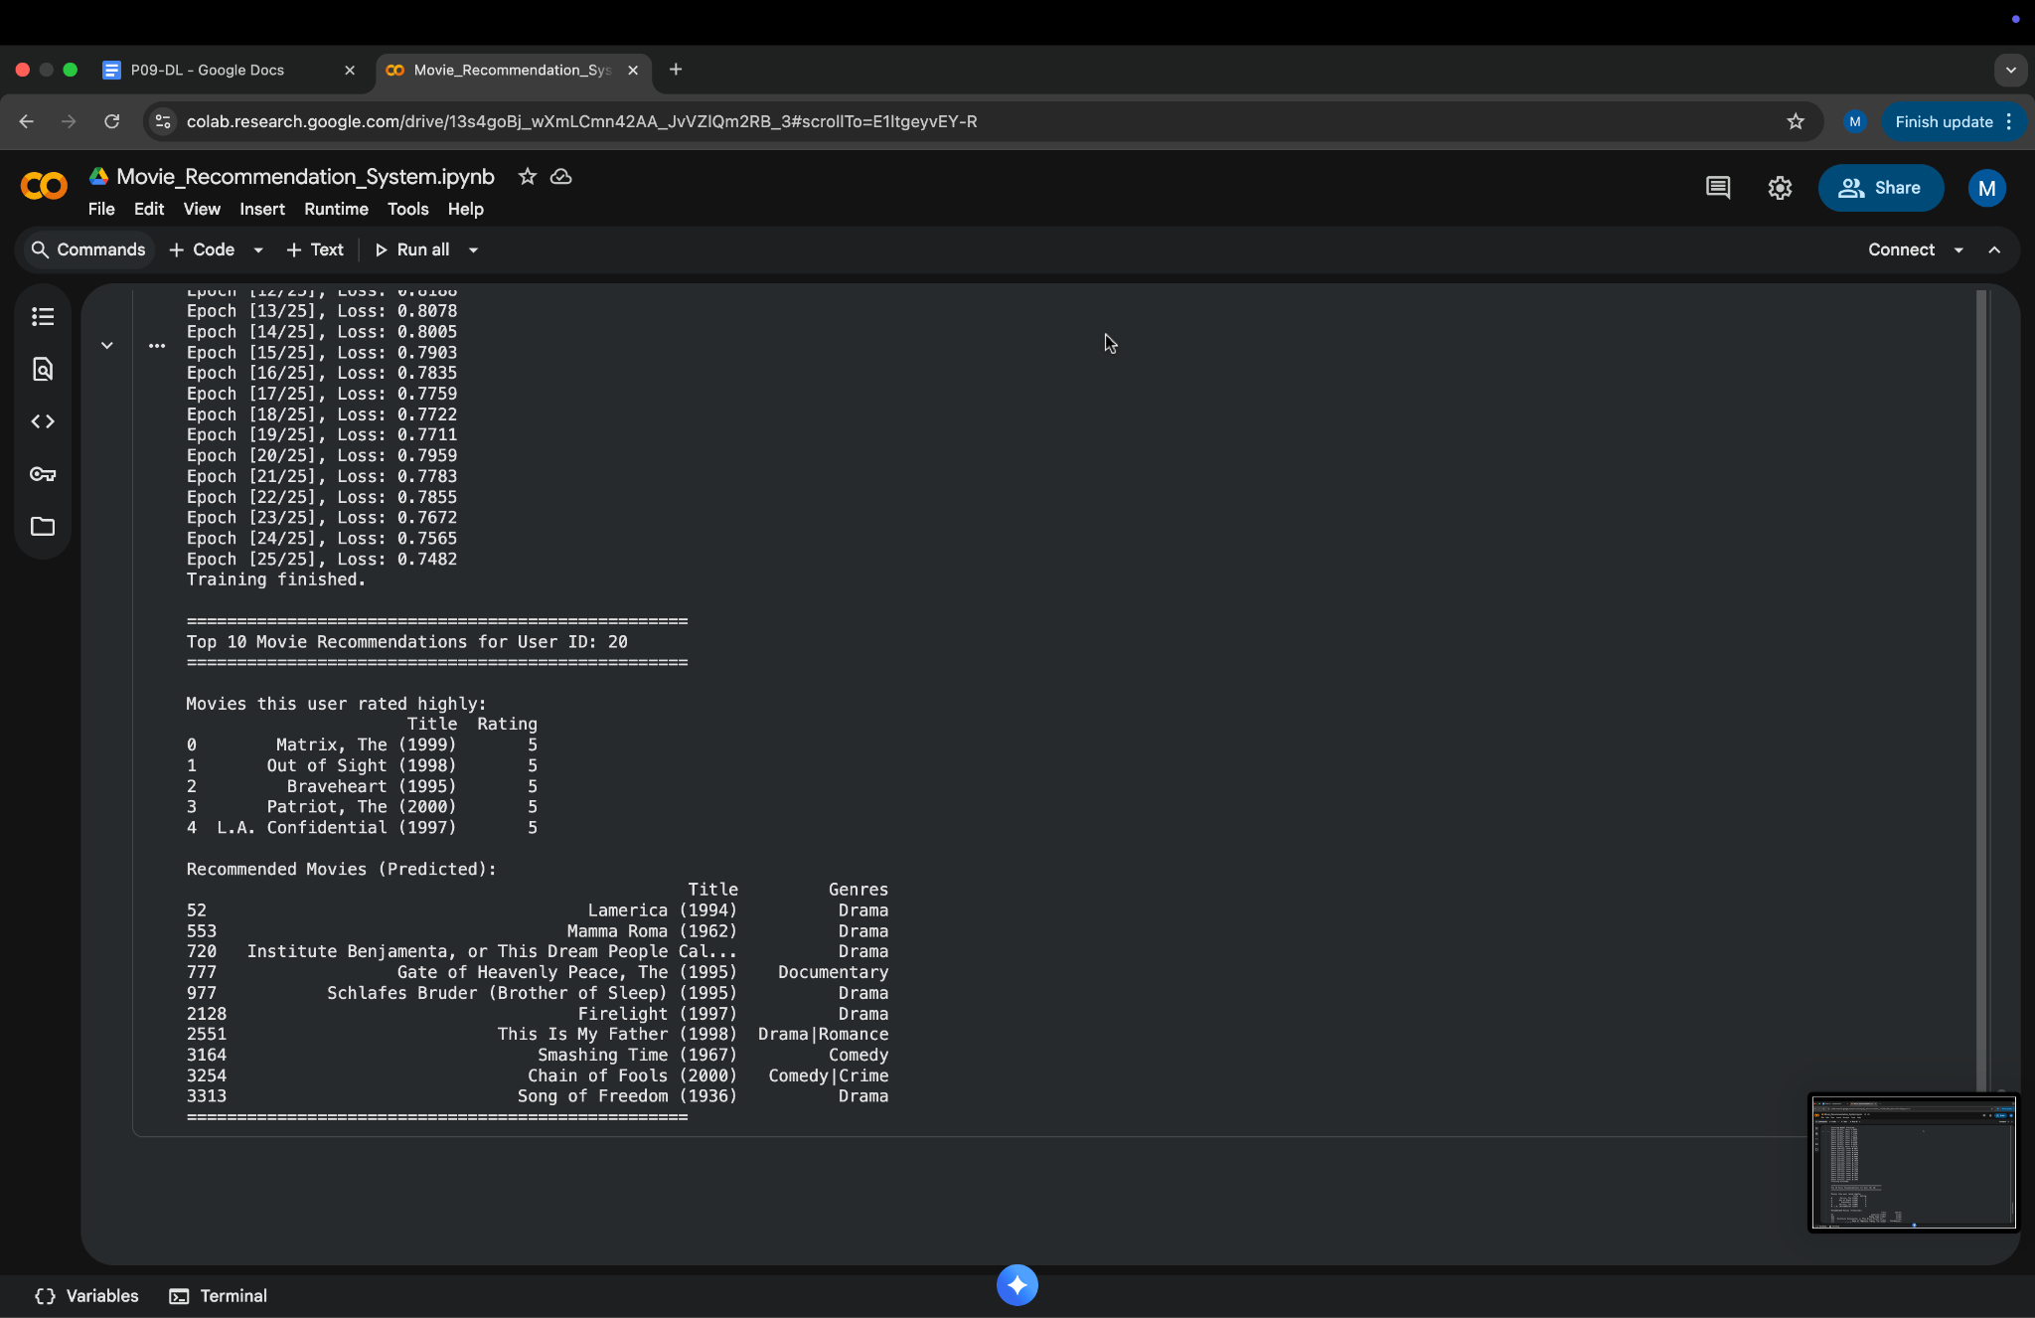

Output Analysis:
The system successfully generated accurate movie recommendations.
- The content-based approach provided relevant results for movies with strong descriptive features.
- The collaborative filtering approach improved personalization by using user behavior data.
- Combining both methods achieved better overall performance.
The model showed high reliability in predicting user preferences and can easily be scaled for larger datasets.
Conclusion:
The Movie Recommendation System effectively predicts and recommends movies to users by analyzing movie metadata and user ratings. Using machine learning techniques like cosine similarity and SVD, the system provides personalized and meaningful recommendations.
This project demonstrates how recommendation algorithms can enhance decision-making and user engagement in digital platforms.
Future improvements can include deep learning-based recommendations (Autoencoders, Neural CF) or real-time deployment using APIs.

Plagiarism Report:
