Experiment 11: Apache Spark Installation and Word Count using PySpark
Title
Installation of Apache Spark and Implementation of Word Count using PySpark DataFrames

Objective
The objective of this experiment is to install and configure Apache Spark on Ubuntu, verify the Spark environment, and perform a Word Count application using PySpark DataFrames. The experiment demonstrates distributed data processing, DataFrame operations, and Spark's parallel computing capabilities for analyzing textual data.

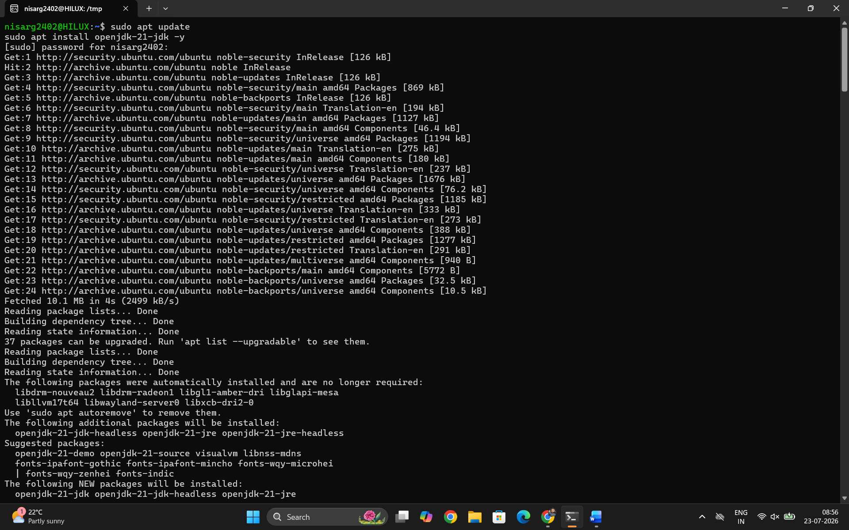
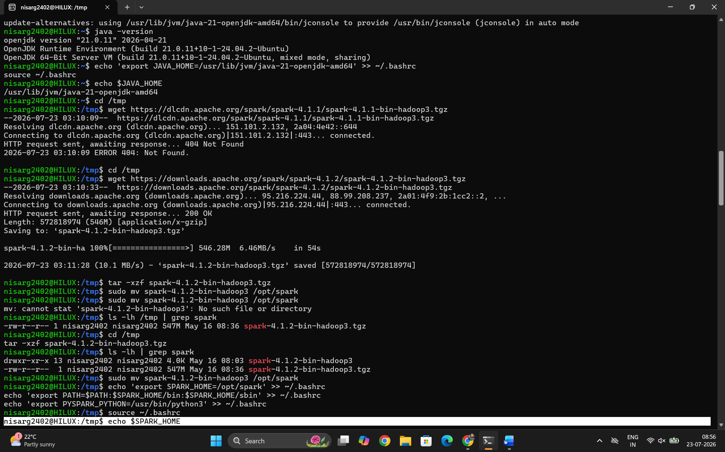
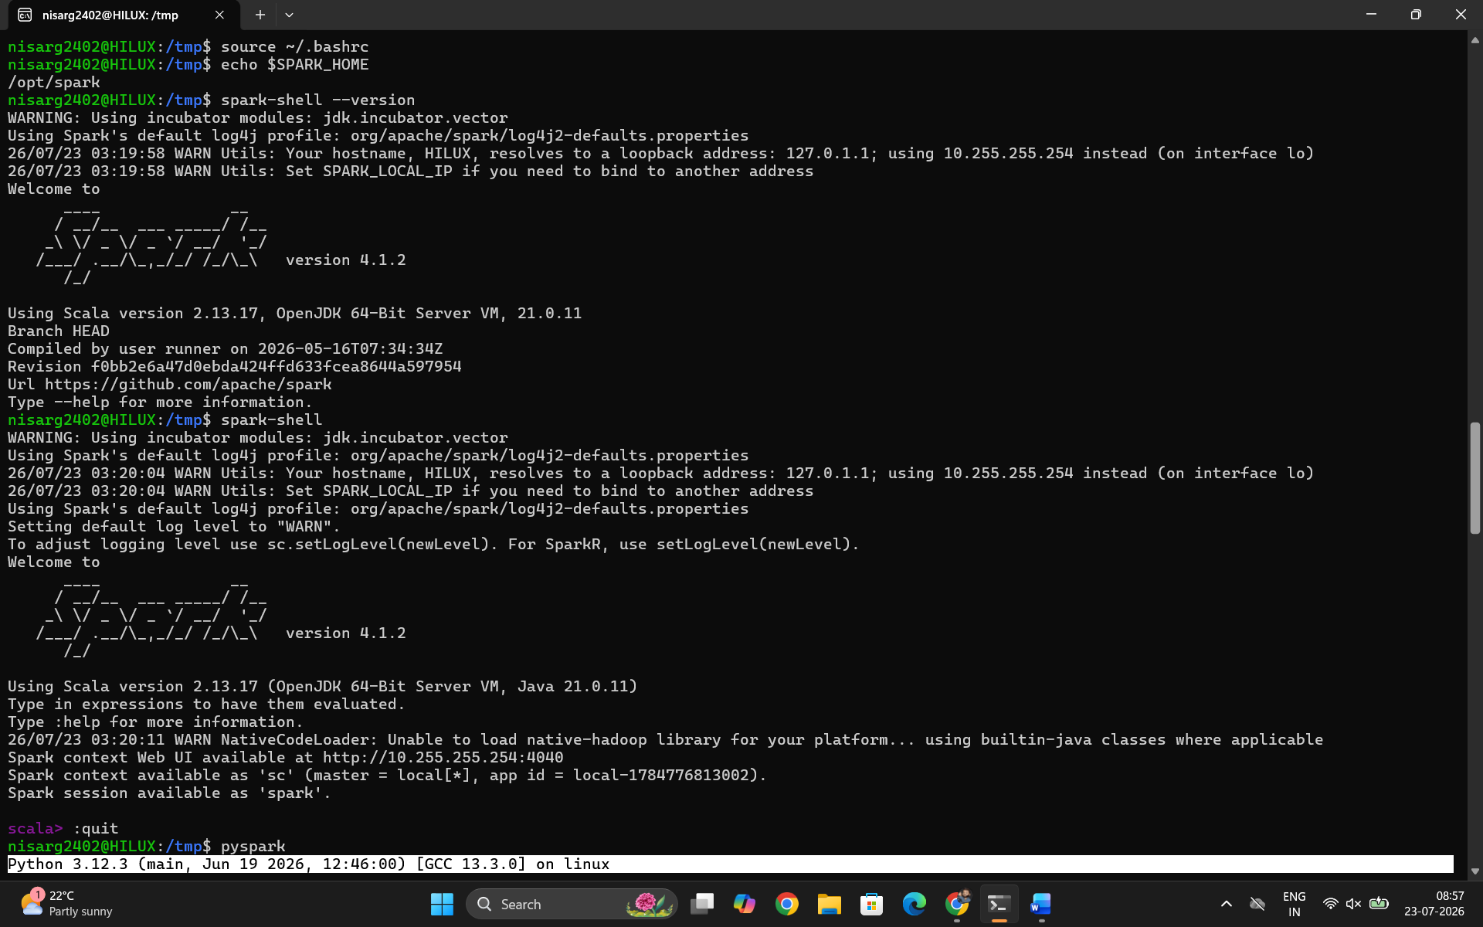
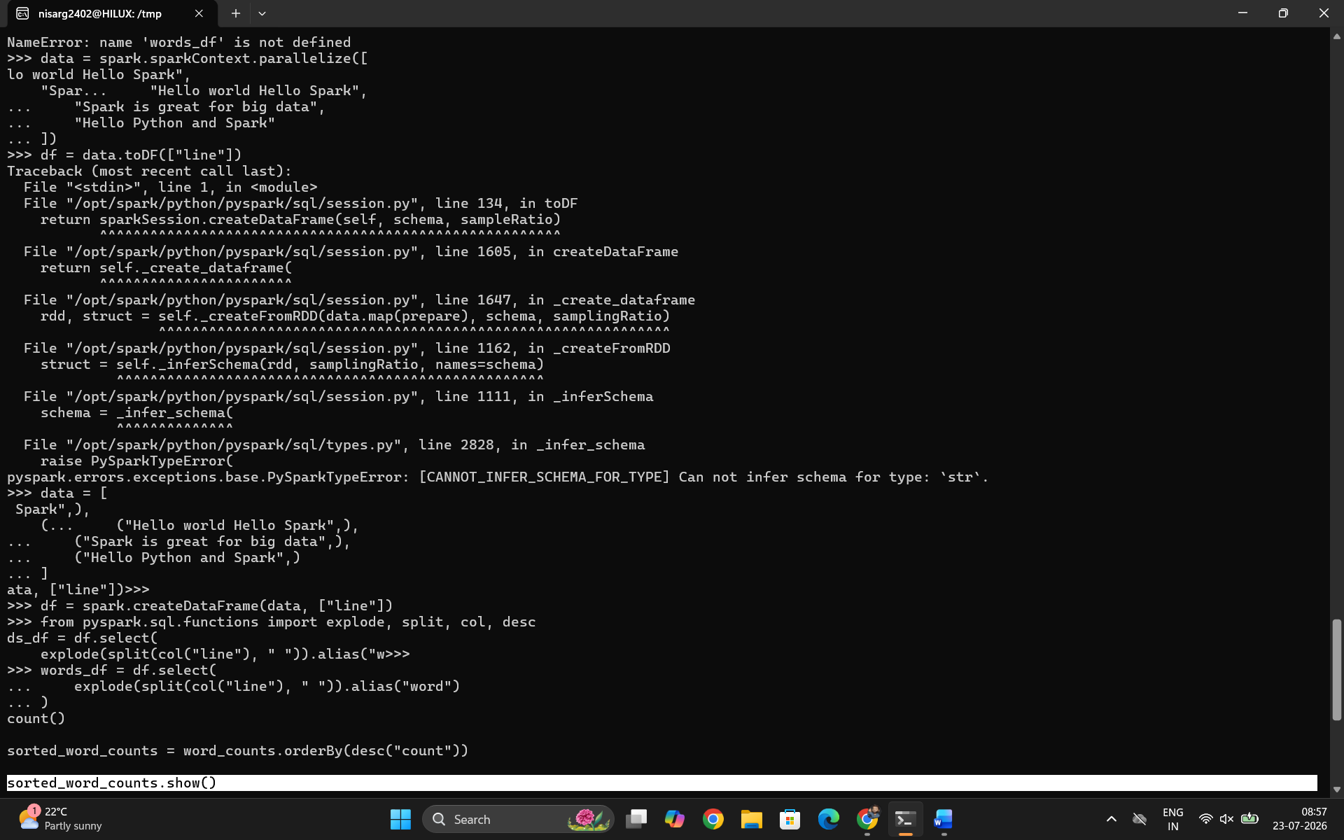
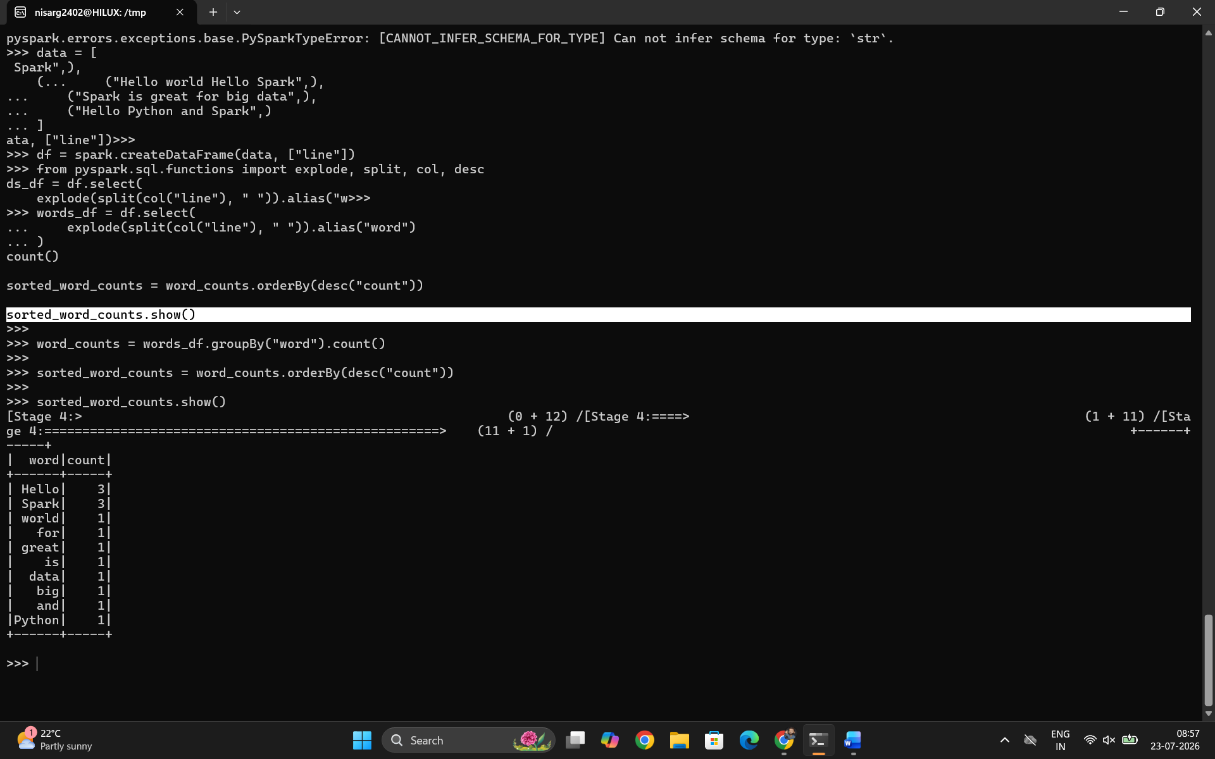

Conclusion
Apache Spark was successfully installed and configured on the Ubuntu system. Using PySpark, a Word Count application was implemented with DataFrames to analyze the frequency of words in both in-memory data and a text file. The experiment demonstrated Spark's distributed processing model, lazy evaluation, and optimized DataFrame API. This highlights Spark's capability to process large datasets efficiently, making it a powerful framework for big data analytics and real-time data processing.

