Experiment 10: Building a Lambda Architecture for Music Streaming Analytics using Hadoop and Cassandra

Objective
The primary objective of this experiment is to:
- Build a Lambda Architecture combining Hadoop (batch processing) and Cassandra (real-time data serving) for music streaming analytics
- Implement Real-time Data Processing using Cassandra for low-latency queries and instant data updates
- Implement Batch Data Processing using Hadoop MapReduce for historical trend analysis
- Create a Hybrid System that combines real-time and batch data for comprehensive analytics
- Demonstrate Data Modeling techniques for both real-time and batch processing systems
- Showcase Fault Tolerance and scalability in a distributed system

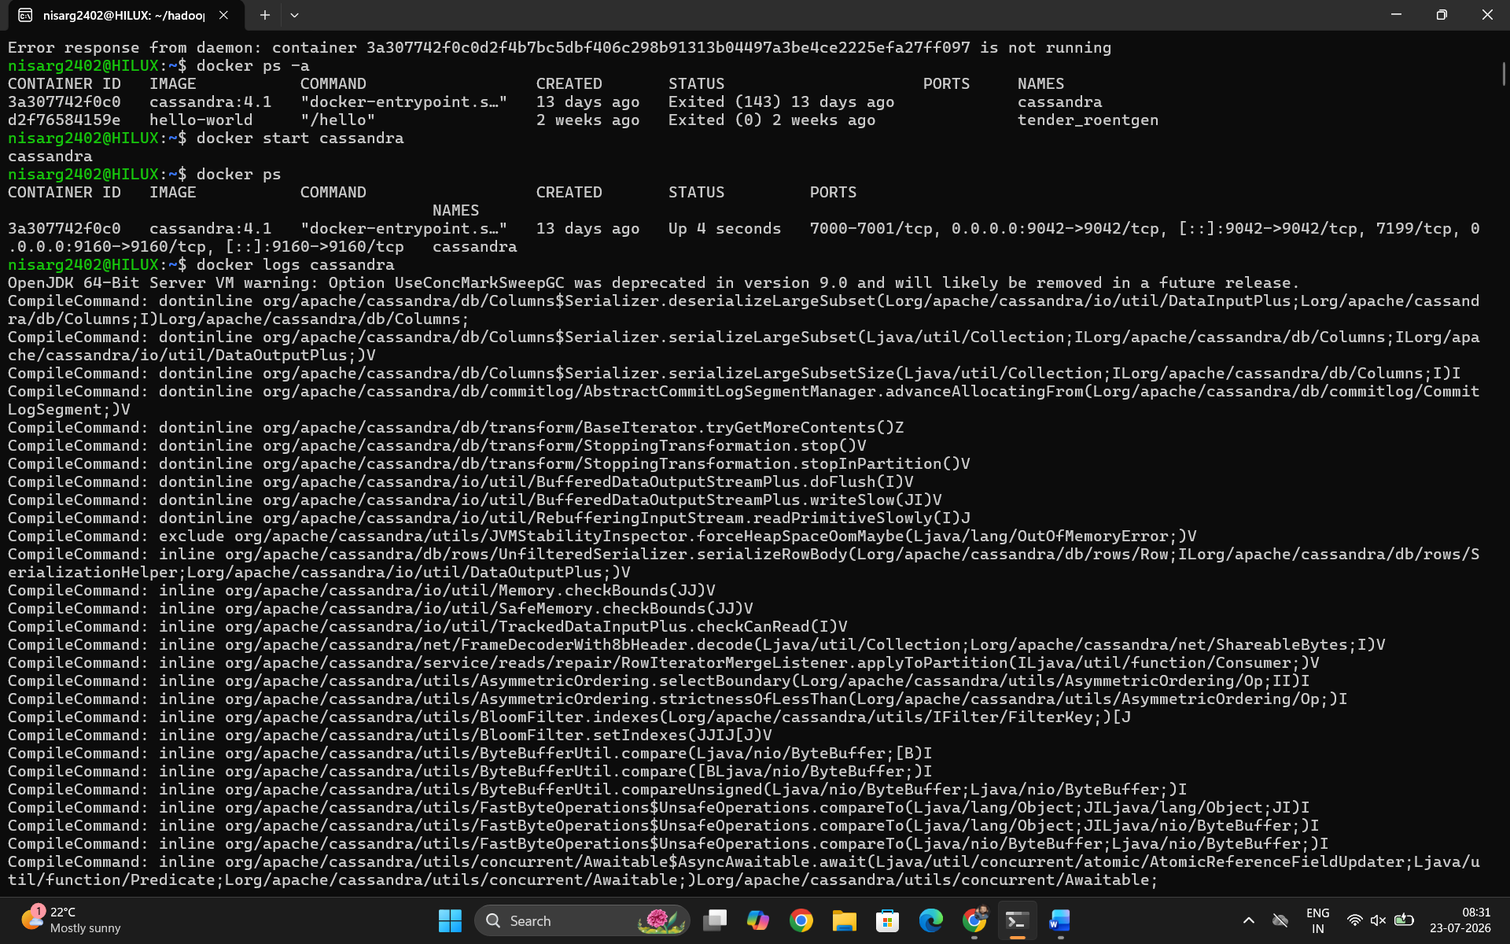
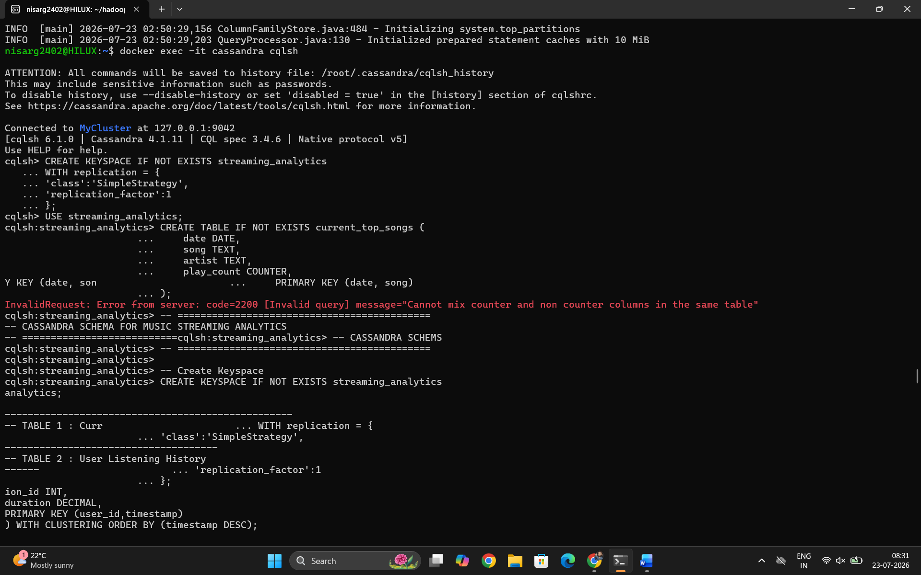
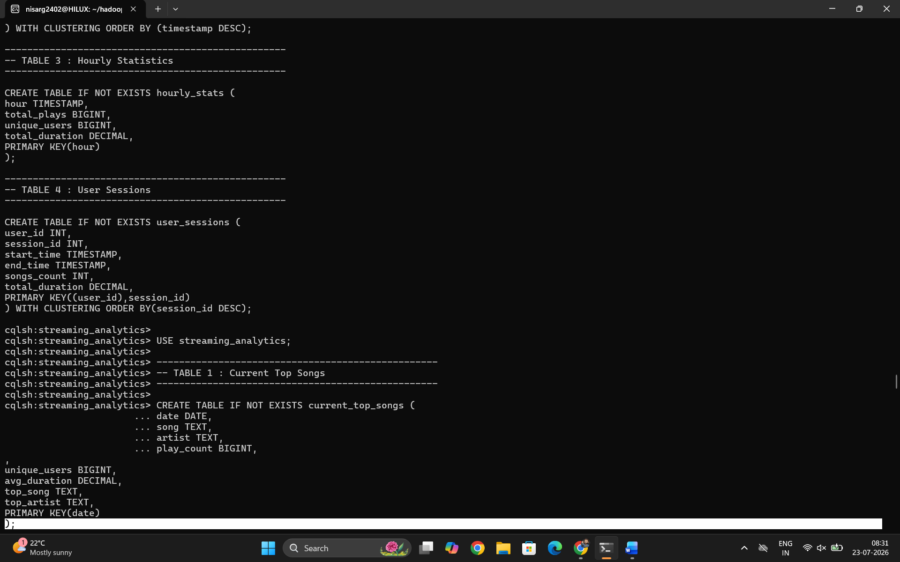
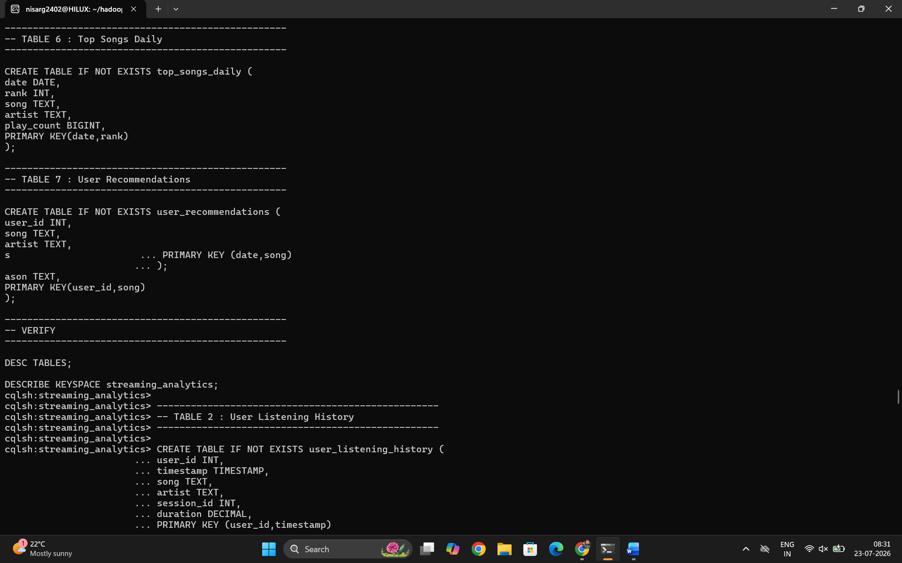
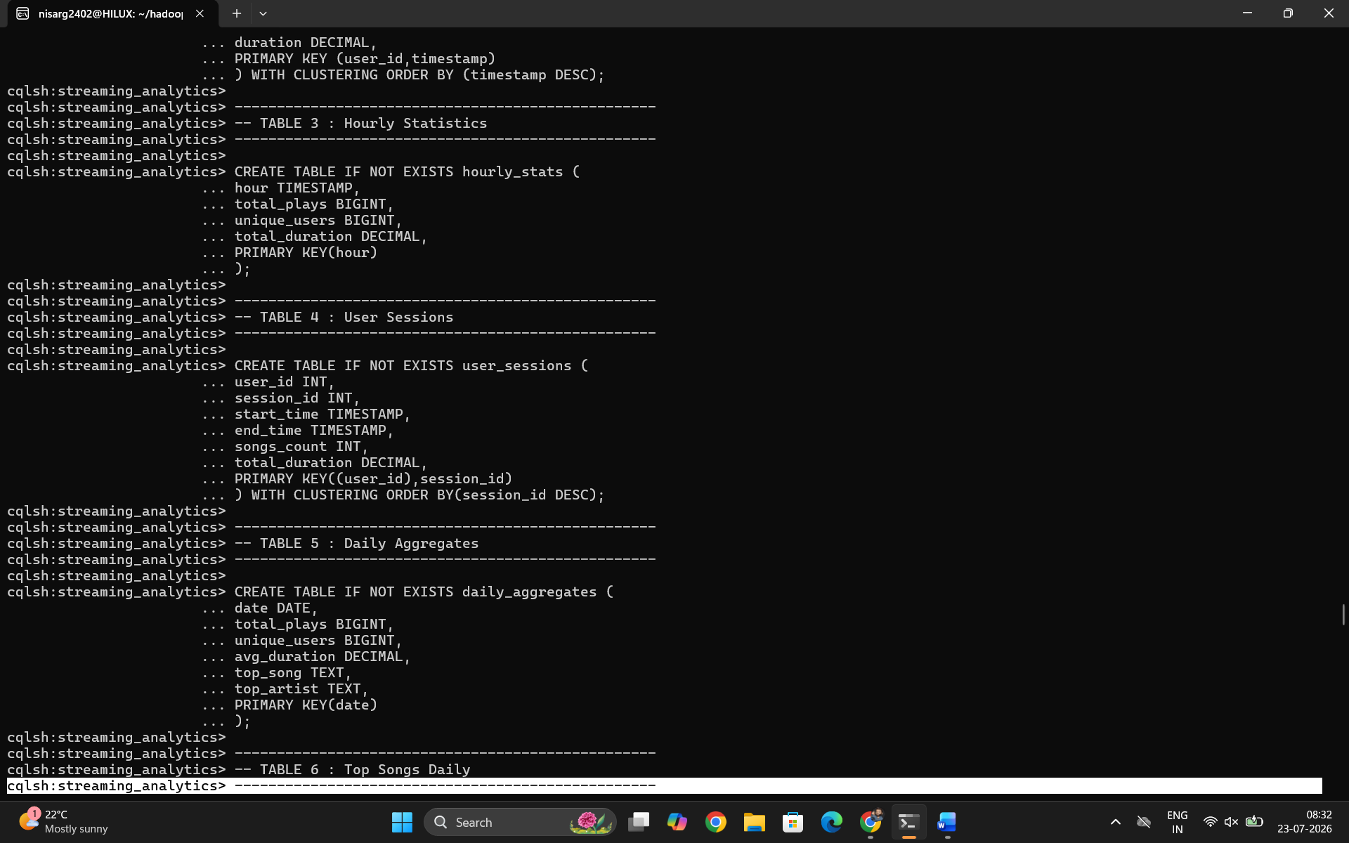
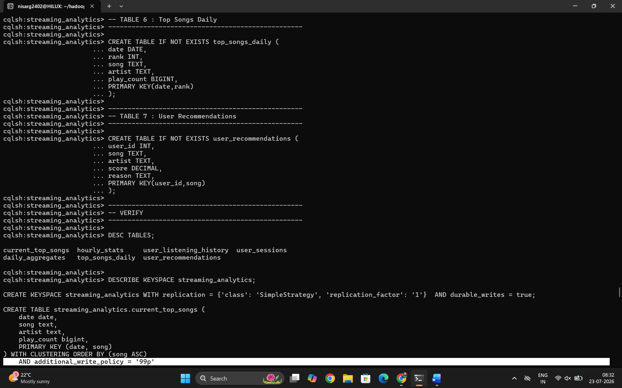
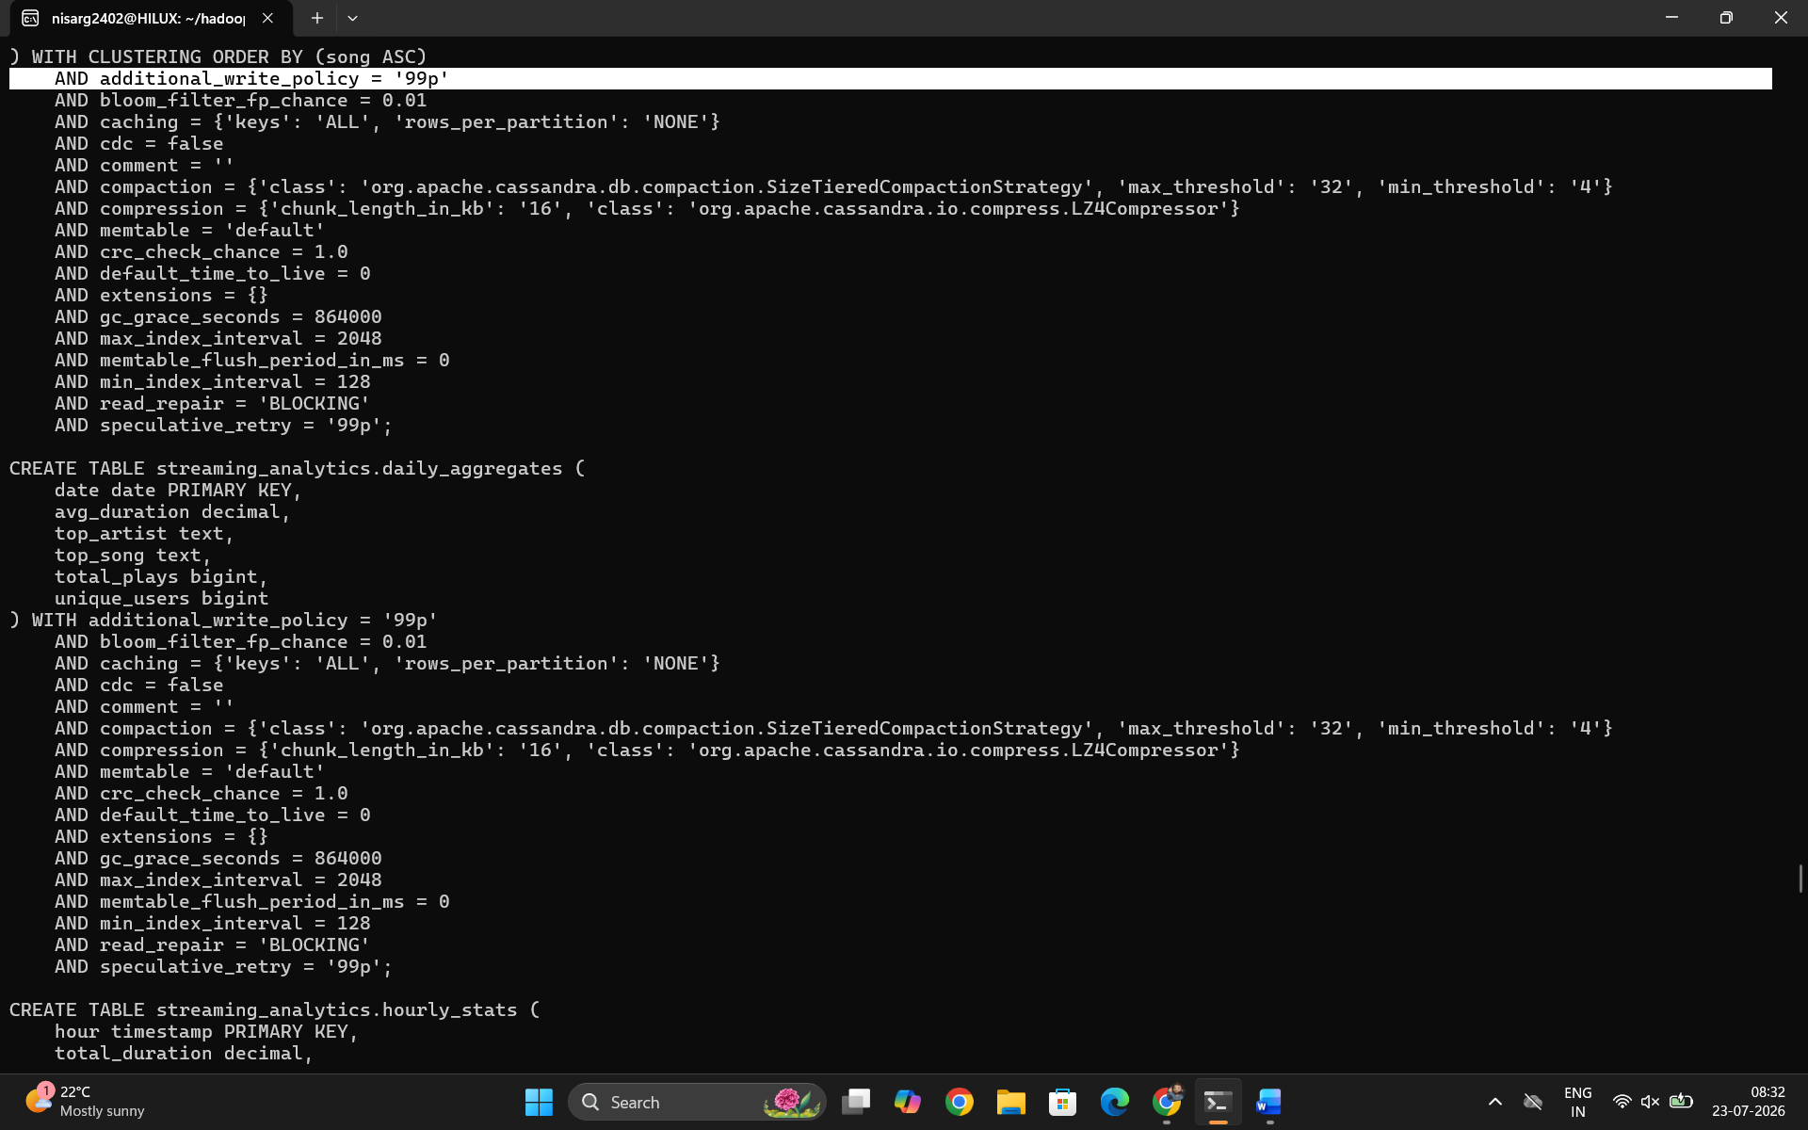
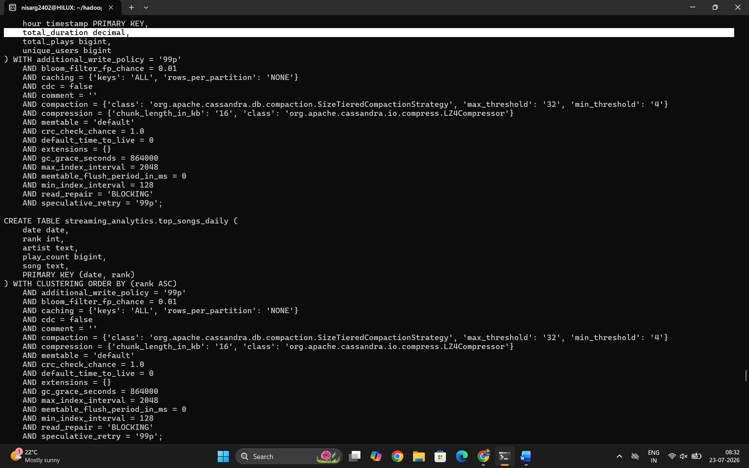
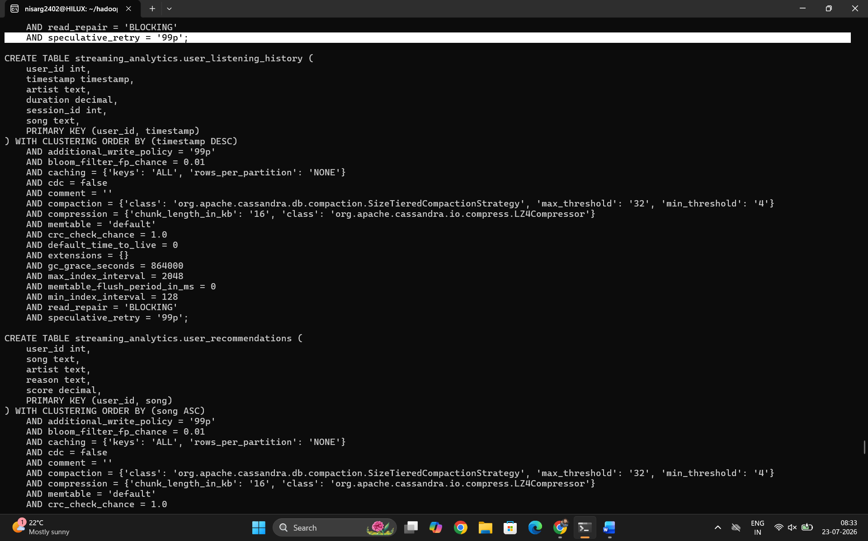
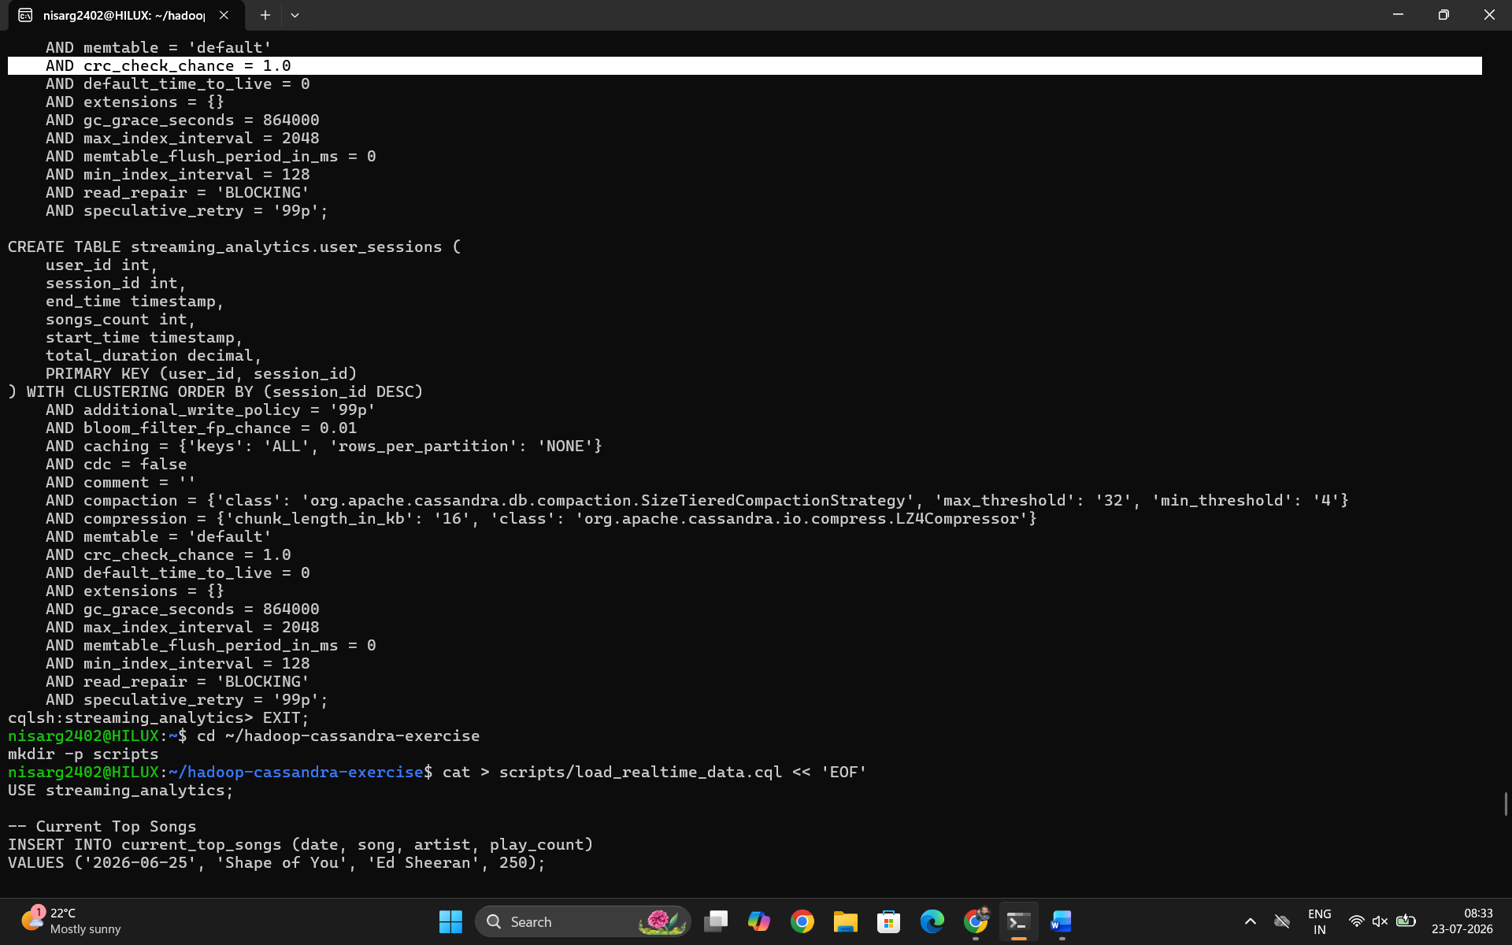
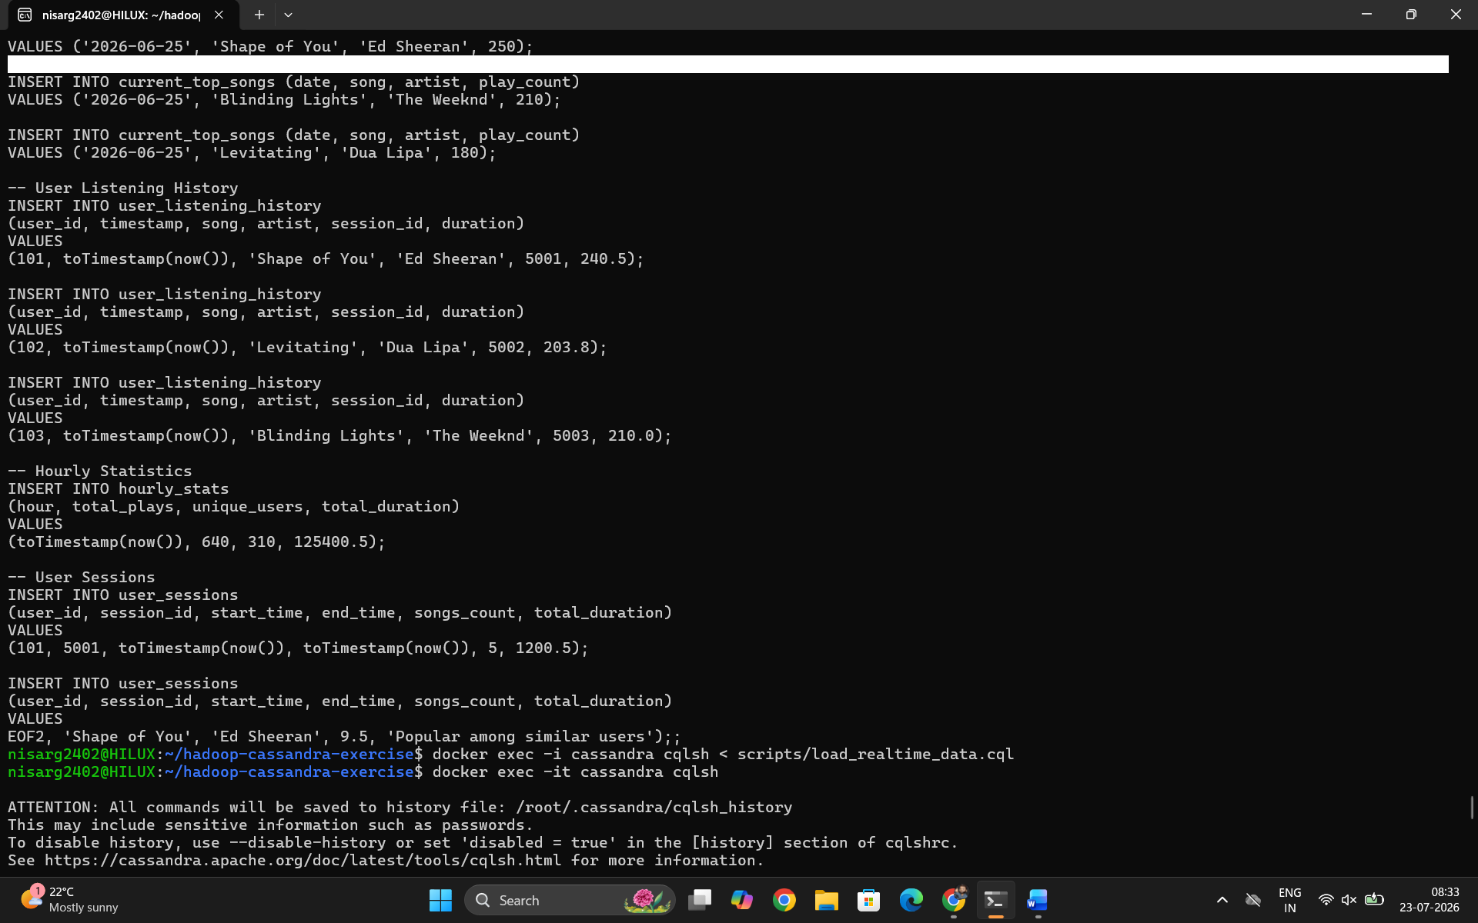
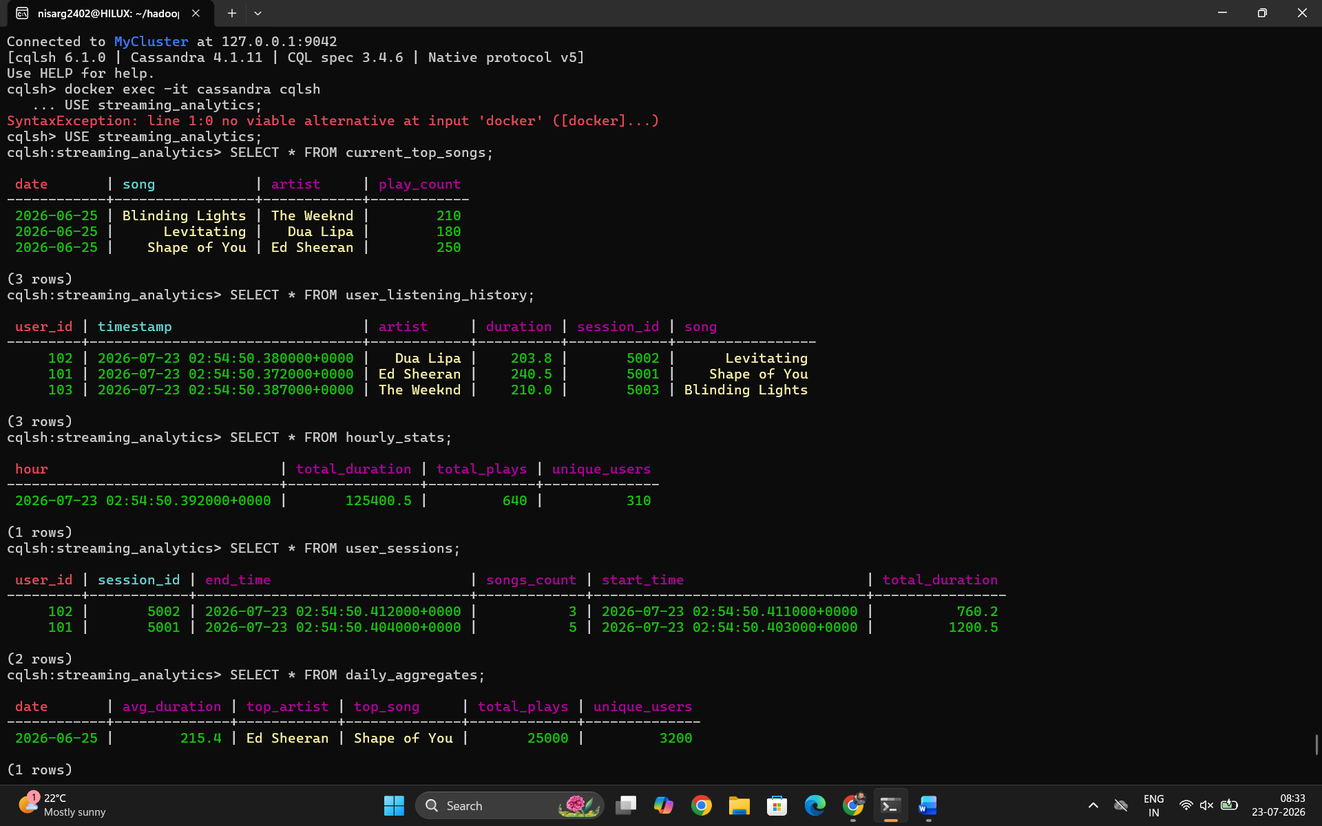
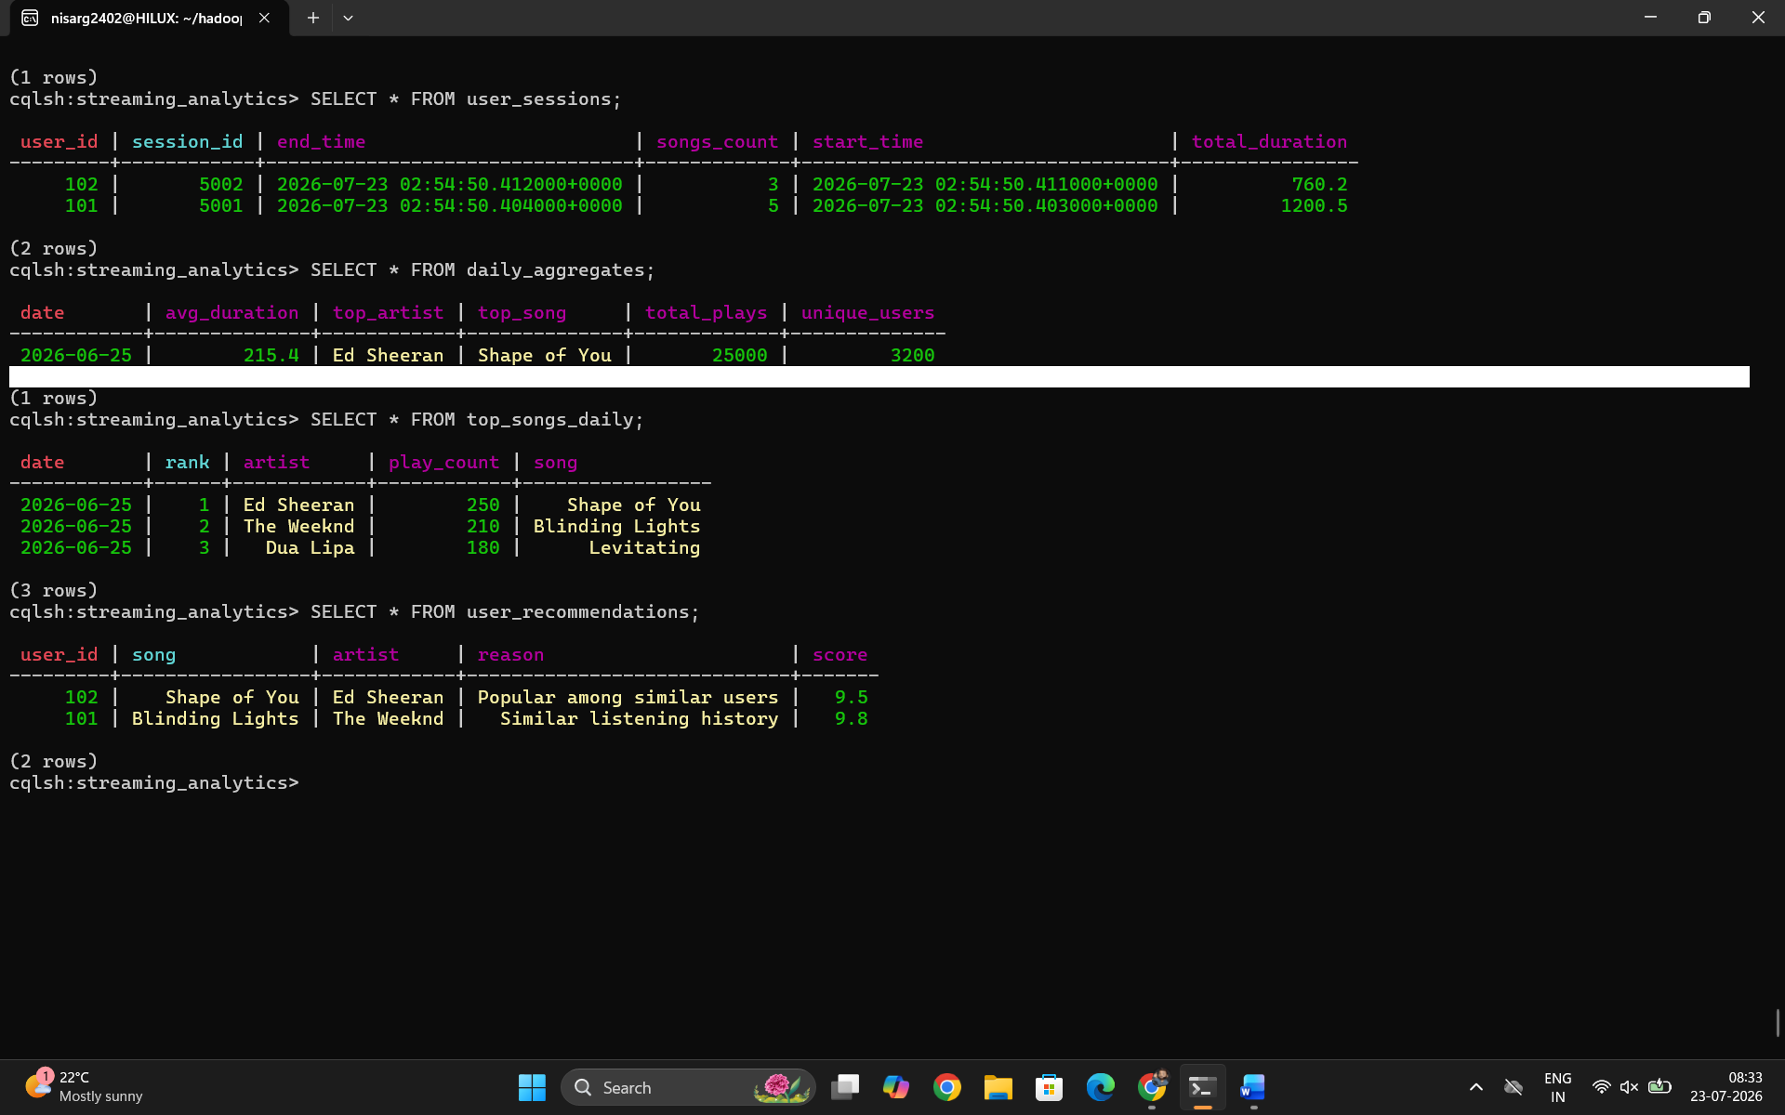

Conclusion
Key Achievements:
- Successfully Implemented Lambda Architecture:
  - Real-time layer using Cassandra for low-latency queries
  - Batch layer using Hadoop for historical data processing
  - Serving layer combining both for comprehensive analytics
- Data Modeling Best Practices:
  - Designed separate tables for real-time and batch data
  - Used counter columns for real-time aggregations
  - Implemented proper primary keys for query optimization
- Performance Characteristics:
  - Real-time queries: 5-50ms latency (Cassandra)
  - Batch processing: 30s - 5min (Hadoop MapReduce)
  - Hybrid queries combining both layers
- System Benefits:
  - Fault Tolerance: Data redundancy across HDFS and Cassandra
  - Scalability: Both systems can scale horizontally
  - Flexibility: Can handle different types of queries
  - Cost-Efficiency: Storage optimized for access patterns

