

**Faculty of Technology and Engineering**

**U & P U. Patel Department of Computer Engineering**

Date: 15 / 1 / 2022

**Practical – 2**

**DICTIONARY**

1. **Write a Python script to check whether a given key already exists in dictionary.**

**CODE:**

**CASE 1:**

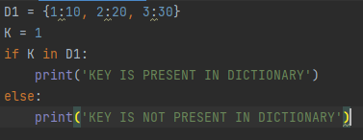

**OUTPUT:**



**CASE2:**

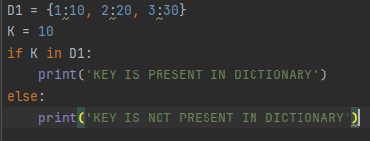

**OUTPUT:**



1. **Write a Python script to merge two Python dictionaries.**

**CODE:**

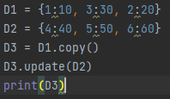

**OUTPUT:**



1. **Write a Python program to sum all the items in a dictionary.**

**CODE:**

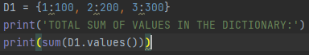

**OUTPUT:**



1. **Write a Python script to add a key to a dictionary.**

**CODE:**

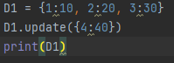

**OUTPUT:**



1. **Write a Python script to concatenate following dictionaries to create a new one.**

**Sample Dictionary :**

**dic1={1:10, 2:20}**

**dic2={3:30, 4:40}**

**dic3={5:50,6:60}**

**Expected Result : {1: 10, 2: 20, 3: 30, 4: 40, 5: 50, 6: 60}**

**CODE:**

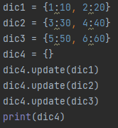

**OUTPUT:**



**TUPLE**

1. **Write a Python program to create a tuple with different data types.**

**CODE:**

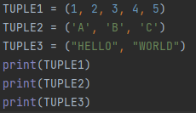

**OUTPUT:**

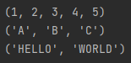

1. **Write a Python program to create a tuple with numbers and print one item.**

**CODE:**



**OUTPUT:**



1. **Write a Python program to add an item in a tuple.**

**CODE:**

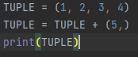

**OUTPUT:**



1. **Write a Python program to convert a tuple to a string.**

**CODE:**

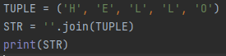

**OUTPUT:**



1. **Write a Python program to find the length of a tuple.**

**CODE:**



**OUTPUT:**



**SET**

1. **Write a Python program to add member(s) in a set and clear a set.**

**CODE:**

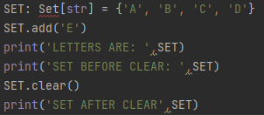

**OUTPUT:**

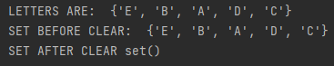

1. **Write a Python program to remove an item from a set if it is present in the set.**

**CODE:**

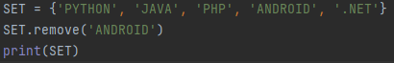

**OUTPUT:**



1. **Write a Python program to create an intersection, Union, difference of sets.**

**CODE:**

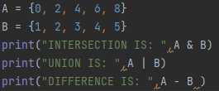

**OUTPUT:**

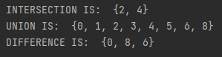

1. **Write a Python program to find maximum and the minimum value in a set.**

**CODE:**

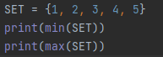

**OUTPUT:**



1. **Write a Python program to find the most common elements and their counts from list, tuple, dictionary.**

**CODE:**

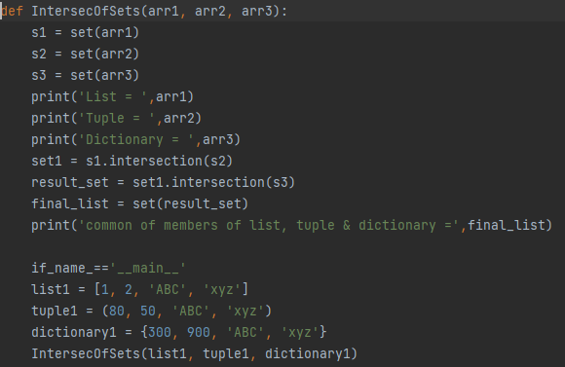

**OUTPUT:**

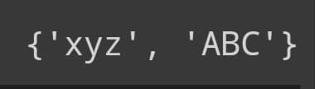

**Github Link:**