Title: Prediction of lithium-ion conductivity in solid-state electrolytes by combined use of physical descriptors and element embeddings
Novelty:
- Optimal blend of physical descriptors and ML-derived descriptors for prediction of ionic conductivity.
- Hidden and complex relations between elements accounted through element embeddings derived from scientific literature.
- Obviates the need for crystal information data.
- Underscores the importance of physical descriptors in prediction problems.
Abstract:

INTRODUCTION:
The rapid advancement of all-solid-state lithium batteries has increased the demand for solid electrolytes with high lithium ion (Li) conductivity. ^{1,2} The solid state electrolytes (SSEs) do not suffer from flammability and leakage issues, motivating an intensive search for solid-state electrolyte materials with high Li+ conductivity.² Direct measurement of ionic conductivity is a major component of this search process for which Electrochemical Impedance Spectroscopy (EIS), Nuclear Magnetic Resonance (NMR), and Galvanostatic Intermittent Titration (GITT) have been considered.^{3,4} Among these, EIS is most commonly employed as it accounts for overall resistance, including that of grain boundaries. ¹ As an alternative to direct measurements, Computational approaches such as ab initio molecular dynamics (AIMD), machine learning molecular dynamics (MLMD), and nonequilibrium molecular dynamics (NEMD) have provided valuable insights into migration pathways and activation barriers in sulphide and halide conductors, including Li₅PS₄Cl₂, Li₆PS₅Cl, and Li₃TiCl₆.^{5,6} However, the accuracy of these predictions depends heavily on exchange-correlation functionals, simulation timescales, and dataset quality.
Machine learning (ML) has rapidly accelerated the screening of lithium-ion conductivity of solid electrolytes. Sendek et al. pioneered the large-scale screening of compounds by considering of 12,000 entries in Materials Project database, and shortlisting superionic conductors based on physical descriptors using logistic regression.⁷ Recent advances in ML have enabled efficient prediction of ionic conductivity, significantly reducing the reliance on computationally demanding AIMD simulations. For example, Dai et al. trained ML models on AIMD-derived ion trajectories, enabling accurate estimation of lithium-ion hopping rates and activation energies across timescales that are inaccessible to direct AIMD simulation.⁸ Guo et al. employed graph neural networks (GNNs) with element embeddings to directly learn about migration barriers from crystal structures.⁹ Sharma et al. reported structural and embedding-based descriptor-driven models for various Li solid electrolytes and LLZO garnets.^{10,11} Other forms of ML uses are (i) screening of inorganic electrolytes for dendrite suppression based on compositional and physicochemical descriptors with embedding techniques,¹² (ii) prediction of ionic conductivity through phonon density of states (PhDOS) descriptors with an Extra Random Tree model,¹³ and (iii) large-scale screening of ionic conductors based on Li-ion transport properties using regular ML and graph neural networks (GNNs), trained on the LiTraj dataset.¹⁴

In addition to these direct predictions based on physically understandable descriptors, there is indirect method involving materials informatics and natural language processing (NLP) tools for this purpose. Tshitoyan et al., demonstrated that the Mat2Vec model trained with word concepts, such as structure-property relationships and elemental similarities. ¹⁵ That is, manual labelling of words is replaced by autonomous learning, and an unprecedented level of accuracy in correlation became possible.¹⁵ Building on this foundation, Kim et al. demonstrated that language-model-derived descriptors significantly enhance ML predictions of ionic conductivity in solid electrolytes and expedite the identification of new Li-ion conductors.¹⁶ Furthermore, Sharma et al. employed Mat2Vec-augmented features to model compositional tuning in LLZO and identified dopants that enhance Li-ion mobility.¹¹ This exercise illustrates how well NLP-based representations can extract latent chemical knowledge directly from text, which can lead to better design of solid-electrolyte. ¹¹ The major motivation for employing element embeddings in Sharma et al.'s work was to avoid reliance on physical descriptors, which may not be readily available for a randomly chosen compound. ¹¹ Beyond solid electrolytes, NLP-driven frameworks have enabled advances in catalysis, synthesis planning, phase-diagram mapping, and the extraction of scientific knowledge networks, as exemplified by large-scale text-mined datasets for inorganic syntheses.¹⁷
Experimental or first-principal approaches for determining lithium-ion diffusivity in solid electrolytes provide rigorous physical insight. However, they demand substantial computational resources, time, financial investment, and domain expertise. In parallel, ML models were proposed primarily for classification tasks, such as identifying whether a compound is a probable superionic conductor or not. ^{7,10} The ML model used a selected set of physical descriptors to classify the compounds into conducting and non-conducting groups. While such approaches are effective for classification, predicting the magnitude of ionic conductivity demands a larger and more diverse set of relevant features along with larger volume of data than for the classification task. ¹⁸ In particular, reliable prediction requires an integrated set of descriptors that capture transport-relevant physicochemical properties, including structural and chemical features that govern ion motion, as well as experimental ionic conductivity data, to enable robust regression models. In many cases, the experimental measurements of physical descriptors for selected compound are unavailable. One way to circumvent this lack of critical information is to extract hidden features and complex relationships from the embedding of words in material science literature and apply this knowledge in tandem with the limited information on physical descriptors available otherwise to predict ionic conductivity. In this work, the ML based predictions were performed by integrating element embeddings with readily accessible physicochemical descriptors. This combined representation might capture latent chemical knowledge embedded in the materials science literature, which when assimilated with highly selective group of descriptors might enable robust and accurate prediction of lithium-ion conductivity. The efficacy of predictions from sets of data from different sources was evaluated.

- Methods:
As illustrated in Figure 1, lithium-ion conductivity data were collected from the Dynamic Database of Solid Electrolytes¹⁹ (DDSE). For each material, 14 physicochemical descriptors were generated with the help of the pymatgen Python library.²⁰ In addition, the 200-dimensional element embeddings were derived from a pretrained Mat2Vec model.¹⁵ These feature sets were then combined into a unified representation. Tree-based regression models were trained to predict ionic conductivity in $\log_{10}{σ}$ (where $σ$ is ionic conductivity in S cm⁻¹). The testing was performed with data from other opensource database.

Data Acquisition and Descriptor Preparation: A total of 2,917 experimental data points of ionic conductivity were obtained from the DDSE for training and testing of the machine learning models. The distribution of ionic conductivity in this set of datapoints is shown in Figure 2. The data were collected in the temperature range of 20 °C to 40 °C, since restricting to room-temperature (25 °C) values alone would provide an insufficient dataset for robust training. Based on prior understanding,^{7,10,21} an initial set of 14 manually engineered descriptors was considered (Table S1). Another 200 descriptors were extracted using Mat2Vec method.¹⁵ In all, 214 descriptors were employed. The dataset was randomly divided into 80% for training and 20% for testing. In addition to the 20% randomly chosen data points from DDSE, an additional 657 data points from other sources were considered for testing. The complete test set comprised the following datasets.
- 583 data points from the DDSE (20 °C to 40 °C).
- 657 external data points, divided as follows:
  - 442 points from the University of Liverpool database,²² (20 °C to 30 °C), labelled as Dataset A.
  - 175 points from LLZO datasets,²¹ (27 °C) labelled as Dataset B.
  - 40 points from Sendek et al.⁷ (room temperature), labelled as Dataset C.

Model Development and Training: To address the wide range and skewed distribution of ionic conductivity (σ) values, the logarithm of conductivity ($\log_{10}{σ}$) was considered as the target variable, which helped in working with a near-normal distribution, as shown for the compiled training dataset in Figure 2. Four distinct modelling experiments were conducted to systematically evaluate the effect of different feature sets (FS) on model performance:
- Feature Set (FS-1): 14 manually selected physiochemical features as descriptors, relevant to the ionic conductivity.
- Feature Set (FS-2): 200 Mat2Vec-generated features, which are vector representations of materials derived through the application of unsupervised machine learning techniques on materials science literature.
- Feature Set (FS-3): Combined set of 214 features, comprising the 14 manually selected features (as in FS-1) and 200 Mat2Vec-generated features (as in FS-2).
- Feature Set (FS-3'): Unlike FS-3, seven physiochemical features shortlisted (from the 14 features considered in FS-1) based on their Pearson correlation significance (discussed in the results and discussion section). Leading to a combined set of 207 features.
The ML models considered here are Decision Tree, Random Forest, Gradient Boosting, XGBoost, LightGBM, and Extra Trees Regressor. Their performances were evaluated using the coefficient of determination (adjusted R² score), and other error metrics²³ for which the respective equations are listed in supplementary information.

- Results and Discussion:
The ionic conductivity depends on various physicochemical descriptors, which were explored in this study. The correlation matrix (Figure 3) highlights how different physical and compositional descriptors relate to the logarithm of ionic conductivity across the dataset.
Temperature shows the strongest positive correlation (r ≈ 0.42), consistent with the thermally-activated nature of ionic transport in solid electrolytes, since higher temperature promotes ion hopping, and reduces activation barriers.²⁶ Among the composition-based descriptors, both Li fraction (r ≈ 0.29) and Li-to-anion ratio (r ≈ 0.21) correlate positively with conductivity. This reflects that lithium-rich compositions typically provide more mobile charge carriers and a greater probability of continuous conduction pathways. This trend was widely reported for garnet, NASICON, and halide based solid electrolytes.²⁷ A weaker, yet positive correlation (r ≈ 0.23) with the proxy representing packing efficiency suggests that moderately dense structure may provide an optimized framework for ion mobility by balancing structural openness with mechanical stability. This is consistent with the recent observations that moderately rigid, and not overly congested lattice favour high Li⁺ mobility.²⁸
In contrast, several structural and electronic features show moderately negative correlations with conductivity. Both the average ionic radius (r ≈ -0.36), and the heaviest element mass (r ≈ -0.36) indicate that larger or heavier constituent ions hinder Li⁺ migration. This is because such constituent ions are likely to reduce lattice flexibility, increase migration path length, or raise phonon-mediated activation barriers.^{29,30} Similarly, total atoms per formula unit (r ≈ -0.32) and electronegativity variance (r ≈ -0.29) show inverse relationships, implying that highly complex or chemically heterogeneous compositions may disrupt conduction pathways, or raise defect based scattering. This is consistent with literature reports that simpler, more systematic frameworks often outperform more complex chemistries.^{31,32} A smaller negative correlation for average electronegativity (r ≈ -0.26) is consistent with the notion that stronger ionic bonding or higher electronegativity frameworks may localise Li-ions, and reduce mobility.³³ The weak correlations observed for composition entropy, group diversity, and number of elements (|r| < 0.20) suggest that configurational complexity alone is not a strong predictor of transport properties, when decoupled from specific structural or electronic effects. The atomic connectivity and mobile ion pathways matter most alongside chemical complexity.^{31,32}
Overall, the trends confirm physically meaningful relationships. The Li ion conductivity rises with temperature and lithium content. The conductivity decreases with increase in ion size, mass, bonding strength and structural complexity respectively. These patterns are consistent with experimental studies on good Li-ion conductors, reinforcing confidence that the descriptors capture genuine structure–property relation. Apart from statistical significance, the correlation can be easily reconciled with the physical understanding of ion transport.
The adjusted coefficient of determination (R²_{adj}) for different regression models is presented in Table 1 for four types of training feature datasets: FS-1 with fourteen physicochemical features, FS-2 with only embedding features, FS-3 combining both physicochemical and embedding features and FS-3' considering a reduced number of physicochemical features alongside embedding features. The adjusted coefficient of determination (R²_{adj}) helped in ascertaining the proportion of variation in the experimental data as per the model. This provided an overview of the model’s fit quality. The models trained on the combined feature set (i.e., FS-3) consistently outperformed those trained either solely on the physicochemical descriptors, or on Mat2Vec embeddings. This suggests that the physicochemical features and the learned Mat2Vec embeddings were captured as complementary information. The Random Forest Regressor achieved the highest R²_{adj} value, demonstrating superior predictive accuracy relative to the other models. To further explore the importance of the physicochemical features in the mixed basket of descriptors, some of the physiochemical descriptors, which are weakly correlated to ionic conductivity were removed. From the previously computed correlation matrix, only those descriptors bearing a correlation threshold of 0.25 and above were considered in the mixed basket in this experiment. Based on this criterion, seven features, i.e., average atomic mass, number of elements, composition entropy, group diversity, packing efficiency proxy, Li-to-anion ratio, and lightest element mass were removed from the mixed basket. This resulted in a reduced feature set, denoted as FS-3', comprising a total of 207 descriptors (i.e., 7 physicochemical features combined with 200 embeddings). However, model performance, deteriorated with this refined set of descriptors (as shown in Table 1), suggesting the importance of retaining all 14 physicochemical descriptors in the mixed feature basket. Also, an attempt was made to increase the pool of physicochemical descriptors beyond the initial set of 14, and no improvement in prediction accuracy was observed. Therefore, the complete set of fourteen physicochemical descriptors was retained. The Random Forest Regressor trained on the combined feature set (FS-3, containing both Mat2Vec embedding and all 14 physicochemical descriptors) was selected for further evaluation.
To assess the dependability of the Random Forest Regressor model trained on FS-3 features, various error measures were examined, including mean absolute error (MAE), root mean squared error (RMSE), and mean bias error (MBE). The mean absolute error (MAE), and the root mean squared error (RMSE) provided an assessment of accuracy in absolute terms. The RMSE exhibits heightened sensitivity to outliers as it penalises greater deviations more severely. The mean bias error (MBE) was calculated to assess the model’s persistent inclination to overpredict (positive bias) or underpredict (negative bias) relative to experimental observations. Additionally, the standard deviation of errors (STD) was computed in this study to assess the variability of the residuals across datasets. The mean target value (MTV) and mean predicted value (MPV) were presented to facilitate the comparison between the average conductivities predicted by the model and those measured experimentally. Collectively, these error measures constitute a comprehensive diagnostic framework: R²_{adj} evaluates the model’s fit, while MAE and RMSE assess its accuracy. MBE and its standard error identify systematic bias, while STD indicates residual variability of the data. Conductivity and associated error metrics are reported on a dex scale, defined as ($\log_{10}{σ}$), where $σ$ is the ionic conductivity in S cm⁻¹. A change of 1 dex corresponds to a tenfold (10¹) change in $σ$. The use of the dex unit is well established in the literature for reporting prediction errors of properties.^{24,25} These indicators offer supplementary insights: MAE and RMSE quantify the average magnitude of prediction errors. The MBE indicates if the model consistently underestimates or overestimates conductivity, and $R_{adj}^{2}$ assesses the model's ability to represent experimental trends accurately. The model attained a $R_{adj}^{2}$ of 0.85 and an RMSE of 0.56 dex for the 20% unseen test data of the DDSE dataset, as detailed in Table 2. Upon assessment using the external datasets shown in Table 3, the model exhibited robust predictive performance across all datasets, consistently achieving high $R_{adj}^{2}$ values (≥ 0.84). The most accurate prediction could be made for Dataset B. Datasets A and C, on the other hand, show systematic overprediction, which is shown by their positive bias ratings. Figure 7 presents the distribution of residual error. The plot appears to follow normal distribution with mean and standard deviation as 0.39 and 0.28 respectively. A normal distribution suggests largely random error with no inherent bias, which in turn demonstrates the robustness of the predictive model. The model achieved an overall $R_{adj}^{2}$ of 0.88, RMSE of 0.72 dex and an MAE of 0.62 dex across 657 compounds from the three external databases. This means that the average prediction errors were moderate, even when the model was used on chemically diverse systems.
The reliability of the model predictions was assessed by analysing both global accuracy and local discrepancies across ionic conductivity ranges. The parity plot (Figure 4) demonstrates a robust linear correlation between predicted and experimental ionic conductivities (log₁₀ σ), with the majority of data points situated near the ideal line (R²_{adj} = 0.88). However, small deviations (overprediction) appeared in the low and intermediate-conductivity range (< 10⁻⁵ S cm). These deviations appeared consistently in the residual analysis and regional error map (Figures 5). In particular, the datasets A and C show positive residuals and larger RMSE and MBE values (0.83 dex and 0.78 dex respectively for A; 0.71 dex and 0.66 dex respectively for C), while Dataset B remained well-centred (RMSE = 0.29 dex, MBE ≈ 0 dex). The heat-map view of region-wise error further confirms that RMSE and MBE were lowest for high-conductivity materials (> 10⁻⁵ S cm⁻¹), and rose sharply below this threshold, reflecting limited data coverage and higher experimental uncertainty in that range.
These trends are supported by the Q-Q plots (Figure 6a), which show that residuals for datasets A and B follow a near-normal distribution, validating the use of RMSE and R²_{adj} as representative performance metrics. Deviations from the normal distribution appear at the two ends of the plot, especially for the dataset C. This is due to a few outliers in the low-conductivity region. The prediction error varied randomly across most part of the range, with systematic bias confined to ranges of data-sparse zones. This may be noted that 82.85% of compounds exhibit conductivities above 10⁻⁵ S cm⁻¹ and only 17.15% fell below, as shown in Figure 2.
To provide a scale-independent perspective, absolute percentage errors (APEs) were estimated (Figure 6b). The overall mean absolute percentage error (MAPE) shows that the predictions differ on average by about 14% from experimental values. Among individual datasets, Set B (comprising LLZO data) shows the smallest median error (~ 6%). For set C (based on Sendek et al.) ⁷, the median error was 11%, and set A shows a median error of 17%. These values are consistent with their respective residual spreads. Only 11 out of 1253 datapoints fall outside the expected whisker range, suggesting a robust performance in general.
The residuals were plotted against observed conductivities in Figure 6c. A greater error variance was observed for materials of lower conductivity, reflecting both experimental uncertainty and model bias in data-scarce regions of lower conductivity. Together, these analyses present a coherent picture. A strong predictive performance (R²_{adj} = 0.88, RMSE = 0.72 dex, MAE = 0.63 dex, MBE = 0.56 dex, MAPE = 14%), with accurately preserved conductivity ranking is evident. The model was found well-calibrated for high-conductivity materials, while exhibiting moderate, interpretable overestimation in the low-conductivity regime.
The other point of interest in this study is the comparison of the performance of different ML models. The Random Forest (RF) model outperformed Gradient Boosting, XGBoost, LightGBM, Extra Trees, and single Decision Trees. Understandably, the aspects of decorrelated regression trees associated with the RF model, along with bagging and random feature selection yielded stable predictions with minimal tuning. Furthermore, the RF model is known to be relatively robust to hyperparameter tuning and does not overfit noisy data.
The machine learning model captured the dominant trends in ionic conductivity across chemically diverse solid electrolytes and generalised well beyond the training data. Its ability to reproduce the relative ordering of conductivities makes it suitable for high-throughput screening of fast-ion conductors, particularly within the technologically relevant range of 10⁻⁵–10⁻² S cm⁻¹. Deviations were found to be more pronounced at the distribution tails, indicating slightly higher uncertainty for extreme conductivity values compared to the intermediate range. These outliers reflect intrinsic physical variability rather than data noise and were therefore retained to preserve realistic predictive behaviour. A minor overprediction for low-conductivity materials is primarily attributed to data imbalance, highlighting the importance of representative datasets and uncertainty-aware modelling. Analysis of residuals from the unseen 20% DDSE test set shows an approximately normal distribution (μ = 0.39, σ = 0.29; Figure 7), indicating largely random and symmetric prediction errors with minimal systematic bias. A similar residual trend is observed for the external dataset (Figure 5a), supporting the statistical reliability of the model. After accounting for systematic bias, the bias- corrected prediction can be estimated as, $\left[\left(Prediction - MBE\right) \left(1.96 × RMSE\right)\right]$, which corresponds to an approximate 95 % prediction interval, assuming the residual errors are approximately normally distributed.

Conclusion:
In this article, the prediction of ionic conductivity for a highly varied dataset of Li-bearing compounds by a mixed set of ML descriptors was explored. The importance of physicochemical descriptors is obvious, and was previously reported for classification of conductors from the non-conductors in our previous study, though the use of these descriptors did not provide a very accurate prediction of magnitude of ionic conductivity as per present study. On the contrary, the use of element embedding in open-source material science literature to derive a set of 200 virtual descriptors did not yield a very promising performance either with regard to prediction of ionic conductivity. However, a mixed basket of descriptors comprising both physiochemically relevant parameters well as embedding-based virtual descriptors made possible a more accurate prediction of conductivity. The use of both types of descriptors in tandem was found to be critical, since experiments with reduced number of physical descriptors led to a loss of accuracy. Understandably, the mixed set of descriptors was able to encode both structure-property relationships and the latent signature of chemical association effectively, which the individual set of descriptors could not.
Another salient observation from this study is the superior performance of the Random Forest (RF) model compared to boosting-based algorithms. Given the level of noise in the experimental data and the presence of correlated variables, the RF model provided a more robust fit for this prediction problem, when compared with the performances by Gradient Boosting, XG Boost, Extra Trees, LightGBM and Decision Tree respectively.
For the most part in this analysis, the prediction error was found to be normally distributed, suggesting that deviations between predicted and actual conductivity are largely random without strong systematic bias. The confidence range in this prediction as per $\left[\left(Prediction - MBE\right) \left(1.96 × RMSE\right)\right]$ was found to be within 95%. A slight overprediction was observed for low-conductivity materials, attributable primarily to data imbalance in that conductivity range.
The method presented here offers a cost-effective way to explore the search of compounds that can serve as high-preforming solid electrolyte in metal ion battery. The method can serve as a precursor step to save time, before undertaking trial-and-error experiments or molecular dynamics simulation. Further integration of graph neural networks with better assimilation of molecular structure, and consideration of experimental uncertainties associated with the data could lead to enhanced performance from the scheme, outlined in this article.

Table 1 : Model performance on the DDSE internal test set (583 samples) and feature-selection results (FS –3')for descriptors with correlation > 0.25 (207 descriptors).

Regressor Model | FS -1 ($R_{adj}^{2}$) | FS -2 ($R_{adj}^{2}$) | FS -3 ($R_{adj}^{2}$) | FS –3' ($R_{adj}^{2}$)
Random Forest | 0.73 | 0.68 | 0.85 | 0.71
Gradient Boosting | 0.71 | 0.66 | 0.83 | 0.70
XGBoost | 0.72 | 0.65 | 0.82 | 0.75
Extra Trees | 0.69 | 0.70 | 0.81 | 0.77
LightGBM | 0.71 | 0.51 | 0.80 | 0.70
Decision Tree | 0.61 | 0.49 | 0.72 | 0.61

Table 2 : Test results on 20% of unseen data of DDSE dataset (Internal test)

Data set | N | $$R_{adj}^{2}$$ | MTV | MPV | MAE | RMSE | MBE | STD
DDSE | 583 | 0.85 | -4.38 | -3.99 | 0.50 | 0.56 | 0.39 | 0.29

Table 3 : Evaluation matrix for different dataset other than training dataset for 657 samples. (External test)
Data set | N | $$R_{adj}^{2}$$ | MTV | MPV | MAE | RMSE | MBE | STD
A | 442 | 0.86 | -5.03 | -4.25 | 0.78 | 0.83 | 0.78 | 0.29
B | 175 | 0.84 | -3.73 | -3.73 | 0.23 | 0.29 | -0.00 | 0.30
C | 40 | 0.92 | -5.74 | -5.07 | 0.66 | 0.71 | 0.66 | 0.26
Overall | 657 | 0.88 | -4.72 | -4.16 | 0.62 | 0.72 | 0.56 | 0.45

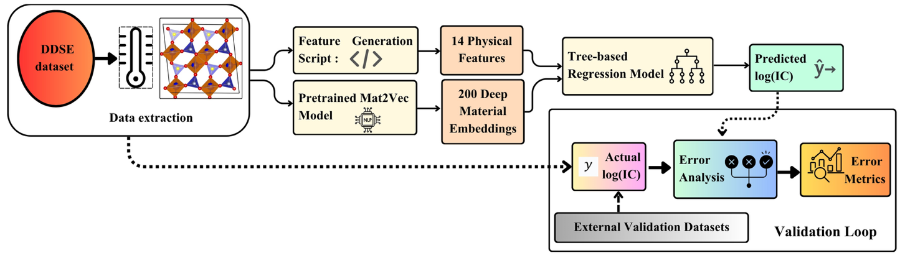
Figure 1: Process flow diagram

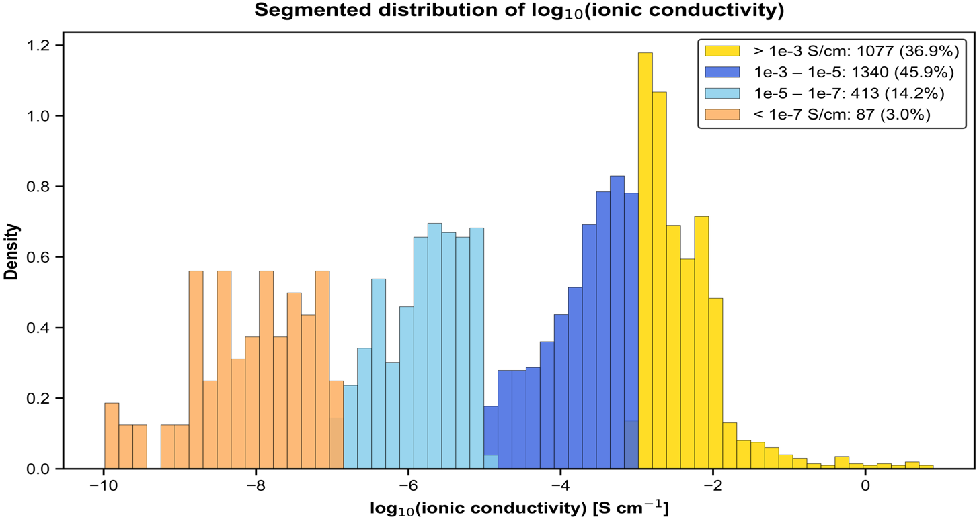

Figure 2 : Distribution of extracted DDSE data

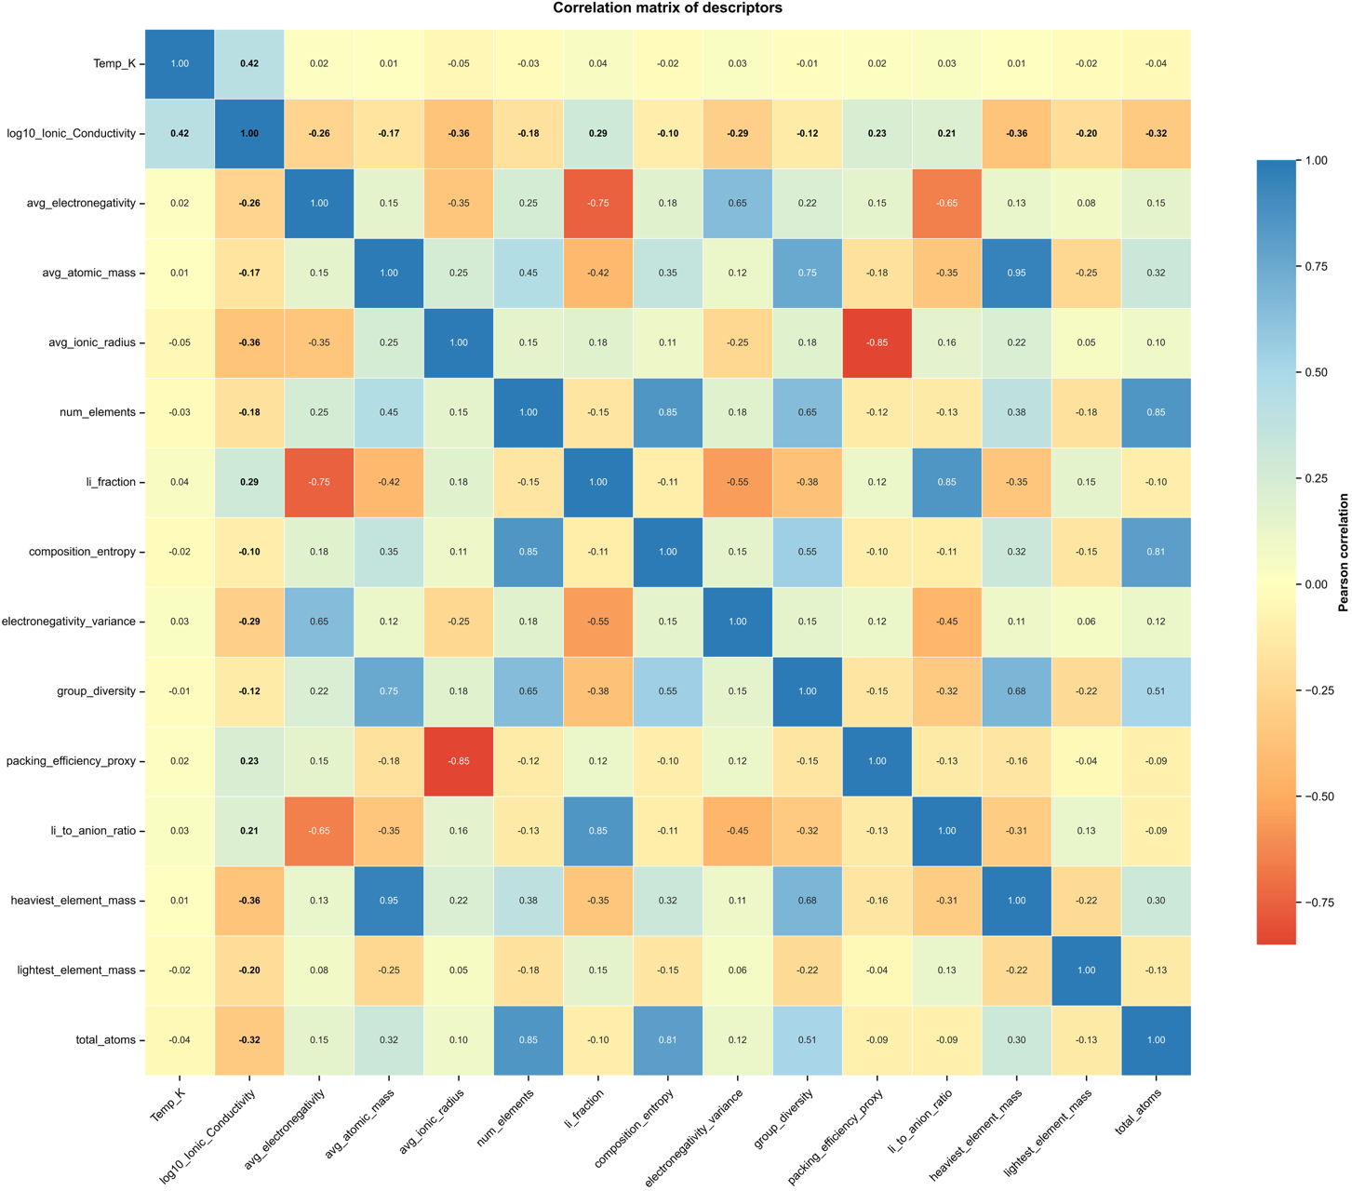
Figure 3 : Pearson corelations of physical descriptors
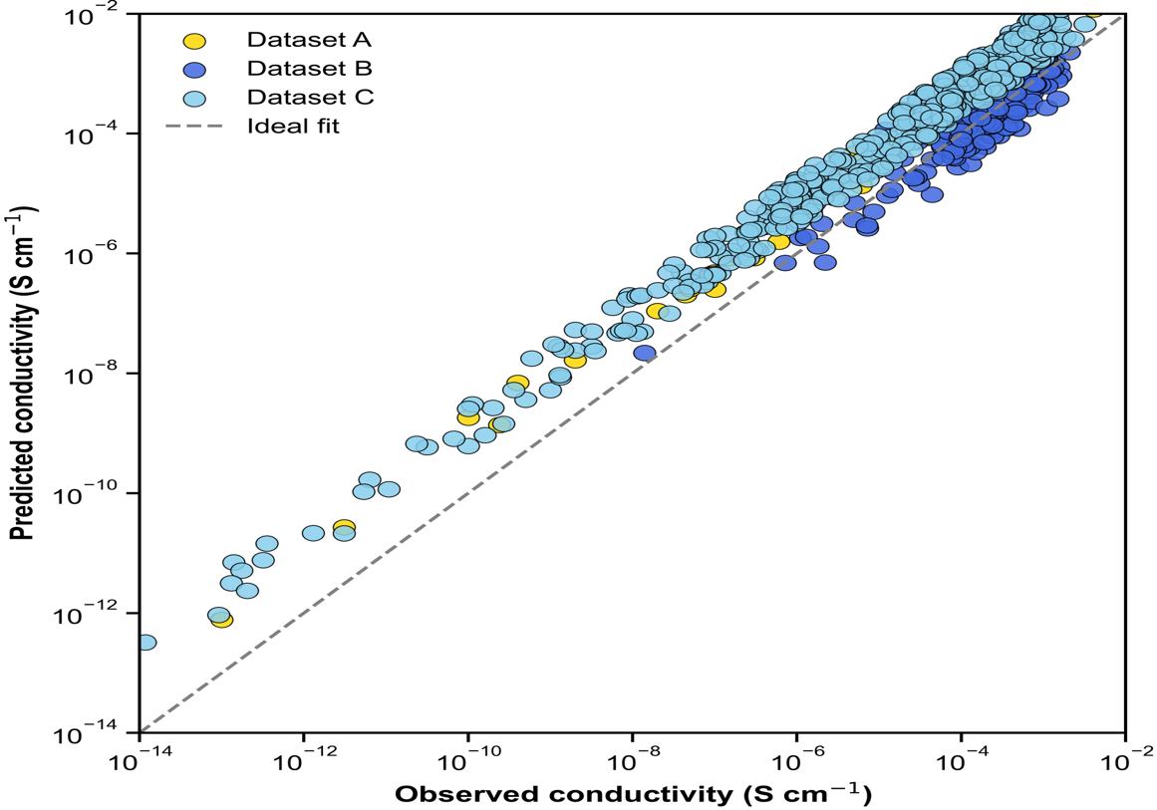

Figure 4: Parity plot : predicted vs. Observed conductivity

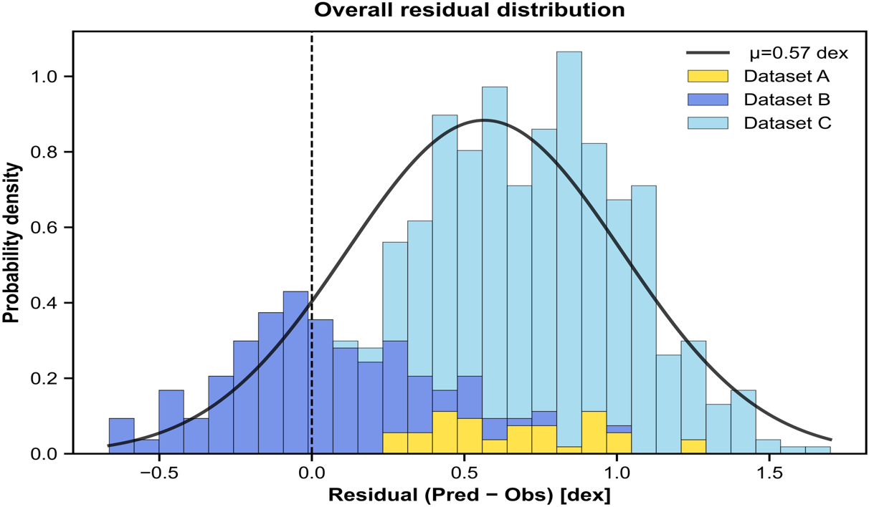
(a)
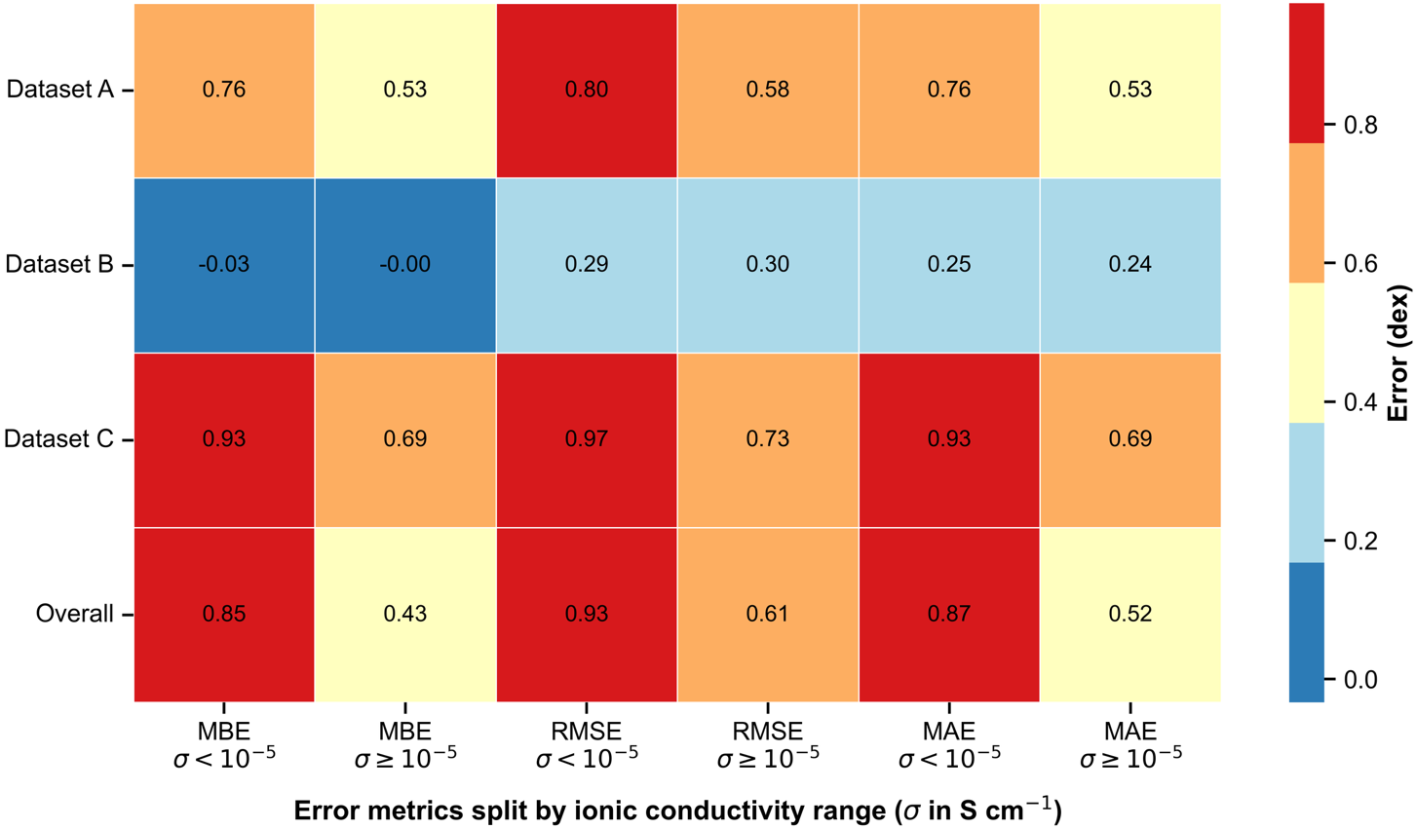
(b)
Figure 5: (a) Residual analysis (b) Heat map of region wise error analysis

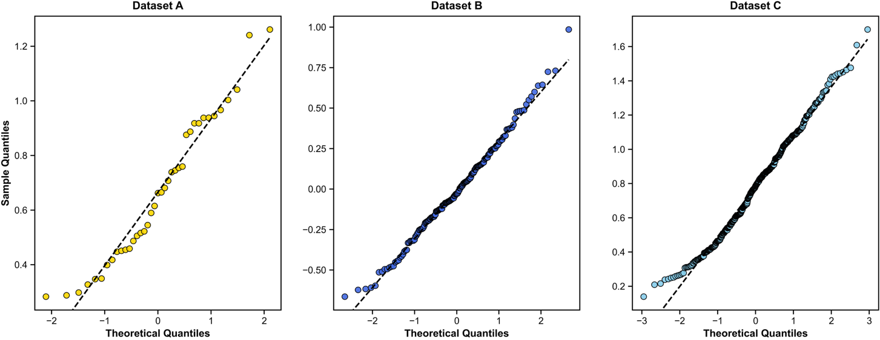
(a)
(a)
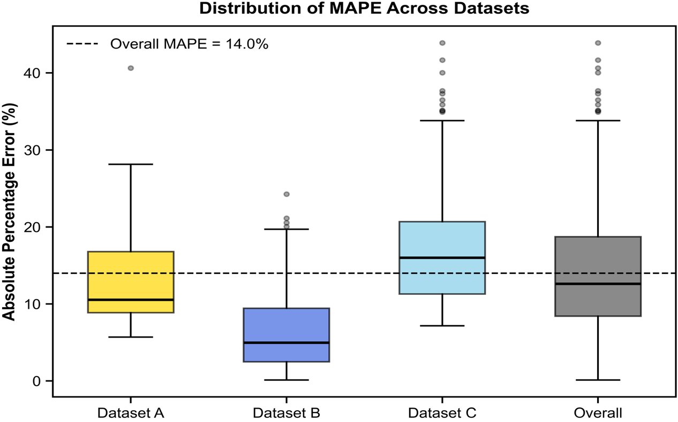

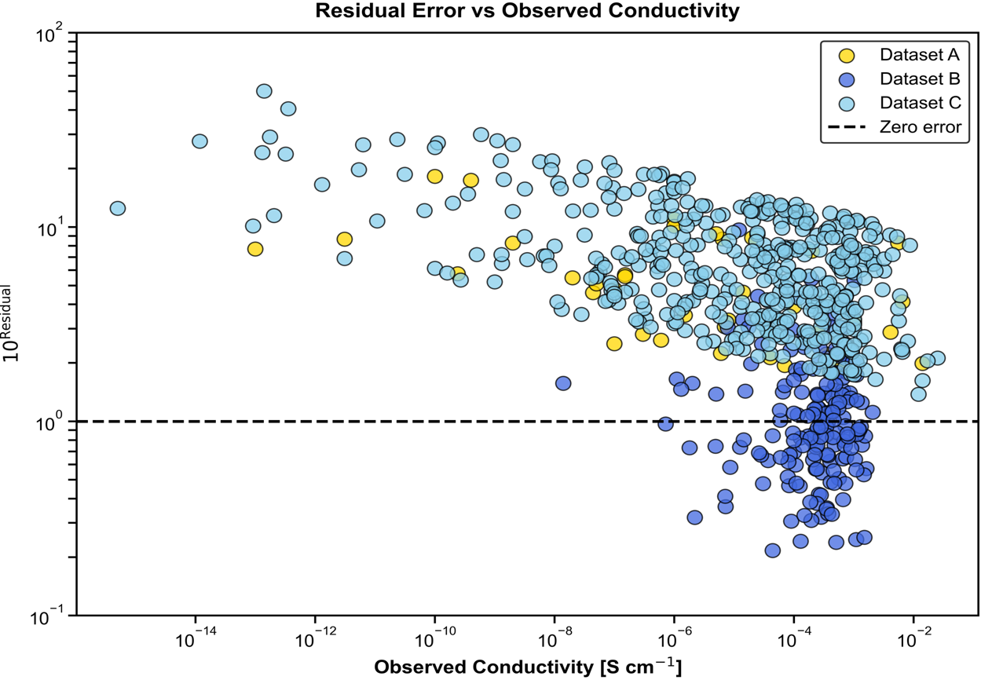
(c)
(b)
Figure 6: Model Error Evaluation: (a) Quantile (q) – Quantile (q) analysis (b) Absolute percentage Error in various data (c) Residual vs. observed ionic-conductivity

(c)
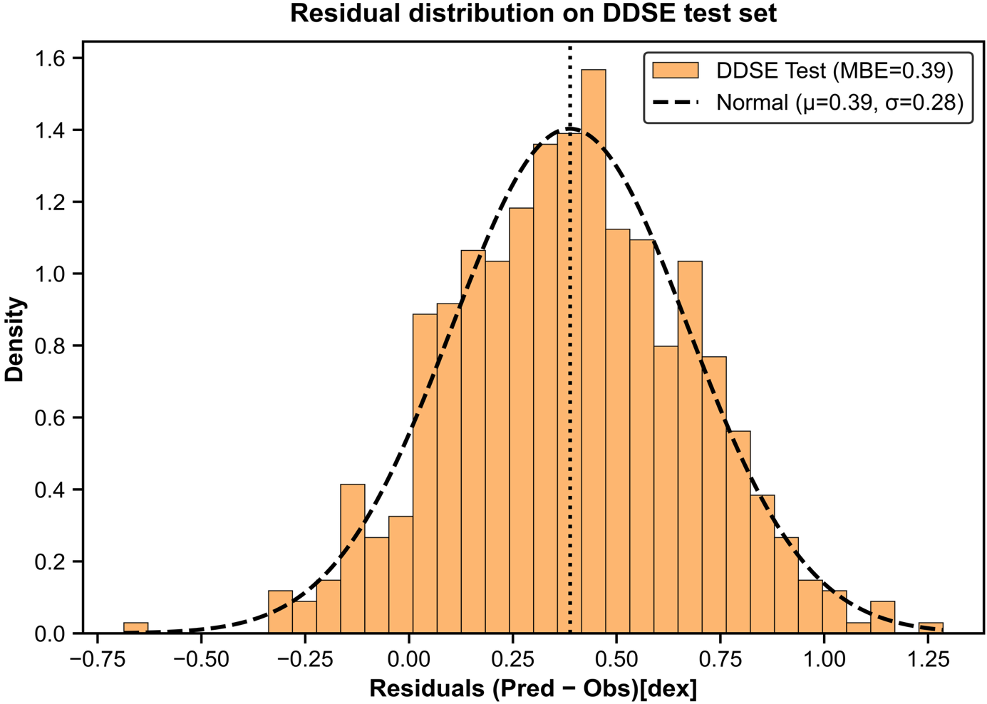

Figure 7: Distribution of residual for 20% unseen DDSE test data
References:
(1) Buchberger, D. A.; Garbacz, P.; Słupczyński, K.; Brzezicki, A.; Boczar, M.; Czerwiński, A. Lithium Transport Studies on Chloride-Doped Argyrodites as Electrolytes for Solid-State Batteries. ACS Appl. Mater. Interfaces 2023, 15 (46), 53417–53428. https://doi.org/10.1021/acsami.3c10857.
(2) Zhang, L.; Dai, Y.; Li, C.; Dang, Y.; Zheng, R.; Wang, Z.; Wang, Y.; Cui, Y.; Arandiyan, H.; Shao, Z.; Sun, H.; Zhuang, Q.; Liu, Y. Recent Advances in Electrochemical Impedance Spectroscopy for Solid-State Batteries. Energy Storage Mater. 2024, 69, 103378. https://doi.org/10.1016/j.ensm.2024.103378.
(3) Park, G.; Kim, H.; Oh, J.; Choi, Y.; Ovchinnikova, O. S.; Min, S.; Lee, Y.-G.; Hong, S. Quantitative Measurement of Li-Ion Concentration and Diffusivity in Solid-State Electrolyte. ACS Appl. Energy Mater. 2021, 4 (1), 784–790. https://doi.org/10.1021/acsaem.0c02660.
(4) Hasegawa, G.; Kuwata, N.; Hashi, K.; Tanaka, Y.; Takada, K. Lithium-Ion Diffusion in Perovskite-Type Solid Electrolyte Lithium Lanthanum Titanate Revealed by Pulsed-Field Gradient Nuclear Magnetic Resonance. Chemistry of Materials 2023, 35 (10), 3815–3824. https://doi.org/10.1021/acs.chemmater.2c03340.
(5) Baktash, A.; Reid, J. C.; Roman, T.; Searles, D. J. Diffusion of Lithium Ions in Lithium-Argyrodite Solid-State Electrolytes. NPJ Comput. Mater. 2020, 6 (1), 162. https://doi.org/10.1038/s41524-020-00432-1.
(6) Selvaraj, S. C.; Koverga, V.; Ngo, A. T. Exploring Li-Ion Transport Properties of Li 3 TiCl 6 : A Machine Learning Molecular Dynamics Study. J. Electrochem. Soc. 2024, 171 (5), 050544. https://doi.org/10.1149/1945-7111/ad4ac9.
(7) Sendek, A. D.; Yang, Q.; Cubuk, E. D.; Duerloo, K.-A. N.; Cui, Y.; Reed, E. J. Holistic Computational Structure Screening of More than 12 000 Candidates for Solid Lithium-Ion Conductor Materials. Energy Environ. Sci. 2017, 10 (1), 306–320. https://doi.org/10.1039/C6EE02697D.
(8) Dai, J.; Jiang, Y.; Lai, W. Study of Diffusion and Conduction in Lithium Garnet Oxides LixLa3Zrx−5Ta7−xO12 by Machine Learning Interatomic Potentials. Physical Chemistry Chemical Physics 2022, 24 (24), 15025–15033. https://doi.org/10.1039/d2cp00591c.
(9) Guo, X.; Wang, Z.; Yang, J. H.; Gong, X. G. Machine-Learning Assisted High-Throughput Discovery of Solid-State Electrolytes for Li-Ion Batteries. J. Mater. Chem. A Mater. 2024, 12 (17), 10124–10136. https://doi.org/10.1039/d4ta00721b.
(10) Sharma, R. R.; Ganguly, S. Screening of Lithium Ionic Conductors in Reference to the Formation of Interface with Lithium Anode. The Journal of Physical Chemistry C 2024, 128 (25), 10270–10280. https://doi.org/10.1021/acs.jpcc.4c00986.
(11) Sharma, R. R.; Venkatkrishna, V.; Balakrishna, V.; Ganguly, S. Machine Learning‐Based Exploration of Dopants in Li 7 La 3 Zr 2 O 12 in Reference to Lithium‐Ion Conductivity. Adv. Eng. Mater. 2025. https://doi.org/10.1002/adem.202402584.
(12) Ahmad, Z.; Xie, T.; Maheshwari, C.; Grossman, J. C.; Viswanathan, V. Machine Learning Enabled Computational Screening of Inorganic Solid Electrolytes for Suppression of Dendrite Formation in Lithium Metal Anodes. ACS Cent. Sci. 2018, 4 (8), 996–1006. https://doi.org/10.1021/acscentsci.8b00229.
(13) Jaafreh, R.; Pereznieto, S.; Jeong, S.; Widiantara, I. P.; Oh, J. M.; Kang, J.-H.; Mun, J.; Ko, Y. G.; Kim, J.-G.; Hamad, K. Phonon DOS‐Based Machine Learning Model for Designing High‐Performance Solid Electrolytes in Li‐Ion Batteries. Int. J. Energy Res. 2024, 2024 (1). https://doi.org/10.1155/2024/2138847.
(14) Dembitskiy, A. D.; Humonen, I. S.; Eremin, R. A.; Aksyonov, D. A.; Fedotov, S. S.; Budennyy, S. A. Benchmarking Machine Learning Models for Predicting Lithium Ion Migration. NPJ Comput. Mater. 2025, 11 (1). https://doi.org/10.1038/s41524-025-01571-z.
(15) Tshitoyan, V.; Dagdelen, J.; Weston, L.; Dunn, A.; Rong, Z.; Kononova, O.; Persson, K. A.; Ceder, G.; Jain, A. Unsupervised Word Embeddings Capture Latent Knowledge from Materials Science Literature. Nature 2019, 571 (7763), 95–98. https://doi.org/10.1038/s41586-019-1335-8.
(16) Kim, E.; Huang, K.; Saunders, A.; McCallum, A.; Ceder, G.; Olivetti, E. Materials Synthesis Insights from Scientific Literature via Text Extraction and Machine Learning. Chemistry of Materials 2017, 29 (21), 9436–9444. https://doi.org/10.1021/acs.chemmater.7b03500.
(17) Kononova, O.; Huo, H.; He, T.; Rong, Z.; Botari, T.; Sun, W.; Tshitoyan, V.; Ceder, G. Text-Mined Dataset of Inorganic Materials Synthesis Recipes. Sci. Data 2019, 6 (1), 203. https://doi.org/10.1038/s41597-019-0224-1.
(18) Shalev-Shwartz, Shai.; Ben-David, Shai. Understanding Machine Learning : From Theory to Algorithms; Cambridge University Press, 2014.
(19) Yang, F.; Campos dos Santos, E.; Jia, X.; Sato, R.; Kisu, K.; Hashimoto, Y.; Orimo, S.; Li, H. A Dynamic Database of Solid-State Electrolyte (DDSE) Picturing All-Solid-State Batteries. Nano Materials Science 2024, 6 (2), 256–262. https://doi.org/10.1016/j.nanoms.2023.08.002.
(20) Ong, S. P.; Richards, W. D.; Jain, A.; Hautier, G.; Kocher, M.; Cholia, S.; Gunter, D.; Chevrier, V. L.; Persson, K. A.; Ceder, G. Python Materials Genomics (Pymatgen): A Robust, Open-Source Python Library for Materials Analysis. Comput. Mater. Sci. 2013, 68, 314–319. https://doi.org/10.1016/j.commatsci.2012.10.028.
(21) Adhyatma, A.; Xu, Y.; Hawari, N. H.; Satria Palar, P.; Sumboja, A. Improving Ionic Conductivity of Doped Li7La3Zr2O12 Using Optimized Machine Learning with Simplistic Descriptors. Mater. Lett. 2022, 308. https://doi.org/10.1016/j.matlet.2021.131159.
(22) Hargreaves, C. J.; Gaultois, M. W.; Daniels, L. M.; Watts, E. J.; Kurlin, V. A.; Moran, M.; Dang, Y.; Morris, R.; Morscher, A.; Thompson, K.; Wright, M. A.; Prasad, B.-E.; Blanc, F.; Collins, C. M.; Crawford, C. A.; Duff, B. B.; Evans, J.; Gamon, J.; Han, G.; Leube, B. T.; Niu, H.; Perez, A. J.; Robinson, A.; Rogan, O.; Sharp, P. M.; Shoko, E.; Sonni, M.; Thomas, W. J.; Vasylenko, A.; Wang, L.; Rosseinsky, M. J.; Dyer, M. S. A Database of Experimentally Measured Lithium Solid Electrolyte Conductivities Evaluated with Machine Learning. NPJ Comput. Mater. 2023, 9 (1), 9. https://doi.org/10.1038/s41524-022-00951-z.
(23) Naser, M. Z.; Alavi, A. H. Error Metrics and Performance Fitness Indicators for Artificial Intelligence and Machine Learning in Engineering and Sciences. Architecture, Structures and Construction 2023, 3 (4), 499–517. https://doi.org/10.1007/s44150-021-00015-8.
(24) Zeraatgari, F. Z.; Hafezianzadeh, F.; Zhang, Y.-X.; Mosallanezhad, A.; Zhang, J.-Y. Exploring Galactic Properties with Machine Learning. Astron. Astrophys. 2024, 688, A33. https://doi.org/10.1051/0004-6361/202348714.
(25) Yang, T.; Li, X. An Autoencoder of Stellar Spectra and Its Application in Automatically Estimating Atmospheric Parameters. Mon. Not. R. Astron. Soc. 2015, 452 (1), 158–168. https://doi.org/10.1093/mnras/stv1210.
(26) Nzereogu, P. U.; Oyesanya, A.; Ogba, S. N.; Ayanwunmi, S. O.; Sobajo, M. S.; Chimsunum, V. C.; Ayanwunmi, V. O.; Amoo, M. O.; Adefemi, O. T.; Chukwudi, C. C. Solid-State Lithium-Ion Battery Electrolytes: Revolutionizing Energy Density and Safety. Hybrid Advances 2025, 8, 100339. https://doi.org/10.1016/j.hybadv.2024.100339.
(27) Il’ina, E. Recent Strategies for Lithium-Ion Conductivity Improvement in Li7La3Zr2O12 Solid Electrolytes. Int. J. Mol. Sci. 2023, 24 (16), 12905. https://doi.org/10.3390/ijms241612905.
(28) Zhang, Y.; Luo, J.-D.; Yao, H.-B.; Jiang, B. Size Dependent Lithium-Ion Conductivity of Solid Electrolytes in Machine Learning Molecular Dynamics Simulations. Artificial Intelligence Chemistry 2024, 2 (1), 100051. https://doi.org/10.1016/j.aichem.2024.100051.
(29) Ghosh, S.; Sudarshan, C.; Sudakar, C. Influence of Lattice Vibrations and Phonon Interactions on the Ion Transport Properties of Grain Boundary Tailored Li1.3Al0.3Ti1.7(PO4)3 Solid-State Electrolyte Ceramics. J. Appl. Phys. 2023, 133 (24). https://doi.org/10.1063/5.0147635.
(30) Sagotra, A. K.; Chu, D.; Cazorla, C. Influence of Lattice Dynamics on Lithium-Ion Conductivity: A First-Principles Study. Phys. Rev. Mater. 2019, 3 (3), 035405. https://doi.org/10.1103/PhysRevMaterials.3.035405.
(31) Sand, S. C.; Rupp, J. L. M.; Yildiz, B. A Critical Review on Li-Ion Transport, Chemistry and Structure of Ceramic–Polymer Composite Electrolytes for Solid State Batteries. Chem. Soc. Rev. 2025, 54 (1), 178–200. https://doi.org/10.1039/D4CS00214H.
(32) Xie, H.; Yang, Z.; Liu, J.; Wu, W.; Huang, T.; Liu, H. High-Entropy Strategies for Designing Advanced Solid-State Electrolytes: A Comprehensive Review. Chemical Communications 2025, 61 (57), 10449–10469. https://doi.org/10.1039/D5CC03141A.
(33) Zhao, W.; Yi, J.; He, P.; Zhou, H. Solid-State Electrolytes for Lithium-Ion Batteries: Fundamentals, Challenges and Perspectives. Electrochemical Energy Reviews 2019, 2 (4), 574–605. https://doi.org/10.1007/s41918-019-00048-0.

