Name : Nisarg Malhotra
PRN: 1262243207
TY AI_DS Panel-F
Batch-F2

UIUX Assignment 1
Domain: UPI Payment Apps
Apps Evaluated: Google Pay (GPay), PhonePe, Paytm
___

Google Pay (GPay)
Parameter | Justification | Rating (1-10)
Learnability | It has a super clean and simple interface that makes it perfect for a beginner to figure out quickly on their own. | 9
Usability | Paying a contact or scanning a QR code is incredibly fast with minimal clicks, as your most frequent contacts are immediately visible right on the home screen. | 9
Consistency | Follows Google's Material Design perfectly, keeping colors, fonts, and button styles exactly the same no matter which page you are on. | 9
Use of Metaphors | Uses standard real-world concepts well, framing user-to-user transactions exactly like a familiar text message conversation and using a physical bank building icon for direct account transfers. | 8
Navigation Structure | Keeps navigation extremely flat with a single scrolling home page and a simple bottom navigation bar, making it nearly impossible to get lost, though finding specific past transactions can sometimes require excessive scrolling. | 8
Visual Hierarchy | Uses large, clear bubbles for frequent contacts and bold, contrasting buttons for primary actions like scanning a QR code, making it instantly obvious exactly where your eyes should focus. | 9
Accessibility | Integrates extremely well with native accessibility tools like Android TalkBack and VoiceOver. Fonts scale well without breaking the UI, and color contrast remains high even in dark mode. | 8
Responsiveness | The clean, minimalist design scales effortlessly across different screen sizes, orientations, and tablet layouts without feeling stretched or breaking the user interface. | 9
Efficiency of Interaction | Allows users to initiate transactions with recent contacts or scan a QR code right from the home screen in just a couple of taps, and offers native Android widgets for even faster access. | 9
Feedback and System Status | Features a highly satisfying and clear blue checkmark animation with a distinct chime for successful payments, and explicitly explains when a bank server is down to prevent users from accidentally trying again and double-paying. | 9
Error Prevention and Recovery | Actively prevents mistakes by showing clear warning prompts when you try to send money to someone not in your contact list, and alerts you beforehand if a specific bank's servers are experiencing high failure rates. | 9
Aesthetic and Minimalist Design | Features an incredibly clean and minimalist interface with generous white space and no intrusive ads, keeping the focus entirely on your core payment actions and recent contacts. | 9
Content Readability | Employs clean, large typography with generous line spacing, making transaction amounts, contact names, and settings effortlessly readable at a glance. | 9
Search and Discoverability | Features a prominent global search bar that quickly finds contacts, businesses, and billers, though search filters for filtering past transaction history are fairly basic. | 8
Performance Perception | Features fluid animations that make the interface feel very premium, but loading the rewards or extensive contact lists can sometimes result in staring at a loading spinner slightly longer than expected. | 8
Trust and Credibility | Backed by Google's global security infrastructure, displaying clear encryption indicators and transparent bank policy notices that build instant user confidence. | 9
Personalization | Customizes the home screen dynamically by highlighting your most frequent contacts, recurring billers, and relevant reward offers based on your transaction history. | 8
User Satisfaction | Delivers a smooth, pleasant, and stress-free user experience, making daily payments feel effortless and dependable for all types of users. | 9
Evidence Screenshots
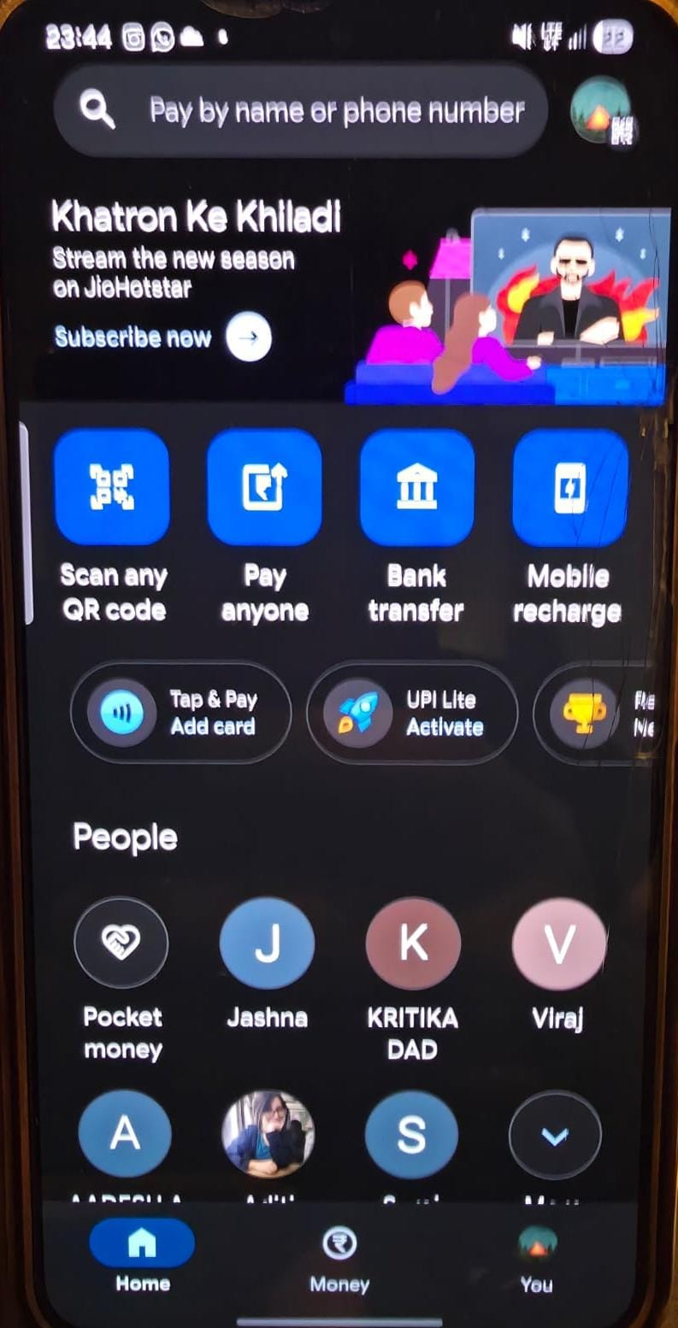
Fig. 1 — GPay Home Screen with frequent contacts and primary action buttons
- Learnability: The extremely clean and simple interface makes it perfect for a beginner to figure out quickly.
- Aesthetic and Minimalist Design: Generous white space and no intrusive ads keep the focus entirely on core payment actions.
- Visual Hierarchy: Large, clear bubbles for contacts and bold buttons make it instantly obvious where the eyes should focus.
- Efficiency of Interaction: Allows users to initiate transactions right from the home screen in just a couple of taps.
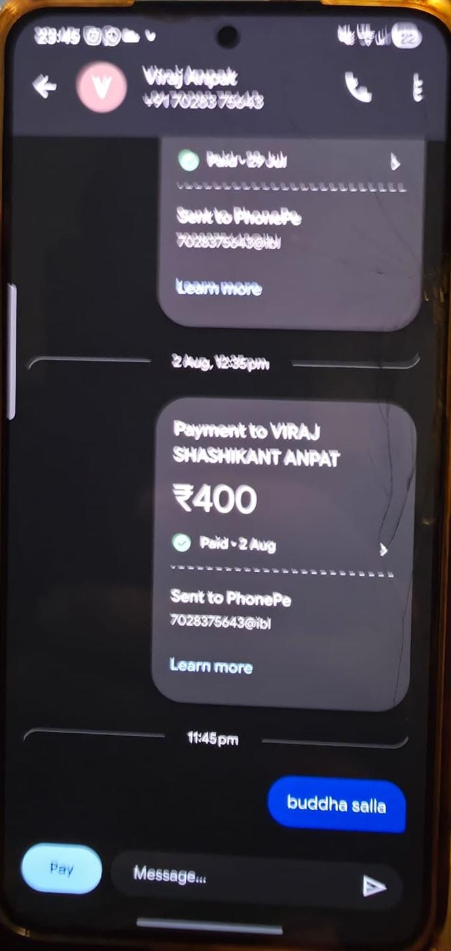
Fig. 2 — GPay peer-to-peer payment screen styled like a messaging app
- Use of Metaphors: Frames user-to-user transactions exactly like a familiar text message conversation.
- Content Readability: Clean, large typography with generous line spacing makes transaction amounts effortlessly readable.
- Error Prevention and Recovery: Shows clear warning prompts when you try to send money to someone not in your contact list.
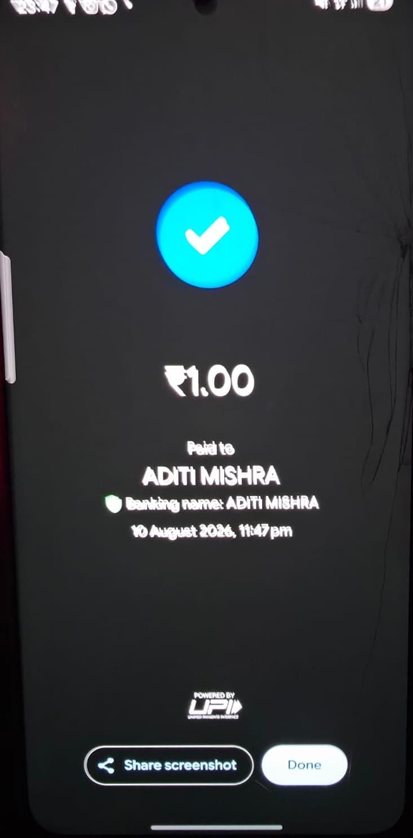
Fig. 3 — GPay successful transaction screen with blue checkmark
- Feedback and System Status: Features a highly satisfying blue checkmark animation and a distinct chime for successful payments.
- Trust and Credibility: Backed by Google's global security infrastructure, building instant user confidence.
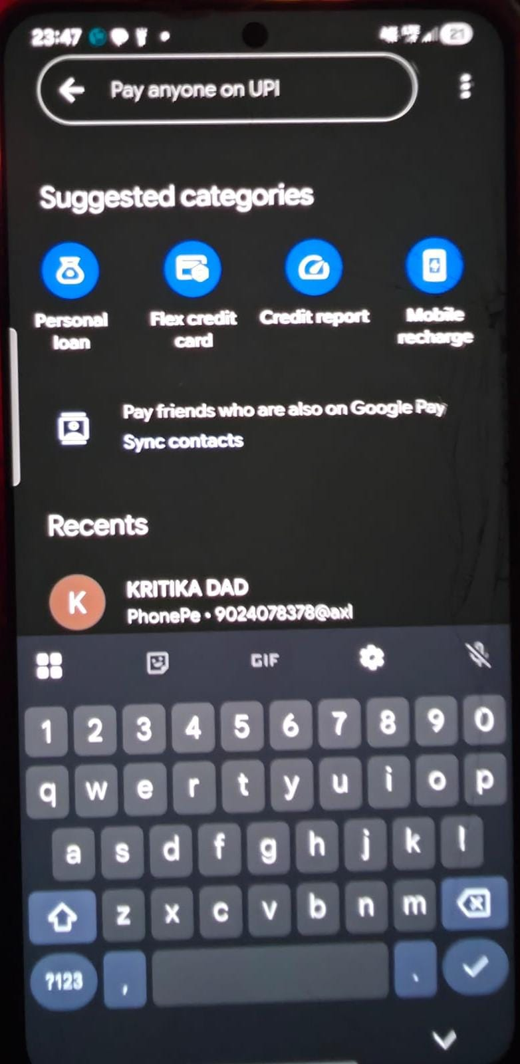
Fig. 4 — GPay search bar and personalized rewards section
- Search and Discoverability: Prominent global search bar quickly finds contacts, businesses, and billers.
- Personalization: Customizes the screen dynamically by highlighting relevant reward offers based on transaction history.
___

PhonePe
Parameter | Justification | Rating (1-10)
Learnability | The layout is really user-friendly and easy to navigate, but the huge amount of extra features could slightly overwhelm a first-time user. | 8
Usability | Routine transactions like bill payments and money transfers are very smooth and reliable, though navigating around the extra insurance and shopping features can take an extra second. | 8
Consistency | Sticks strictly to its signature purple and white theme, and the layout for different sections like wealth or insurance feels very uniform. | 9
Use of Metaphors | Heavily utilizes recognizable everyday objects as metaphors, such as a lightbulb for electricity bills, a shield/umbrella for insurance, and a piggy bank for wealth management. | 9
Navigation Structure | Excellent bottom navigation bar logically separates Home, Stores, Wealth, and History, ensuring users always know exactly where they are without digging through deep or confusing menus. | 9
Visual Hierarchy | Uses its signature purple color blocking to effectively group all the main money transfer actions at the very top of the screen, creating a strong and clear focal point. | 8
Accessibility | Good scaling for larger font sizes and works decently with screen readers, but the heavy use of purple gradients sometimes slightly lowers the visual contrast for visually impaired users. | 7
Responsiveness | Adapts flawlessly across varying mobile and tablet screens, maintaining well-proportioned touch targets and consistent layout component scaling. | 9
Efficiency of Interaction | Groups all essential payment quick-actions (To Contact, To Account, Scan) squarely at the top of the interface, drastically reducing the number of steps required to send money. | 9
Feedback and System Status | Provides immediate, unmistakable green success screens and is excellent at diagnosing and displaying the exact reasons for failed transactions, such as a wrong PIN or a receiver's network issue. | 9
Error Prevention and Recovery | Does a great job with error recovery by instantly offering clear, actionable alternatives if a payment fails, like prompting you to switch to a different linked bank account or re-enter your UPI PIN. | 8
Aesthetic and Minimalist Design | Maintains a visually appealing and consistent color scheme, but the home screen is somewhat crowded with numerous tiles for secondary services like insurance, wealth management, and shopping. | 7
Content Readability | Uses highly legible fonts with appropriate sizing for primary actions and transaction histories, though some secondary text in the wealth or insurance sections can feel a bit small. | 8
Search and Discoverability | Combines a solid search bar with clear category grids for utilities, bills, and financial products, making everyday services very easy to discover. | 8
Performance Perception | Prioritizes core payment features for near-instant loading, utilizing snappy screen transitions that make the entire app feel incredibly fast and lightweight. | 9
Trust and Credibility | Prominently highlights security features like mandatory biometric locks and explicit transaction safeguards, making users feel safe during high-value transfers. | 9
Personalization | Tailors suggestions by surfacing regular payment categories, saved bill accounts, and relevant financial products like insurance or investments based on past activity. | 8
User Satisfaction | Highly satisfying and reliable for everyday transactions, though the expanding list of financial services makes the app feel more functional than delightful. | 8
Evidence Screenshots
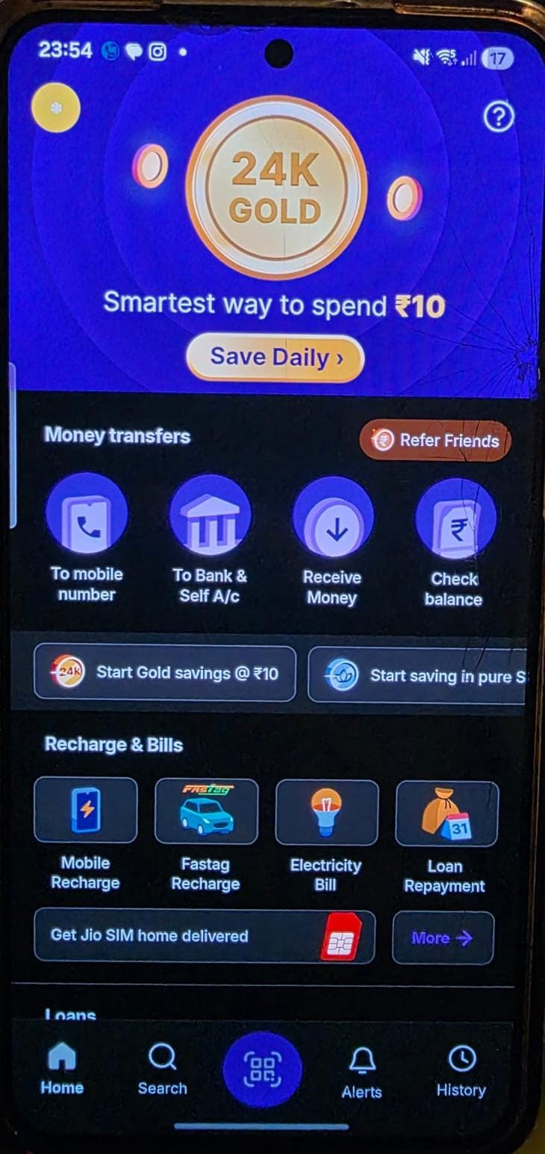
Fig. 5 — PhonePe Dashboard showing top action buttons and bottom navigation
- Navigation Structure: Excellent bottom navigation bar logically separates Home, Stores, Wealth, and History.
- Efficiency of Interaction: Groups all essential payment quick-actions squarely at the top, drastically reducing steps to send money.
- Consistency: Sticks strictly to its signature purple and white theme uniformly.
- Use of Metaphors: Heavily utilizes recognizable everyday objects like a lightbulb for electricity and an umbrella for insurance.
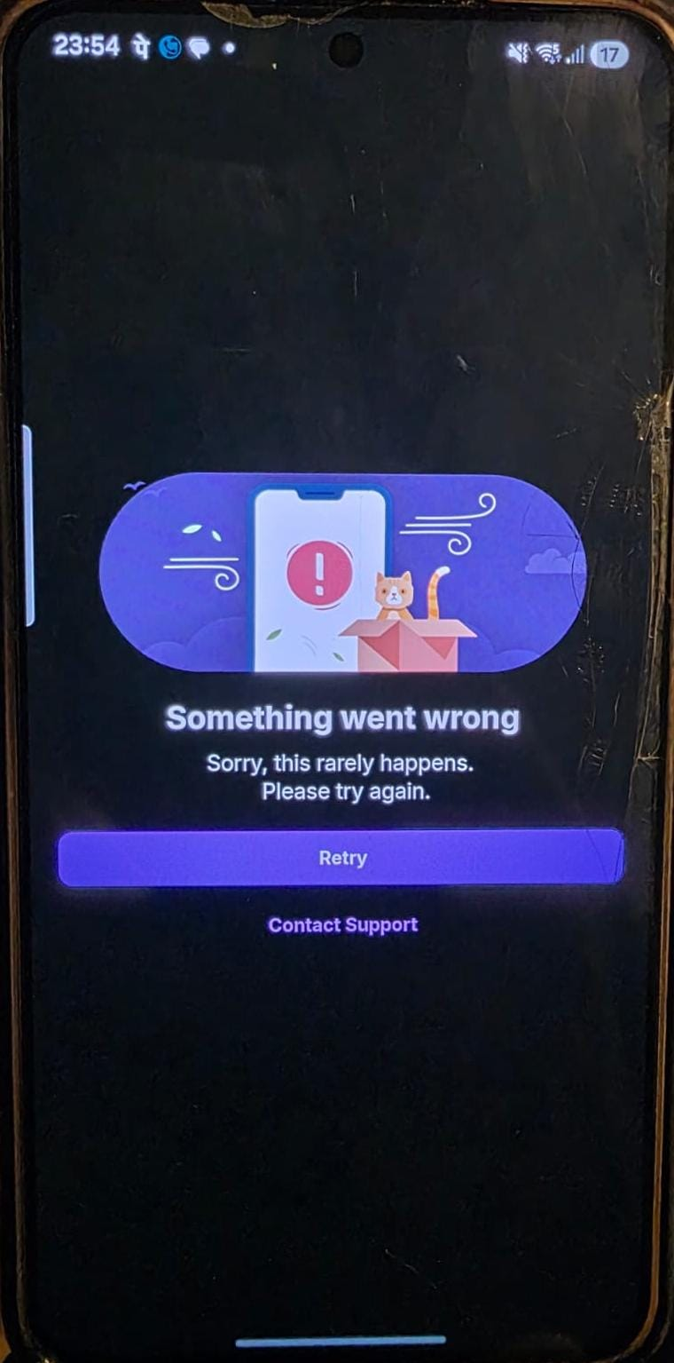
Fig. 6 — PhonePe error recovery screen during a failed transaction
- Error Prevention and Recovery: Instantly offers actionable alternatives if a payment fails, like switching to a different linked bank account.
- Feedback and System Status: Excellent at diagnosing and displaying the exact reasons for failed transactions (e.g., receiver's network issue).
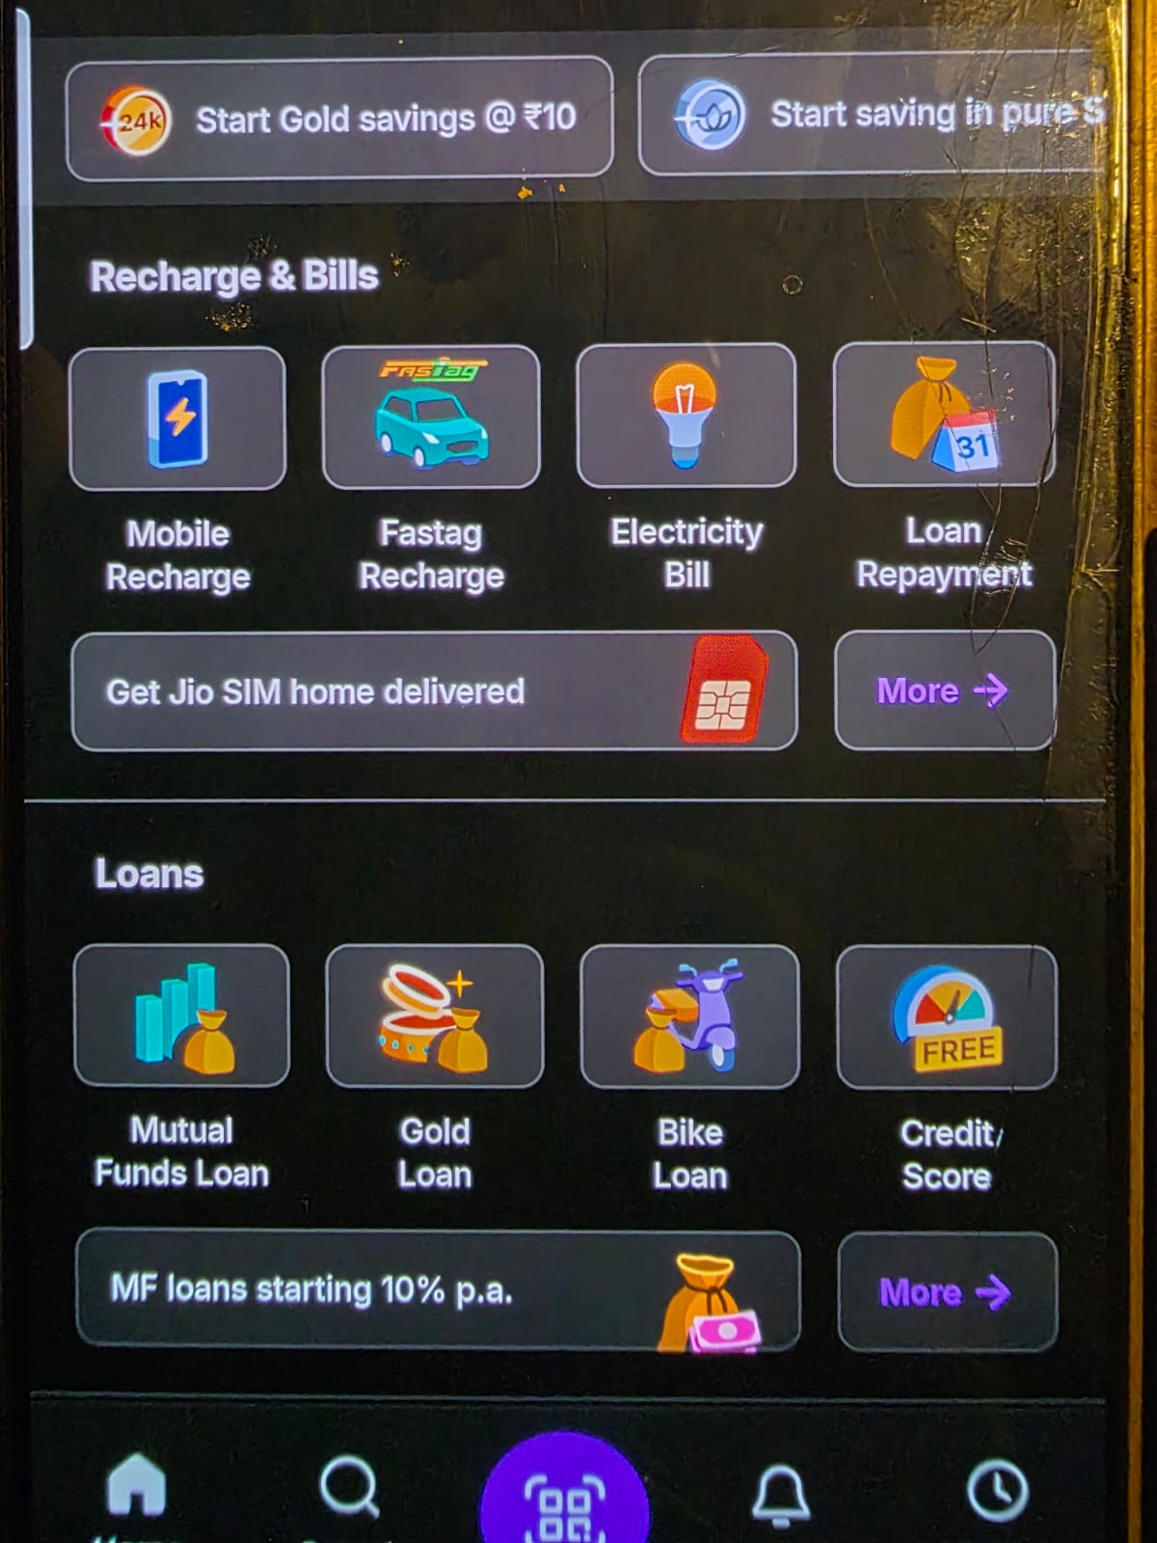
Fig. 7 — PhonePe categorised bill payment section
- Search and Discoverability: Combines a solid search bar with clear category grids for utilities and bills.
- Personalization: Tailors suggestions by surfacing saved bill accounts based on past activity.

Paytm
Parameter | Justification | Rating (1-10)
Learnability | It has the most cluttered interface with lots of wallet and mini-app features, making it much harder for a brand new user to figure out how to just send money. | 6
Usability | While the core payment engine is highly effective, users often have to bypass promotional banners and a dense grid of unrelated mini-services just to complete simple tasks. | 7
Consistency | Struggles a lot here because many of its mini-apps and shopping sections look like completely different websites squeezed into one app, breaking the visual consistency. | 5
Use of Metaphors | Has standard metaphors for its e-commerce and booking side like shopping carts and airplanes, but often relies on confusing, abstract symbols for its deeper financial and banking features. | 7
Navigation Structure | The sheer volume of features creates a deep and overwhelming information hierarchy, often requiring users to dig through hidden hamburger menus or rely on the search bar just to find basic services. | 5
Visual Hierarchy | Almost every single element, promotional banner, and mini-app icon is competing for attention with bright, clashing colors, which destroys the visual hierarchy and makes the screen feel chaotic. | 5
Accessibility | Falls short because the extremely dense interface makes it difficult for screen readers to navigate logically. Small promotional text and low-contrast banners further hinder readability. | 5
Responsiveness | Works decently on standard smartphones, but the heavy density of banners, text, and mini-apps often leads to awkward layout stretching and cramped elements on larger tablet screens. | 7
Efficiency of Interaction | While the primary QR scanner is accessible, accessing specific payment types or secondary features often involves clicking through extra menus and dismissing promotional overlays. | 7
Feedback and System Status | Offers incredibly clear visual receipts and distinct audio confirmations within the app, making it instantly and undeniably obvious when a transaction has successfully gone through. | 9
Error Prevention and Recovery | While it catches basic errors, the cluttered interface makes it much easier to accidentally click on a promotional banner or the wrong mini-app by mistake, and some error messages can feel a bit too technical. | 7
Aesthetic and Minimalist Design | Suffers from severe visual clutter, often overwhelming the user with flashing promotional banners, aggressive cross-selling, and a massive grid of mini-apps that detract from the core payment experience. | 4
Content Readability | The heavy density of the interface forces the use of very small fonts and tight spacing, which severely impacts the readability of promotional text, cashback terms, and mini-app labels. | 6
Search and Discoverability | Houses the most powerful and comprehensive search bar that instantly indexes everything from contacts and billers to flight tickets and mini-apps across its massive ecosystem. | 9
Performance Perception | The heavy load of dynamic ads, image banners, and mini-apps often causes noticeable jitter and sluggishness when first opening the app or scrolling down the home screen. | 6
Trust and Credibility | While maintaining bank-grade security protocols, past regulatory scrutiny and aggressive promotional popups slightly erode perceived trust compared to its peers. | 7
Personalization | Delivers highly personalized recommendations across its vast ecosystem, dynamically adjusting feeds for deals, travel, commerce, and financial services based on extensive user tracking. | 9
User Satisfaction | While powerful as an all-in-one super app, the overwhelming amount of ads, popups, and mini-services reduces overall user enjoyment and creates a fragmented experience. | 6
Evidence Screenshots
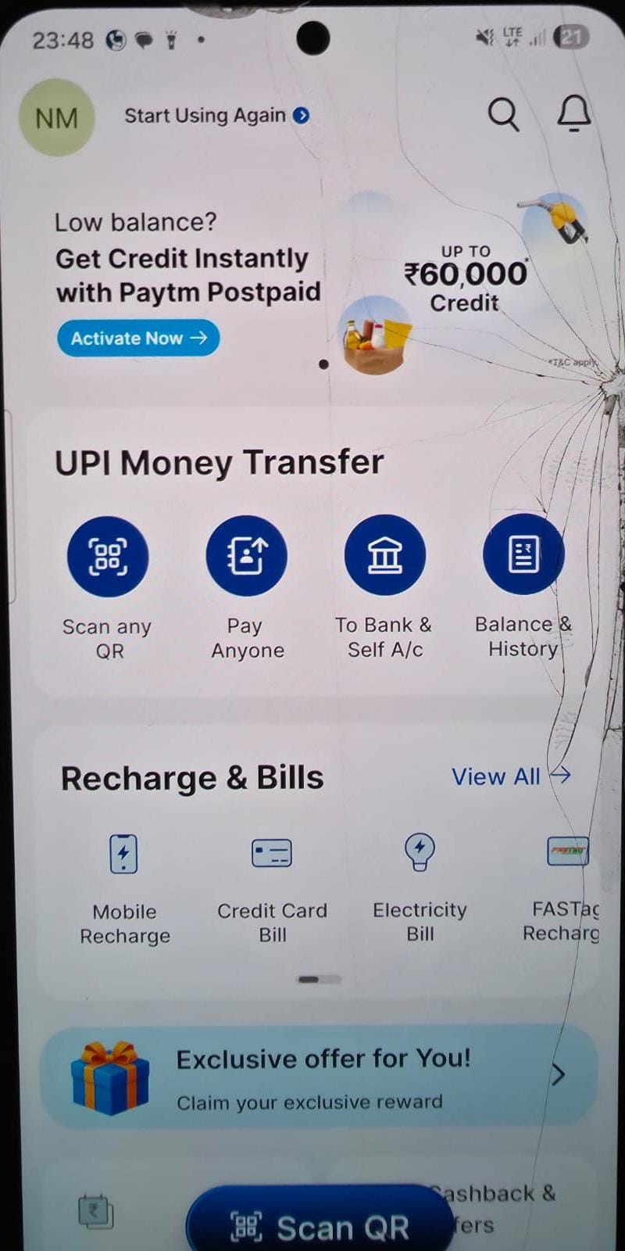
Fig. 9 — Paytm Home Screen showing high density of mini-apps and promotional banners
- Aesthetic and Minimalist Design: Suffers from severe visual clutter, overwhelming the user with flashing banners and a massive grid of mini-apps.
- Visual Hierarchy: Almost every single element is competing for attention, destroying the visual hierarchy and making the screen feel chaotic.
- Learnability: The cluttered interface makes it much harder for a brand new user to figure out how to just send money.
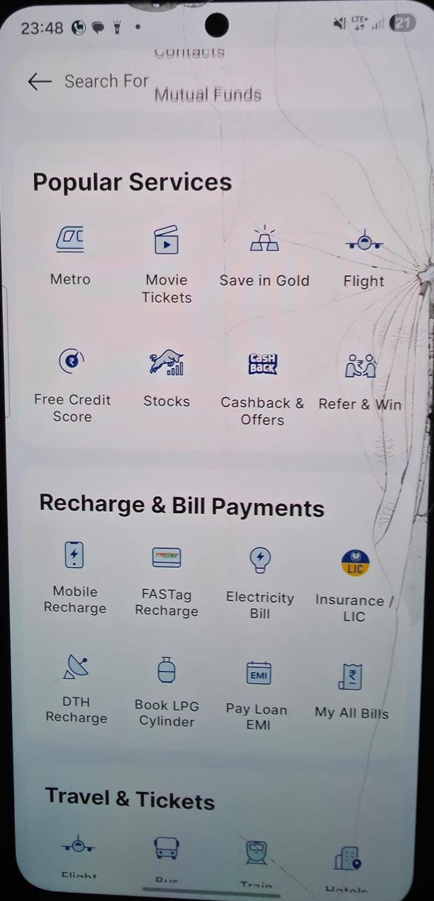
Fig. 10 — Paytm universal search indexing ecosystem services
- Search and Discoverability: Houses a powerful search bar that instantly indexes everything from contacts to flight tickets across its ecosystem.
- Personalization: Delivers highly personalized recommendations, dynamically adjusting feeds for deals and commerce.
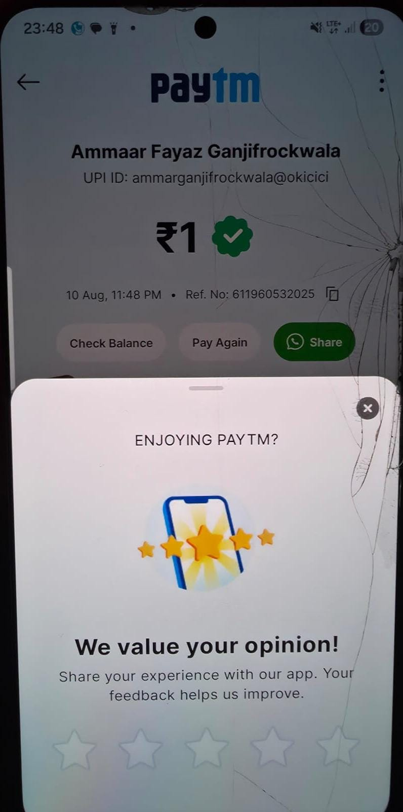
Fig. 11 — Paytm Post-Transaction Visual Receipt
- Feedback and System Status: Offers incredibly clear visual receipts making it instantly and undeniably obvious when a transaction has gone through.
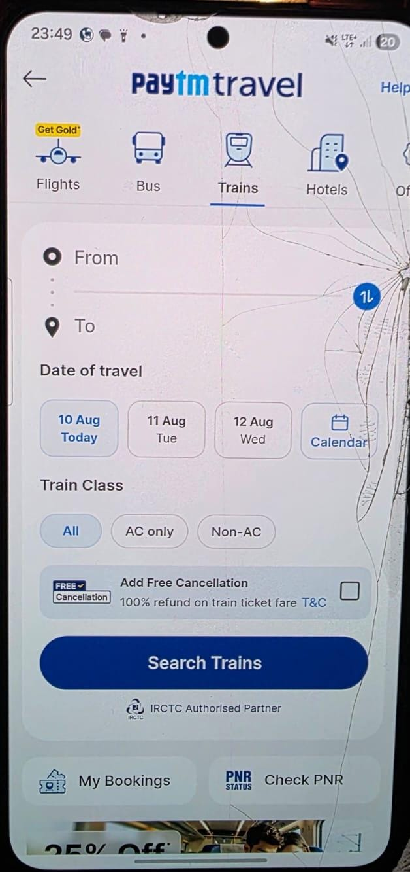
Fig. 12 — Paytm deeper navigation into mini-apps and shopping
- Navigation Structure: The sheer volume of features creates a deep information hierarchy, requiring users to dig through menus.
- Consistency: Mini-apps and shopping sections look like completely different websites squeezed into one app, breaking visual consistency.
- Content Readability: Heavy density forces the use of very small fonts and tight spacing, impacting readability.

