**A Project Report On**

**Horticulture Management System**

Made By:

IT-115 Pipaliya Nisarg

IT-123 Salodiya Snehal

IT-125 Sangani Kevin

Guided By

Prof. Shweta Jambukia

Department of Information Technology

Faculty of Technology

DD University



**Index:**

**Page NO.**

|  |  |
| --- | --- |
| **Certificate** | **3** |
| 1. **Project Overview** | **4** |
| 1. **ER and Relational Schema** | **5** |
| 1. **Data Dictionary** | **7** |
| 1. **Implementation** | **12** |
| 1. **Inserted Data** | **21** |
| 1. **Join and subquery** | **26** |
| 1. **Functions and triggers** | **31** |

**CERTIFICATE**

This is to certify that the project entitled “Horticulture Management system” is a bonafide. report of the work carried out by:

1)Pipaliya Nisarg-21ITUES081

2)Sangani Kevin-21ITUOS067

3)Salodiya Snehal-21CHUOT152

of Department of Information Technology, semester IV, under the guidance and supervision for the subject Database Management System. They were involved in Project training during the academic year 2022-2023.

Prof. Shweta Jambukia

Project Guide, Department of Information Technology,

Faculty of Technology,

Dharmsinh Desai University, Nadiad

Date:15/03/2023

Prof. Vipul Dabhi

Head, Department of Information Technology

**1.Project Overview**

Horticulture management system.

Our goal was to design a management system for a firm which was providing skilled labors, tool, medicines, etc things to the farmers who want a helping hand in managing their farm and in return they get the rent which they have decided.

Here we have only considered Fruits, Flowers and Berries and we can refer the farm/land where any of this three grows as “Garden” so we refer it as garden throughout the whole file.

This system helps in analyzing that which crop/produce was mostly chosen by the farmer or which is the most useful tool or multipurpose tool, which produce gives us maximum profit or which kind of disease is common among plants and around which period.

**2.ER-Diagram & Relational Schema.**

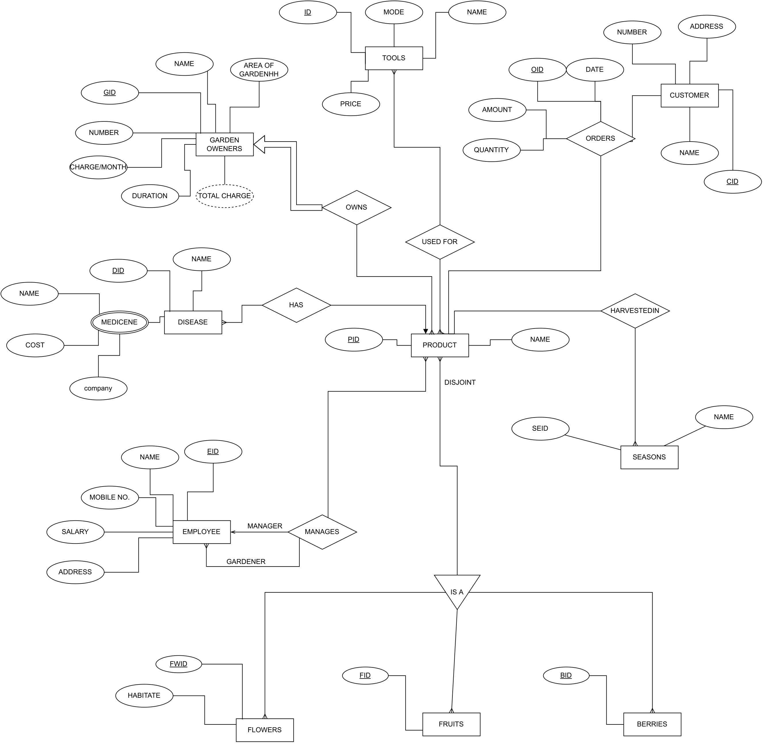

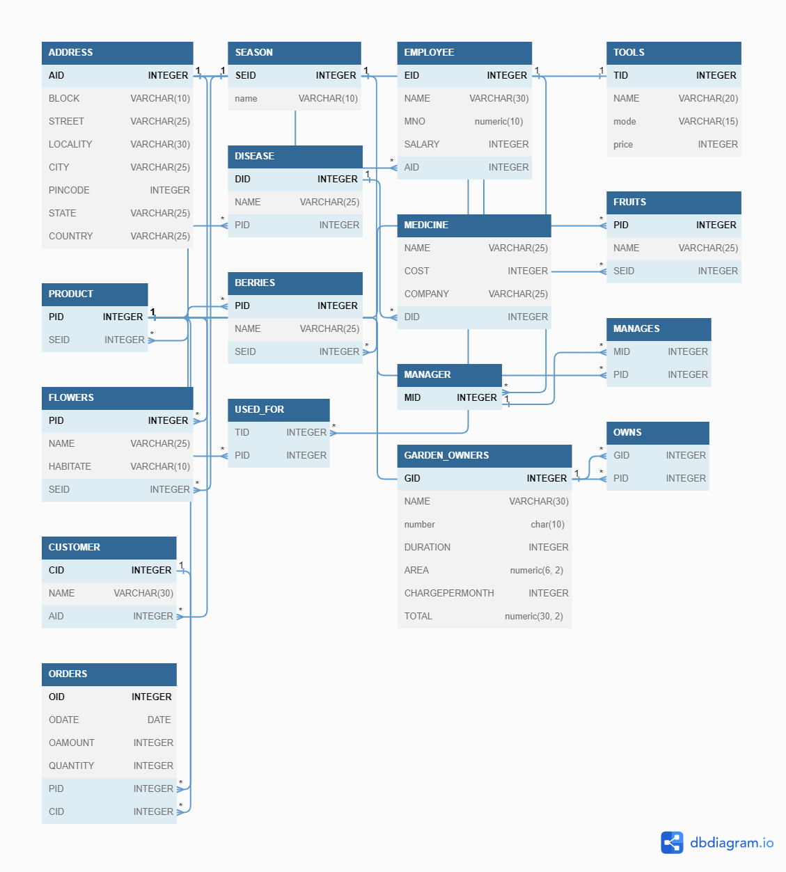

**3.Data Dictionary**

1.Address:

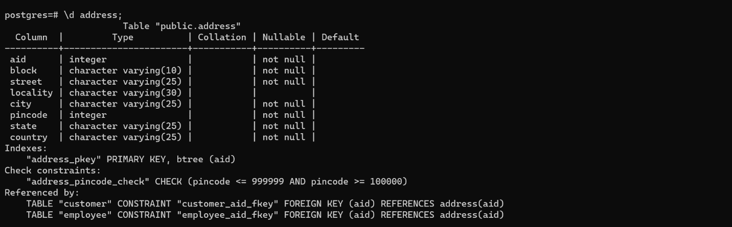

2.Customers

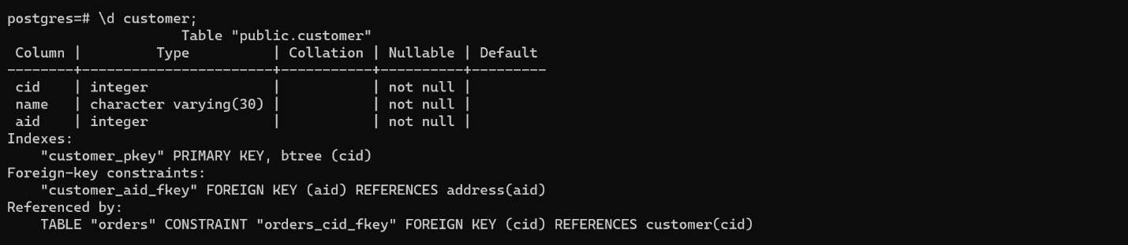

3.Employees

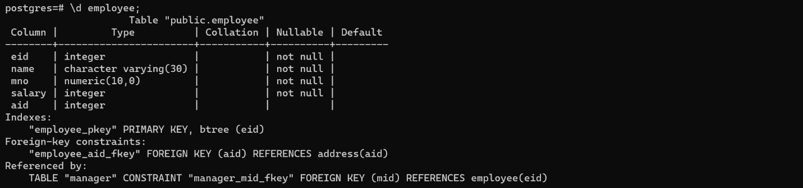

4.Manager

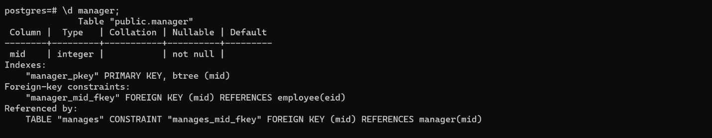

5.Manages

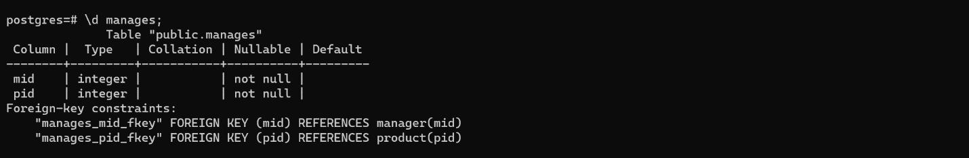

6.Orders

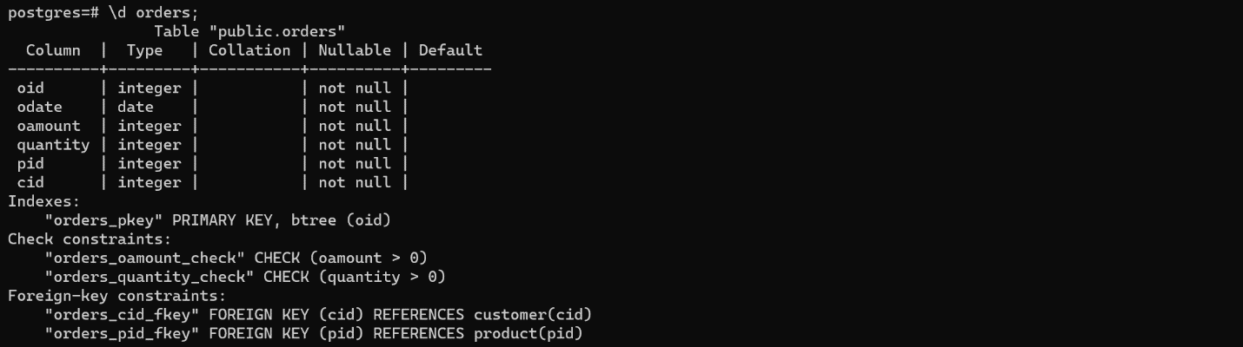

7.Garden Owners

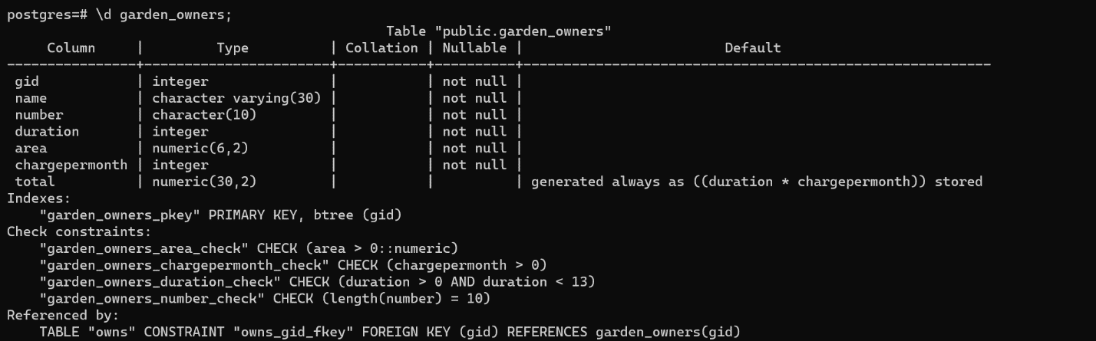

8.Owns

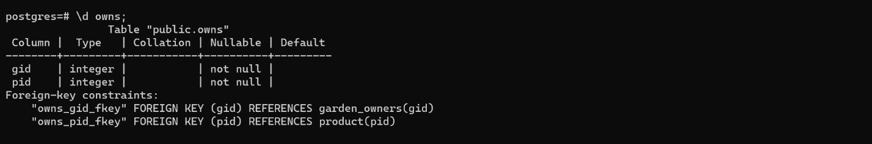

9.Medicine

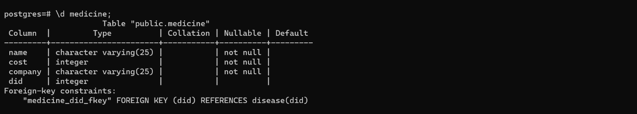

10.Seasons

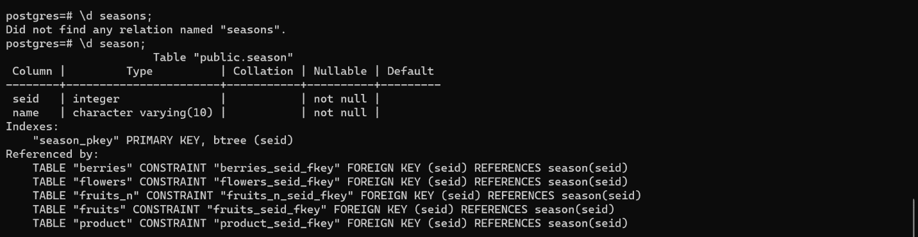

11.Tools

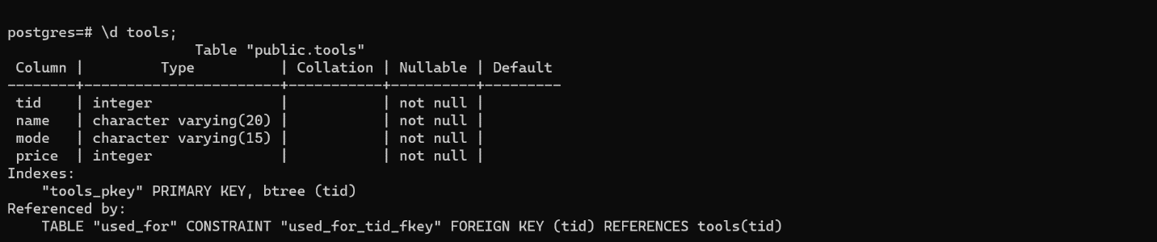

12.Used for

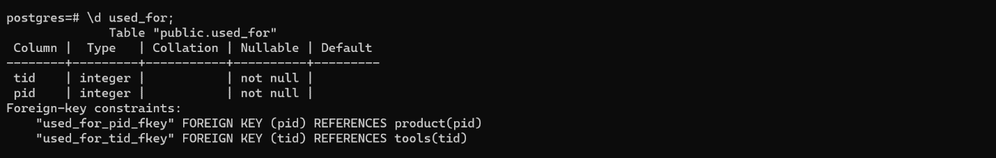

13.Product

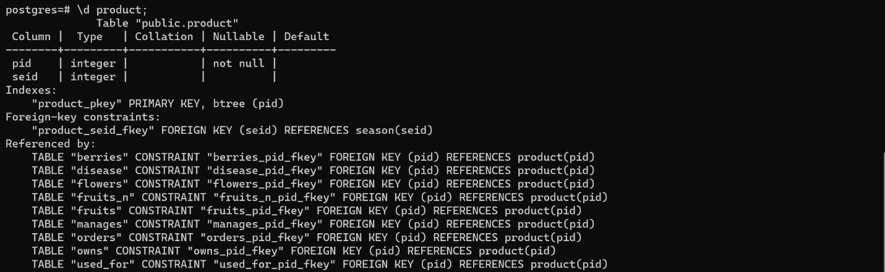

14.Fruits

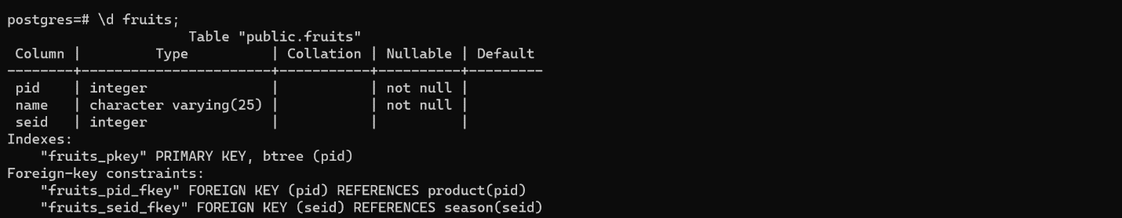

15.Flowers

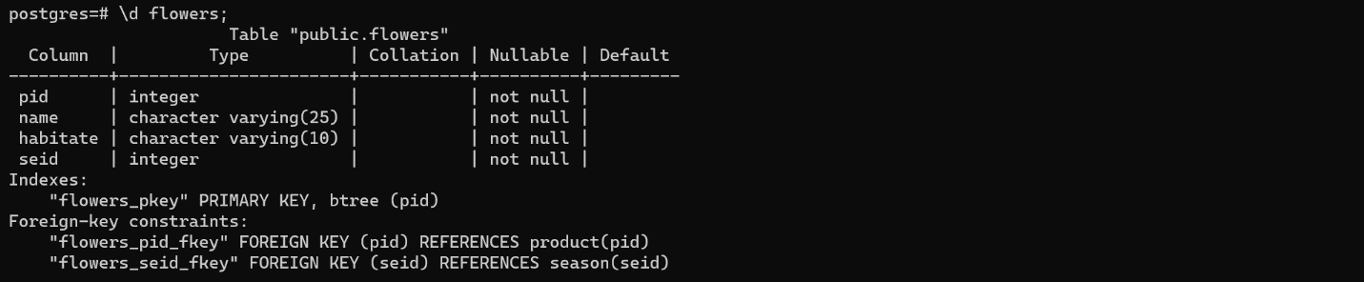

16.Berries

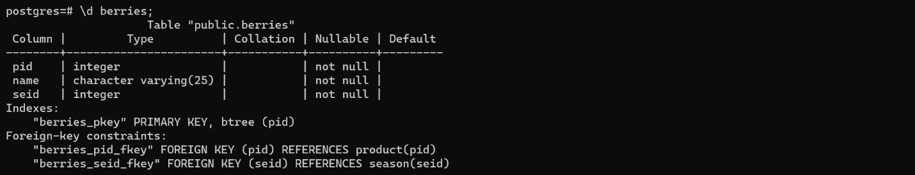

17.Disease

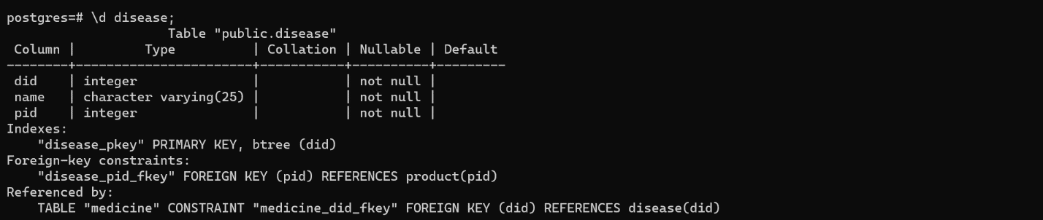

**4.Implementation**

SCHEMAS:

CREATE TABLE ADDRESS(

  AID INTEGER PRIMARY KEY,

  BLOCK VARCHAR(10) NOT NULL,

  STREET VARCHAR(25) NOT NULL,

  LOCALITY VARCHAR(30) ,

  CITY VARCHAR(25) NOT NULL,

  PINCODE INTEGER NOT NULL CHECK(PINCODE <= 999999 AND PINCODE >=100000),

  STATE VARCHAR(25) NOT NULL,

  COUNTRY VARCHAR(25) NOT NULL

);

CREATE TABLE SEASON (

  seid INTEGER PRIMARY KEY,

  name VARCHAR(10) NOT NULL

);

CREATE TABLE EMPLOYEE (

  EID INTEGER PRIMARY KEY,

  NAME VARCHAR(30) NOT NULL,

  MNO numeric(10) NOT NULL,

  SALARY INTEGER NOT NULL,

  AID INTEGER references ADDRESS(AID)

);

CREATE TABLE TOOLS(

  TID INTEGER PRIMARY KEY,

  NAME VARCHAR(20) NOT NULL,

  mode VARCHAR(15) not NULL,

  price INTEGER not NULL

);

CREATE TABLE PRODUCT(

  PID INTEGER PRIMARY KEY,

  SEID INTEGER references SEASON(SEID)

);

CREATE TABLE DISEASE(

  DID INTEGER PRIMARY KEY,

  NAME VARCHAR(25) NOT NULL,

  PID INTEGER references PRODUCT(PID) NOT NULL);

CREATE TABLE MEDICINE(

  NAME VARCHAR(25) NOT NULL,

  COST INTEGER NOT NULL,

  COMPANY VARCHAR(25) NOT NULL,

  DID INTEGER references DISEASE(DID)

);

CREATE TABLE FRUITS(

  PID INTEGER references PRODUCT(PID) PRIMARY KEY,

  NAME VARCHAR(25) NOT NULL,

  SEID INTEGER references SEASON(SEID)

);

CREATE TABLE FLOWERS(

  PID INTEGER references PRODUCT(PID) PRIMARY KEY,

  NAME VARCHAR(25) NOT NULL,

  HABITATE VARCHAR(10) NOT NULL,

  SEID INTEGER references SEASON(SEID) NOT NULL

);

CREATE TABLE BERRIES(

  PID INTEGER references PRODUCT(PID) PRIMARY KEY,

  NAME VARCHAR(25) NOT NULL,

  SEID INTEGER references SEASON(SEID) NOT NULL

);

CREATE TABLE MANAGER(

  MID INTEGER references EMPLOYEE(EID) PRIMARY KEY

);

CREATE TABLE MANAGES(

  MID INTEGER references MANAGER(MID) NOT NULL,

  PID INTEGER references PRODUCT(PID) NOT NULL

);

CREATE TABLE CUSTOMER(

  CID INTEGER PRIMARY KEY,

  NAME VARCHAR(30) NOT NULL,

  AID INTEGER references ADDRESS(AID) NOT NULL

);

CREATE TABLE USED_FOR(

  TID INTEGER references TOOLS(TID) NOT NULL,

  PID INTEGER references PRODUCT(PID) NOT NULL

);

CREATE TABLE GARDEN_OWNERS(

  GID INTEGER PRIMARY KEY,

  NAME VARCHAR(30) NOT NULL,

  number char(10) NOT NULL CHECK(LENGTH(number) =10),

  DURATION INTEGER NOT NULL CHECK(DURATION >0  AND DURATION <13),

  AREA numeric(6,2) NOT NULL CHECK (AREA > 0),

  CHARGEPERMONTH INTEGER NOT NULL CHECK(CHARGEPERMONTH > 0),

  TOTAL numeric(30,2) GENERATED ALWAYS AS (DURATION * CHARGEPERMONTH) STORED

);

CREATE TABLE OWNS(

  GID INTEGER references GARDEN_OWNERS(GID) NOT NULL,

  PID INTEGER references PRODUCT(PID) NOT NULL

);

CREATE TABLE ORDERS(

  OID INTEGER PRIMARY KEY,

  ODATE DATE NOT NULL,

  OAMOUNT INTEGER NOT NULL CHECK (OAMOUNT > 0),

  QUANTITY INTEGER NOT NULL CHECK(QUANTITY > 0),

  PID INTEGER references PRODUCT(PID) NOT NULL,

  CID INTEGER references CUSTOMER(CID) NOT NULL

);

Data Insertion:

INSERT INTO address (aid, block, street, locality, city, pincode, state, country)

VALUES

  (1, 123, 'Main Street', 'XYZ Colony', 'Mumbai', 400000, 'Maharashtra', 'India'),

  (2, 456, 'Park Avenue', 'ABC Nagar', 'Delhi', 110001, 'Delhi', 'India'),

  (3, 789, 'Ocean Drive', 'LMN Society', 'Goa', 403001, 'Goa', 'India'),

  (4, 987, 'River Road', 'PQR Colony', 'Chennai', 600000, 'Tamil Nadu', 'India'),

  (5, 654, 'Mountain View', 'STU Nagar', 'Hyderabad', 500032, 'Telangana', 'India'),

  (6, 321, 'Desert Drive', 'VWX Society', 'Jaipur', 302001, 'Rajasthan', 'India'),

  (7, 741, 'Highway Road', 'YZ Colony', 'Kolkata', 700064, 'West Bengal', 'India'),

  (8, 852, 'Beach Drive', 'AB Society', 'Vishakapatnam', 530001, 'Andhra Pradesh', 'India'),

  (9, 963, 'Meadow Lane', 'CD Nagar', 'Lucknow', 226001, 'Uttar Pradesh', 'India'),

  (10, 147, 'Forest Road', 'EF Colony', 'Bengaluru', 560001, 'Karnataka', 'India'),

  (11, 256, 'Sunset Boulevard', 'GHI Nagar', 'Pune', 411001, 'Maharashtra', 'India'),

  (12, 369, 'Rainbow Road', 'JKL Society', 'Ahmedabad', 380009, 'Gujarat', 'India'),

  (13, 159, 'River Bank', 'MNO Colony', 'Surat', 395007, 'Gujarat', 'India'),

  (14,753, 'Mountain Trail', 'PQR Nagar', 'Nagpur', 440018, 'Maharashtra', 'India'),

  (15, 951, 'Valley View', 'STU Society', 'Indore', 452001, 'Madhya Pradesh', 'India'),

  (16, 864, 'Desert Mirage', 'VWX Colony', 'Bhopal', 462001, 'Madhya Pradesh', 'India'),

  (17, 729, 'Highway Hill', 'YZ Nagar', 'Chandigarh', 160017, 'Chandigarh', 'India'),

  (18, 638, 'Beach Shore', 'AB Society', 'Dehradun', 248001, 'Uttarakhand', 'India'),

  (19, 547, 'Meadow Fields', 'CD Nagar', 'Patna', 800001, 'Bihar', 'India'),

  (20, 456, 'Forest Glade', 'EF Colony', 'Ranchi', 834001, 'Jharkhand', 'India');

INSERT INTO customer (cid, name, aid)

VALUES

  (101, 'John Doe', 2),

  (102, 'Jane Smith', 1),

  (103, 'Bob Brown', 3),

  (104, 'Alice Smith', 5),

  (105, 'Tom Jones', 4),

  (106, 'Sarah Johnson', 6),

  (107, 'Michael Davis', 7),

  (108, 'Emily Martinez', 8),

  (109, 'William Anderson', 9)

  ;

INSERT INTO season (seid, name)

VALUES

  (1, 'Spring'),

  (2, 'Summer'),

  (3, 'Autumn'),

  (4, 'Winter'),

  (5, 'Monsoon'),

  (6,'nse');

INSERT INTO employee (eid, name, mno, salary, aid)

VALUES

  (201, 'John Doe', '9876543210', 50000, 10),

  (202, 'Jane Doe', '9765432100', 60000, 11),

  (203, 'Jim Smith', '9567432100', 70000, 12),

  (204, 'Emily Brown', '9234567890', 80000, 13),

  (205, 'Michael Johnson', '9632147850', 90000, 14),

  (206, 'Emily Davis', '9087654321', 55000, 15),

  (207, 'William Wilson', '9867123456', 65000, 16),

  (208, 'Daniel Brown', '9561237890', 75000, 17),

  (209, 'David Anderson', '9461237890', 85000, 18),

  (210, 'Richard Wilson', '9741503698', 95000, 19);

INSERT INTO tools (tid, name, mode, price)

VALUES

  (301, 'Lawn Mower', 'Manual', 1000),

  (302, 'Pruning Shears', 'Manual', 100),

  (303, 'Hedge Trimmer', 'Electric', 1500),

  (304, 'Leaf Blower', 'Gas', 2000),

  (305, 'Garden Trowel', 'Manual', 50),

  (306, 'Garden Hoe', 'Manual', 75),

  (307, 'Garden Rake', 'Manual', 80),

  (308, 'Wheelbarrow', 'Manual', 300),

  (309, 'Gardening Gloves', 'Manual', 20),

  (310, 'Watering Can', 'Manual', 25),

  (311, 'Garden Shovel', 'Manual', 75),

  (312, 'Tree Pruner', 'Manual', 200),

  (313, 'Garden Scissors', 'Manual', 60),

  (314, 'Soil Knife', 'Manual', 40),

  (315, 'Garden Spade', 'Manual', 90);

  INSERT INTO product (pid, seid)

VALUES

  (401, 1),

  (402, 2),

  (403, 3),

  (404, 4),

  (405, 5),

  (406, 1),

  (407, 2),

  (408, 3),

  (409, 4),

  (410, 5),

  (411, 1),

  (412, 2),

  (413, 3),

  (414, 4),

  (415, 5),

  (416, 1),

  (417, 2),

  (418, 3),

  (419, 4),

  (420, 5);

INSERT INTO disease (did, name, pid)

VALUES

  (501, 'Blackspot', 402),

  (502, 'Powdery Mildew', 402),

  (503, 'Rust', 403),

  (504, 'Leaf Spot', 404),

  (505, 'Bacterial Wilt', 405),

  (506, 'Late Blight', 406),

  (507, 'Downy Mildew', 407),

  (508, 'Verticillium Wilt', 408),

  (509, 'Fusarium Wilt', 409),

  (510, 'Clubroot', 410),

  (511, 'Root Rot', 411),

  (512, 'Crown Rot', 412),

  (513, 'Aphid Infestation', 413),

  (514, 'Spider Mite Infestation', 414),

  (515, 'Thrips Infestation', 415),

  (516, 'Whitefly Infestation', 415),

  (517, 'Blossom End Rot', 417),

  (518, 'Fire Blight', 418),

  (519, 'Scab', 419),

  (520, 'Verticillium Wilt',420),

  (521, 'Damping Off', 411),

  (522, 'Virus Infection', 412);

INSERT INTO medicine (name, cost, company, did)

VALUES

  ('Amoxicillin', 15, 'XYZ Laboratories', 501),

  ('Metronidazole', 20, 'PQR Inc.', 502),

  ('Ciprofloxacin', 25, 'DEF Corp', 503),

  ('Clindamycin', 30, 'GHI Enterprises', 504),

  ('Azithromycin', 35, 'JKL Ltd', 505),

  ('Erythromycin', 40, 'MNO Inc', 506),

  ('Doxycycline', 45, 'STU Enterprises', 507),

  ('Minocycline', 50, 'VWX Pvt Ltd', 508),

  ('Tetracycline', 55, 'YZ Company', 509),

  ('Levofloxacin', 60, 'ABC Limited', 510),

  ('Linezolid', 65, 'DEF Pvt Ltd', 511),

  ('Nitrofurantoin', 70, 'GHI Corp', 512),

  ('Penicillin', 75, 'JKL Inc', 513),

  ('Sulfamethoxazole', 80, 'MNO Laboratories', 514),

  ('Trimethoprim', 85, 'PQR Enterprises', 515),

  ('Cefuroxime', 90, 'STU Corp', 516),

  ('Cefpodoxime', 95, 'VWX Ltd',517),

  ('Cefixime', 100, 'YZ Pvt Ltd',518),

  ('Ceftriaxone', 105, 'ABC Limited', 519),

  ('Ceftazidime', 110, 'DEF Enterprises',520);

INSERT INTO FRUITS (PID, NAME, SEID)VALUES

(401, 'Apple', 4),

(402, 'Banana', 6),

(403, 'Mango', 2),

(404, 'Papaya', 2),

(405, 'Grapes', 4),

(420,'Watermelon',2);

INSERT INTO FLOWERS (PID, NAME,HABITATE, SEID)VALUES

(411,'Rose','Garden',5),

(412,'Marigold','Wild',3),

(413,'Hibiscus','Tropical',4),

(414,'Jasmin','Temperate',2),

(415,'Lotus','Woodland',2);

INSERT INTO BERRIES (PID,NAME,SEID) VALUES

(406,'Blackberry',5),

(407,'Blueberry',3),

(408,'Craneberry',1),

(409,'Avocado',1),

(410,'Tayberry',4),

(416,'Strawberry',4),

(417,'Raspberry',2),

(418,'Lychee',2),

(419,'abcberry',5);

INSERT INTO MANAGER (MID) VALUES

(210),

(209),

(208);

INSERT INTO MANAGES(MID,PID) VALUES

(210,401),

(210,411),

(208,416),

(209,417),

(210,402),

(209,403),

(210,404),

(208,405),

(209,406),

(209,407),

(208,408),

(209,409),

(210,410),

(208,412),

(208,413),

(210,414),

(210,415),

(209,418),

(209,419),

(208,420);

INSERT INTO USED_FOR(TID,PID) VALUES

(301,411),

(303,412),

(302,413),

(301,414),

(302,401),

(305,402),

(303,403),

(305,404),

(304,405),

(306,412),

(310,417),

(310,420),

(315,410),

(313,417),

(314,418);

  insert into GARDEN_OWNERS(gid, name, number,DURATION, AREA, CHARGEPERMONTH) VALUES

  (101, 'Nisarg', 9999999999, 12,50,50000),

  (102, 'Snehal', 9998999999, 10,22,5000),

  (103, 'Akshay', 9999999989, 6,100,100000),

  (104, 'ABC', 9999999999, 12,120,80000),

  (105, 'XYZ', 9999999999, 5,500,125000);

 insert into owns(gid, pid) VALUES

 (101,402),

 (101,405),

 (102,412),

 (103,415),

 (103,404),

 (104,405),

 (105,420);

 insert into ORDERS(oid, odate, oamount, QUANTITY,pid, cid) VALUES

 (201,'2023-02-09', 20000,12, 402, 101),

(202,'2023-02-14', 29000,50, 405, 102),

(203,'2023-02-15', 1000,3, 412, 105),

(204,'2023-02-10', 89000,50, 415, 107),

(205,'2023-02-12', 36000,23, 420, 106),

(206,'2023-01-10', 96000,100,415,109);

**5.Inserted Data:**

1.Address

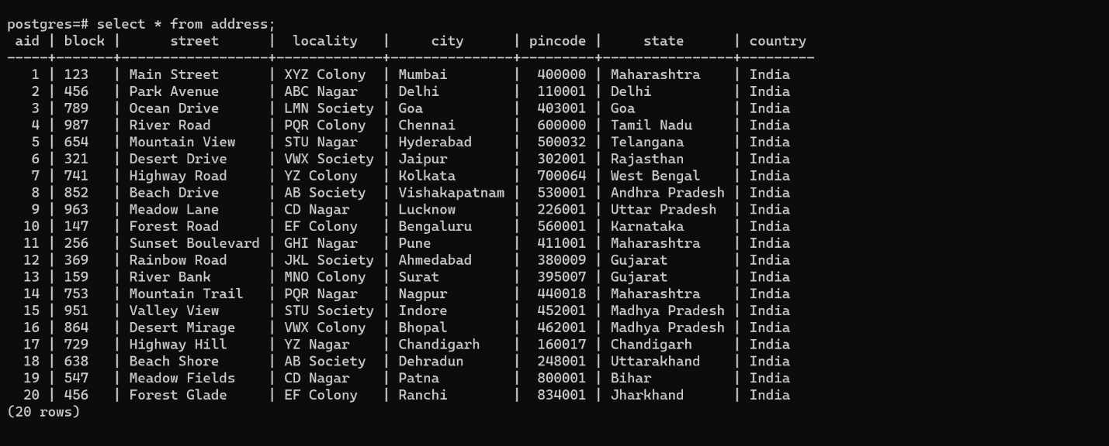

2.Products

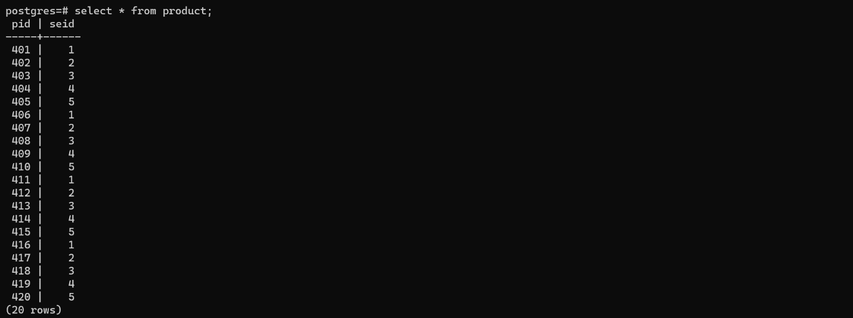

3.Season

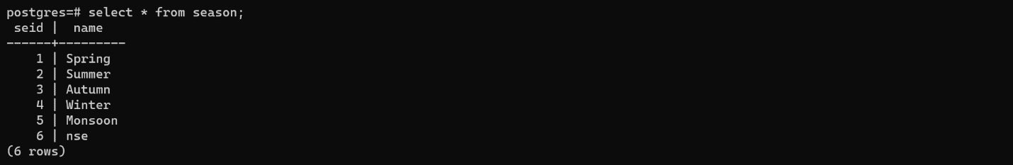

4.Berries

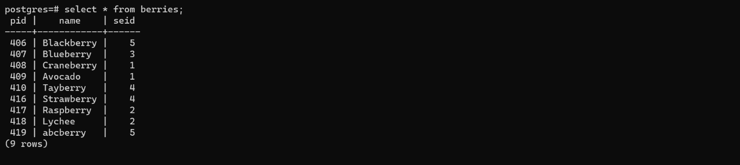

5.Flowers

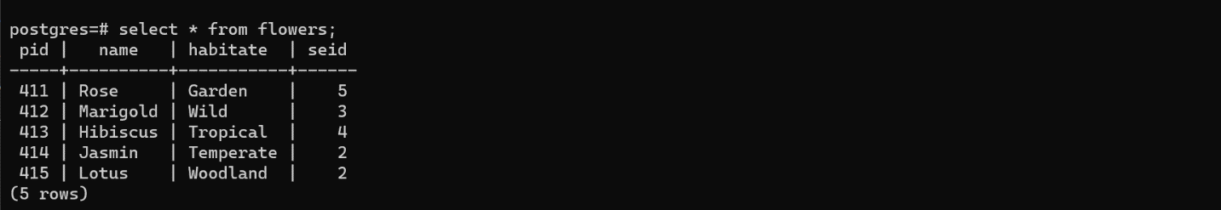

6.Fruits

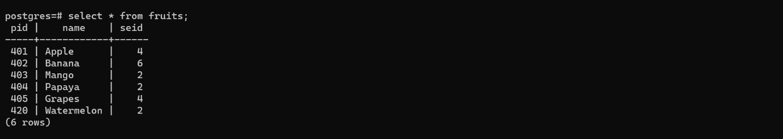

7.Customers

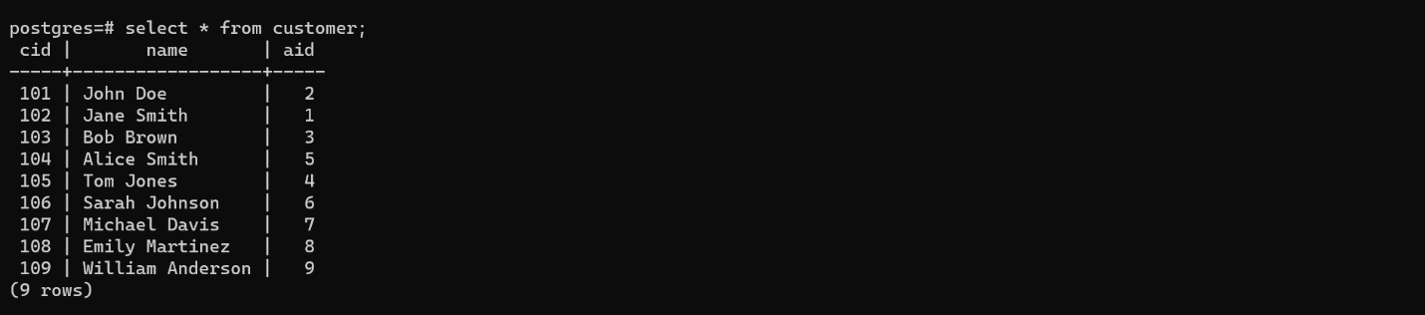

8.Disease

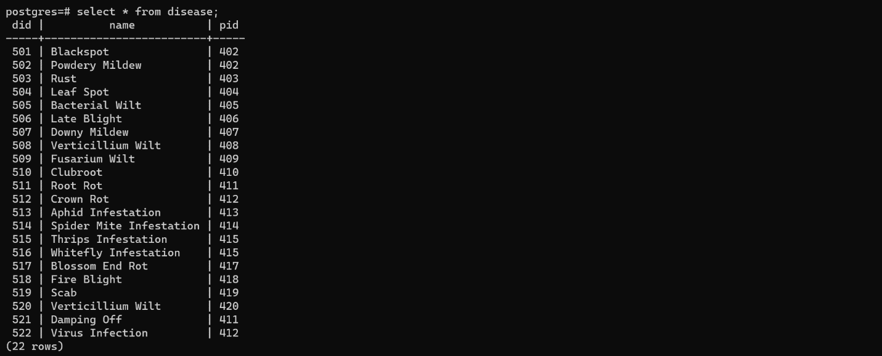

9.Employees

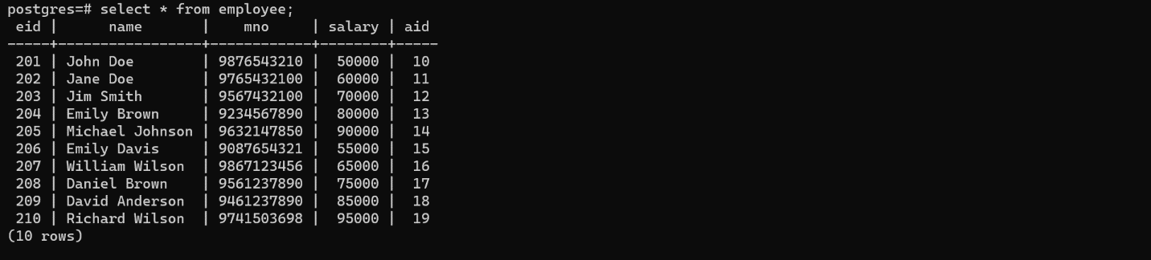

10.Garden Owners

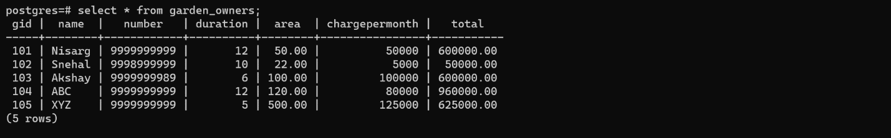

11.Managers

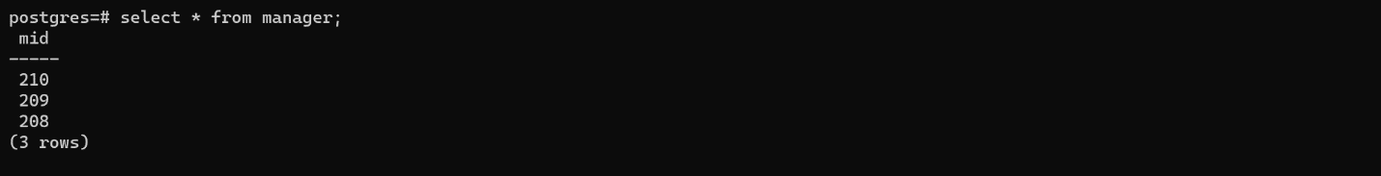

12. Manages

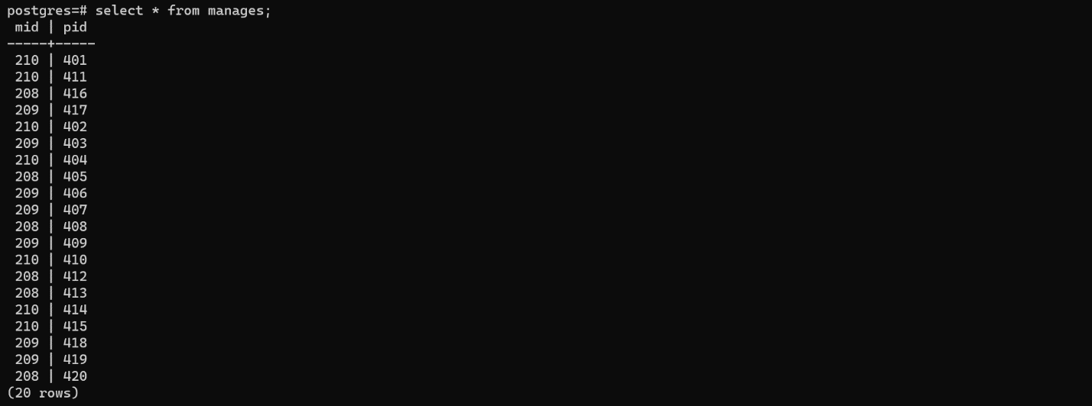

13.Medicine

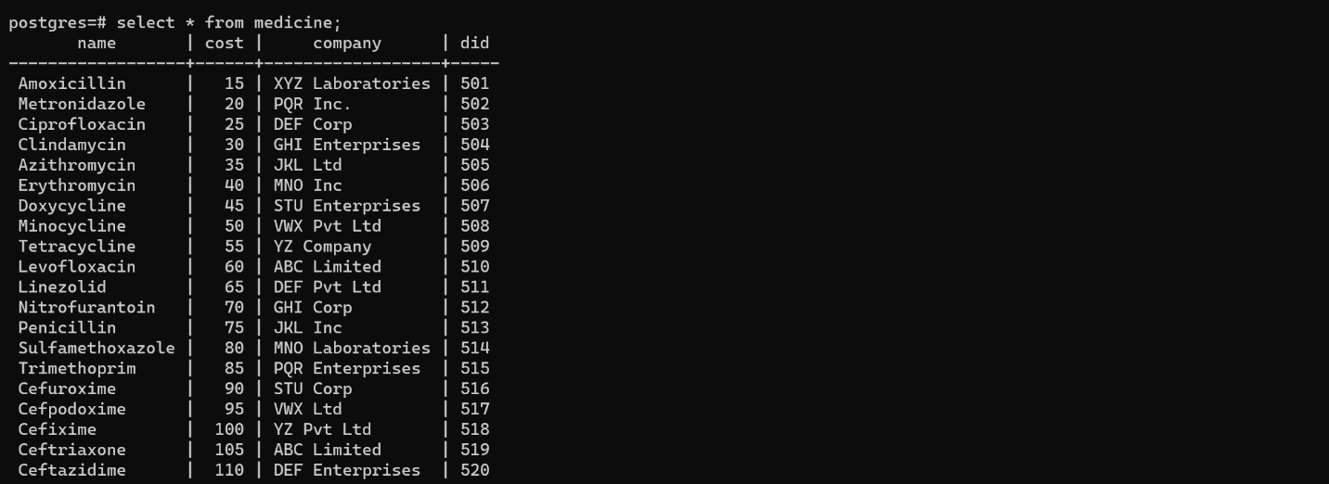

14.Orders

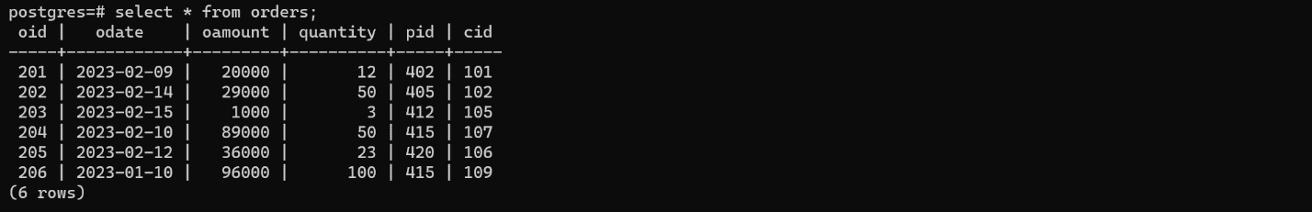

15.Owns

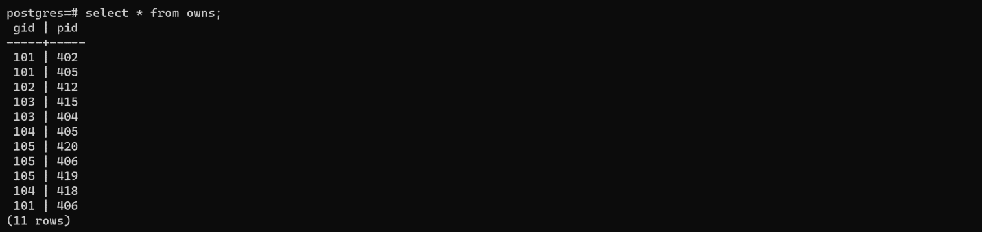

16.Tools

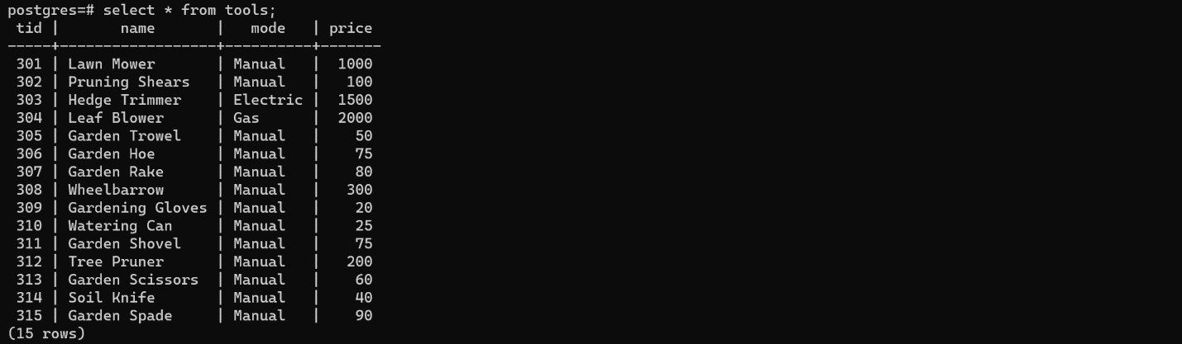

17.Used for

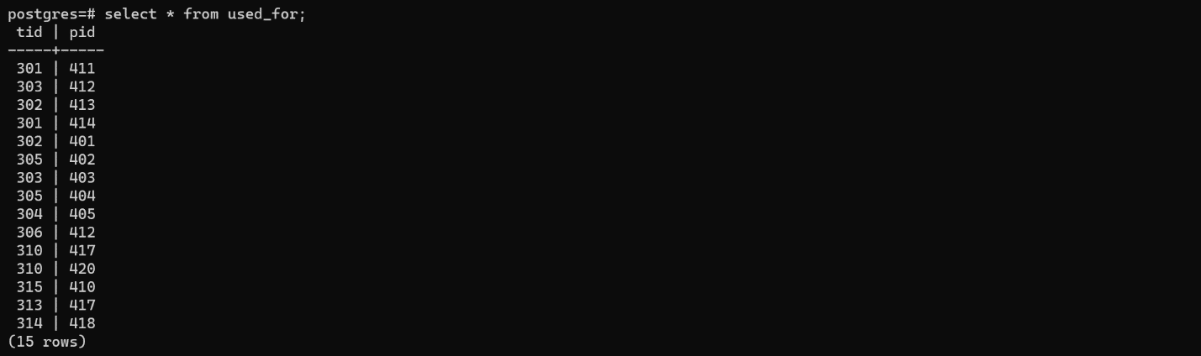

**6.QUERIES USING BASIC DBMS CONSTRUCTS**

**JOIN & SUBQUERIES:**

1. select t.name from (tools t join used_for u on u.tid=t.tid)join fruits f on f.pid=u.pid;

name

----------------

Pruning Shears

Garden Trowel

Hedge Trimmer

Garden Trowel

Leaf Blower

Watering Can

1. select e.name from (employee e join manages m ON m.mid=e.eid) where m.mid in (select m.mid from manages m join fruits f on f.pid=m.pid);

name

----------------

Richard Wilson

Richard Wilson

Daniel Brown

David Anderson

Richard Wilson

David Anderson

Richard Wilson

Daniel Brown

David Anderson

David Anderson

Daniel Brown

David Anderson

Richard Wilson

Daniel Brown

Daniel Brown

Richard Wilson

Richard Wilson

David Anderson

David Anderson

Daniel Brown

1. select c.cid,c.name from customer c where c.name like 'J%';

cid | name

-----+------------

101 | John Doe

102 | Jane Smith

1. select cid,c.name from customer c where c.cid in (select cid from orders where oamount=(select max(oamount) from orders));

cid | name

-----+------------------

109 | William Anderson

1. select c.name,o.* from customer c join orders o on o.cid=c.cid order by odate limit 1;

name | oid | odate | oamount | quantity | pid | cid

------------------+-----+------------+---------+----------+-----+-----

William Anderson | 206 | 2023-01-10 | 96000 | 100 | 415 | 109

Queries Given by Madam:

1. select name from garden_owners where gid in(select o.gid from owns o join berries b on o.pid=b.pid);

name

--------

Nisarg

ABC

XYZ

1. select seid,count(*) from product group by seid order by seid;

seid | count

------+-------

1 | 4

2 | 4

3 | 4

4 | 4

5 | 4

1. select distinct e.name,t.name from (employee e join manages m ON m.mid=e.eid), (tools t join used_for u on u.tid=t.tid)join fruits f on f.pid=u.pid where m.mid in (select m.mid from manages m join fruits f on f.pid=m.pid);

name | name

----------------+----------------

Richard Wilson | Leaf Blower

Daniel Brown | Hedge Trimmer

Daniel Brown | Watering Can

Richard Wilson | Hedge Trimmer

Richard Wilson | Watering Can

Richard Wilson | Garden Trowel

David Anderson | Hedge Trimmer

David Anderson | Leaf Blower

Daniel Brown | Pruning Shears

Daniel Brown | Garden Trowel

Daniel Brown | Leaf Blower

David Anderson | Pruning Shears

David Anderson | Watering Can

David Anderson | Garden Trowel

Richard Wilson | Pruning Shears

**7.Pl/PGSQL queries:**

Trigger 1:

Create a trigger to prevent the deletion of a row from the PRODUCT table if there are any corresponding rows in the ORDERS table.

CREATE OR REPLACE FUNCTION prevent_deletion() RETURNS trigger AS $$

DECLARE

  orders_count INTEGER;

BEGIN

  SELECT COUNT(*) INTO orders_count

  FROM orders

  WHERE pid = OLD.pid;

  IF orders_count > 0 THEN

    RAISE EXCEPTION 'Cannot delete product with associated orders.';

  END IF;

  RETURN OLD;

END;

$$ LANGUAGE plpgsql;

CREATE TRIGGER prevent_deletion

BEFORE DELETE ON product

FOR EACH ROW

EXECUTE FUNCTION prevent_deletion();

Triger 2:

When new employee is inserted, increase salary of previous employees.

CREATE OR REPLACE FUNCTION update_employee_salary()

RETURNS TRIGGER AS $$

BEGIN

  UPDATE employee

  SET salary = salary + (salary * 0.1)

  WHERE eid = NEW.eid;

  RETURN NEW;

END;

$$ LANGUAGE plpgsql;

CREATE TRIGGER increase_employee_salary

AFTER INSERT ON employee

FOR EACH ROW

EXECUTE FUNCTION update_employee_salary();

Cursor:

Create a cursor to calculate tax on salary of employees.

create or replace procedure calc_tax()

language plpgsql

as $$

declare

rec1 record;

tax integer;

cur1 cursor for select * from employee ;

begin

    open cur1;

     loop

        fetch cur1 into rec1;

        exit when not found;

        tax := rec1.salary*0.3;

        raise notice 'NAME = %',rec1.name;

        raise NOTICE 'Tax = %',tax;

     end loop;

    close cur1;

end; $$;

**Function 1:**

Fetch the average salary of employees of one city

CREATE OR REPLACE FUNCTION get_avg_salary_by_city(ucity VARCHAR(25))

RETURNS INTEGER AS $$

DECLARE

avg_salary INTEGER;

BEGIN

SELECT AVG(SALARY)

INTO avg_salary

FROM EMPLOYEE e

INNER JOIN ADDRESS a ON e.AID = a.AID

WHERE a.CITY = ucity;

RETURN COALESCE(avg_salary, 0);

END;

$$ LANGUAGE plpgsql;

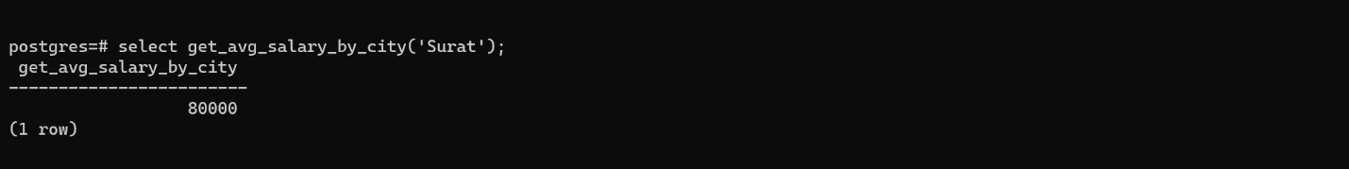

**Function 2:**

Get the revenue generated a product

CREATE OR REPLACE FUNCTION get_garden_owner_revenue(upid INTEGER)

RETURNS numeric(30,2) AS $$

DECLARE

total numeric(30,2);

BEGIN

SELECT SUM(OAMOUNT * QUANTITY)

INTO total

FROM ORDERS

WHERE PID = upid;

RETURN COALESCE(total, 0);

END;

$$ LANGUAGE plpgsql;

