- ABSTRACT

The business-to-consumer aspect of electronic commerce (e-commerce) is the most visible business use of the World Wide Web. The primary goal of an e-commerce site is to sell goods and services online.

This project deals with developing an e-commerce website for Online Electronics Sale. It provides the user with a catalog of different electronics items available for purchase in the store. In order to facilitate online purchase a shopping cart is provided to the user. The system is implemented using a 3-tier approach, with a backend database, a middle tier of Microsoft Internet Information Services (IIS) and PHP, and a web browser as the front end client.

In order to develop an e-commerce website, a number of Technologies must be studied and understood. These include multi-tiered architecture, server and client side scripting techniques, implementation technologies such as PHP, scripting programming language (such as php), relational databases (such as MySQL,).

This is a project with the objective to develop a basic website where a consumer is provided with a shopping cart application and also to know about the technologies used to develop such an application.

2. INTRODUCTION

E-commerce is fast gaining ground as an accepted and used business paradigm. More and more business houses are implementing web sites providing functionality for performing commercial transactions over the web. It is reasonable to say that the process of shopping on the web is becoming common place.

The objective of this project is to develop a general purpose e-commerce store where any product (such as books, computers, mobile phones, electronic items, and home appliances) can be bought from the comfort of home through the Internet. However, for implementation purposes.

An online store is a virtual store on the Internet where customers can browse the catalog and select products of interest. The selected items may be collected in a shopping cart. At checkout time, the items in the shopping cart will be presented as an order. At that time, more information will be needed to complete the transaction. Usually, the customer will be asked to fill or select a billing address, a shipping address, a shipping option, and payment information such as credit card number. An e- mail notification is sent to the customer as soon as the order is placed.

2.1 Objective and Scope Of Project

User Friendly
our main objective is to make customers feel at ease and comfortable while using ecommerce shopping cart software. We have created and designed the templates and software keeping in mind their needs and objectives. We try to present your products in a neat and straightforward manner through our designed templates.

Designed Templates
The Company offers wide range of designed templates to its customers, specified to their individual needs. All our designed templates can be used as it is or can be modified according to your requirements.

Supports all Major Browsers
Our designed storefront and ecommerce shopping cart software works with all the major search engines. The looks of the backend pages are identical in all major browsers.

Support Multiple Languages
We offer ecommerce shopping cart software that supports different language used by the customer. The facility of multiple languages allows the online marketers to interact with customers situated in different locations.

Cross-selling
our cross-selling services include direct links of recommended products to their respective pages. This would enable the product to be highlighted in the frontend detailed product view.

Inventory Control
Our designed shopping cart software manages the record of every product available in the store. Every product has an in stock quantity that will be automatically updated if it is ordered, sold or returned due to order being canceled.

2.2 Theatrical Background
Electronic Commerce (e-commerce) applications support the interaction between different parties participating in a commerce transaction via the network, as well as the management of the data involved in the process.

The increasing importance of e-commerce is apparent in the study conducted by researchers at the GVU (Graphics, Visualization, and Usability) Center at the Georgia Institute of Technology. In their summary of the findings from the eighth survey, the researchers report that “e-commerce is taking off both in terms of the number of users shopping as well as the total amount people are spending via Internet based transactions”.

Over three quarters of the 10,000 respondents report having purchased items online. The most cited reason for using the web for personal shopping was convenience (65%), followed by availability of vendor information (60%), no pressure from sales person (55%) and saving time (53%).

Although the issue of security remains the primary reason why more people do not purchase items online, the GVA survey also indicates that faith in the security of e-commerce is increasing. As more people gain confidence in current encryption technologies, more and more users can be expected to frequently purchase items online.

A good e-commerce site should present the following factors to the customers for better usability:
- Knowing when an item was saved or not saved in the shopping cart.
- Returning to different parts of the site after adding an item to the shopping cart.
- Easy scanning and selecting items in a list.
- Effective categorical organization of products.
- Simple navigation from home page to information and order links for specific products.
- Obvious shopping links or buttons.
- Minimal and effective security notifications or messages.
- Consistent layout of product information.
Another important factor in the design of an e-commerce site is feedback. The interactive cycle between a user and a web site is not complete until the web site responds to a command entered by the user. According to Norman , "feedback--sending back to the user information about what action has actually been done, what result has been accomplished--is a well known concept in the science of control and information theory. Imagine trying to talk to someone when you cannot even hear your own voice, or trying to draw a picture with a pencil that leaves no mark: there would be no feedback".

Web site feedback often consists of a change in the visual or verbal information presented to the user. Simple examples include highlighting a selection made by the user or filling a field on a form based on a user's selection from a pull down list. Another example is using the sound of a cash register to confirm that a product has been added to an electronic shopping cart.

Completed orders should be acknowledged quickly. This may be done with an acknowledgment or fulfillment page. The amount of time it takes to generate and download this page, however, is a source of irritation for many e-commerce users. Users are quick to attribute meaning to events. A blank page, or what a user perceives to be "a long time" to receive an acknowledgment, may be interpreted as "there must be something wrong with the order." If generating an acknowledgment may take longer than what may be reasonably expected by the user, then the design should include intermediate feedback to the user indicating the progress being made toward acknowledgment or fulfillment.
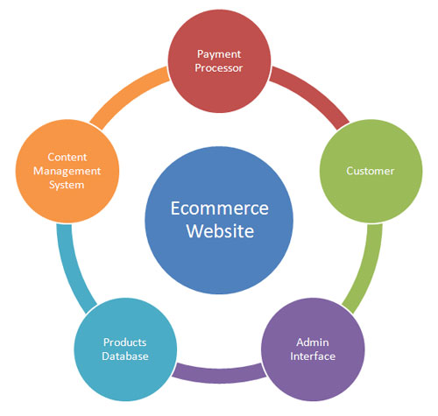

2. 3. Problem Definition
E-commerce is fast gaining ground as an accepted and used business paradigm.
More and more business houses are implementing web sites providing functionality for performing commercial transactions over the web. It is reasonable to say that the process of shopping on the web is becoming commonplace.
The objective of this project is to develop a general purpose e-commerce store.

3. SYSTEM ANALYSES
3. 1.Introduction
Systems are created to solve problems. One can think of the systems approach as an organized way of dealing with a problem. In this dynamic world, The subject System Analysis and Design, mainly deals with the software development activities.
Objective
After going through this lesson, you should be able to:
- understand a system
- understand the different phases of system developments life cycle
- know the components of system analysis
- know the components of system designing
Defining a System
A collection of components that work together to realize some objective forms a system. Basically there are three major components in every system, namely input, processing and output.
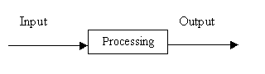
In a system the different components are connected with each other and they are interdependent. For example, Human body represents a complete natural system. We are also bound by many national systems such as political system, economic system, educational system and so forth. The objective of the system demands that some output is produced as a result of processing the suitable inputs.
The different phases of software development life cycle is shown in Fig
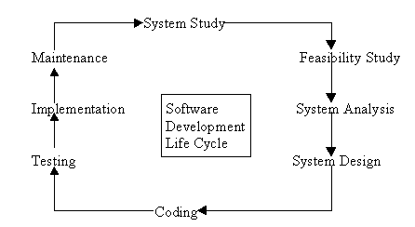
Fig: Different phases of Software development Life Cycle
Let us now describe the different phases and the related activities of system development life cycle in detail.
(a) System Study
System study is the first stage of system development life cycle. This gives a clear picture of what actually the physical system is? In practice, the system study is done in two phases. In the first phase, the preliminary survey of the system is done which helps in identifying the scope of the system. The second phase of the system study is more detailed and in-depth study in which the identification of user’s requirement and the limitations and problems of the present system are studied. After completing the system study, a system proposal is prepared by the System Analyst (who studies the system) and placed before the user. The proposed system contains the findings of the present system and recommendations to overcome the limitations and problems of the present system in the light of the user’s requirements.
To describe the system study phase more analytically, we would say that system study phase passes through the following steps:
- problem identification and project initiation
- background analysis
- inference or findings
(b) Feasibility Study
On the basis of result of the initial study, feasibility study takes place. The feasibility study is basically the test of the proposed system in the light of its workability, meeting user’s requirements, effective use of resources and .of course, the cost effectiveness. The main goal of feasibility study is not to solve the problem but to achieve the scope. In the process of feasibility study, the cost and benefits are estimated with greater accuracy.
(c) System Analysis
Assuming that a new system is to be developed, the next phase is system analysis. Analysis involved a detailed study of the current system, leading to specifications of a new system. Analysis is a detailed study of various operations performed by a system and their relationships within and outside the system. During analysis, data are collected on the available files, decision points and transactions handled by the present system. Interviews, on-site observation and questionnaire are the tools used for system analysis. Using the following steps it becomes easy to draw the exact boundary of the new system under consideration:
- Keeping in view the problems and new requirements
- Workout the pros and cons including new areas of the system
All procedures, requirements must be analyzed and documented in the form of detailed data flow diagrams (DFDs), data dictionary, logical data structures and miniature specifications. System Analysis also includes sub-dividing of complex process involving the entire system, identification of data store and manual processes.
The main points to be discussed in system analysis are:
- Specification of what the new system is to accomplish based on the user requirements.
- Functional hierarchy showing the functions to be performed by the new system and their relationship with each other.
- Function network which are similar to function hierarchy but they highlight the those functions which are common to more than one procedure.
- List of attributes of the entities - these are the data items which need to be held about each entity (record)

3.2 Existing System
Here in the existing system, the E-commerce maintains all the separate system which will be accessible for all Product booking details through Online and the administrator can access the earlier details and present details of booking.
Searching for related Product items booking based on manufacturer, Categories etc. is a time saving process.
Managing the products category wise and restrict them not to be accessible based on the user type becomes complicated.
This system doesn’t restrict unnecessary booking products.
3.3 Proposed System
The proposed system is fully computerized, which removes all the drawbacks of existing system. In the proposed system, it allows different Customers of our site to reserve their products booking into this system which will be verified by next level users to avoid data overwrites.
Advantages:
- Choose suitable product.
- Customer orders a product.
- Customer cancels his product booking.
- Customer booking products and require home delivery service.
- They cancel their product ordered.
- Customer pays bills.
- List of Regular customers.
- Email facility.
- Sending SMS to customer for confirmation of booking.
- Finally compute the bill etc.
- Feedbacks.

4. SYSTEM DESIGN
4.1 Introduction
Based on the user requirements and the detailed analysis of a new system, the new system must be designed. This is the phase of system designing. It is a most crucial phase in the development of a system. Normally, the design proceeds in two stages:
- preliminary or general design
- Structure or detailed design
Preliminary or general design: In the preliminary or general design, the features of the new system are specified. The costs of implementing these features and the benefits to be derived are estimated. If the project is still considered to be feasible, we move to the detailed design stage.
Structure or Detailed design: In the detailed design stage, computer oriented work begins in earnest. At this stage, the design of the system becomes more structured. Structure design is a blue print of a computer system solution to a given problem having the same components and inter-relationship among the same components as the original problem. Input, output and processing specifications are drawn up in detail. In the design stage, the programming language and the platform in which the new system will run are also decided.
There are several tools and techniques used for designing. These tools and techniques are:
- Flowchart
- Data flow diagram (DFDs)
- Data dictionary
- Structured English
- Decision table
- Decision tree

4.2 Methodology Used

Incremental Model
The incremental, or iterative, development model breaks the project into small parts. Each part is subjected to multiple iterations of the waterfall model. At the end of each iteration, a new module is completed or an existing one is improved on, the module is integrated into the structure, and the structure is then tested as a whole.
For example, using the iterative development model, a project can be divided into 12 one- to four-week iterations. The system is tested at the end of each iteration, and the test feedback is immediately incorporated at the end of each test cycle. The time required for successive iterations can be reduced based on the experience gained from past iterations. The system grows by adding new functions during the development portion of each iteration. Each cycle tackles a relatively small set of requirements; therefore, testing evolves as the system evolves. In contrast, in a classic waterfall life cycle, each phase (requirement analysis, system design, and so on) occurs once in the development cycle for the entire set of system requirements.

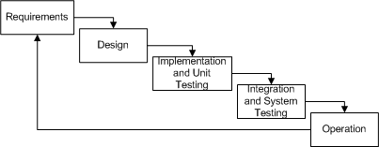

The Basic idea
- The basic idea behind iterative enhancement is to develop a software system incrementally, allowing the developer to take advantage of what was being learned during the development of earlier, incremental, deliverable versions of the system. Learning comes from both the development and use of the system, where possible key steps in the process are to start with a simple implementation of a subset of the software requirements and iteratively enhance the evolving sequence of versions until the full system is implemented. At each iteration, design modifications are made and new functional capabilities are added

- The procedure itself consists of the initialization step, the iteration step, and the Project Control List. The initialization step creates a base version of the system. The goal for this initial implementation is to create a product to which the user can react. It should offer a sampling of the key aspects of the problem and provide a solution that is simple enough to understand and implement easily. To guide the iteration process, a project control list is created that contains a record of all tasks that need to be performed. It includes such items as new features to be implemented and areas of redesign of the existing solution. The control list is constantly being revised as a result of the analysis phase.
Advantages of Incremental Model
- Generates working software quickly and early during the software life cycle.
- More flexible – less costly to change scope and requirements.
- Easier to test and debug during a smaller iteration.
- Easier to manage risk because risky pieces are identified and handled during its iteration.
- The main advantage of the iterative development model is that corrective actions can be taken at the end of each iteration. The corrective actions can be changes to the specification because of incorrect interpretation of the requirements, changes to the requirements themselves, and other design or code-related changes based on the system testing conducted at the end of each cycle.

Disadvantages of Incremental Model
- Problems may arise pertaining to system architecture because not all requirements are gathered up front for the entire software life cycle.
- It is difficult to freeze requirements, and they may continue to change in later iterations because of increasing customer demands. As a result, more iteration may be added to the project, leading to project delays and cost overruns.
- The project requires a very efficient change control mechanism to manage changes made to the system during each iteration.

4.3 System Modeling Using UML

Project Design

In order to design a web site, the relational database must be designed first. Conceptual design can be divided into two parts: The data model and the process model. The data model focuses on what data should be stored in the database while the process model deals with how the data is processed. To put this in the context of the relational database, the data model is used to design the relational tables. The process model is used to design the queries that will access and perform operations on those tables.

Data Model
A data model is a conceptual representation of the data structures that are required by a database. The first step in designing a database is to develop an Entity-Relation Diagram (ERD). The ERD serves as a blue print from which a relational database maybe deduced. Figure 1 shows the ERD for the project and later we will show the transformation from ERD to the Relational model

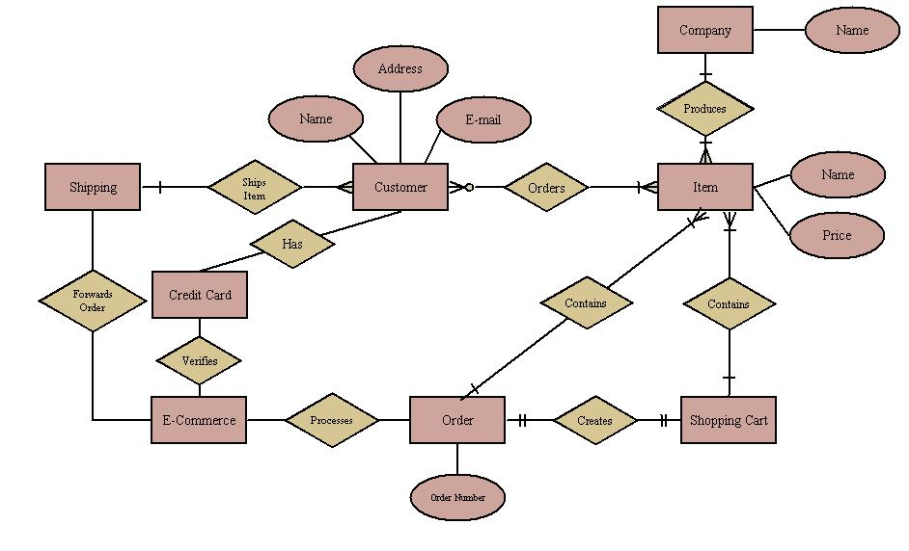
Fig: E-R-Diagram of e-commerce system

Entity A matches exactly one record in entity B and every record in B matches exactly one record in A. One to many means that every record in A matches zero or more records in B and every record in B matches exactly one record in A. If there is a one to much relationship between two entities, then these entities are represented as Associative Entities. In the Relational Database model, each of the entities will be transformed into a table. The tables are shown below along with the attributes.

The Unified Modeling Language (UML) is a graphical language for visualizing,
specifying, constructing, and documenting the artifacts of a software-intensive system.
The UML offers a standard way to write a system's blueprints, including conceptual things such as business processes and system functions as well as concrete things such as programming language statements, database schemas, and reusable software components.

Process Model
A Process Model tells us about how the data is processed and how the data flows from one table to another to gather the required information. This model consists of the Functional Decomposition Diagram and Data Flow Diagram.

Functional Decomposition Diagram
A decomposition diagram shows a top-down functional decomposition of a system and exposes the system's structure. The objective of the Functional Decomposition is to break down a system step by step, beginning with the main function of a system and continuing with the interim levels down to the level of elementary functions. The diagram is the starting point for more detailed process diagrams, such as data flow diagrams (DFD). Figure 2 shows the Functional Decomposition Diagram for this project.

Data Flow Diagram (DFD)
Data Flow Diagrams show the flow of data from external entities into the system, and from one process to another within the system. There are four symbols for drawing a DFD:

- Rectangles representing external entities, which are sources or destinations of data.

- Ellipses representing processes, which take data as input, validate and process it and output it.

- Arrows representing the data flows, which can either, be electronic data or physical items.

- Open-ended rectangles or a Disk symbol representing data stores, including electronic stores such as databases or XML files and physical stores such as filing cabinets or stacks of paper.

Figures 3 - 6 are the Data Flow Diagrams for the current system. Each process within the system is first shown as a Context Level DFD and later as a Detailed DFD. The Context Level DFD provides a conceptual view of the process and its surrounding input, output and data stores. The Detailed DFD provides a more detailed and comprehensive view of the interaction among the sub-processes within the system.

Shopping Cart - Detailed DFD
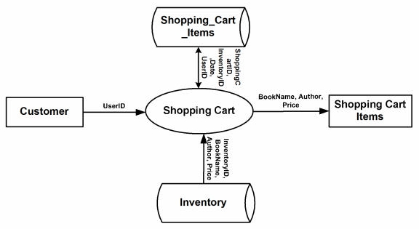

Figure. Customer - Shopping Cart Detailed DFD

Customer - Authentication Context DFD

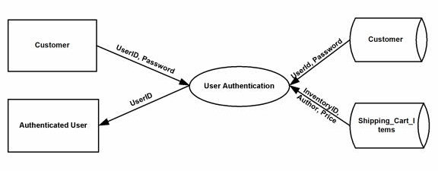

Figure . Customer - Authentication Detailed DFD

Customer - Authentication-Purchase History DFD
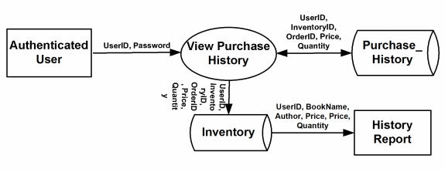

Figure. Customer – Authentication Purchase Cart Detailed DFD

Customer - Authentication-User Profile DFD

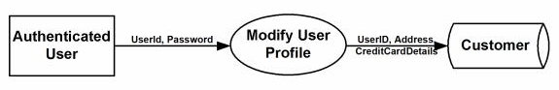

Figure: Customer - Authentication - User Profile

Use case Diagram
Use case diagrams are behavior diagrams used to describe a set of actions (use cases) that some system or systems (subject) should or can perform in collaboration with one or more external Users of the system (actors). Each use case should provide some observable and valuable result to the Actors or other stakeholders of the system. Use case diagrams are in fact twofold - they are both behavior diagrams (because they describe behavior of the system), and they are also structure diagrams.

Give Shipping Info
Buy the Product
Give Payment Info
CUSTOMER
Get Invoice (i.e., Slip)
Get confirmed i.e. Received Product
User Login

Fig: Use case diagram of E-commerce system

Enter Product Details
User Login
Small Problem
Medium Problem
CUSTOMER
Replace Product
Customer Satisfied

Fig: Use Case diagram – Customer-wise
Class Diagram
The class diagram is the main building block of object oriented modeling. It is used both for general modeling the systematics of the application, and for detailed modeling translating the models into programming code. Class diagrams can also be used for data modeling.
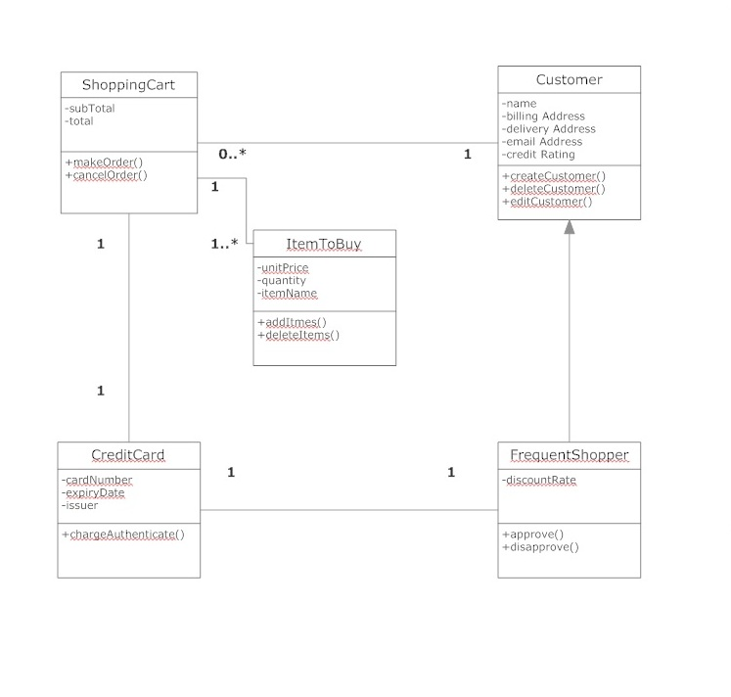 Fig: Class Diagram of E-commerce System

Sequence Diagram
A sequence diagram in a Unified Modeling Language (UML) is a kind of interaction diagram that shows how processes operate with one another and in what order. It is a construct of a Message Sequence Chart. A sequence diagram shows object interactions arranged in time sequence. It depicts the objects and classes involved in the scenario and the sequence of messages exchanged between the objects needed to carry out the functionality of the scenario. Sequence diagrams typically are associated with use case realizations in the Logical View of the system under development.

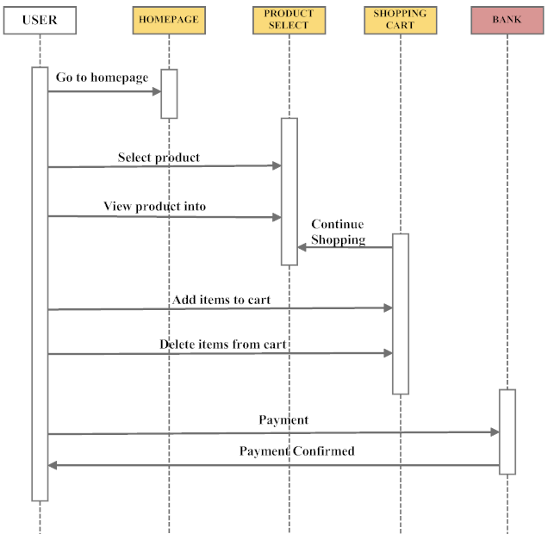

Fig: Sequence Diagram of Ecommerce System
4.4 Modules Description

- Default Page
- Login page
- Product details Page
- Member’s info page
- Product order Page
- Transaction Page
- Admin Login Page
- Default admin page
- Product add page
- Product update page
- Service Add page
- Service Add Page
- Report Page
- Search Page
- Registration Page
- How to Buy

4.5 Database Design
In this section, the basic structure of the tables composing the database for the
Projects are shown along with information about primary and foreign keys.

Customer
SNO |  |  | NAME |  | TYPE |  | DESCRIPTION
1 |  |  | UserID |  | Varchar |  | Primary key for Customer identification
2 |  |  | Password |  | Varchar |  | Security for Customer
3 |  |  | First_Name |  | Varchar
4 |  |  | Last_Name |  | Varchar
5 |  |  | Address |  | Varchar
6 |  |  | City |  | Varchar
7 |  |  | Zip |  | Integer
8 |  |  | State |  | Varchar
9 |  |  | Email Address |  | Varchar
10 |  |  | Phone_Number |  | Varchar
Product
SNO |  | NAME |  | TYPE |  | DESCRIPTION
1 |  | InventoryID |  | Integer |  | Primary key for Inventory Identification,
 |  |  |  |  |  | ISBN of a product
2 |  | Product_Name |  | Varchar
3 |  | Company_name |  | Varchar
5 |  | Nr_products |  | Integer
6 |  | Price |  | Double

State_Tax

SNO |  |  | NAME |  | TYPE |  | DESCRIPTION
1 |  |  | State Name |  | Varchar |  | Primary key for State Identification
2 |  |  | Sales Tax Rate |  | Double |  | Sales tax for each state
Shopping_Cart_Items
SNO |  | NAME |  | TYPE |  | DESCRIPTION
1 |  | ShoppingCartID |  | Integer |  | Primary key for Shopping Cart
 |  |  |  |  |  | Identification
2 |  | InventoryID |  | Varchar |  | Foreign key to Inventory
3 |  | Price |  | Double
4 |  | Date |  | Date
5 |  | UserID |  | Varchar |  | Foreign key to Customer
6 |  | Quantity |  | Integer
Order_Details
SNO |  |  | NAME |  | TYPE |  | DESCRIPTION
1 |  |  | OrderID |  | Integer |  | Primary key for Order identification
1 |  |  | UserID |  | Char |  | Foreign key to Customer
2 |  |  | Receiver’s Name |  | Char |  | If order is to be sent to other address rather
 |  |  |  |  |  |  | than to the customer, we need that address
3 |  |  | Address |  | Char
4 |  |  | City |  | Char
5 |  |  | Zip |  | Integer
6 |  |  | State |  | Char |  | Foreign key to State Tax
7 |  |  | Type of Shipping |  | Char |  | Foreign key to Shipping Type
8 |  |  | Date of Purchase |  | Date

Shipping_Type

SNO | NAME |  | TYPE | DESCRIPTION
1 | Type of Shipping |  | Varchar | Primary key to define type of shipping
2 | Price |  | Double
3 | Approximate days |  | Integer
 | for delivery
Credit_Card
SNO | NAME |  | TYPE | DESCRIPTION
1 | Credit Username |  | Varchar | Primary key for Customer Identification
2 | Credit Card |  | Varchar
 | Number
3 | Card Type |  | Varchar | Master Card, Visa, Discover
4 | CVV Number |  | Integer | Number present on the back of the card for
 |  |  |  | extra security
5 | Expiry Date |  | Date
6 | UserID |  | Varchar | Foreign key to Customer
Product_Review
SNO | NAME |  | TYPE | DESCRIPTION
1 | InventoryID |  | Varchar | ISBN of the product on which the review is
 |  |  |  | Written
2 | Reviews |  | Varchar | Review on the product
3 | Rating |  | Varchar | Rating given to the book in a scale of 5
4 | Review Date |  | Date
5 | User Name |  | Varchar | Name of the user providing the review

Purchase_History

SNO | NAME | TYPE | DESCRIPTION
1 | UserID | Varchar | Primary key for Customer Identification
2 | InventoryID | Varchar | Product purchased by the user
3 | Date of Purchase | Date
4 | OrderID | Integer | Foreign key to Order_details
5 | Quantity | Integer
6 | Price | Double

5. HARDWARE AND SOFTWARE REQUIREMENTS

5.1 Hardware Requirement

Processor Pentium 4 at 1.4 GHz
Main Memory 512MB
Disk space 1 GB

5.2 Software Requirement
Front End Php (CMS – Joomla)
Database MYSQL
Operating System Windows XP

5.3 BRIEF CHARACTERISTICS OF SOTWARE TOOLS

The objective of this project is to develop an online electronic store. When the user types in the URL of the electronic Store in the address field of the browser, a Web Server is contacted to get the requested information. In the .NET Framework, IIS (Internet Information Service) acts as the Web Server. The sole task of a WebServeris to accept incoming HTTP requests and to return the requested resourceinan HTTPresponse. The first thing IIS does when a request comes in is to decide how to handle the request. Its decision is based upon the requested file's extension.
PHP
PHP is an "Open Source" scripting language and provides very similar functionality to Microsoft's ASP. This compatibility allows the users to use the following features through PHP.
1. PHP runs on different platforms (Windows, Linux, Unix, etc.)
2. PHP is compatible with almost all servers used today (Apache IIS, etc.)
3. PHP is FREE to download from the official PHP resource:
4. PHP is easy to learn and runs efficiently on the server side
5. PHP automatically recovers from memory leaks and errors to make sure that the website is always available to the visitors.

Authentication in PHP
There are two separate authentication layers in an php application. All
requests flow through IIS before they are handed to php, and IIS can decide to deny access before php even knows about the request. Here is how the process works :
1. IIS checks to see if an incoming request is coming from an IP address that is allowed access to the domain. If not, the request is denied.

2. IIS performs its own user authentication, if it is configured to do so. By default, IIS allows anonymous access and requests are authenticated automatically.

3. When a request is passed from IIS to PHP with an authenticated user, PHP checks to see whether impersonation is enabled. If so, PHP acts as though it were the authenticated user. If not, PHP acts with its own configured account.

4. Finally, the identity is used to request resources from the operating system. If all the necessary resources can be obtained, the user's request is granted; otherwise the request is denied.

MySQL Database
In this project, MySQL is used as the backend database. MySQL is an open source database management system. The features of MySQL are given below:

• MySQL is a relational database management system. A relational database stores information in different tables, rather than in one giant table. These tables can be referenced to each other, to access and maintain data easily.
• MySQL is open source database system. The database software can be used and modify by anyone according to their needs.
• It is fast, reliable and easy to use. To improve the performance, MySQL is multi-threaded database engine. A multithreaded application performs many tasks at the same time as if multiple instances of that application were running simultaneously.

In being multithreaded MySQL has many advantages. A separate thread handles each incoming connection with an extra thread that is always running to manage the connections. Multiple clients can perform read operations simultaneously, but while writing, only hold up another client that needs access to the data being updated. Even though the threads share the same process space, they execute individually and because of this separation, multiprocessor machines can spread the thread across many CPUs as long as the host operating system supports multiple CPUs.Multithreading is the key feature to support MySQL’s performance design goals. It is the core feature around which MySQL is built.

MySQL database is connected to PHP using an ODBC driver. Open
Database Connectivity (ODBC) is a widely accepted application-programming interface (API) for database access. The ODBC driver is a library that implements the functions supported by ODBC API. It processes ODBC function calls, submits SQL requests to MySQL server, and returns results back to the application. If necessary, the driver modifies an application's request so that the request conforms to syntax supported by MySQL.

Integrating IIS and WAMP
When a request comes into IIS Web server its extension is examined and, based on this extension, the request is either handled directly by IIS or routed to an ISAPI extension. An ISAPI extension is a compiled class that is installed on the Web server and whose responsibility is to return the markup for the requested file type. By default ,IIS handles the request, and simply returns the contents of the requested file .

This makes sense for static files, like images, HTML pages, CSS files, external JavaScript files, and so on. For example, when a request is made for a .html file, IIS simply returns the contents of the requested HTML file

Integrating the Website and Database
Customers ordering from an e-commerce website need to be able to get information about a vendor’s products and services, ask questions, select items they wish to purchase, and submit payment information. Vendors need to be able to track customer inquiries and preferences and process their orders. So a well organized database is essential for the development and maintenance of an e-commerce site. In a static Web page, content is determined at the time when the page is created. As users access a static page, the page always displays the same information. Example of a static Web page is the page displaying company information. In a dynamic Web page, content varies based on user input and data received from external sources. We use the term “data-based Web pages” to refer to dynamic Web pages deriving some or all of their content from data files or databases.
A data-based Web page is requested when a user clicks a hyperlink or the submit button on a Web page form. If the request comes from clicking a hyperlink, the link specifies either a Web server program or a Web page that calls a Web server program .In some cases, the program performs a static query, such as “Display all items from the Inventory”. Although this query requires no user input, the results vary depending on when the query is made. If the request is generated when the user clicks a form’s submit button, instead of a hyperlink, the Web server program typically uses the form inputs to create a query. For example, the user might select five books to be purchased and then submit the input to the Web server program. The Web server program then services the order, generating a dynamic Web page response to confirm the transaction. In either case, the Web server is responsible for formatting the query results by adding HTML tags. The Web server program then sends the program’s output back to the client’s browsers Web page.

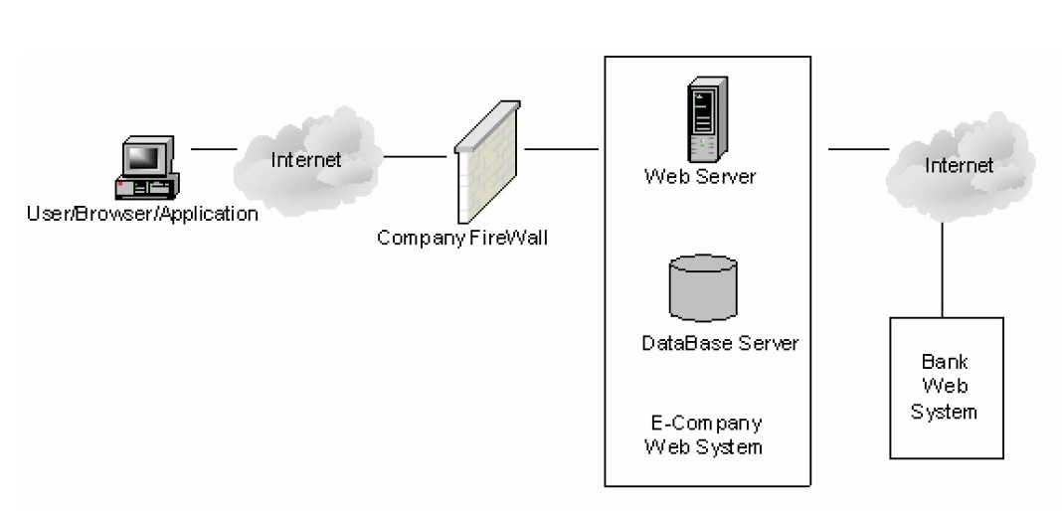

Fig: website and database integration

6. SYSTEM IMPLEMENTATION
System implementation is the stage of project when the theoretical design is turned into a working system. If the implementation stage is not carefully controlled and planned it can cause problems.
After proper testing and validation, the question arises whether the system can be implemented or not. Implementation includes all those activities that take place to convert from old system to the new.

The new system may be totally replacing an existing system or it may be a major modification to an existing system. In either case, proper implementation is essential to provide a reliable system to meet organizational requirements.

The process of putting the developed system in actual use is called a system implementation.
Implementation is done in different phase. The phases are follows
First phase includes table design for Database module
Second phase includes coding for GUI
Third phase includes connection between the front-end and back-end
Fourth phase includes error handling and message generating
Fifth phase includes report generating
Steps involved in implementation are has follows:
Step 1: All the tables are designed
Step 2: Primary key is assigned
Step 3: Reference is created between different table.
Step 4: All the web form are designed by using the tools
Step 5: Search form is designed and data grid is used to display the search results
Step 6: Connection is established between the front-end and back-end
Step 7: Code is written to different functionalities and condition is check for varies alert message to be displayed

Training
A well design system, if not operated and used properly could fail. Training the users is important, as if not done well it could prevent the successful implementation of this application.
Analyst should posses an accurate idea of the uses that need to be trained. They must know what their role will be and how they can use the system and what the system will do and what the system will not do.
The training could cover:
- Familiarization with the system itself.
- Training in using the application i.e, software application.
- Good documentation is essential, but this cannot replace training.
- There is no substitute for hands on operation of the system while learning its use.

Payment Gateway:

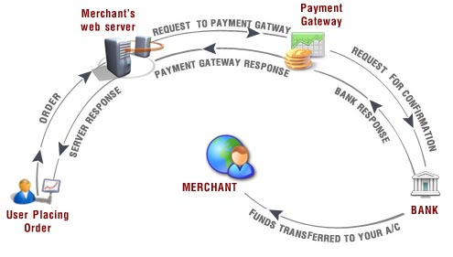

Payment Gateway Integration Payment Gateway refers to an e-commerce service that authorizes payments for e-businesses & online retailers. In a way, it represents a physical POS (Point-of-sale) terminal located at most retail outlets. Payment gateways encrypt sensitive information, such as credit card numbers, to ensure that information passes securely between the customer and the merchant.

Working of Payment Gateway
Though it may sound simple but actually the entire working of a payment gateway comprises of multiple complex steps; a brief of which is given below: -
1 Visitor places the order on the website and it is sent to the merchant's web server in encrypted format. This is usually done via SSL (Secure Socket Layer) encryption.
2 The transactions details are then forwarded to the concerned Payment Gateway.
3 The transaction information is then passed on to the merchants acquiring bank by the Payment Gateway.
4 Merchants acquiring bank then forwards the transaction information to the issuing bank (one that issued the credit card to the customer).
5 Then the card issuing bank sends a response back to the Payment Gateway. The response includes information that whether the payment has been approved or declined. In case of declination the reason is also sent in the response.
6 The response is then forwarded by the Payment Gateway to the merchant's server. At merchants’ server the response is encrypted again and is relayed back to the customer. This allows the customer to know that whether the order has been placed successfully or not.
7 The entire process typically takes less than 5 seconds. At the end of the bank day (or settlement period), the acquiring bank (or card issuing bank) deposits the total of the approved funds in to the merchant's nominated account.

Why is Payment Gateway needed?
Payment Gateway holds the essence of any e-commerce site. One cannot think of making or receiving on-line payments without a Payment Gateway. Payment Gateway basically refers to an e-commerce service that authorizes payments for e-businesses & online retailers. It, in a way, represents a physical POS (Point-of-sale) terminal located in most retail outlets. Payment gateways encrypt sensitive information, such as credit card numbers to ensure that information passes securely between the customer and the merchant.

Virtual Mart
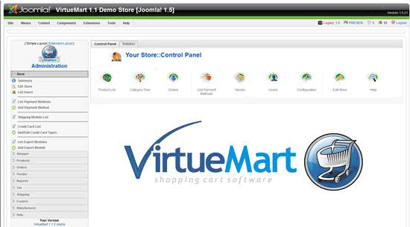

Useful features Virtual Mart offered:
1 capable of using Secure Sockets Layer (https) Encryption (128-bit)
2 flexible Tax Models
3 Shoppers can manage their User Accounts (registration required)
4 Shipping Address Management
5 Order Management with Order History, Customer Notification and Order Edit Functionality
6 Order Confirmation Mail (customizable!) is sent to Shopper and Store Owner
7 Powerful Web-Administration Interface (JavaScript-powered)
8 Can be used as a Shop or just as an Online-Catalog (you can even turn off Price Display)
9 quick Search for Products, Categories and Manufacturers; filter by features or discounted
10 "Product is back in Stock"-Notification for subscribed Customers
11 Support for multiple Images and Files
12 Product Types for Classification
13 multiple Prices per Product (Quantity-based and/or Shopper Group-based Prices)
14 flexible Price Display (number & currency formatting; including or excluding tax)
15 Support for live Credit Card Processing
16 pre-defined Payment Gateways like authorize.net®, PayPal, 2Checkout, eWay, Worldpay,
17 PayMate and NoChex
18 extend your Shop with other Payment Modules using the Payment Module API!
19 flexible Shipping Carriers and Rates Configuration
20 Live-Shipping Rates using Shipping Modules
21 extend your Shop with other Shipping Modules using the Shipping Module API!

Payment Method:
In the India we accept the following payment methods: MasterCard, Diners Club, Visa Electron, Visa, American Express, PayPal, Maestro, JCB, Electronic Bank Transfer (BACS), Cheque and Solo Card.
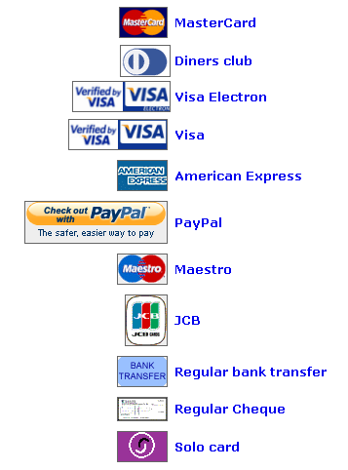
7. Screen
Home Page:
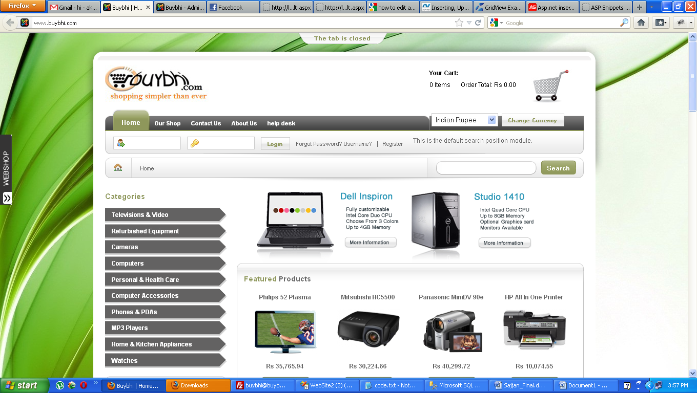
Figure 7.1
This Home page, it shows menus of overall application, including Home, about us, Login, Profile and Logout.

Customer Register Page:
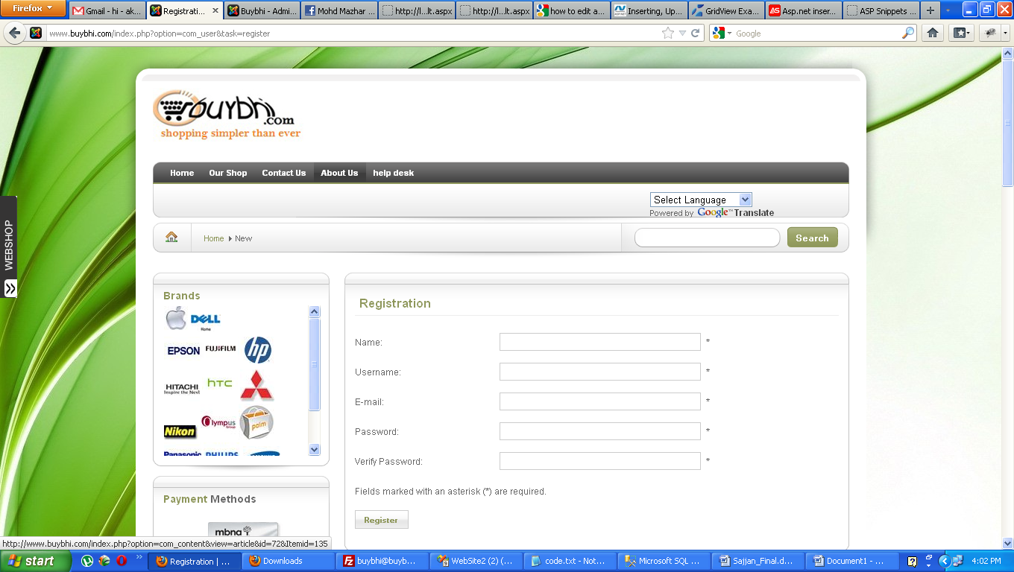
Figure 7.2
Customer Register page, here users enters Username and Password, and more information

Admin Page
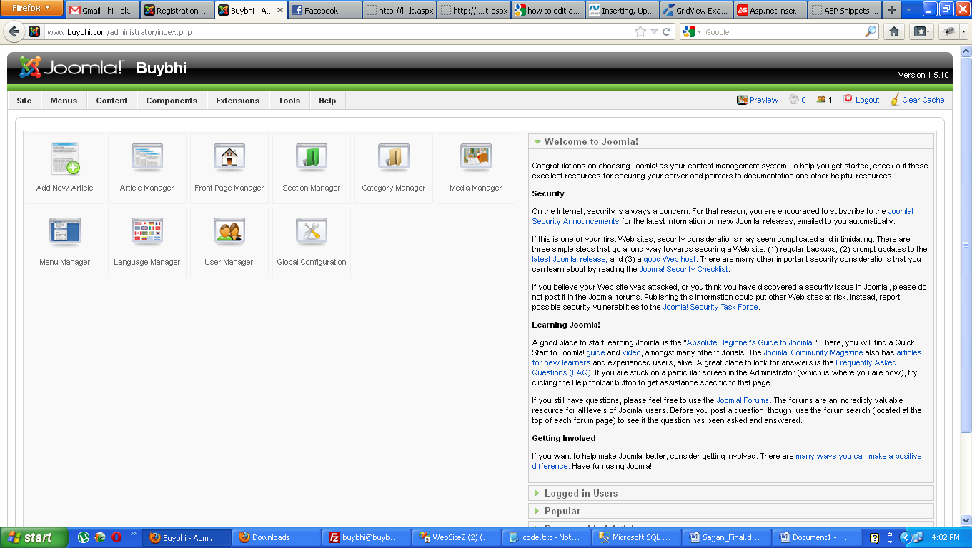
Figure 7.3
This is Admin Page; it shows Admin controls including Add New, Edit Customer, Delete Customer, ShowAll Customers, Upload Data, Run Cluster and Predict Module Output.

Virtual Cart Product

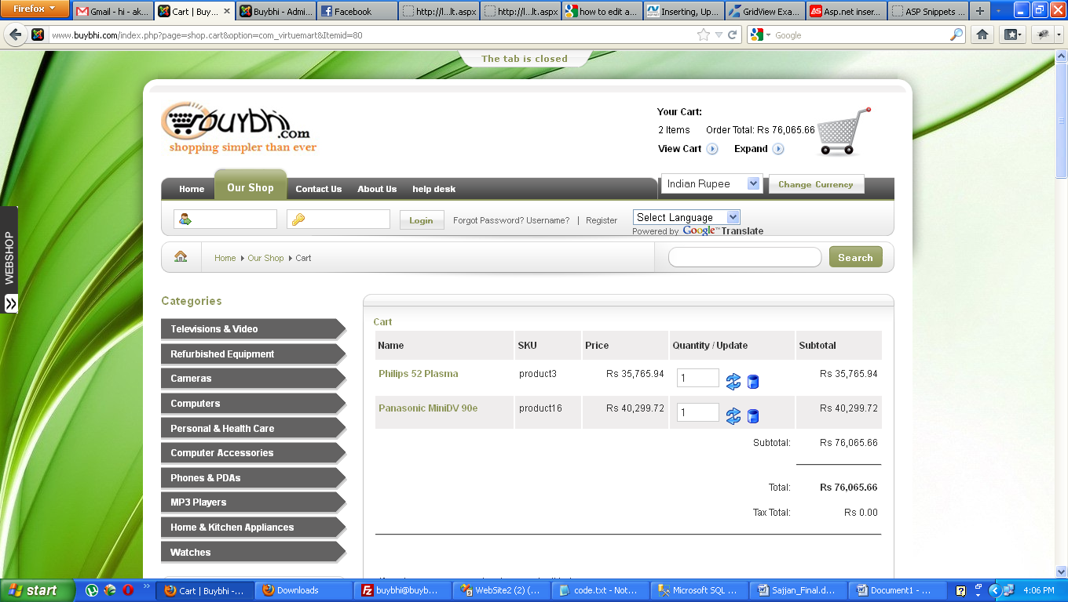
Figure 7.4
This is Add New Customer page, here Admin make Customer registration, with the help of Insert option connects to the database and stores the information.

View Cart Product

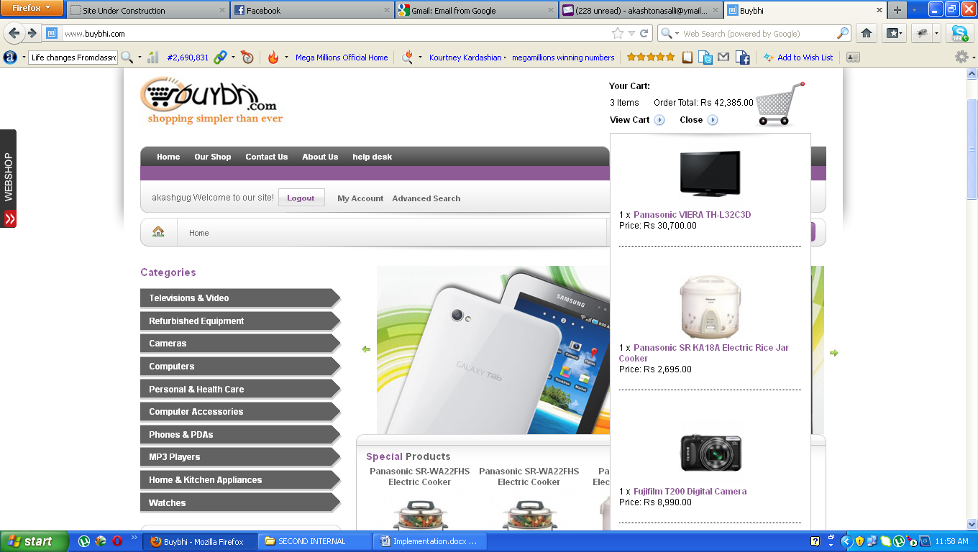
Figure 7.5

Special Categories

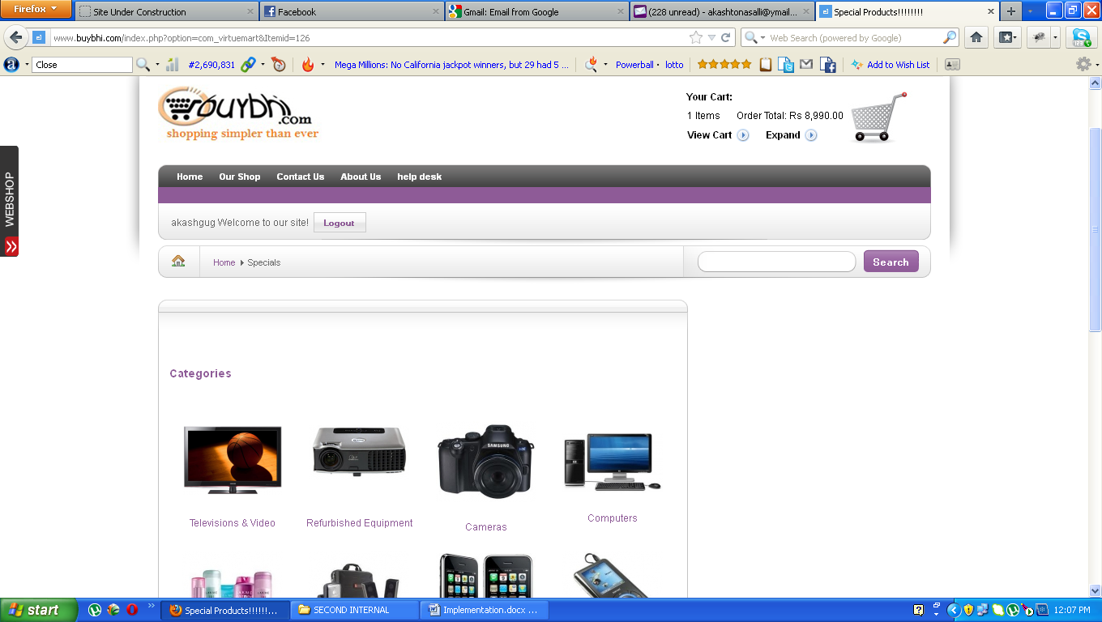
Figure 7.6

Delivery Information

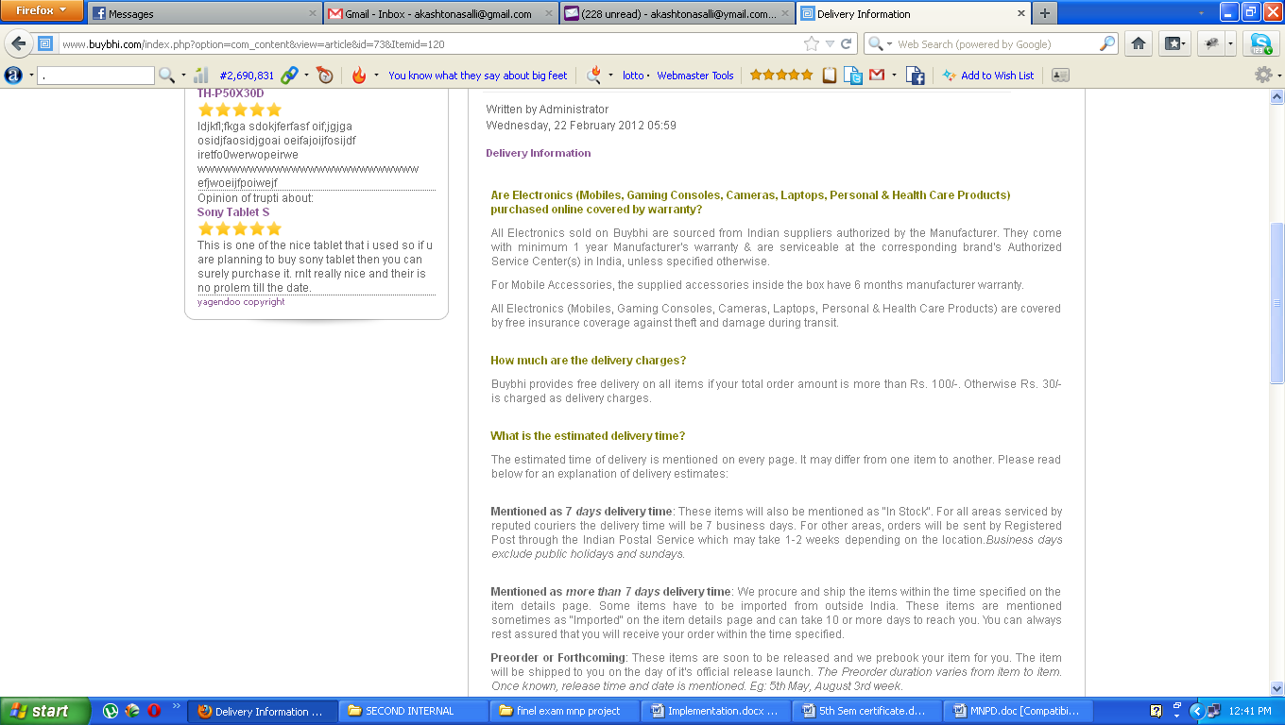

Figure 7.7

User Account Registration

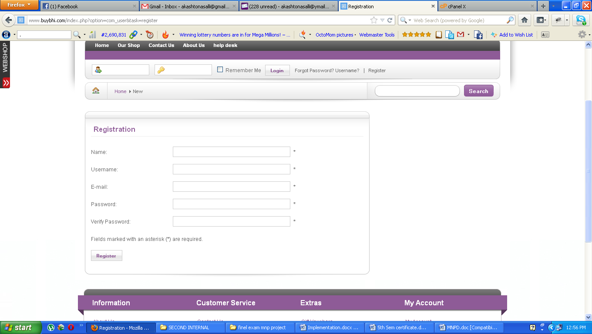
Figure 7 .8

About us
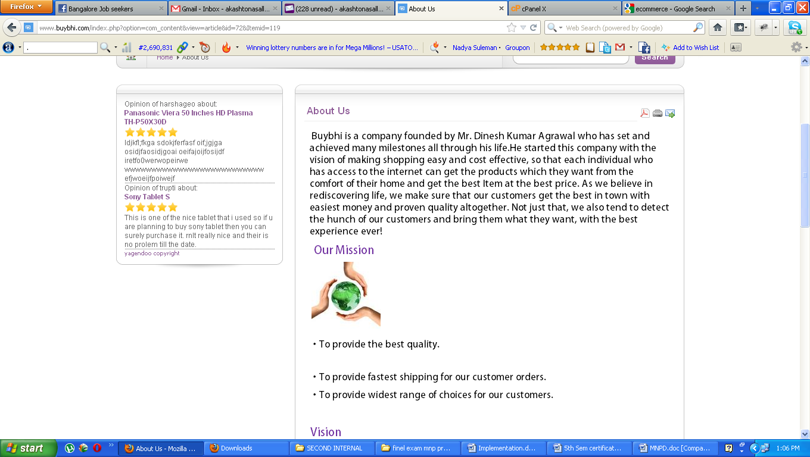
Figure 7.9

Contact Us

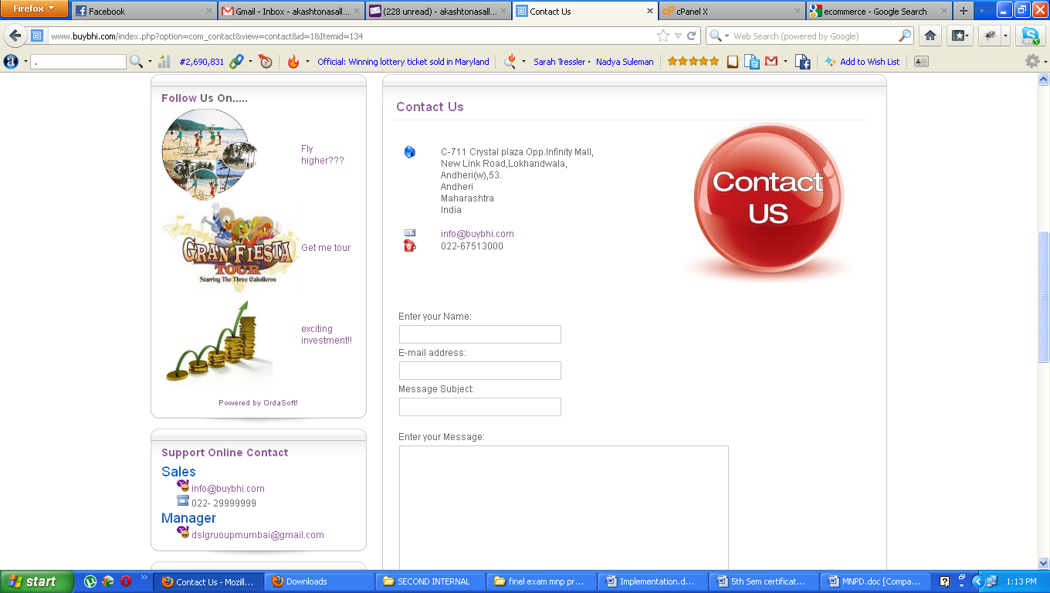
Figure 7.10

8.SYSTEM TESTING
8.1.Introduction
System testing is the stage of implementation , which aims at ensuring that the system works accuratly and efficiently before actual operation commerces.
Testing is usually performed for the following purposes:
- To improve quality
- For Verification & Validation (V&V)
- For reliability estimation
- There are basically two types of testing approaches:

8.2 Methodology Used For Testing
Unit Testing
In this testing we test each module individually. Our project has ten module and tested each module is tested independently
Integration Testing
Once individual program components have been tested, they must be integrated to create a partial or complete system. At the end all modules get integrated and tested as a whole system.

Verification &Validation Testing
The terms verification and validation are used interchangeably. Verification is the process of determining whether or not the products of given phase of software development fulfill the specifications established in the previous phase.
Validation is the process of evaluating the software at the end of software development process; we find how well the software satisfies the requirement specifications.

8.3 Testing Report
Various tests have to do on our project. All the tests work has to perform. Some of the test work is under progress.

S.No | Test Cases | Expected  Output | Actual Output | Result
1 | Enter the User name and password. | Username and password matched. | Username and password matched | Pass
2 | Enter the username and password. | Username and password not matched. | Username and password not matched | Fail
3 | Enter card no for create customer account. | The account is created. | The account is created. | Pass
4 | Enter card no for create customer account. | The account is created. | The card no is already exist. | Fail
5 | Customer transaction for different category | The transaction successful. | The transaction successful. | Pass
6 | Customer transaction for different category. | The transaction is successful. | The transaction is aborted. Card no doesn’t exists | Fail
7 | Purchase of different item through card. | Purchase successful. | Purchase successful. | Pass
8 | Purchase of different item through card. | Purchase successful. | Purchase aborted. Insufficient money in account. | Fail
9 | Add new customer. | Customer added successful | Customer added successful. | Pass
10 | Add new customer. | Customer added successful | Customer not added. Customer is already existing. | Fail

9.CONCLUSION
It has been a great pleasure for me to work on this existing and challenging project. This project helped us a lot to get the practical knowledge of how to work in the real time along with programming in PHP and java script web based application and learnt the knowledge up to some extent how to work on Web Applications and MYSQL, but also about all handling procedure related with “E-commerce Website Development Model”. It also provides knowledge about the latest technology used in developing web enabled application and client server technology that will be great demand in future. This will provide better opportunities and guidance in future while developing projects independently.

Finally I can conclude that, this project has been developed with all the features those are presented in the Requirements specification.

10. BIBLIOGRAPHY
Books
Designing Flexible Object-Oriented Systems with UML by Charles Ritcher, Techmedia Publications.
References
Other web forms in the system.
Training documents

Sites
Www. msdn.microsoft.com
www.w3schools.com
http://www.c-sharpcorner.com
http://www.mysql.com
http://www.mysql.in/index.php/general-articles.html
http://en.wikipedia.org

