WEEK 2 — FINTECH DOMAIN & SOFTWARE DEVELOPMENT FUNDAMENTALS
Assignment 4: Basic Software Development Concepts
Software Architecture & Data Flow in a Web Application
1. Objective
The objective of this task is to understand how a web application generates and processes data and how that data ultimately becomes available for analytics. The architecture connects the user interface, application server, security controls, database, data pipeline, analytics layer and dashboard.
2. Architecture Diagram
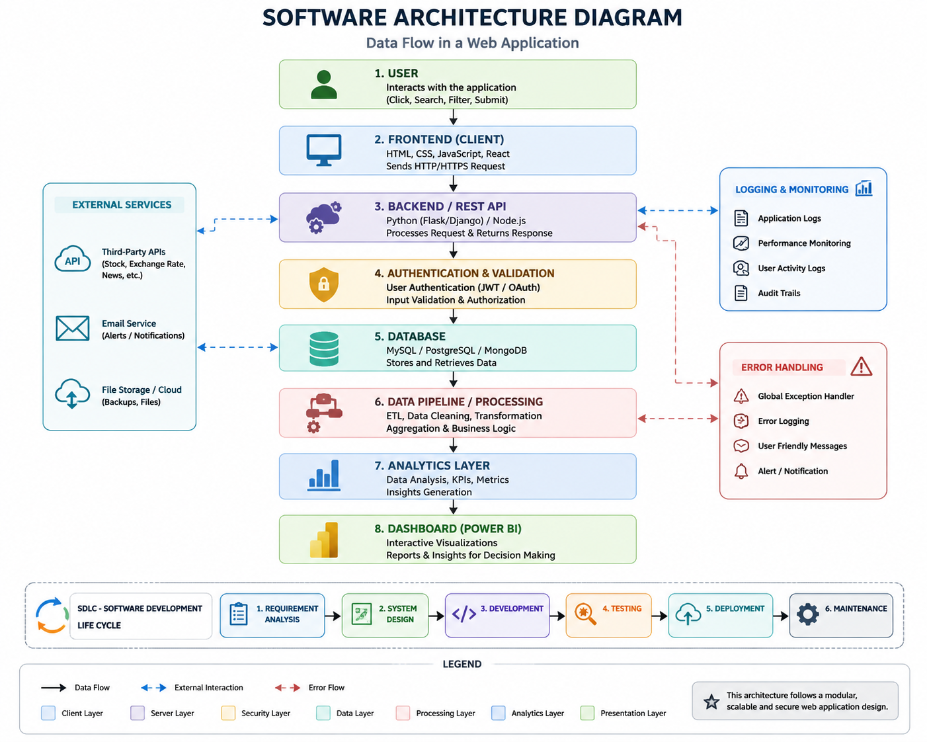
Figure 1. End-to-end data flow architecture for a web application.
3. Data Flow Explanation
1. User: A user performs an action such as clicking, searching, filtering or submitting a form.
2. Frontend (Client): The browser/mobile interface captures the user action and sends an HTTP/HTTPS request to the application server.
3. Backend / REST API: The server receives the request, applies application logic and returns a response. APIs provide a structured interface between the client and server.
4. Authentication & Validation: Authentication verifies the user's identity, while validation and authorization help ensure that the request contains acceptable data and that the user has permission to access the requested operation.
5. Database: Structured application data is stored and retrieved from a database such as MySQL, PostgreSQL or MongoDB.
6. Data Pipeline / Processing: Data can be cleaned, transformed, aggregated and enriched through ETL/ELT processes before analytics.
7. Analytics Layer: Analysts calculate KPIs, metrics and other analytical measures to generate insights from processed data.
8. Dashboard: A BI tool such as Power BI presents the resulting information through interactive charts, tables, filters and reports for decision-making.
4. Logging and Monitoring
Application logs record events such as requests, errors and important application actions. Performance monitoring helps detect slow operations or system bottlenecks. User-activity and audit logs can support traceability and troubleshooting. Logging is therefore an important supporting layer rather than a replacement for the main data flow.
5. Error Handling
Error handling ensures that failures are detected and managed safely. Typical mechanisms include exception handling, error logs, user-friendly error messages and alerts/notifications. A global error handler can provide a consistent response when an unexpected application failure occurs.
6. External Services
Modern applications may also consume third-party services, such as market-data APIs, exchange-rate APIs, email services or cloud/file storage. These services typically interact with the backend rather than directly with the analytics dashboard.
7. Client–Server Architecture
The client is responsible for presentation and user interaction, while the server handles application logic, security and data access. Separating these responsibilities makes applications easier to maintain and scale.
8. SDLC — Software Development Life Cycle
A basic SDLC flow includes requirement analysis, system design, development, testing, deployment and maintenance. Feedback and monitoring during maintenance can generate new requirements and begin another development cycle.
9. Relevance to Data Analysts
Understanding this architecture helps analysts identify where a dataset originates, how application events become records, where validation and transformation occur, and why the same business metric may look different at the source, database, pipeline and dashboard layers.
10. Conclusion
The architecture demonstrates the complete journey from user action to analytical insight. Understanding frontend, backend, REST APIs, authentication, databases, pipelines, logging, error handling and SDLC provides the software-development context required for effective collaboration between data analysts and engineering teams.
11. Deliverables
Software_Architecture_Diagram.png — architecture diagram.
Week_2_Assignment_4_Software_Architecture_Report.docx — explanatory report.

