WEEK 2 — FINTECH DOMAIN & SOFTWARE DEVELOPMENT FUNDAMENTALS
Assignment 2: REST APIs & JSON Data Extraction
Bluestock Fintech Internship | Practical API Data Extraction Assignment
1. Objective
The objective of this assignment is to understand how a REST API exposes structured data over HTTP, how a client sends a request and receives a JSON response, and how that response can be transformed into tabular CSV data for analysis. The implementation uses a public foreign-exchange API and Python.
2. Tools and Technologies
Python 3.13, the requests library for HTTP communication, Python's built-in csv module for file creation, VS Code for development and execution, and Microsoft Excel for visual inspection of the resulting CSV file.
3. API Used
Public API endpoint used: https://api.frankfurter.app/latest?from=USD
HTTP method: GET. The query parameter from=USD requests the latest exchange rates with USD as the base currency.
4. REST API Concepts Applied
REST (Representational State Transfer) is an architectural style for networked applications. A client communicates with a server through HTTP requests. The GET method is used to retrieve data without modifying the server-side resource. Query parameters provide additional input to the request. In this assignment, from=USD specifies the base currency.
The API returns data in JSON (JavaScript Object Notation), a lightweight structured format commonly used by web services. The response contains an amount, base currency, date and a nested rates object containing currency codes and exchange rates.
5. Implementation Method
The Python program performs the following sequence: (1) defines the API URL, (2) sends an HTTP GET request using requests.get(), (3) checks that the HTTP response status is 200, (4) parses the JSON response using response.json(), (5) extracts base, date and rates, (6) iterates through the currency-rate pairs, and (7) writes the results to exchange_rates.csv with the fields base, date, currency and rate.
6. Execution Result
The API call completed successfully with HTTP status code 200. The executed response reported USD as the base currency and the date 2026-08-17. The returned dataset contained multiple currency rates, including INR = 95.61, EUR = 0.86259, GBP = 0.73751 and JPY = 159.23 for the returned date.
7. Proof of API Execution
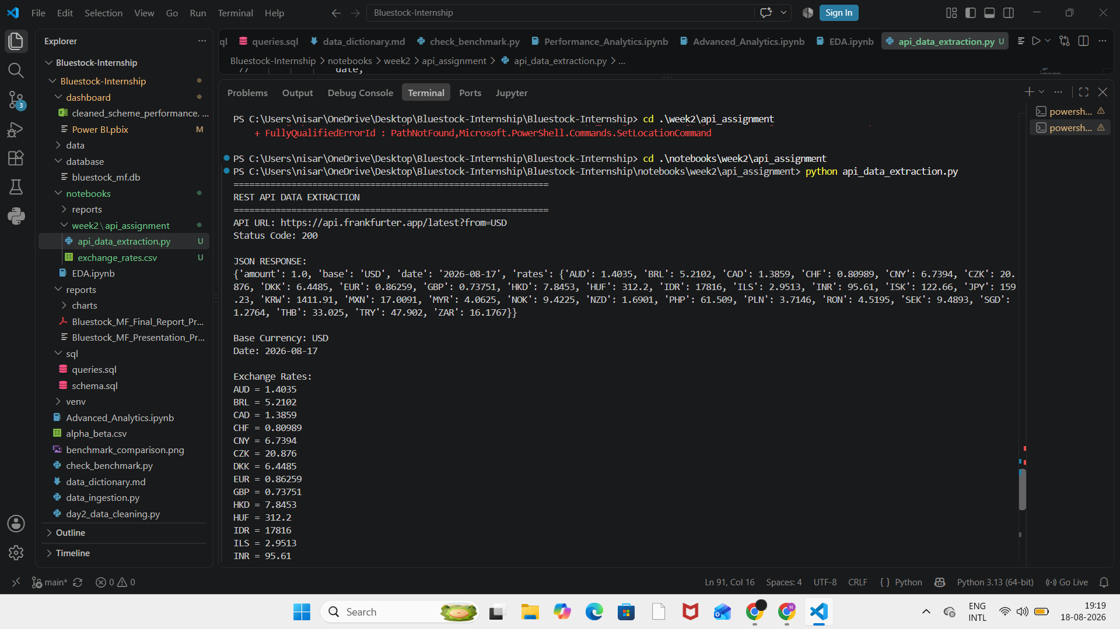
Figure 1. VS Code execution showing the API URL, HTTP 200 response, JSON payload, extracted exchange rates and successful CSV conversion.
8. JSON-to-CSV Transformation
The nested JSON rates object is flattened into one CSV row per currency. The resulting tabular structure contains four columns: base, date, currency and rate. This makes the API data easy to load into Excel, pandas, Power BI or a database.
base | date | currency | rate
USD | 17-08-2026 | AUD | 1.4035
USD | 17-08-2026 | EUR | 0.86259
USD | 17-08-2026 | GBP | 0.73751
USD | 17-08-2026 | INR | 95.61
USD | 17-08-2026 | JPY | 159.23
9. Proof of CSV Output
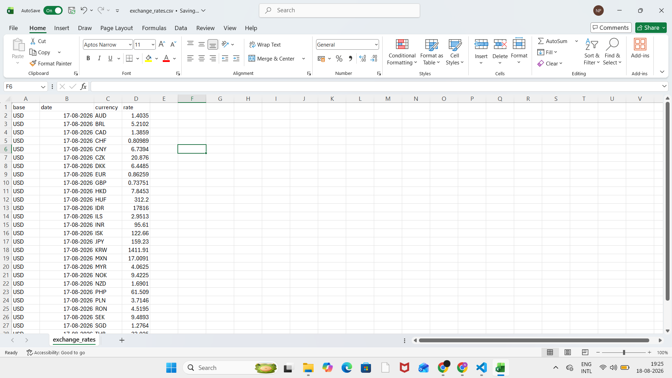
Figure 2. exchange_rates.csv opened in Excel, showing the converted tabular data and visible date values.
10. Output Files
The practical submission contains api_data_extraction.py, which implements the API request and JSON-to-CSV transformation, and exchange_rates.csv, which contains the extracted tabular result.
11. Learning Outcomes
This assignment demonstrates understanding of REST API communication, HTTP GET requests, query parameters, JSON parsing, error/status-code checking, data transformation and CSV generation. These are core skills for analysts who work with web-based and financial data sources.
12. Conclusion
The REST API assignment was completed successfully. A public API was accessed using a GET request, the JSON response was inspected and parsed in Python, and the currency-rate data was converted into CSV format. The successful HTTP 200 response and the generated exchange_rates.csv provide execution evidence for the required workflow.
13. Evidence Checklist
✓ Public REST API selected and documented.
✓ GET request executed successfully.
✓ HTTP response status code 200 verified.
✓ JSON response inspected and parsed.
✓ Currency-rate fields extracted.
✓ JSON converted into exchange_rates.csv.
✓ CSV opened and visually verified in Excel.
✓ Python source file stored in the internship repository.
14. File Location in Internship Project
Project path: notebooks/week2/api_assignment/
Files: api_data_extraction.py and exchange_rates.csv

