**I. Perform the following DB operations using MongoDB.**

**Create a database “Student” with the following attributes Rollno, Age, ContactNo, Email-Id.**

6. Update to add hobbies

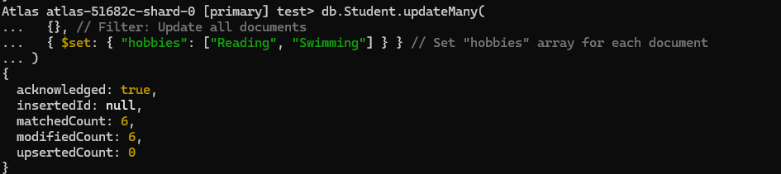

7. Find documents where hobbies is set neither to Chess nor to Skating

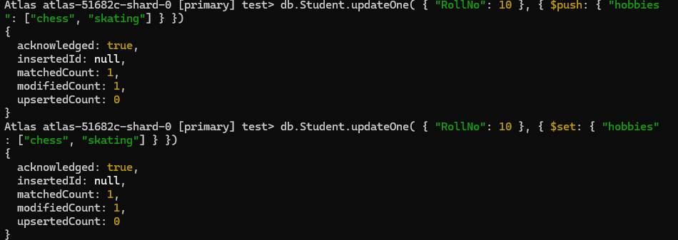

8.Find documents whose name begins with A

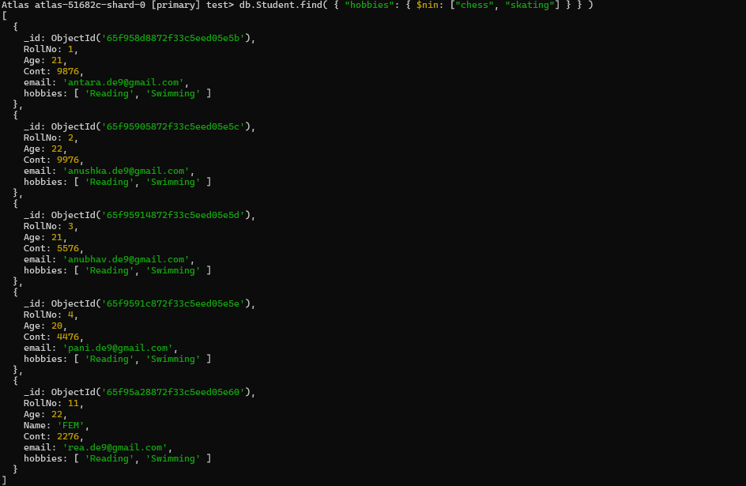

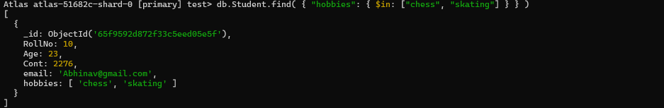

**II. Perform the following DB operations using MongoDB.**

**Create a collection by name Customers with the following attributes.**

**Cust_id, Acc_Bal, Acc_Type**

5. Sort the documents based on Customer ID in ascending order and Account Balance in descending order

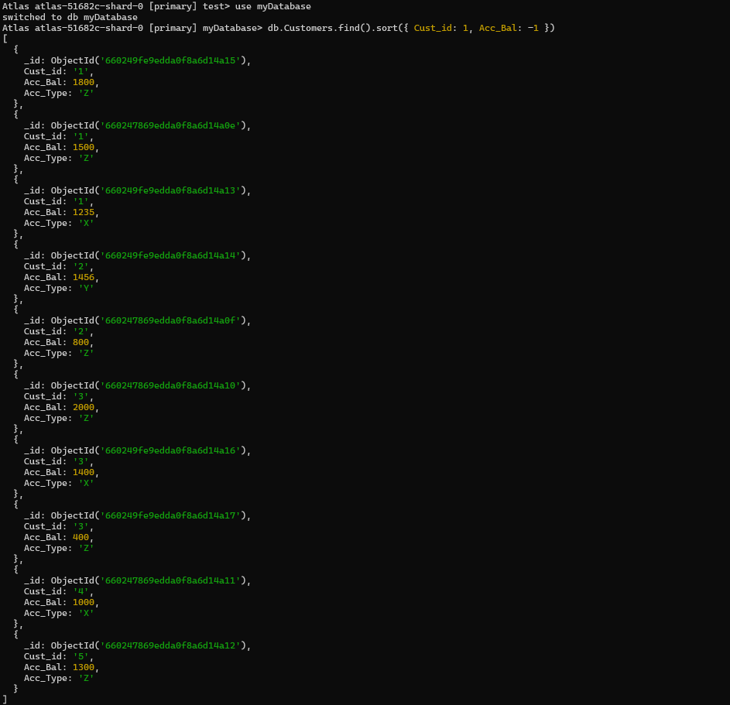

6. Display only 2 nd and 3 rd records from the collection

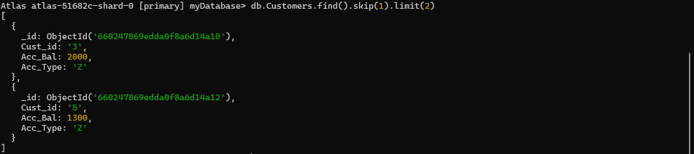

**Create a collection by the name blogPosts and it has 3 fields id, title and comments.**

**In the collection the comments field is an array which consists of user details. Each collection**

**consists of two user details inside the comments array- user name and text**

**Demonstrate the following**

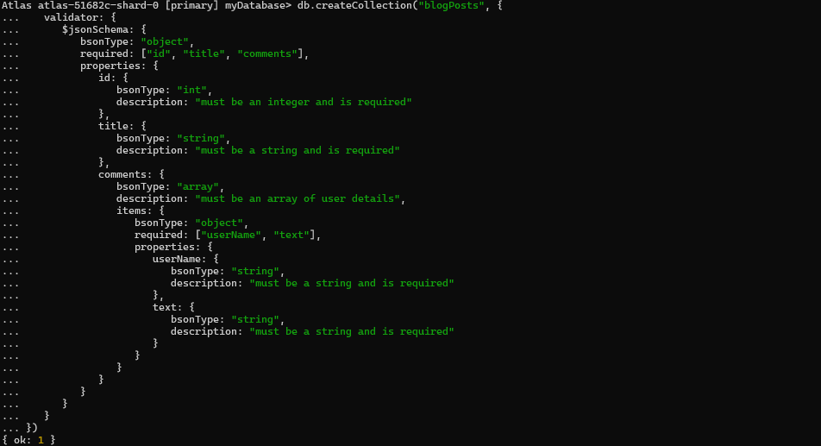

1. Adding an element into array

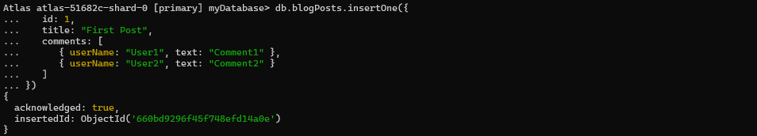

2. Display second element

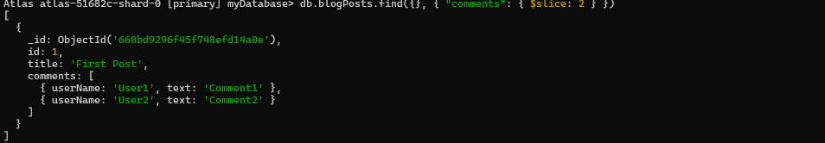

3. Display size of the array

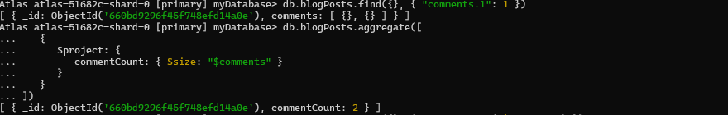

5. Update the document with id 4 and replace the element present in 1st index position of the

array with another array

