**Lab program- Week 4**

**Perform the following DB operations using Cassandra.**

**1.Create a keyspace by name Employee**

cqlsh

Connected to Test Cluster at 127.0.0.1:9042

[cqlsh 6.1.0 | Cassandra 4.1.4 | CQL spec 3.4.6 | Native protocol v5]

Use HELP for help.

cqlsh> create keyspace Employee with replication = {

...

cqlsh> create keyspace if not exists Employee with replication = {

... 'class': 'SimpleStrategy',

... 'replication_factor': 1

... };

cqlsh> describe keyspaces

employee system_auth system_schema system_views

system system_distributed system_traces system_virtual_schem**a**

**2. Create a column family by name Employee-Info with attributes**

**Emp_Id Primary Key, Emp_Name,**

**Designation, Date_of_Joining, Salary,**

**Dept_Name**

cqlsh> CREATE TABLE IF NOT EXISTS Employee.Employee_Info ( Emp_Id UUID PRIMARY KEY, Emp_Name TEXT, Designation TEXT, Date_of_Joining DATE, Salary DECIMAL, Dept_Name TEXT );

**3. Insert the values into the table in batch**

cqlsh> use employee

... ;

cqlsh:employee> begin batch

... insert into Employee_info (Emp_Id, Emp_Name, Designation, Date_of_Joining, Salary, Dept_Name)

... values (uuid(), 'John Doe', 'Software Engineer', '2023-01-15', 75000, 'Engineering');

... insert into Employee_info (Emp_Id, Emp_Name, Designation, Date_of_Joining, Salary, Dept_Name)

... values (uuid(), 'Jane Smith', 'Product Manager', '2022-11-20', 90000, 'Product Management');

... insert into Employee_info (Emp_Id, Emp_Name, Designation, Date_of_Joining, Salary, Dept_Name)

... values (uuid(), 'Michael Johnson', 'Data Analyst', '2023-03-10', 60000, 'Analytics');

... apply batch;

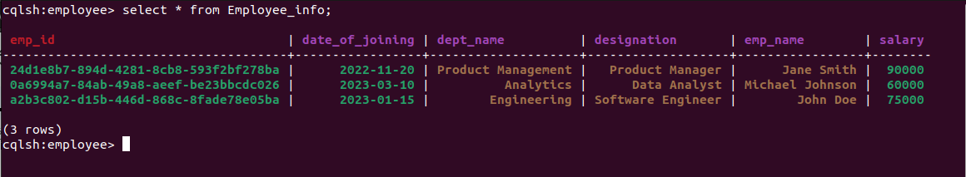

**4. Update Employee name and Department of**

**Emp-Id 121**

cqlsh:employee> SELECT emp_id FROM Employee_info WHERE emp_name = 'Jane Smith' allow filtering;

**emp_id**

**--------------------------------------**

**24d1e8b7-894d-4281-8cb8-593f2bf278ba**

cqlsh:employee> update Employee_info

... set date_of_joining = '2023-01-13'

... where emp_id = 24d1e8b7-894d-4281-8cb8-593f2bf278ba;

cqlsh:employee> select * from Employee_info;

