**Hadoop HDFS**

to start hadoop services

***start-all.sh***

***jps***

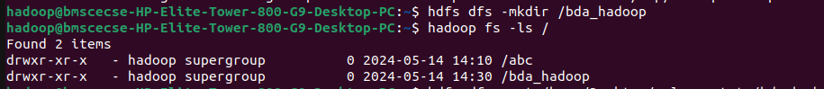we have to make a new directory and display the dierctory contents to check what directories are there

use put to copy files from local to bda_hadoop folder

use copyFromLocal to copy files from local to bda_hadoop folder

use get to copy files from hadoop folder to local

make a merged file from hadoop and store it in local desktop

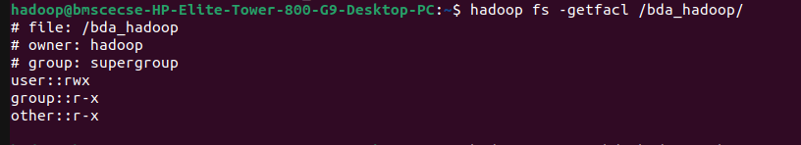use getfacl to show the access rights

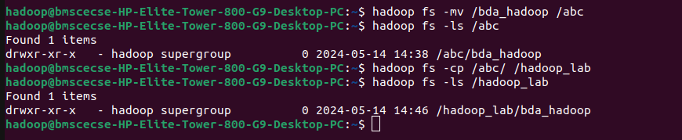move the contents of a directory to another directory in hadoop