

SCHOOL OF ADVANCED TECHNOLOGY

ICT - Applications & Programming

Computer Engineering Technology – Computing Science

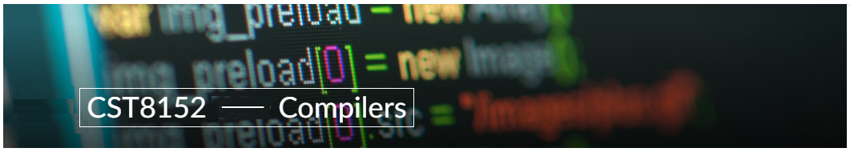

A21
Model Definitions (RE/Automaton)

Lab Professor / Lab Session:
[Paulo Sousa / Week 6]

Team:
[Bhagyesh Salvi] - Id: [041103856] / [Nisargkumar Patel] - Id: [041102856]

Language Name [AliceJS]

This template is suggested (not mandatory) to answer A11 Specification.

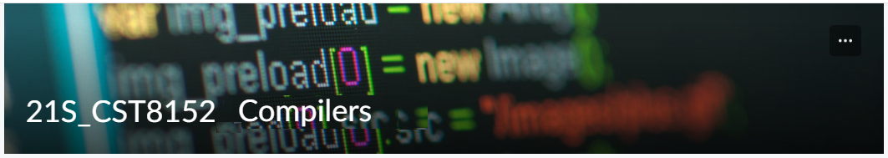

MODEL TASK FOR ASSIGNMENT 2.1 – AliceJS

- Note: This task is part of the Assignment 2 from Compilers Course. Any problem, contact your lab professor.

Task 1: Language Symbols (2.0 marks)

List examples: Define main symbols to be used:
- Comments
- Variables
- Functions
- Literals (numbers, strings)
- Keywords
- Datatypes

Answer:
Comments: /
Variables: int, string, real
Functions: myFunction(…)
Literals: 36, 1.5, ‘Star’, ‘a’
Keywords: ‘delete’, ‘do’, else, break, false, private, public, return, try, catch, for, while, void, else
Datatypes: String, number, Boolean, null, array, sets, object

Task 2: RE – Regular Expression (3.0 mark)

Special Chars: List all special chars that must be used in your language:
Char: Usage:
/ Define SLC
/ Used to define SLC
/* Define MLC
( Assigning function
. Floating point
“ String Assign
_ Underscores define in function
\n new line
= Used to assign variable value
+ - * / Arithmetic expression
{ Loops

Lexeme Classes: Define the classes to be used in your regular expression:

Answer:
Matasymbol
S - ‘/’
Q - ‘’, “”
F - ‘.’
L - ‘A’ | ‘B’ | ‘C’ | … | ‘Z’ | ‘a’ | … | ‘z’
N - ‘0’ | ‘1’ | … | ‘9’
E - \n
U - _
A - &
M - *
C - ,
B - =
O - [^L.^U.^B.^C.^N.^F.^Q.^S.^E]
C - (
MID - L[L|D|U]*C
SL - Q[^Q]*Q

Define the RE to be used for: variables, literals and keywords:

Answer:
* Comments: SM [^S] SM (MLC)
SS{^S}SS (SLC)
* Variables: L{L|N|U} = L+
* Methods: L{L|N}*C
* Literals:
- Numbers N{N*}
- Strings L{L*}
* Keywords: L{L}*

Task 3: TD – Transition Diagram (3.0 marks)

Activity: Starting from the previous lexeme classes and obeying the RE, it is possible to define the automata for your language:

Answer (draw / copy image of the automata):

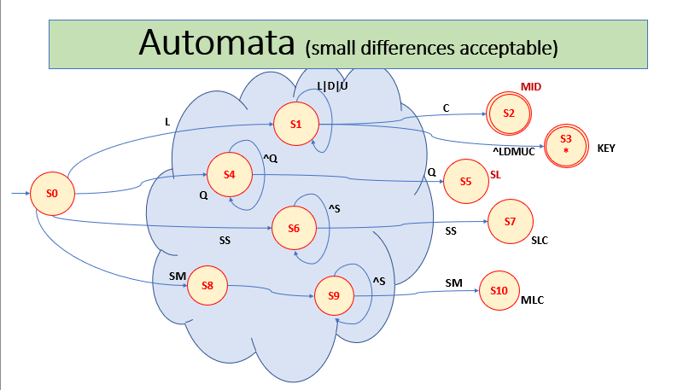

Task 4: TT – Transition Table (2.0 marks)

Activity: Now, it is possible to define the TT for these lexemes:

Answer (Transition Table):

Input |  |  | Input Symbol |  |  |  |  |  | Output
State \ Classes | 0 | 1 |  | 2 | 3 | 4 | 5 | 6 | Type
 | L(A-Z) | D(0-9) |  | U(_) | M(*) | C[(] | Q(') | O | -
S0 | S1 | ES |  | ES | ES | S4 | ES | ES | NOFS[0]
S1 | S1 | S1 |  | S1 | S2 | S3 | S3 | S3 | NOFS [1]
S2 | FS | FS |  | FS | FS | FS | FS | FS | FSNR (MNID) [2]
S3 | FS | FS |  | FS | FS | FS | FS | FS | FSWR (KEY) [3]
S4 | S4 | S4 |  | S4 | S4 | S4 | S5 | S4 | NOFS [4]
S5 | FS | FS |  | FS | FS | FS | FS | FS | FSNR (SL) [5]
S6 | S6 | S6 |  | S6 | S6 | S6 | S6 | ES | NOFS [6]
S7 | FS | FS |  | FS | FS | FS | FS | FS | FSNR (SLC) [7]
S8 | S8 | S8 |  | S8 | S8 | S8 | S8 | ES | NOFS [8]
S9 | S9 | S9 |  | S9 | S9 | S9 | S9 | ES | NOFS [9]
S10 | FS | FS |  | FS | FS | FS | FS | FS | FSNR (MLC) [10]

Update: Oct 1st 2024.

Adapted from resources developed by Prof. Svillen Ranev (Algonquin College, 2019)

